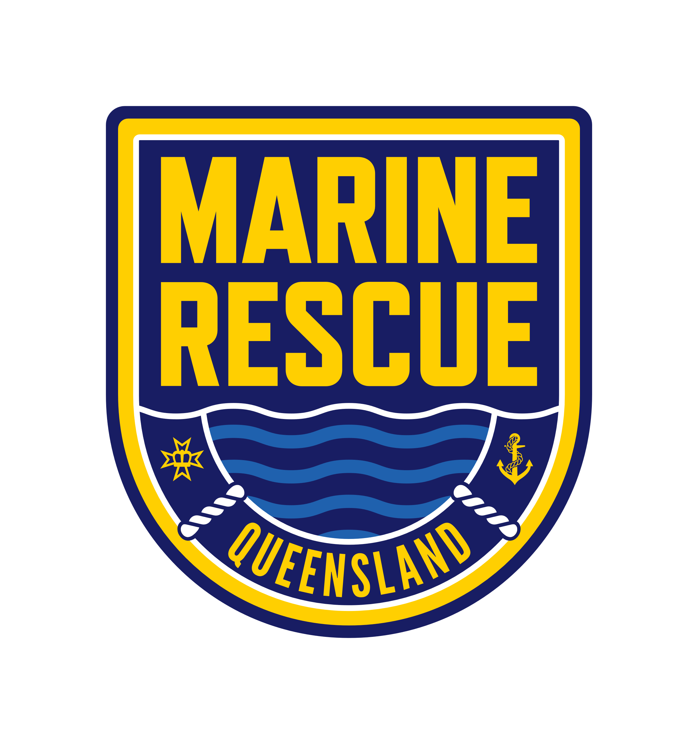

Queensland Police Service

Strategic Workforce Plan 2024-2028

# Our vision

A safer and more resilient Queensland.

# Strategic Context

Together we keep the people, places and communities of Queensland safe through excellence in policing and community safety services. This plan links to the Queensland Government Even Better Public Sector for Queensland Strategy 2024-2028. It supports the QPS Strategic Plan to develop a health and engaged workforce to serve the people of Queensland.

The Queensland Police Service is responsible for the functions of:

* Policing and community safety.
* State Emergency Service.
* Marine Rescue Queensland.

# Our opportunities

* Embracing technology to optimise new and better ways of working.
* Building a highly skilled, resilient workforce enhancing our capabilities to meet future demand.
* Fostering diverse talent and expertise to improve our resilience and sustainability.
* Optimising recommendations to drive reform and build an inclusive and diverse culture.

# Our risks

* Addressing complex issues impacting our workforce including safety, wellbeing and mental health matters.
* Building and aligning capacity and capability to meet future demand and promote fiscal sustainability.
* Attracting and retaining talent in a highly competitive labour market and declining volunteerism.
* Declining community trust and confidence in the integrity and professionalism of police.

# Our values

* **Integrity.** We are honest, trustworthy and serve the community with the highest standards of professional conduct at all times.
* **Respect.** We treat everyone fairly and with dignity, embrace diversity, and consider and value all perspectives.
* **Courage.** We hold each other to account and serve in the face of adversity.

# Our Profile (as at 30 June 2024)

## Our paid workforce (18,919)

* Police 65.5%: Male 71.3%. Female 28.5%. Other 0.2%.
* Staff 31.1%: Male 39.8%. Female 60.1%. Other 0.1%.
* Recruits 3.4%. Male 76.8%. Female 23.2%.

## Our volunteers (5,197)

* Volunteers in Policing 3.9%. Male 50.0%. Female 50.0%.
* State Emergency Service 96.1%: Male 61.0%. Female 39.0%.
* Marine Rescue Queensland. Transition in progress.

## Diversity

|  |  |  |  |
| --- | --- | --- | --- |
| First Nations | Our target 4% | Our profile 2.5% | Working for Queensland 2023 3.7% |
| Non-operational staff members with disability | Our target 6% | Our profile 4.8% | Working for Queensland 2023 11.8% |
| Culturally and linguistically diverse | Our target 8% | Our profile 6.3% | Working for Queensland 2023 8.0% |
| Women in leadership | Our target 30% | Our profile 30.5% |  |

## Location

* Urban 68.8%.
* Regional 27.5%.
* Rural 3.7%.

## Employment status

* Permanent 90.9%.
* Temporary 4.7%.
* Contracts 3.8%.
* Casual 0.6%.

## Average Age

* Volunteers 47.
* Staff 45.
* Police 42.
* Recruits 29.

Note. Police includes Special Constables who exceed compulsory retirement age (60).

## Attrition rate

* Police 5.3%.
* Staff 10.6%.

# Our objectives

## Healthy and engaged workforce

Build an engaged and capable workforce with health, safety and wellbeing of our people a priority.

* Keep our people safe and feeling supported.
* Grow a capable workforce that represents and understands the community we serve.
* Develop authentic leaders who empower and engaged our people.
* Support a connected workforce who are collaborative, innovative and resilient.
* Strengthen our culture to better reflect our values.

# How we will support delivery of our objectives

## Our work

Our ways of working inspire trust in government by ensuring we are equipped to respond to complex challenges and connected to our community.

* Build our capability to deliver better services.
* Strengthen partnerships across the Queensland Police Service, other government agencies, the private sector and the community.
* Leveraging opportunities and emerging technology to redesign the way we serve the community.
* Enhancing our knowledge and understanding through better use of research, analytics and intelligence.

## Our workforce

Our people are ready to meet any challenge enabled through building expertise, identifying future leaders and growing diverse potential.

* Developing authentic leadership that reflects the community we serve.
* Empowering our people with opportunities to embrace continual learning.
* Strengthening our recruitment and retention strategies to attract and support diverse talent and expertise.
* Enhancing our performance management framework to improve engagement on performance and development.

## Our workplace

Our workplaces support our people to serve their community by providing opportunities for them to perform at their best and make decisions that serve the interests of Queenslanders.

* Prioritising the health, safety and wellbeing of our people and cultivating supportive workplaces.
* Growing our workforce planning capability to prepare for the future.
* Building a diverse, inclusive, culturally capable and safe workforce culture.
* Supporting the integration of the State Emergency Service and Marine Rescue Queensland.

# Performance measures

* Employee engagement.
* Volunteer engagement.
* Delivery of police personnel.
* Outcomes and initiatives delivered.
* Workforce data and analytics.

# Acknowledgement of Country

The Queensland Police Service respectfully acknowledges First Nations peoples as the Traditional Owners and Custodians of Queensland. We recognise their connection to land, sea and community. We pay our respects to them, their cultures, and to their elders, past, present and emerging.

# Our Human Rights Commitment

The Queensland Police Service is committed to respecting, protecting and promoting human rights in our decision making and actions.