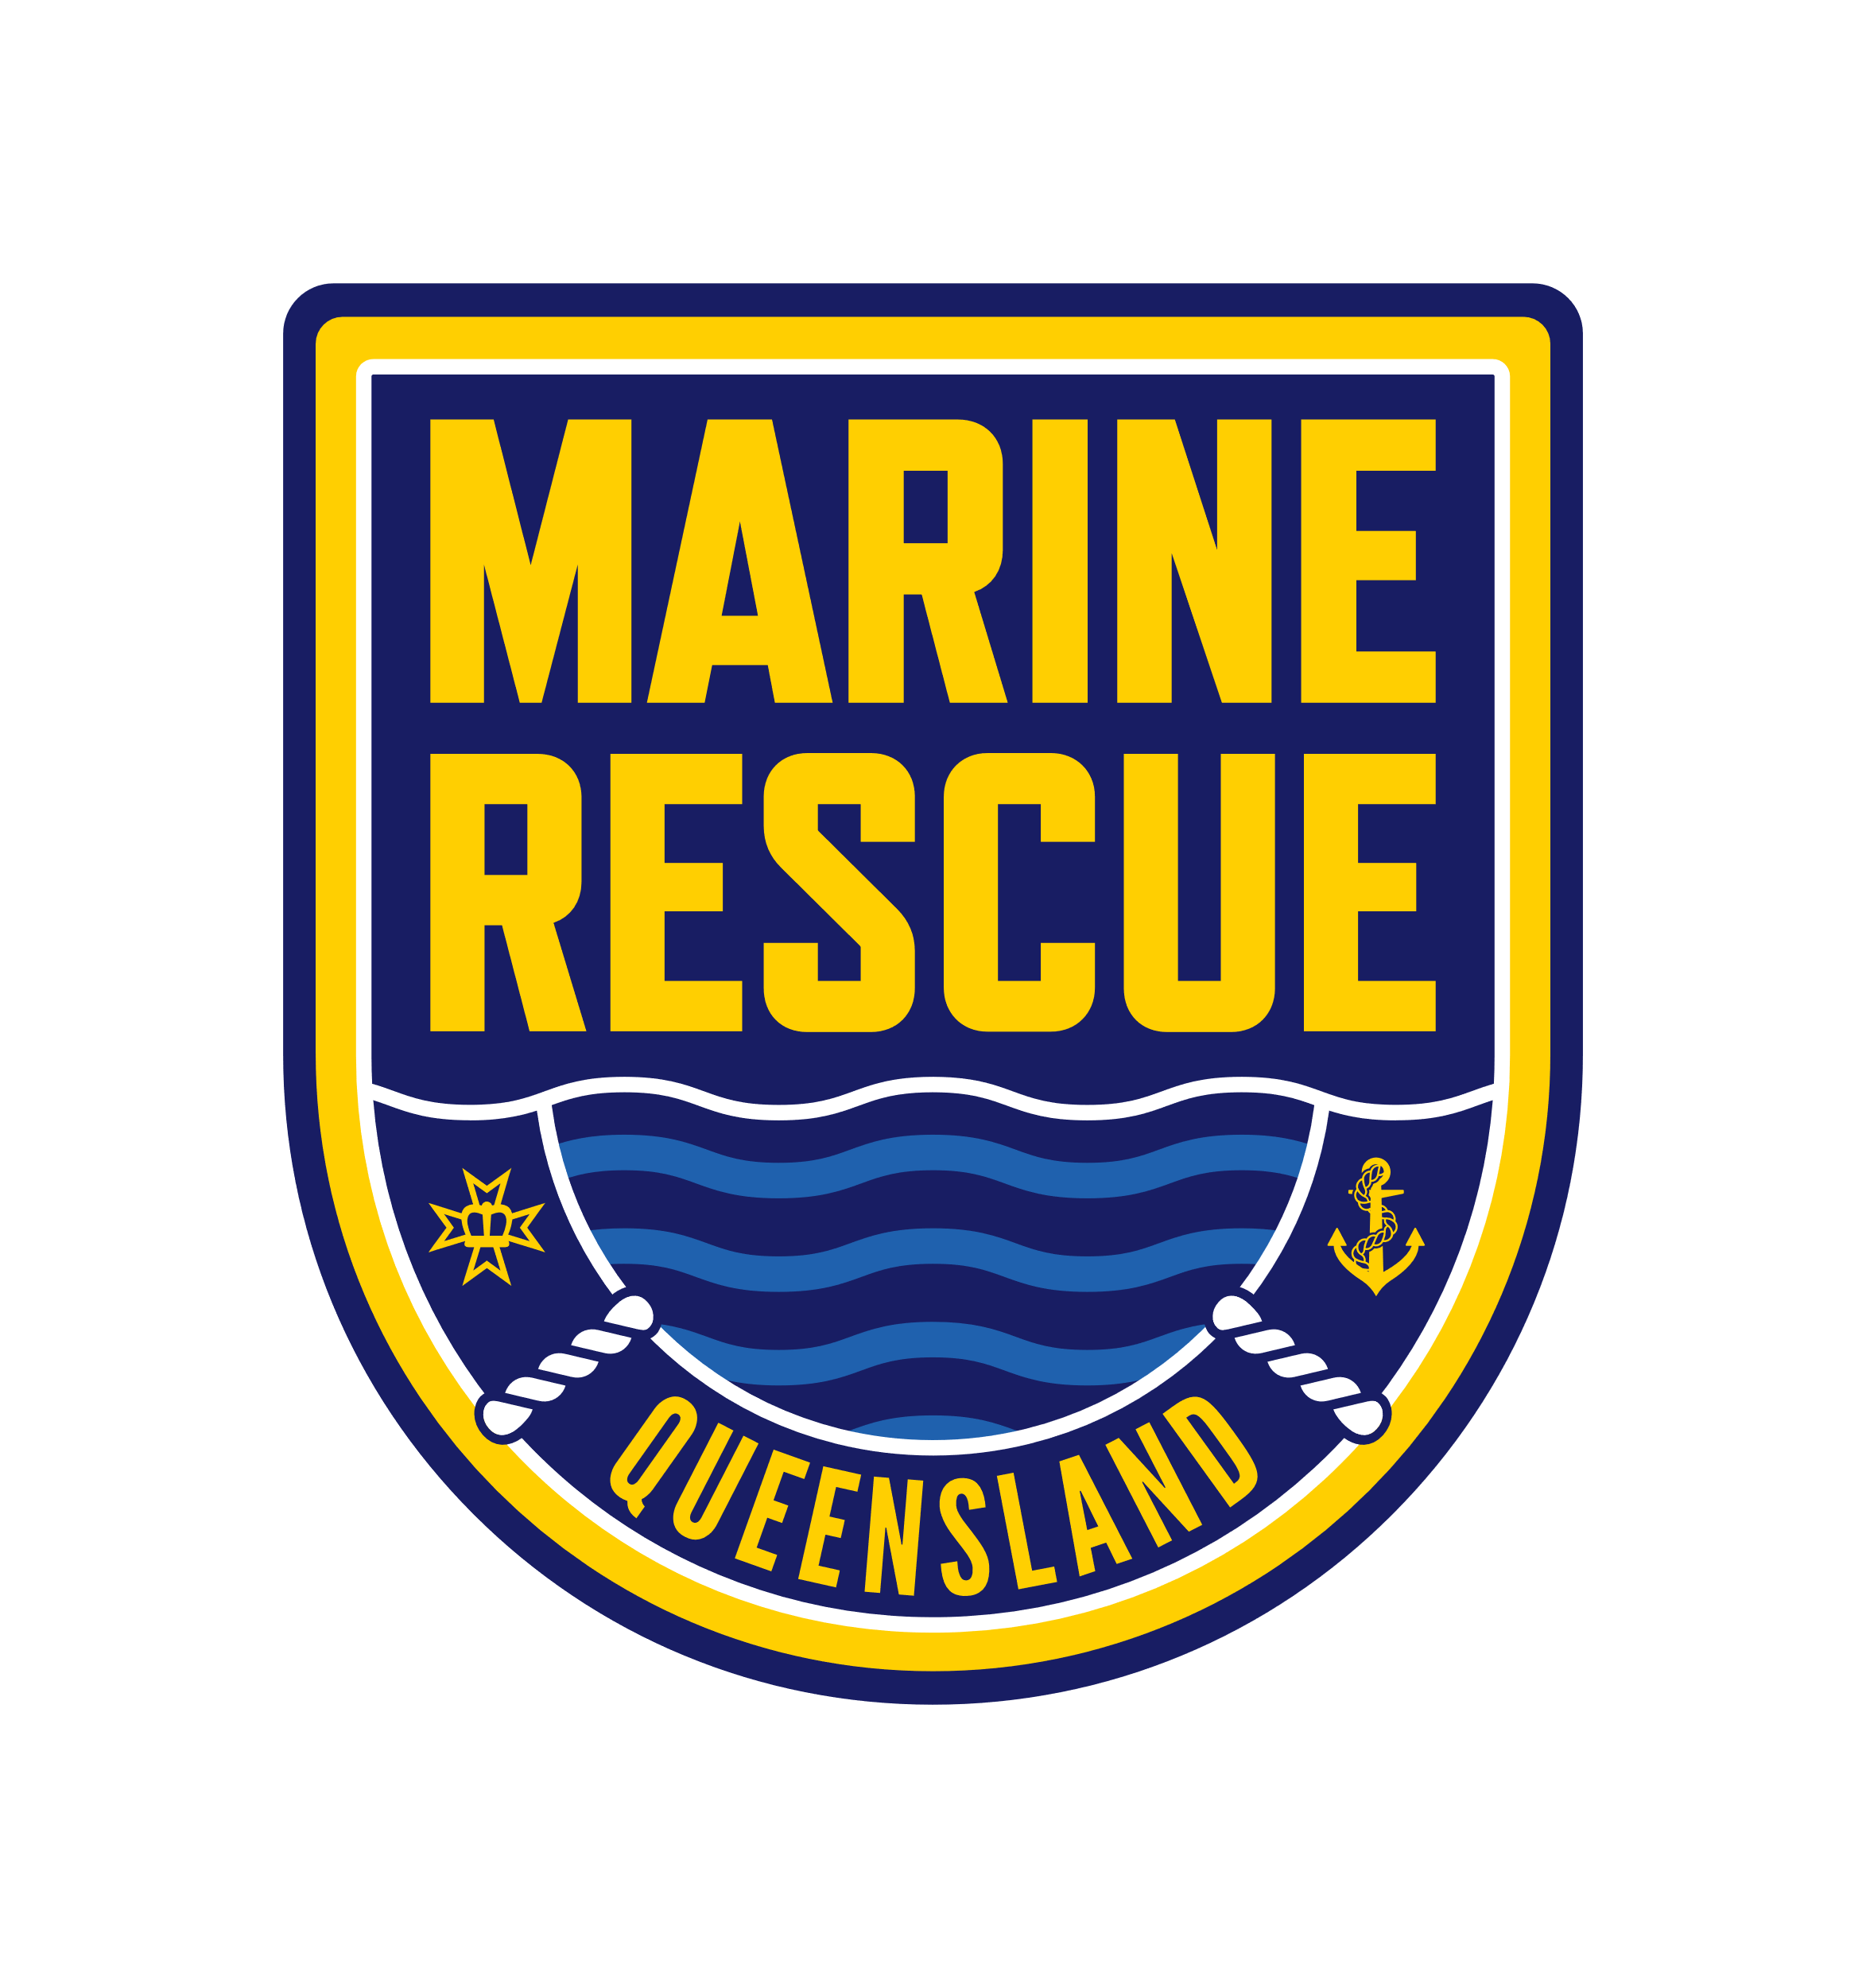

Queensland Police Service

Equity, Diversity and Inclusion Plan 2024-2025

# **Acknowledgement of country**

The Queensland Police Service (QPS) acknowledges First Nations peoples as the Traditional Owners and Cultural Custodians of the lands, waters, and seas across Australia. We pay our respects to Elders past and present and recognise the role of current and emerging leaders. We recognise the First Nations peoples in Queensland are both Aboriginal peoples and Torres Strait Islander peoples, and support the cultural knowledge, determination and commitment of Aboriginal and Torres Strait Islander communities.

# Message from the Commissioner

I am pleased to present the QPS Equity, Diversity and Inclusion Plan 2024–2025.

The community we proudly serve is more complex and diverse than ever. Our ability to keep the people, places and communities of Queensland safe depends on our connection to, and reflection of, the community we proudly serve.

Preserving community safety is a complicated, ever changing and demanding role where our people are frequently relied upon to respond to difficult and demanding situations. Many of the answers are not in books, laws or manuals but in the diverse skills, experiences and innovative thinking of our people when confronted with an emergency or challenge. Our people are critical to our success, and I am immensely proud of the work we do every day and the impact we have on the lives of those we serve.

Equity, inclusion and diversity is everyone’s responsibility, and we all play a role in driving change. This plan reaffirms our commitment to promoting an equitable, diverse and inclusive service where everyone feels safe, respected and included.

I look forward to continuing to promote, support and progress equity and diversity and demonstrating my commitment to fostering a culture of respect and inclusion across the QPS.

**Stephan Gollschewski APM**

**COMMISSIONER**

# About equity, diversity and inclusion

**Equity.** Everyone is treated fairly and has equal access to opportunities and resources.

**Diversity.** Recognising all the differences between people and how they identify.

**Inclusion.** A sense of respect and belonging for all our people.

**Intersectionality.** Recognising how different aspects of a person’s identity, such as gender, culture, sexuality, religion and ability, overlap and interconnect. These overlaps can create multiple layers of discrimination or disadvantage and compound inequality.

## Respect for the whole person

Traditional approaches to diversity focused on a person’s visible characteristics. Contemporary approaches recognise the whole person including those less visible aspects of diversity, such as gender identity, faith, cultural background, socioeconomic background, marital status, disability and more.

We as individuals are not one dimensional. We have many layers to our identities, and some of these layers can present barriers. To enable our people to thrive, we must all be committed to creating a workplace where everyone feels safe, valued, respected and empowered to bring their whole self to work.

## Why this matters

Embracing diversity helps the QPS to foster a deeper understanding of the communities we serve. This allows us to appreciate community needs, perspectives and concerns, strengthening trust and enhancing community relations and cooperation.

Diversity brings together individuals with varied points of view, experiences and problem-solving approaches. This diversity of thought helps us to develop more effective strategies and solutions to the complex issues and challenges we face. Diversity also plays a critical role in building organisational resilience and strengthening our capacity to adapt to changing circumstances and navigate uncertainty.

Community safety is a team-based endeavour where trust and respect are vital. Fostering an equitable, diverse and inclusive culture where everyone feels safe, valued and included promotes a sense of wellbeing where everyone can contribute. It helps bring strategy to fruition, shapes positive experiences for our people and enables the best outcomes for the people of Queensland.

## Everyone’s responsibility

An inclusive and welcoming workplace is everyone’s business. We are all responsible for creating a workplace where all our people feel safe, respected, and included. This means:

* treating everyone with respect and fairness
* behaving inclusively, and actively fostering inclusion, trust, and a sense of belonging
* actively challenging processes or behaviours that are not inclusive.

Our workforce and our people include all police, staff members and volunteers who make up the QPS and proudly serve the communities of Queensland.

# About our equity, diversity and inclusion plan

## Purpose

This plan sets out the strategies, actions and measures we have identified for driving meaningful and lasting progress.

The plan supports the QPS Strategic Plan 2024–2028 in keeping the people, places and communities of Queensland safe through excellence in policing and community safety services. It is also a key priority under our Strategic Workforce Plan 2024–2028, building an engaged and capable workforce with the health, safety and wellbeing of our people a priority.

While this plan plays a vital role in contributing to creating a more inclusive workplace, improving equity, diversity, respect and inclusion within the QPS is a continuous journey, that’s fostered through progressive and incremental organisation change.

## Monitoring and reporting

Performance against this plan will be monitored by quarterly reporting through the QPS governance framework and reviewed annually through our equity and diversity audit.

The purpose of our equity and diversity audit is to gather information about the composition of the workforce, analyse our performance against this plan and identify opportunities to promote, support and progress equity and diversity in the QPS. It draws on relevant employee data from across the QPS, including Working for Queensland and other workforce surveys, and provides a valuable tool for measuring our progress over the long term.

The plan will be reviewed every year to ensure we continue to drive meaningful and lasting progress, leveraging data-driven insights and drawing on contemporary best practice approaches. This enables us to continue to align the plan with our strategic objectives and values, and to acknowledge and address the evolving needs and perspectives of our workforce and the communities we serve.

## Our values

**Integrity.** We are honest, trustworthy and serve the community with the highest standards of professional conduct at all times.

**Respect.** We treat everyone fairly and with dignity, embrace diversity, and consider and value all perspectives.

**Courage.** We hold each other to account and serve in the face of adversity.

## Our workforce

The QPS is committed to developing a workforce that represents and reflects the diverse views, experiences and backgrounds of Queenslanders. The opportunities and actions set out in this plan will ensure we continue to prioritise work to achieve our diversity targets for women in leadership, Aboriginal and Torres Strait Islander peoples, people from culturally and linguistically diverse backgrounds and non-operational staff members with disability.

The QPS Aurion Employee Self Service (ESS) system is the primary source for QPS HR employee data, including employee equity and diversity data. Our Working for Queensland survey results also provide an important benchmark for monitoring progress.

In 2023, 9,995 QPS employees (57%) responded to the Working for Queensland survey providing valuable insight into our workforce, our culture and the experiences of our people.

Our workforce profile as identified from Working for Queensland and our QPS HR employee data:

* Aboriginal and Torres Strait Islander peoples. Our target 4%. Our Working for Queensland survey results 3.7%.
* People who speak a language other than English at home. Our target 8%. Our Working for Queensland survey results 8.0%.
* Staff members with a disability. Our target 6%. Our Working for Queensland survey results 11.8%.
* People who identify as non-binary. Our Working for Queensland survey results 1.0%.
* People who identify as LGBTIQ+. Our Working for Queensland survey results 4.1%.
* People aged over 55 years of age. Our Working for Queensland survey results 12.9%.
* Women police officers. Our QPS HR employee data 28.5%.
* Women in leadership roles. Our target 30%. Our QPS HR employee data 27.8%.

Our data is sourced from the 2023 Working for Queensland survey results and our QPS HR employee data as at 29 February 2024. It does not include the State Emergency Service or Marine Rescue Queensland.

# Strategic framework

The actions within this plan were informed by the outcomes of the QPS Equity and Diversity Audit (April 2024) and operate within a broader framework of strategies, plans and activities which work together to promote equity, diversity and inclusion within the QPS, including:

* QPS Strategic Plan
* QPS Strategic Workforce Plan
* QPS Multicultural Action Plan (MAP)
* QPS Reframing the Relationship Plan (RtR)
* QPS Disability Service Plan (DSP)
* Queensland Public Sector Inclusion and Diversity Strategy 2021–2025
* Queensland Public Sector LGBTIQ+ Action Plan 2023–2025.

This plan is also informed by the Independent Commission of Inquiry into QPS responses to domestic and family violence (COIDFV) and other associated reviews, such as the Women’s Safety Justice Taskforce, and the voices of our people heard within them.

# Disaster and emergency services

As part of the Queensland Government’s disaster and emergency reform the QPS now includes additional disaster management functions including the State Emergency Service (SES) and newly established Marine Rescue Queensland (MRQ).

Both SES and MRQ have proud histories of commitment and service to the community and their integration into the QPS will be a key priority during the implementation of this plan.

The QPS acknowledges the very important contribution volunteers bring to Queensland’s many unique and diverse communities and will incorporate SES and MRQ into our annual equity and diversity audit and review processes.

# Our drivers for change

**Our People.** Ensuring we attract, recruit, develop, promote and retain a **healthy and engaged workforce** that represents and understands the community we serve.

**Our Leaders.** Fostering **culturally capable and inclusive leadership** that empowers and supports our people.

**Our Organisation.** Building **inclusive systems and** **workplace cultures** where our people feel valued, safe and able to bring their whole selves to work and thrive.

# Our people

Ensuring we attract, recruit, develop, promote and retain a **healthy and engaged workforce** that represents and understands the community we serve.

| **No.** | **Focus area** | **Strategy** | **Actions** | **Timing** | **Milestones / Measures** | **Owner** | **Linkages** |
| --- | --- | --- | --- | --- | --- | --- | --- |
| **1.1** | **Strengthen the health and wellbeing of our people** | Develop and implement a whole-of-service WHS (Workplace Health and Safety) strategy and deliver health, safety and wellbeing services that are inclusive of the diverse needs of our people. | Develop and implement a whole-of-service WHS strategy to strengthen WHS culture and capabilities and create a proactive safety culture, empowering individuals and fostering a safe workplace for everyone. | Jun 2025 | WHS strategy developed and implemented.  WHS culture and capability uplift.  Health, safety and wellbeing services available. | Health Safety and Wellbeing Division and Safety Strategy Division | RtR Action 2.6  RtR Action 2.7  MAP Action 6 |
| Implement and promote health, safety and wellbeing services that are inclusive, tailored for the needs of diverse groups and culturally safe. | Ongoing |
| Deliver support tailored for various stages of the employee lifecycle, such as transition to parenthood and mandatory age retirement. | Ongoing |
| **1.2** | **Strengthen our people networks and promote diversity and inclusion across the QPS** | Empower our people by strengthening our people networks and recognising the important contribution that people with diverse backgrounds, experiences and perspectives make to our community and our organisation. | Strengthen our people networks and consultative committees and acknowledge the vital role they play in promoting diversity and inclusion within the QPS. | Ongoing | Our people network engagement.  Diversity network action plan progress.  Aurion ESS completion rates. | Communication Culture and Engagement Division  *supported by First Nations Division, Human Resources Division, our people networks and all business areas* | DSP Action 2.6  MAP Action 6  RtR Action 1.1  RtR Action 1.2  RtR Action 8.7  LGBTIQ+ Action 1 |
| Support the development and implementation of diversity network action plans. | Jun 2025 |
| Promote opportunities for our people to participate in connecting to country opportunities, days of significance and other special events that celebrate diversity and inclusion. | Ongoing |
| Share lived experiences of diversity and inclusion across our workforce. | Ongoing |
| Continue to encourage employees to update their equity and diversity information in Aurion ESS. | Ongoing |
| **1.3** | **Enhance our ability to attract and recruit diverse staff member and volunteer talent that represents the community we serve** | Review our attraction and recruitment policy, procedures and associated resources to ensure they align with the QPS commitment to building a more inclusive culture that invites and accommodates diversity. | Develop a meaningful employee value proposition (EVP) to support the attraction, recruitment and engagement of diverse talent and build our value as an employer of choice. | Dec 2024 | EVP developed and implemented.  Improvement strategies identified and implemented.  Increase in applicants from diversity target groups.  Targeted recruitment activities delivered.  Practical tools and resources delivered.  Staff member panel training and associated resources delivered. | Human Resources Division  *supported by First Nations Division, Communications Culture and Engagement Division and relevant business areas* | DSP Action 2.1  DSP Action 2.3  MAP Action 2  RtR Action 6.2  RtR Action 6.4  RtR Action 6.5 |
| Review our external staff member QPS recruitment website, application guides and associated resources to identify and implement improvement strategies. | Dec 2024 |
| Review our recruitment and selection policy, procedures and associated resources to promote and support implementation of the new equity and diversity recruitment and selection arrangements under the *Public Sector Act 2022.* | Dec 2024 |
| Develop partnerships and recruitment channels to widen our reach and support positive engagement with diversity target and other underrepresented groups. | Ongoing |
| Develop and deliver practical tools and resources to support and promote our targeted recruitment process. | Jun 2025 |
| Develop and deliver practical tools and resources to support and promote reasonable adjustment across the attraction and recruitment process. | Jun 2025 |
| Strengthen the integration of diversity and inclusion principles into our staff member panel training and associated resources. | Jun 2025 |
| **1.4** | **Enhance our ability to attract and support police recruit applicants from diversity target groups** | Continue to develop and enhance our police recruitment strategies and entry pathways to ensure we are building a diverse and capable workforce that meets organisational needs and community expectations. | Continue to implement the QPS Police Recruitment Strategy. | Jun 2025 | Delivery of the QPS Police Recruitment Strategy.  Increase in police recruit applicants from diversity target groups.  Targeted recruitment activities delivered. | People Capability Command  *supported by First Nations Division and Communications Culture and Engagement Division* | MAP Action 2  RtR Action 6.2  RtR Action 6.4  RtR Action 6.5  DFV COI Rec 11 |
| Develop and implement tailored induction, support and development pathways for First Nations and culturally and linguistically diverse police recruit applicants. | Jun 2025 |
| Develop partnerships and recruitment channels to widen our reach and support positive engagement with diversity target and other underrepresented groups. | Ongoing |
| **1.5** | **Support the QPS Diversity and Inclusion Review** | Continue to actively engage in and support the Queensland Human Rights Commission (QHRC) review to increase diversity and inclusion within the QPS. | Support the QHRC review. | Dec 2024 | Delivery of QHRC review recommendations.  Review recommendations implemented.  QHRC evaluation outcomes. | People Capability Command  *supported by relevant business areas* | DFV COI Rec 12 |
| Plan, coordinate and implement the QHRC review recommendations. | 2024-26 |
| Support the QHRC review evaluation. | 2026-27 |
| **1.6** | **Embed a workplace culture where women can thrive and reach their full potential** | Acknowledge and promote the contribution of women within the QPS and support targeted leadership and development programs at all levels. | Identify and acknowledge the contribution and achievements of women within the QPS through participation in relevant awards such as the Queensland Women in Policing Award, Australasian Council of Women in Policing (ACWAP) Awards. | Ongoing | Award applications and outcomes.  Leading Women Network engagement.  Leadership and development programs delivered. | Communications Culture and Engagement Division  *supported by all business areas* |  |
| Promote opportunities for our people to participate in International Women’s Day events and other days of significance. | Ongoing |
| Continue to support and promote the Leading Women Network which seeks to embed a diverse and inclusive workplace culture where women can fully participate, thrive and are supported towards their potential. | Ongoing |
| Develop and deliver targeted leadership and development programs for women. | Ongoing | People Capability Command |

# Our Leaders

Fostering **culturally capable and inclusive leadership** that empowers and supports our people.

| **No.** | **Focus area** | **Strategy** | **Actions** | **Timing** | **Milestones / Measures** | **Owner** | **Linkages** |
| --- | --- | --- | --- | --- | --- | --- | --- |
| **2.1** | **Develop and demonstrate inclusive leadership and cultural capability** | Support the QPS Executive Leadership Team (ELT) to engage in learning and development activities and diversity and inclusion initiatives that will develop their cultural capability, inclusive leadership skills and build a more inclusive culture that invites and accommodates diversity. | Support ELT members to identify and engage in learning and development activities to develop their cultural capability and become a more inclusive leader. | Ongoing | ELT engagement in learning and development activities.  ELT engagement in diversity and inclusion initiatives.  ELT member feedback. | QPS Senior Leadership Team  *supported by First Nations Division, Communications Culture and Engagement Division, and People Capability Command* | MAP Action 6  RtR Action 4.2  LGBTIQ+ Action 4 |
| Support ELT members to identify and engage in diversity and inclusion initiatives. | Ongoing |
| **2.2** | **Drive opportunities for positive cultural change across our workforce** | Incorporate diversity and inclusion principles across our Working for Queensland and other workforce survey results to understand our workforce and drive workplace improvement and positive cultural change. | Encourage our people to engage in Working for Queensland and other relevant workforce surveys. | Ongoing | Workforce survey participation rates.  Practical tools and resources delivered. | Communication Culture and Engagement Division  *supported by all business areas* |  |
| Develop and deliver practical tools and resources and support leaders and change makers to apply an inclusion and diversity lens to relevant workforce survey results and identify and implement workplace improvements. | Ongoing |
| **2.3** | **Embed inclusion and diversity principles within our performance framework** | Review the QPS Organisational Performance Management framework to embed inclusion and diversity principles. | Review the QPS Organisational Performance Management framework. | Jun 2025 | Reviewed framework delivered.  Commissioner’s Performance Reviews conducted. | Policy and Performance Division  *supported by Communications Culture and Engagement Division and Human Resources Division* |  |
| Incorporate inclusion and diversity principles into Commissioner’s Performance Reviews. | Jun 2025 |
| **2.4** | **Enable authentic leadership that supports and empowers our people to reach their full potential** | Enable our leaders to support the professional development of our workforce through regular, person-centred, constructive and positive conversations on their performance, learning and development. | Develop and deliver practical tools and resources to enhance the QPS development and performance (DAP) process and promote positive performance management principles. | Jun 2025 | Practical tools and resources delivered. | Human Resources Division  *supported by People Capability Command* | DSP Action 2.5  RtR Action 8.5 |
| Develop and deliver practical tools and resources to help managers better support the professional development of their people by connecting them with learning and development opportunities. | Jun 2025 |

Our Organisation

Building **inclusive systems and workplace culture** where our people feel valued, safe and respected and able to bring their whole selves to work and thrive.

| **No.** | **Focus area** | **Strategy** | **Actions** | **Timing** | **Milestones / Measures** | **Owner** | **Linkages** |
| --- | --- | --- | --- | --- | --- | --- | --- |
| **3.1** | **Increase gender equity in male-dominated areas** | Review workforce data to identify male-dominated areas within the QPS and work with business areas to identify potential barriers and opportunities to improve gender equity. | Review workforce data to identify areas within the QPS where opportunities to increase gender equity exist. | Jun 2025 | Workforce data review completed.  Strategies identified and implemented.  Increase in applicants from diversity target groups. | Human Resources Division  *supported by relevant business areas* |  |
| Work with business areas to identify and implement strategies to increase gender equity. | Jun 2025 |
| **3.2** | **Support employee wellbeing, economic security and gender equality** | Support implementation of the Queensland Government reproductive health entitlements and superannuation payments during parental leave. | Develop and deliver policies, procedures and associated resources in partnership with key stakeholders. | Jun 2025 | Policies, procedures and associated resources delivered.  Practical tools and resources delivered. | Human Resources Division |  |
| Develop and deliver practical tools and resources to support successful implementation of the new policy and procedures. | Jun 2025 |
| **3.3** | **Develop more transparent, fair and inclusive higher duties and relieving processes** | Review our higher duties and relieving data, policy, procedures and associated resources to ensure that they are transparent, fair and inclusive and support equitable access to relieving and development opportunities for all our people. | Review our higher duties and relieving data, policies, procedures and associated resources to identify and implement improvement strategies. | Jun 2025 | Improvement strategies identified and implemented.  Improvements in data capture delivered. | Human Resources Division |  |
| **3.4** | **Enhance our systems supporting flexible work and flexible work approaches** | Review our flexible work data, policies, procedures and associated resources to enhance equitable access for all employees, whilst recognising the challenges associated with incorporating flexible work approaches into a 24-hour rotational shift working environment to keep the community safe. | Review our flexible work arrangements policies, procedures and associated resources to identify and implement improvement strategies. | Dec 2024 | Reviewed policy, procedures and associated resources delivered.  Improvements in data capture delivered.  Practical tools and resources delivered.  Flexible Work Committee review. | Human Resources Division | DSP Action 2.4 |
| Review our flexible work data, systems and processes to identify and implement strategies to improve our data capture and data reliability. | Jun 2025 |
| Develop and deliver practical tools and resources for managers and employees to support implementation of the reviewed policy and procedures. | Jun 2025 |
| **3.5** | **Grow a more inclusive culture through information and training** | Design and promote information and training resources to raise awareness and understanding on equity, diversity, respect and inclusion and develop a stronger understanding of stigma and bias (both conscious and unconscious) and the way they can affect our everyday decisions. | Design and promote information and training resources on equity, diversity, respect and inclusion. | Jun 2025 | Information and training resources delivered.  Actions to facilitate organisational approach.  Strengthened policies, procedures and products delivered. | Communications Culture and Engagement Division  *supported by People Capability Command and First Nations Division* | MAP Action 2  MAP Action 6  RtR Action 4.1  RtR Action 4.4  DFV COI 41  DFV COI 42 |
| Facilitate a top-down bottom-up organisational approach to education and training on inclusive behaviours. | Jun 2025 |
| Strengthen the integration of diversity and inclusion principles into our learning and development policies, procedures and products. | Ongoing |
| **3.6** | **Grow our understanding on why employees leave the QPS to improve employee retention** | Review our employee exit survey, systems and processes to ensure we collect meaningful information responsive to the needs of our employees and available to inform our decision making and future thinking. | Review our employee exit survey questionnaire. | Dec 2024 | Exit survey questions reviewed.  Improvement strategies identified and implemented.  Improvements in data capture delivered. | Human Resources Division  *supported by Communications Culture and Engagement Division, First Nations Division and relevant business areas* |  |
| Review our employee exit survey systems and processes to identify and implement improvement strategies. | Jun 2025 |
| **3.7** | **Build a safer more respectful workplace** | Build a safer more respectful workplace culture by addressing barriers and strengthening our capability to identify, examine and respond to misconduct and other workplace issues, in particular complaints and allegations of sexist, misogynistic, homophobic and bullying behaviours. | Review our sexual harassment policy, procedures and associated resources to identify and implement improvement strategies. | Dec 2024 | Reviewed policy, procedures and associated resources delivered.  Improvement strategies identified and delivered.  Information and training resources delivered.  Ethical health scorecard data.  Complaints data. | Communications Culture and Engagement Division  *supported by Ethical Standards Command, Human Resources Division, First Nations Division, Health Safety and Wellbeing Division and People Capability Command* | MAP Action 6  RtR Action 7.1  RtR Action 7.2  LGBTIQ+ Action 6  DFV COI Rec 24  DFV COI Rec 25 |
| Develop and promote information and training resources on sexist, racist, misogynistic, homophobic and bullying behaviour, including how to identify it, how to respond to it, and its adverse consequences on our workforce. | Jun 2025 |
| Identify and implement improvement strategies to strengthen access to support options and referral services, including establishment of the QPS Contact Officers Network. | Jun 2025 |
| Review our complaints process to reduce the barriers to reporting misconduct and identify and implement improvement strategies. | Jun 2025 |