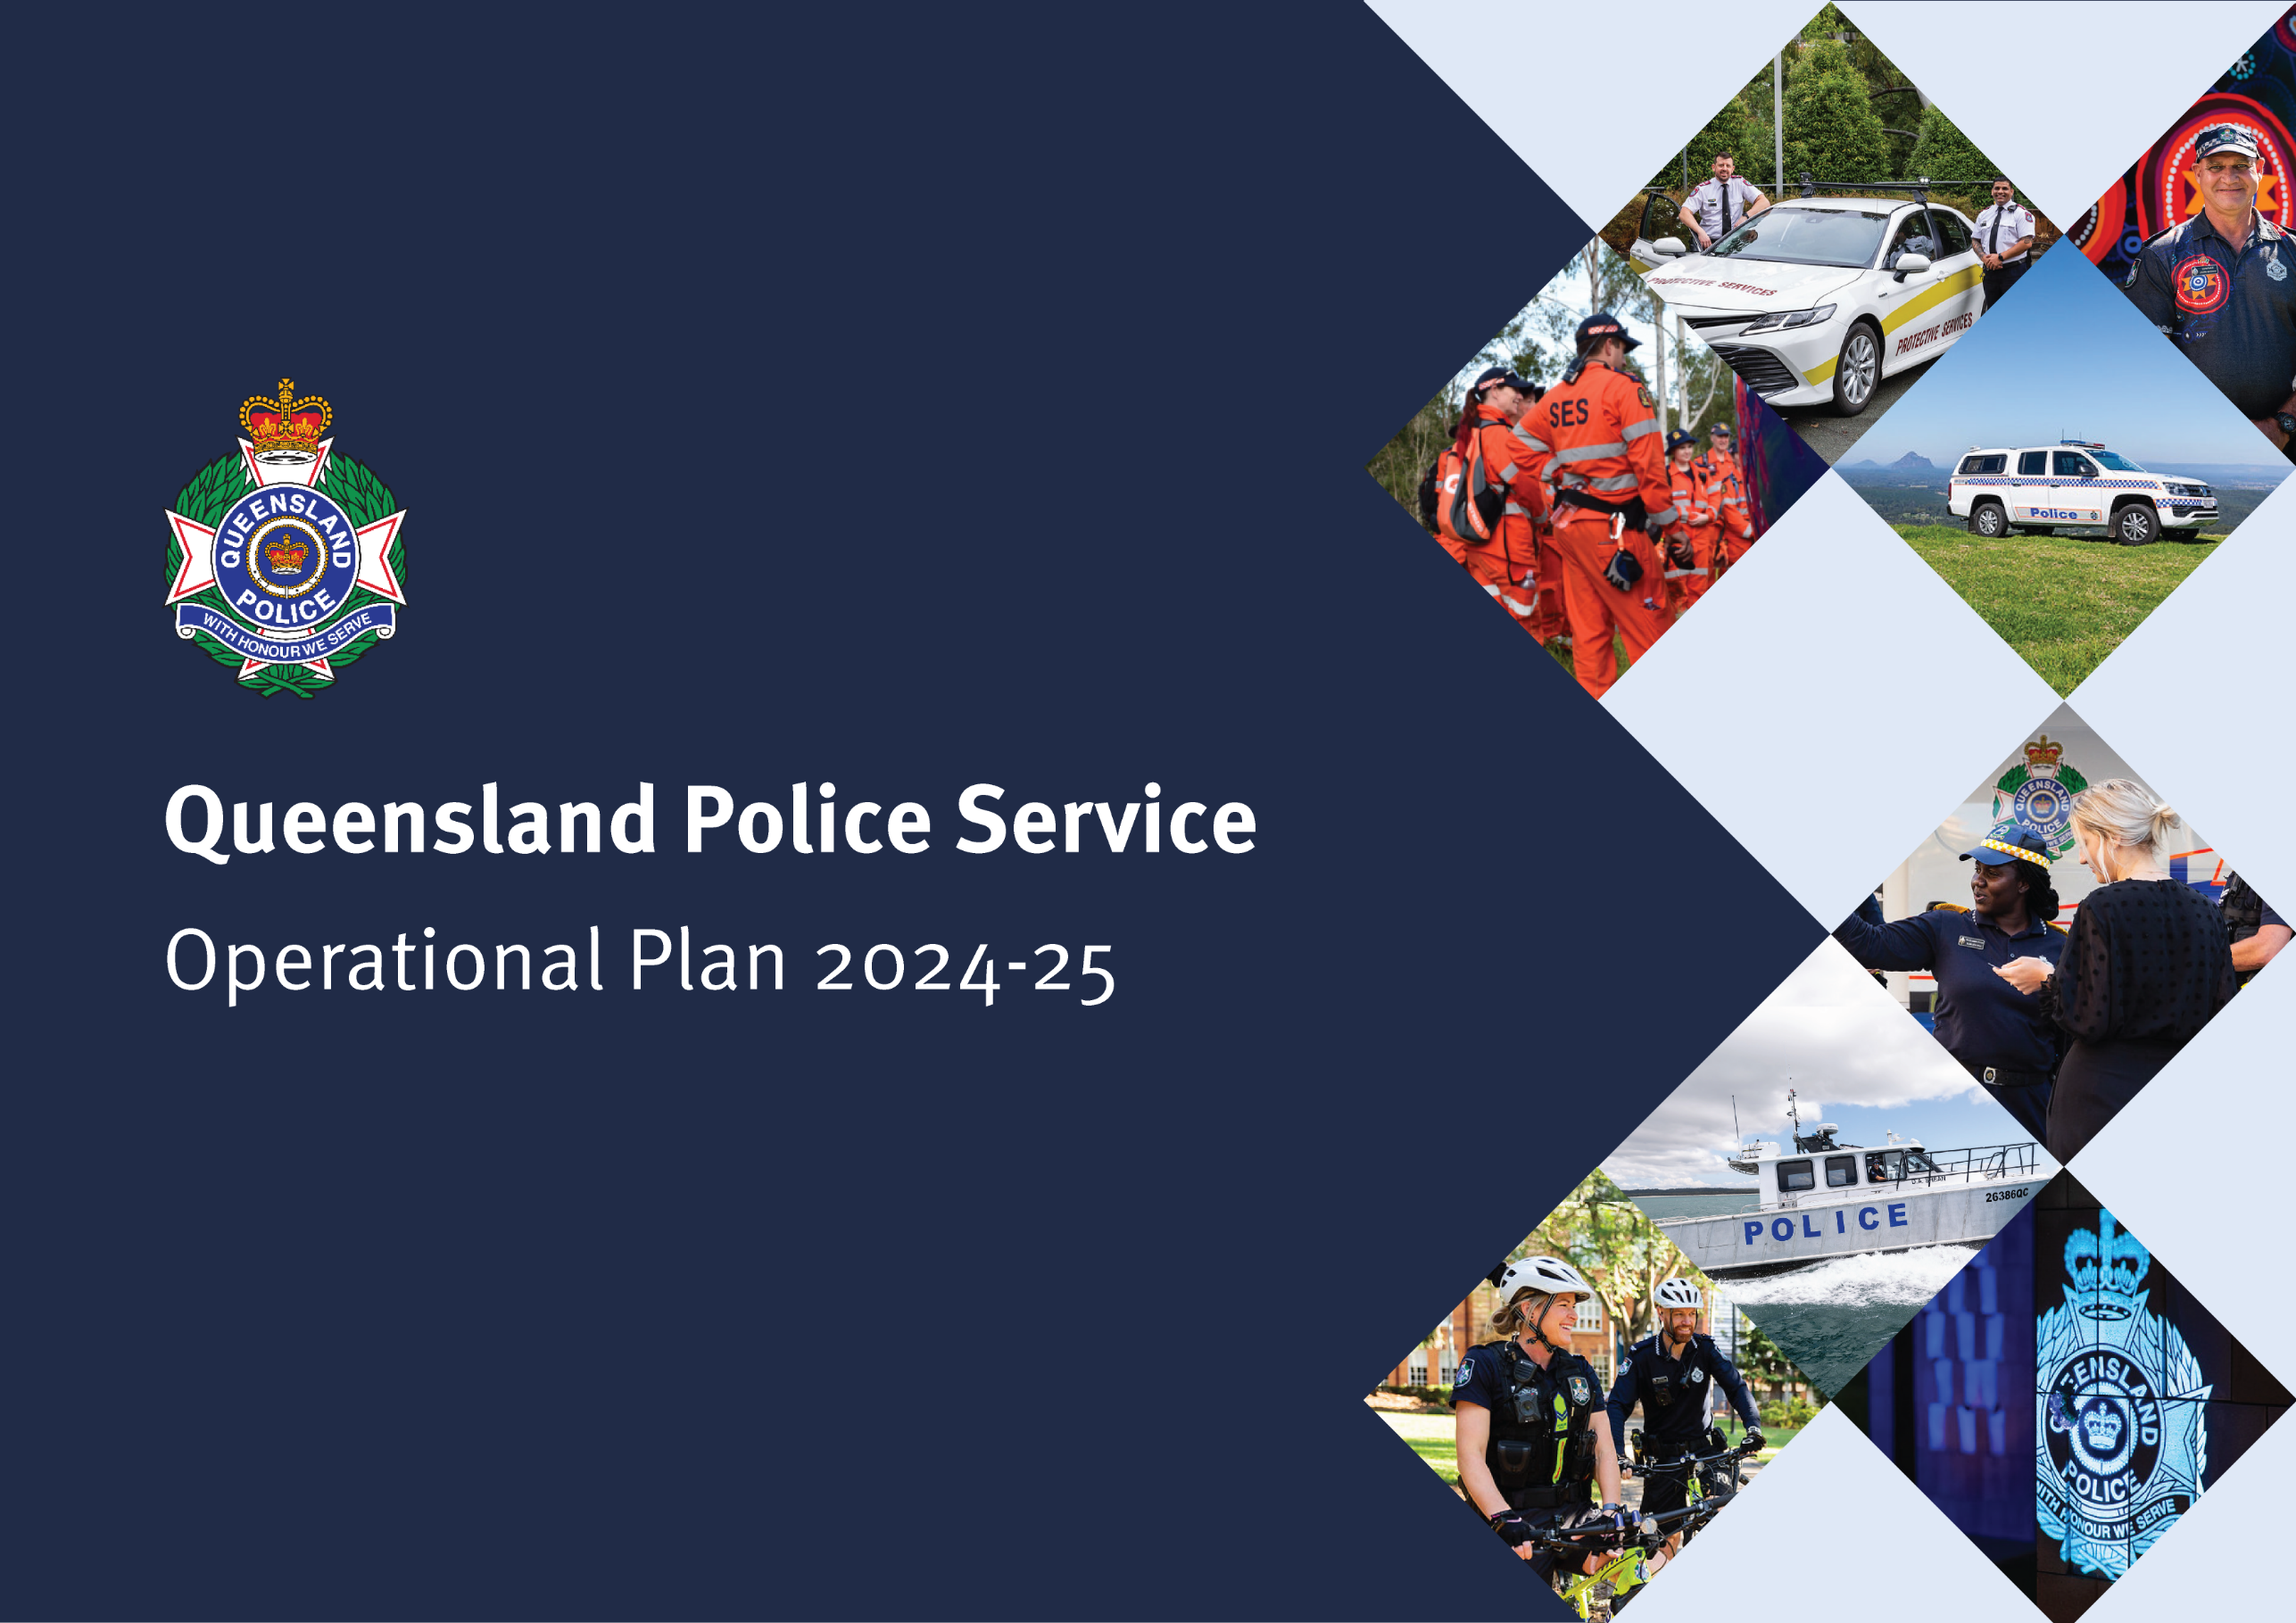

Operational Plan 2024-25
Purpose of the Operational Plan

The Queensland Police Service (QPS) Operational Plan 2024-25 (operational plan) highlights our operational responses to address the key strategic risks and opportunities impacting our service delivery in 2024-25. The annual operational plan should be read in conjunction with the QPS Strategic Plan 2024-28.
The operational plan is informed by the:
  - QPS 2024 Environmental Scan
  - QPS Audit, Risk and Compliance Committee consultation and associated strategic risk reports
  - Government election commitments
  - QPS-related priorities in the Minister for Police and Community Safety Portfolio Priorities Statement
  - QPS Strategic Plan 2024-2028.
The operational plan complies with the Agency Planning Requirements prepared by the Department of the Premier and Cabinet and the requirements of Division 2 of the Financial and Performance Management Standard 2019.
We are honest, trustworthy and serve the community with the highest standards of professional conduct at all times.
We treat everyone fairly and with dignity, embrace diversity, and consider and value all perspectives.
We hold each other to account and serve in the face of adversity.
COURAGE
RESPECT
INTEGRITY
Acknowledgement of Country

The Queensland Police Service respectfully acknowledges First Nations peoples as the Traditional Owners and Custodians of Queensland. We recognise their connection to land, sea and community. We pay our respects to them, their cultures, and to their elders, past present and emerging.

Levels of planning
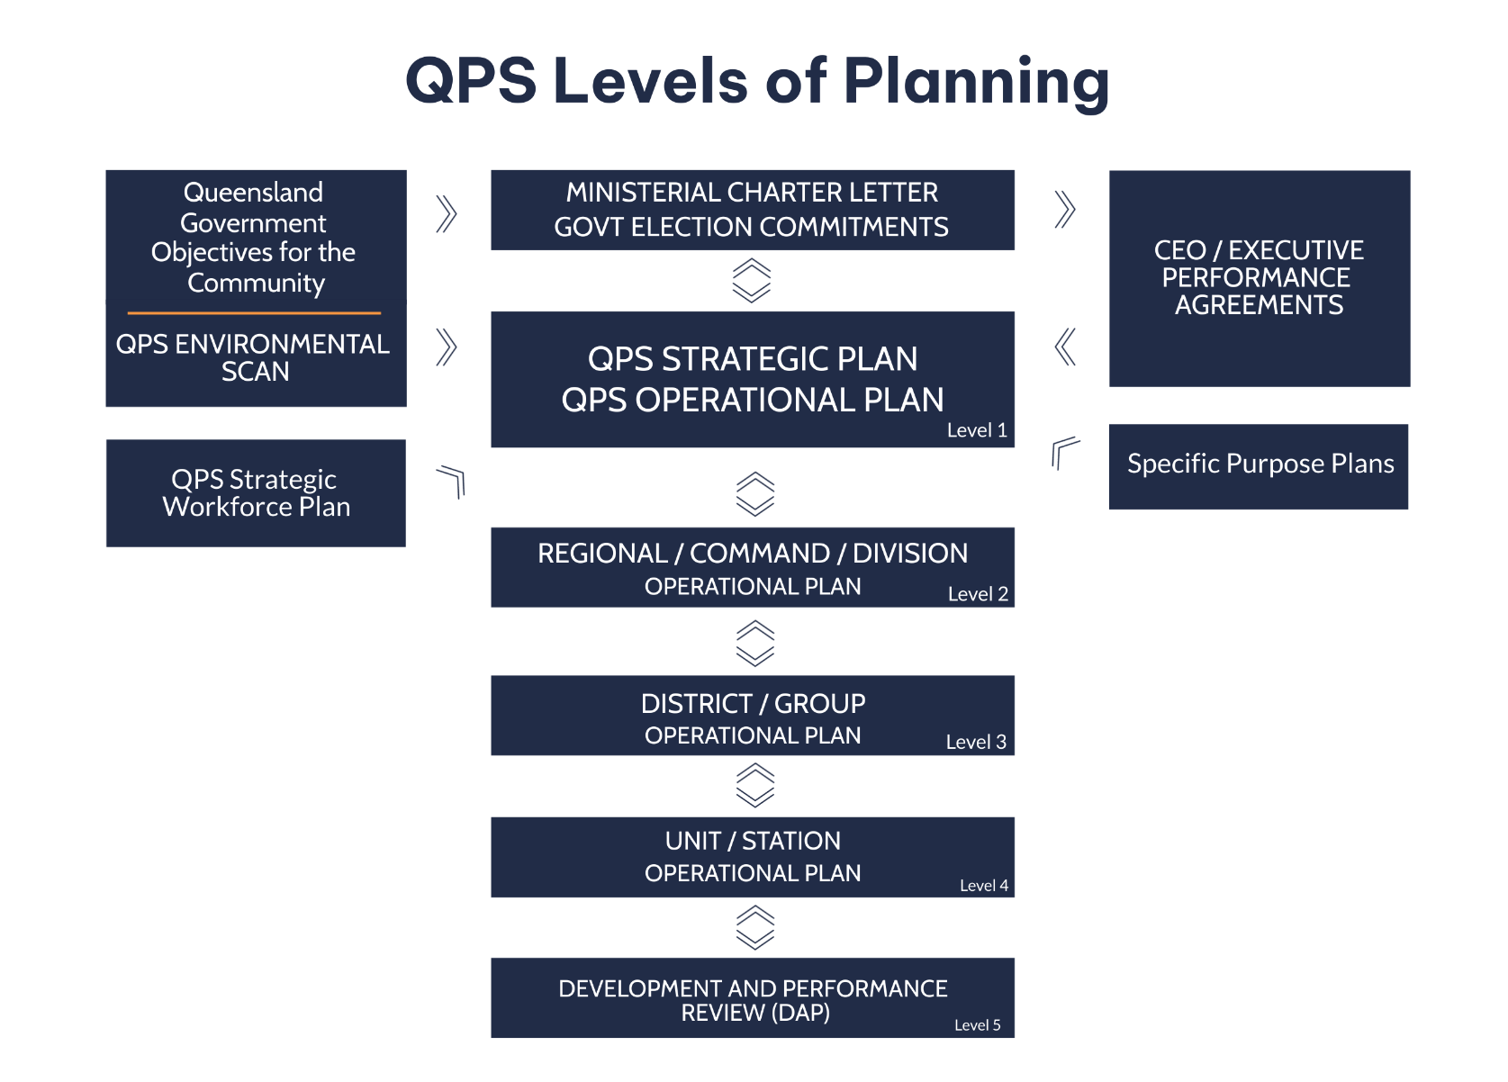
The various levels within the QPS prepare operational plans to reflect actions to be undertaken at each level as they relate to the strategic direction established through the Strategic Plan. These levels are outlined below. For more information, see the QPS Guide to Strategic and Operational Planning 2024-25.
OBJECTIVE:

HEALTHY AND ENGAGED WORKFORCE
Performance Indicators
- Employee and volunteer levels of agency engagement in relation to motivation, inspiration and pride
- Employee perception of leadership and a positive workplace culture that models ethical behaviour and promotes innovation
- Diversity of our workforce in line with QPS diversity targets
- Employees feel the organisation places a value on their health, safety
and wellbeing

Key Activities: | KEY | RESPONSIBLE  OFFICER | COMPLETION DATE | STRAT PLAN ALIGNMENT
- Develop and implement the QPS Suicide Management Framework. |  | ED HW | 31/12/2024 | 1.1, 1.4
- Progress exploratory research into police desensitisation to DFV in partnership with Griffith University. |  | AC DFV&VPC | 31/12/2024 | 1.2, 1.5
- Respond to the Fitzgerald Commission of Inquiry into the Crime and Corruption Commission as it relates to the secondment of police officers. |  | ED HR | 30/09/2024 | 1.5, 3.2
- Continue to support and engage our people to create healthy, inclusive, safe and productive workplaces. |  | ED CCE | 30/06/2025 | 1.1, 1.4, 1.5
- Deliver the government election commitment of 2,025 more QPS personnel by 2025. | GC | ED HR | 31/12/2025 | 1.2
- Deliver an additional 400 of the 900 police personnel positions to meet increasing policing demands in serving communities and keeping Queenslanders safe. | CSPQ | ED HR | 30/06/2025 | 1.2
- Deliver a contemporary leadership capability program to meet the development needs of our members. |  | AC PCAP | 30/06/2025 | 1.3, 1.5, 1.1, 1.4
Key Activities: | KEY | RESPONSIBLE  OFFICER | COMPLETION DATE | STRAT PLAN ALIGNMENT
- Develop a Diversity Recruitment Strategy for police officer recruitment, in consultation with the Human Rights Commission (COIDFV – Recommendation 12). | CLC | AC PCAP | 31/12/2024 | 1.2, 1.5, 1.1
- Develop and embed cultural training to enhance cultural awareness and capability. |  | ED FND | 30/06/2026 | 1.2, 1.5, 1.1
- Continue delivery of the Injury Management Refresh Project to deliver improved health and wellbeing outcomes for ill and/or injured members. Emphasis on process optimisation. | CSIP | ED HW | 30/06/2025 | 1.1, 1.4
- Work with the Corporate Services Improvement team to ensure Health and Wellbeing services are reformed to enhance our capability and capacity to ensure our people receive the right support at the right time and in the right way. | CSIP | ED HW | 30/06/2025 | 1.1, 1.4
- Deliver and support communications that are QPS values based and inform our workforce on strategic, operational plans, and revised organisational plans. |  | ED CCE | 30/06/2025 | 1.5, 1.3, 1.4
- Develop and deliver contemporary human resource strategies, including leadership capabilities, to meet the needs and provide support for our volunteers. |  | CO MRQ | 30/06/2025 | 1.1, 1.3, 1.4
- Enhance SES training and skill maintenance system to support capability development, volunteer skills and safety. |  | CO SES | 30/06/2025 | 1.2, 1.1, 1.4
- Scope a program to improve SES recruitment and onboarding. |  | CO SES | 30/06/2025 | 1.2, 1.1
- Build frontline capacity to respond to DFV through enhanced coercive control, DFV leadership training and annual refresher training. |  | AC DFV&VPC | 30/06/2025 | 1.2, 1.5, 2.1
Key Activities: | KEY | RESPONSIBLE  OFFICER | COMPLETION DATE | STRAT PLAN ALIGNMENT
- Develop early intervention and prevention strategies and initiatives aligned with the Commission of Inquiry into the QPS responses to domestic and family violence (COIDFV). |  | AC ESC | 30/06/2025 | 1.5, 1.1, 1.4, 2.1
- Implement the Safe Driving Policy through training in driving skills that support both recruits and police officers in pursuit resolution, critical decision-making, tyre deflation devices and vehicle-specific training. |  | AC PCAP | 30/06/2025 | 1.2, 1.3
- Develop and implement a transformational plan to address widespread culture, values, and beliefs (Women’s Safety and Justice Task Force Report 1 - Recommendation 31). |  | ED CCE | 30/06/2025 | 1.5, 1.2, 2.1
OBJECTIVE:

COMMUNITY SAFETY
Performance Indicators
- Public perception of safety  - Rate of crime victims and repeat crime victimisation  - Rate of personal safety, property security and offences against good order cleared within 30 days  - Rate of road crash fatalities and hospitalisations | - Rate of domestic and family violence related offences  - Proportion of youth reoffending  - Percentage of proceedings where offenders were offered and accepted a diversion option
Key Activities: |  | KEY | RESPONSIBLE  OFFICER | COMPLETION DATE | STRAT PLAN ALIGNMENT
- Continue the delivery of the Queensland Gangs Exit Program (Exit) in facilitating the disaffiliation from gangs by former and prospective members, supporting their rehabilitation through mentoring, mental health support, skill enhancement, job ready training, and obtaining sustainable employment. |  | CSPQ | AC CIC | 30/06/2025 | 2.2
- Support implementation and monitoring of the Fourth Action Plan (2022-23 to 2025-26) of the Domestic and Family Violence Prevention Strategy 2016-2026. |  | PPS | ED PPD | 31/12/2026 | 2.1, 2.2, 2.3, 3.2
- Implement the Domestic and Family Violence Process Improvement Program. |  | ELT | AC DFV&VPC | 30/06/2025 | 2.1, 2.2, 2.3, 1.2, 1.5
- Coordinate the implementation of recommendations from the COIDFV that contribute to systemic reform. |  | CLC | DC RS | 31/12/2026 | 2.1, 2.2, 1.2, 1.5
- Develop innovative actuarial analytical tools to better identify at-risk victims and disrupt DFV offending. |  |  | AC DFV&VPC | 31/12/2024 | 4.1, 2.3, 2.1
- Trial the use of video statements of aggrieved in DFV matters and assess trial outcomes for rollout. |  | SLI | AC DFV&VPC | 30/06/2025 | 4.2, 2.2, 2.1
Key Activities: |  | KEY | RESPONSIBLE  OFFICER | COMPLETION DATE | STRAT PLAN ALIGNMENT
- Coordinate the implementation of key recommendations from the Women’s Safety and Justice Taskforce Hear her Voice – Reports 1 and 2. |  |  | DC RS  DC SO | 30/06/2025 | 2.1, 2.2, 2.3, 4.1, 1.2
- Continue to integrate the Person-Centred Review dashboard into statewide use and evaluate capabilities. |  |  | AC DFV&VPC | 30/06/2025 | 2.1, 2.2, 2.3, 4.1
- Enhance the capability of frontline members to ensure that the person most in need of protection is identified and responded to appropriately. |  |  | AC DFV&VPC | 30/06/2026 | 4.1, 2.1
- Contribute to Operation Unison – Extreme High Visibility Policing and Police Liaison Officer High Visibility Proactive Patrols. |  |  | DC ROYC | 30/06/2025 | 2.2
- Implement and support the expansion of Jack’s Law wanding trial, encompassing all safe night precincts and public transport vehicles, hubs and infrastructure, to detect weapons and combat violence across Queensland. |  | CSPQ | DC ROYC | 30/04/2025 | 2.2, 2.3
- Continue to support activities to decrease the rate of road crash fatalities and hospitalisations through road safety operations and campaigns in conjunction with external partners. |  | GO | AC RPRSC  Regional ACs | 30/06/2025 | 3.2
- Continue the road safety anti hooning trial, including camera trailers, and undertake an evaluation. |  |  | AC RPRSC | 30/06/2025 | 2.2, 2.3
- Continue the statewide roll-out for the Towing Scheme for Victims of Property Crime to ease the financial burden on victims of crime and ensure owners are repatriated with their vehicles as soon as possible. |  |  | AC RPRSC | 30/06/2025 | 3.3, 3.1, 2.1
Key Activities: |  | KEY | RESPONSIBLE  OFFICER | COMPLETION DATE | STRAT PLAN ALIGNMENT
- Deliver the Cyber Crime Strategy 2021-25 to prevent, disrupt, respond to and investigate cybercrime and deliver key initiatives to ensure a safe and secure Queensland community. |  | ELT | AC CIC | 30/06/2025 | 2.2
- Continue to implement the QPS Sexual Violence Response Strategy and recommendations from the Women’s Safety and Justice Taskforce Hear her Voice Report 2. |  |  | AC CIC | 30/06/2025 | 2.2, 2.1
- Conduct extensive research and implement the Total Harm Risk evaluation tool (THRet) to respond to the management of registered child sex offenders and further crime types. |  |  | AC CIC | 30/06/2025 | 2.2, 2.1, 2.3
- Continue development and implementation of the School Support Officer Program across the QPS to support early identification and intervention for young people at risk of victimisation. |  | GC | ED CCE | 1/11/2024 | 2.2, 3.1
- Respond to recommendations from the Inquiry into Serious Vilification and Hate Crimes. |  |  | ED CCE | 30/06/2025 | 2.2, 2.1, 2.3, 3.3
- Deliver the Fast Track Sentencing Pilot in four Childrens Court locations to address delays in court proceedings through proactive case management of matters. |  | CSPQ | ED LD | 30/06/2025 | 2.2, 4.3, 3.2
- Support the National Firearms Register. |  |  | AC OSC | 1/07/2028 | 3.1, 2.2, 4.1, 4.3
- Establish the Youth Crime Taskforce as a permanent organisational entity. |  | CSPQ | AC YCTF | 30/06/2025 | 2.3, 2.2, 4.1, 4.3
Key Activities: |  | KEY | RESPONSIBLE  OFFICER | COMPLETION DATE | STRAT PLAN ALIGNMENT
- Continue operational oversight of Taskforce Guardian, using intelligence driven modelling to inform deployments. |  |  | AC YCTF | 30/06/2025 | 4.1, 2.3, 2.2
- Support the expansion of Youth Co-Responder Teams to provide targeted and collaborative engagement with young people across all police districts, responding to at-risk youth, to prevent or reduce offending and increase community safety. |  | CSPQ | AC YCTF | 30/06/2025 | 2.3, 2.2, 3.1
- Finalise, publish and implement the QPS Youth Crime Strategy 2024-2026 and associated action plans. |  |  | AC YCTF | 30/06/2026 | 2.3, 2.2, 3.1
- Support activities associated with A Safer Queensland – Queensland Youth Justice Strategy. |  |  | AC YCTF | 30/06/2026 | 2.3, 2.2, 3.1
- Contribute to the youth justice reform agenda by operationalising relevant legislative amendments in the Queensland Community Safety Bill 2024. |  |  | AC YCTF | 30/06/2025 | 2.3, 2.2, 2.1, 4.3, 4.2, 3.1, 1.1
- Implement and deliver proactive communication strategies to enhance awareness of community safety for the Queensland boating community. |  |  | CO MRQ | 30/06/2025 | 3.3, 2.4
- Expand the Project Booyah program to include the Bike School and Adventure Journey to improve support for vulnerable Queensland young people. |  | GC | ED CCE | 30/06/2025 | 2.2, 3.2
- Enhance digital communications to ensure ongoing coordination of SES in disaster and emergency response activities. |  |  | CO SES | 30/06/2025 | 2.4

OBJECTIVE:

ENGAGED AND TRUSTED RELATIONSHIPS
Performance Indicators
- Satisfaction of people who have had contact with police in the last 12 months  - Public confidence to contact the police to report domestic and family violence  - Rate of complaints against police | - Public perception of police integrity, including police professionalism, trust  and confidence in police, police honesty, and fair and equitable behaviour
Key Activities: |  | KEY | RESPONSIBLE  OFFICER | COMPLETION DATE | STRAT PLAN ALIGNMENT
- Continue to participate in the whole-of-government Justice Policy Partnership work program and achieving Targets 10 and 11 under the National Agreement on Closing the Gap. |  |  | ED PPD | 30/06/2025 | 3.1, 3.3, 2.2, 2.1
- Support and contribute to the work of the Justice Reform Office to reduce demand across the criminal justice system. |  |  | ED PPD | 30/06/2025 | 3.1, 2.2
- Manage the QPS response to the Truth-telling and Healing Inquiry. |  |  | ED FND | 31/12/2026 | 3.1, 3.3, 2.1
- Implement the QPS Reframing the Relationship Plan 2024-2027. |  |  | ED FND | 31/12/2027 | 1.2, 3.3, 3.2, 1.5, 2.1, 1.4, 4.3
- Continue to implement DFV and Vulnerable Persons Units in partnership with other agencies to enhance an integrated response strategy in regional areas. |  | ELT | AC DFV&VPC | 31/12/2024 | 3.1, 2.2, 2.1, 2.3, 3.3
- Develop and implement culturally safe disaster management engagement activities to support resilience in discrete and Torres Strait communities. (Objective 5.3 QPS Reframing the Relationship Plan 2024-2027). |  |  | AC EMCC | 30/06/2025 | 2.1, 3.3, 2.2
Key Activities: |  | KEY | RESPONSIBLE  OFFICER | COMPLETION DATE | STRAT PLAN ALIGNMENT
- Continue collaboration with the University of Queensland through the Identifying Effective Diversionary Practice: An Exploration of Policing, Legal and Youth Justice Responses to Youth Crime Project (Phase 2) to assist with delivering effective and responsive policing and community safety services. |  |  | AC CIC | 31/10/2024 | 3.1, 2.2, 2.3
- Develop and implement partnerships with other intelligence capabilities to identify best practice and develop new ways of preventing crime, reducing harm, building resilience and delivering intelligence services. |  |  | AC CIC | 30/06/2025 | 3.1, 2.2
- Work in partnership with key agencies to deliver on recommendations and actions from the government response to the Youth Justice Reform Select Committee and the Community Safety Plan for Queensland. |  | CSPQ | AC YCTF | 30/06/2025 | 2.3, 2.2, 2.1, 4.3, 3.1, 1.1
- Partner with stakeholders to build capability and awareness within SES around diversity and inclusion. |  |  | CO SES | 30/06/2025 | 3.2, 1.2
- Work in partnership with key Queensland Security and Counter-Terrorism Committee agencies to build a protective security culture within the Queensland Government as part of the staged implementation of the Queensland Protective Security Framework. |  | PPS | AC SCTC | 30/06/2025 | 3.1
- Refine the Project Booyah RESPECT program to include a cultural assessment prior to delivery of the program for First Nations and culturally and linguistically diverse communities to ensure cultural appropriateness. |  |  | ED CCE | 30/06/2025 | 2.2, 1.2, 3.2
- Develop the security and safety arrangements for the Brisbane 2032 Olympic and Paralympic Games. |  |  | ED OPGG | 30/06/2025 | 3.1

OBJECTIVE:

EFFECTIVE AND EFFICIENT SERVICE DELIVERY
Performance Indicators
- Percentage of code 1 and 2 incidents attended within 12 minutes (Triple Zero calls only)  - Public satisfaction with police dealing with emergencies and disasters  - Percentage of disaster management training participants with enhanced capability | - Percentage of state-wide State Emergency Service volunteers that meet minimal operational training requirements  - Engagement levels for volunteers from the State Emergency Service  - Percentage of state-wide Marine Rescue Queensland Volunteers that meet the minimum training requirements
Key Activities: |  | KEY | RESPONSIBLE  OFFICER | COMPLETION DATE | STRAT PLAN ALIGNMENT
- Deliver modern, mobile and flexible policing across Queensland through the introduction of mobile police beat vans and a range of other police resources, including body-worn video cameras, integrated load-bearing ballistic vests and QLiTEs, to meet Government strategic and operational priorities and local needs. |  | GC | AC OCC | 30/06/2025 | 4.1, 4.2
- Build Protective Services Group IT architecture to meet government security demands, including exploring expansion into new technologies to improve service delivery, including AI, e-invoicing and digitising Government identification cards. |  |  | AC SCTC | 30/06/2025 | 4.1, 4.2
- Plan and transition aircraft into the Aviation Capability Group fleet to enhance QPS aviation capability across the State. |  |  | AC OSC | 01/09/2026 | 4.1
- Coordinate implementation of recommendations from the Commission of Inquiry into DNA testing at Queensland Health Forensic and Scientific Services. |  |  | DC RS | 31/12/2024 | 4.3
- Continue to develop and implement enhanced Significant Event Reporting that harnesses lessons learned, with a focus on continual improvement to improve community satisfaction with police and enhance police legitimacy. |  |  | AC ESC | 31/12/2024 | 4.3
Key Activities: |  | KEY | RESPONSIBLE  OFFICER | COMPLETION DATE | STRAT PLAN ALIGNMENT
- Develop a Blueprint and Roadmap to implement digital transformation within the QPS that will support frontline officers do their job successfully in the rapidly changing technological environment. |  |  | CDO DSD | 30/06/2025 | 4.1, 4.2, 4.3
- Develop the digital innovation framework that will enable the QPS to mature as a digital and data enabled organisation, including the necessary digital and data capabilities uplifts required. |  |  | CDO DSD | 30/06/2025 | 4.1, 4.2, 4.3
- Develop a suite of documents that drive data transformation across the Service, and optimise the use of data for informed decision-making, operational efficiency and improved service delivery. |  |  | CDO DSD | 30/06/2025 | 4.1, 4.2, 4.3
- Develop and implement a framework that enables the QPS to explore and maximise opportunities offered by emerging artificial intelligence capabilities. |  |  | CDO DSD | 30/06/2025 | 4.1, 4.2, 4.3
- Develop the foundations required to build a better understanding of demand at an enterprise and strategic level to enable enhanced foresight and data-enabled strategic decision making. |  |  | CDO DSD | 30/06/2025 | 4.1, 4.2, 4.3
- In line with the ICT Service Transition Interdepartmental Committee direction, implement the agreed Transition Roadmap or Plan. |  |  | CIO FDD | 24/02/2025 | 4.2, 3.2
- Explore and implement technical enhancements to operating systems to increase visibility of information, remove process complexity, and support victim survivor and perpetrator accountability. |  |  | CIO FDD | 1/12/2025 | 4.1, 4.2, 2.3, 2.1
- Progress the planned invitation to offer for the Client Management Program and commence an implementation planning study. |  |  | AC OCC | 30/06/2025 | 4.2, 4.1
- Finalise the backlog of firearm transfer forms prior to 30 June 2022, in the Weapons Licensing Management System. |  |  | AC OSC | 31/12/2024 | 4.3
Key Activities: |  | KEY | RESPONSIBLE  OFFICER | COMPLETION DATE | STRAT PLAN ALIGNMENT
- Design, develop and implement the new Weapons Licensing Management System. |  |  | AC OSC | 31/12/2025 | 4.2
- Support the development and delivery of the Budget Modernisation Program implementation plan. |  | CSIP | DCE SCS | 30/06/2025 | 4.2, 4.1, 4.3
- Establish a sentiment analysis and reporting platform to better inform the QPS on key policing and community issues. |  |  | ED CCE | 30/06/2025 | 4.2, 4.1
- Explore the use of data insights to enhance the frontline response to DFV. |  | SLI | ED PPD | 30/06/2025 | 4.1, 2.3, 2.1
- Develop a business case for the Digital Evidence Capability Program. |  |  | AC OSC | 31/10/2024 | 4.2
- Deliver a new QPS Fleet Management System. |  |  | AC OCC | 30/06/2025 | 4.2, 4.1
- Undertake an evaluation of Taskforce Guardian operations and impacts. |  |  | AC CIC | 30/06/2025 | 4.1, 4.3
- Deliver a new QPS Interview Recording System. |  |  | AC OCC | 30/06/2025 | 4.2
- Undertake a discovery phase for a new digital solution for the Queensland Disaster Management Platform to optimise business processes, enhance information sharing to improve service delivery. |  |  | AC EMCC | 30/06/2025 | 4.2, 4.3, 3.1
Key Activities: |  | KEY | RESPONSIBLE  OFFICER | COMPLETION DATE | STRAT PLAN ALIGNMENT
- Establish the State Disaster Management Plan and Disaster Management Guidelines Review and Renewal Framework and complete stakeholder consultation and engagement. |  |  | AC EMCC | 30/06/2025 | 4.3, 3.2
- Scope the procurement of a new Queensland Disaster Management Public Information and Warnings platform to enable effective and accessible community safety messaging services. |  |  | AC EMCC | 30/06/2025 | 4.2, 3.3, 2.2
- Progress a new self-service application and management system for police recruiting to streamline and automate the application journey, improve the applicant experience, and maintain appropriate governance and real time reporting. |  |  | AC PCAP | 31/12/2026 | 4.2
- Deliver processing improvements under the Transport Operations (Road Use Management) Act and State Penalties Enforcement Act through the Image and Infringement Processing System. |  |  | AC RPRSC | 30/06/2025 | 4.3, 4.2
- Review the suitability of the QPS Stolen Property Investigation and Recovery System (SPIRS) to determine if it is still fit for purpose, including consideration of options for an improved system of tracking stolen second hand goods (Inquiry into scrap metal theft – Recommendation 4). |  |  | AC CIC | 30/06/2025 | 4.3, 4.2
- Revise the QPS Intelligence Doctrine to outline an aspirational intelligence model for the service, contributing to the delivery of effective and responsive policing and the targeting of serious and repeat offending behaviours. |  |  | AC CIC | 30/06/2025 | 4.1
- Implement the recommendations of the Intelligence Capability Assessment and Uplift Project to ensure the intelligence capability is positioned to deliver valuable insights for decision makers to support frontline service delivery for the Queensland community. |  |  | AC CIC | 30/06/2025 | 4.1
- Provide ongoing intelligence and evaluation support of Operation Whiskey Legion (OWL). |  |  | AC CIC | 30/06/2025 | 4.1
Key Activities: |  | KEY | RESPONSIBLE  OFFICER | COMPLETION DATE | STRAT PLAN ALIGNMENT
- Develop and implement enhanced service delivery for the Queensland boating community through Marine Rescue Queensland to improve safety on or near the water across the State. |  |  | CO MRQ | 30/06/2025 | 4.3, 2.4, 3.3
- Implement and deliver a fully integrated operational system through Noggin to provide our members and volunteers in MRQ with a better way to manage operational information including information from the boating community to enhance community safety on or near the water. |  |  | CO MRQ | 30/06/2025 | 4.2, 4.1, 2.4, 1.4
- Plan and deliver vessels required to provide MRQ with the necessary capability to deliver marine rescue and disaster management responses across the State. |  |  | CO MRQ | 30/06/2025 | 4.1
- Progress the infrastructure program of works as per the 2020 QPS Government Election Commitments. |  | GC | AC OCC | 30/06/2025 | 4.1, 3.3
- Oversee the implementation of the Queensland Audit Offices Regulating Firearms Report. |  | CLC | AC OSC | 31/08/2025 | 4.3, 4.2
- Establish the interim police aerial support capability as a permanent capability in Townsville. |  |  | AC OSC | 30/06/2025 | 4.1, 2.2, 2.3, 3.3
- Deliver interim capabilities with helicopters for Far North Queensland and Wide Bay/Sunshine Coast and enhanced drone capability in priority regions across Queensland. |  | CSPQ | AC OSC | 30/06/2025 | 4.1, 2.2, 2.3, 3.3
Key Activities: |  | KEY | RESPONSIBLE  OFFICER | COMPLETION DATE | STRAT PLAN ALIGNMENT
- Modernise and upgrade the network of watchhouses to improve safety and security for all detainees and staff. |  |  | AC OCC | 30/06/2025 | 4.2, 1.1
- Procure and deliver 1000 state of the art Taser 10’s to the frontline to enhance policing capabilities which may also reduce the need for lethal force in some high-risk situations. |  | CSPQ | AC OCC | 30/06/2027 | 4.1
- Complete the transition and embed SES within QPS. |  |  | CO SES | 31/12/2024 | 4.2, 4.3, 3.2, 1.4
- Enhance severe weather preparedness to ensure SES is best placed to deliver effective emergency response. |  |  | CO SES | 30/06/2025 | 4.1, 4.2, 4.3

KEY*
GO | Government Objectives for the Community | PPS | Portfolio Priorities Statement | ELT | Executive Leadership Team input
GC | Government Commitment | CLC | Charter Letter Commitment | SLI | Senior Leaders input
CSIP | Corporate Services Improvement Program | CSPQ | Community Safety Plan for Queensland

Context of the Operational Plan 2024-25
The policing environment is dynamic, and we must remain agile in our responses. For this reason, operational plans are ‘living documents’ and are reviewed quarterly. Therefore, although some specific key activities scheduled for 2024-25 are already included for reporting, there may be changes in the activities included in quarterly reports over the 12 months.

Strategic Plan
In the QPS Strategic Plan 2024-2028 (see below), we articulate what we are striving to achieve through our strategic objectives, outlining our strategies and performance indicators. The Strategic Plan also outlines our key strategic risks and opportunities.

Government’s objectives for the community
The Queensland Police Service supports the Government’s objectives for the community:
- Good jobs: secure jobs in our traditional and emerging industries
  - Investing in skills
- Better services: Deliver even better services right across Queensland
  - Backing our frontline services
  - Keeping Queenslanders safe
- Great lifestyle: Protect and enhance our Queensland lifestyle as we grow
  - Honoring and embracing our rich and ancient cultural history

Our service areas
Our services to the community are represented by the following service areas (as reported in the Service Delivery Statement):
Police and community safety:
To keep the people, places and communities of Queensland safe through excellence in policing and community safety services.
State Emergency Service:
To prepare for and respond to disaster events and emergencies ensuring the safety of all individuals and communities affected.
Marine Rescue Queensland:
To deliver community safety in Queensland by preparing for and responding to maritime search and rescue incidents and disaster events at sea, ensuring the safety of all individuals and communities.

Our commitment to Queensland’s disaster management arrangements
The QPS continues to support the Queensland Disaster Management Arrangements (QDMA) whilst aligning to prevention, preparedness, response and recovery activities to ensure communities are supported when faced with disaster events.

Our Human Rights commitment
The Queensland Police Service is committed to respecting, protecting and promoting human rights in our decision-making and actions.

Reporting on the QPS Operational Plan 2024-25
Relevant areas of the Service will be required to provide information about actions and outcomes undertaken in support of the Strategic Plan objectives and strategies. Responsible executive officers will be accountable to their respective Deputy Commissioner and through their Senior Executive Officer’s Performance Agreement. Progress will also be monitored by the Board of Management through the QPS Quarterly Report. The Minister will be provided with a progress report on request, as required, under the Financial and Performance Management Standard 2019.
Planning and Strategic Performance coordinate the data collection for the QPS Quarterly Reports. If you have any questions in relation to the QPS Operational Plan, please contact the Planning Team, Planning and Strategic Performance, on 3364 6966 or email QPS.Planning@police.qld.gov.au.
