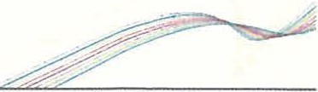
QUEENSLAND TREASURY

Impact Analysis Statement
Summary IAS

Lead department | Queensland Police Service
Name of the proposal | Police Service Administration (Oath and Affirmation) Amendment Regulation 2024
Submission type  (Summary IAS I Consultation IAS I Decision IAS) | Decision IAS
Title of related legislative or regulatory instrument | Police Service Administration Act 1990  Police Service Administration Regulation 2016
Date of issue | 5 February 2024

For aspects of the proposal noted in table below, no regulatory impact analysis is required:

Proposal type | Details
Regulatory proposals where no RIA is required | The proposal relates to an internal process to the Queensland Police Service involving police powers and administration and is not subject to RIA requirements under the Better Regulation Policy.

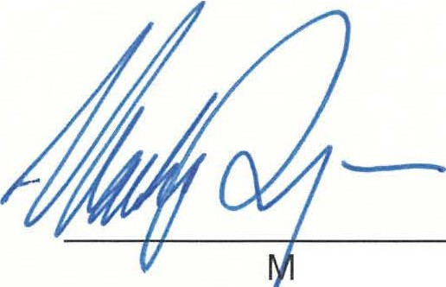
Signed

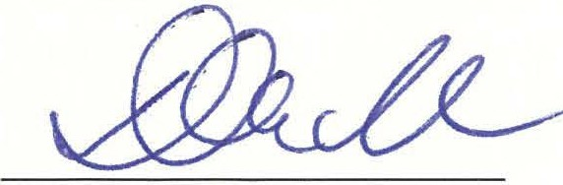

Katarina Carroll Commissioner
Queensland Police Service Date: 'ii""· d) • .:Jt.,;-
ark Ryan MP Minister for Police and Community Safety

Impact Analysis Statement 1
Queensland
Government

