PIC.CoreBusiness@police.qld.gov.au

QPS LEGAL BPOINT Payment Page
Instructional Guide – 2024

Overview
This document serves as a comprehensive guide on how to complete the QPS Legal BPOINT Payment Page. It provides clear, step-by-step instructions, ensuring that even those unfamiliar with the process can successfully make payments.
The guide covers all necessary details, from filling in each field correctly to choosing a payment method. It also includes helpful tips to avoid common errors and ensure a smooth transaction. This resource aims to make the payment process more accessible and efficient for all users, reflecting our commitment to serving the public.

Abbreviations
Abbreviation | Full Description
IMS | Information Management Services
QPS | Queensland Police Services
FAQs | Frequently Asked Questions
QLD | Queensland
Organis’n | Organisation
App | Application
Individ | Individual

FAQS

Why change processes?
The Queensland Police Service (QPS) Information Management Services (IMS) substantial transition towards a more environmentally friendly and customer efficient agency has resulted in the previous payment solution for criminal and person history checks to be revised. With guidance from respected QPS agencies, IMS has coordinated and constructed a brand new, secure online payment platform through the Commonwealth Bank Group; BPOINT. The new customer focused platform allows for direct online payment to be made (via credit/debit accounts), with access via mobile or computer, present day pricing and instant receipt of payment.

What is the wait time for the application to finalise and be returned?
Once payment has been confirmed, requests will be processed within a 28 business day timeframe.

How are documents returned?
After completion, documents are returned to applicant/representing organisation through email address supplied on application.

Table of Contents
Overview 1
Abbreviations 1
FAQS 1
Why change processes? 1
What is the wait time for the application to finalise and be returned? 1
How are documents returned? 1
Step-by-Step Instructions 3
Step 1 – Select suitable service and provide details 3
Step 2 – Enter and confirm amount: 4
Step 3 – Payment Information: 5
Step 4 – Confirm Information: 6
Step 5 - Approval: 7
Step 6 – Email to Core Business Team Leader: 7

Step-by-Step Instructions

Step 1 – Select suitable service and provide details
Select the suitable service from the list of services provided for the “Biller Code”, complete the “Full Name”, “Email Address” and “Business Name” ⁽¹⁾ fields with the appropriate information. Then click “NEXT”.
(1) – If completing the form as an individual, the “Business Name” field will be your Full Name
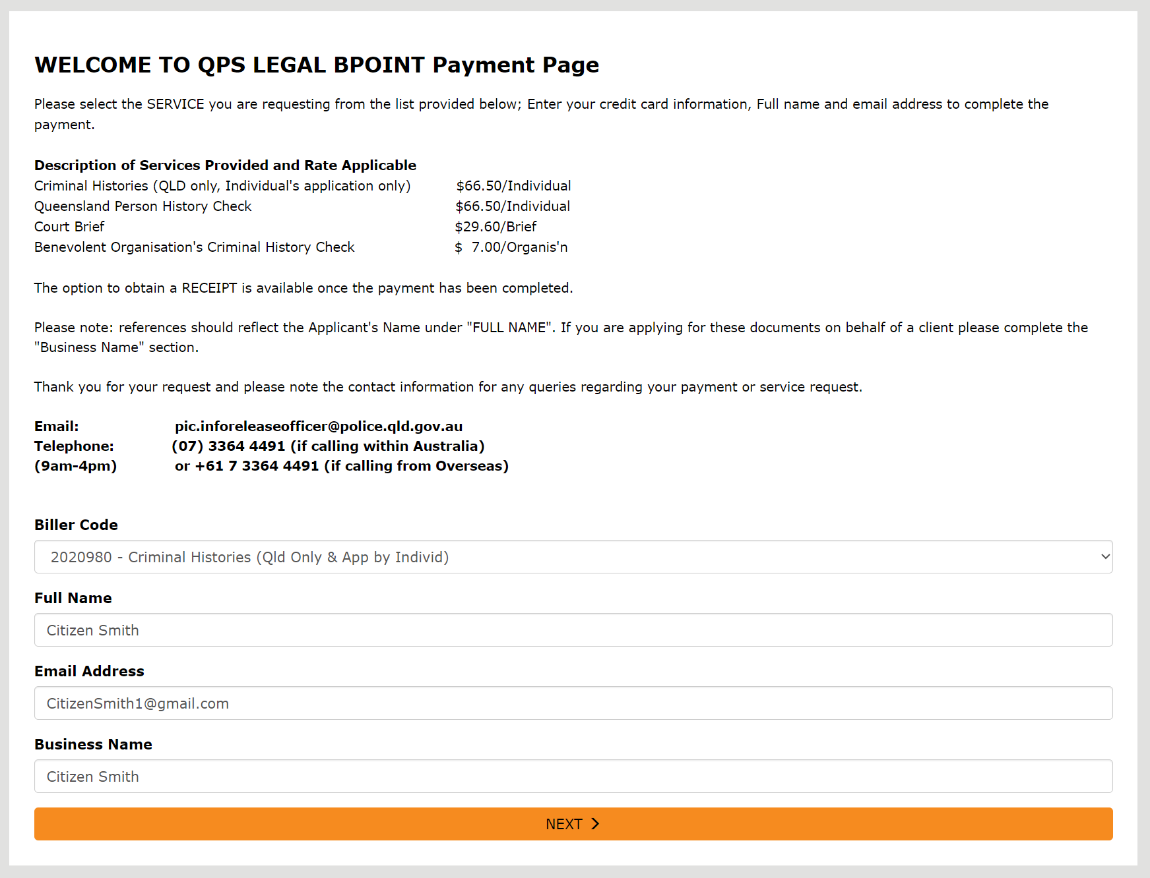

Step 2 – Enter and confirm amount:
Enter and confirm the “Amount” being paid in relation to the “Description of Services Provided and Rate Applicable”. Then click “NEXT”.
** The form will not proceed to the next page if the amount field does not reflect the rate applicable to the service.
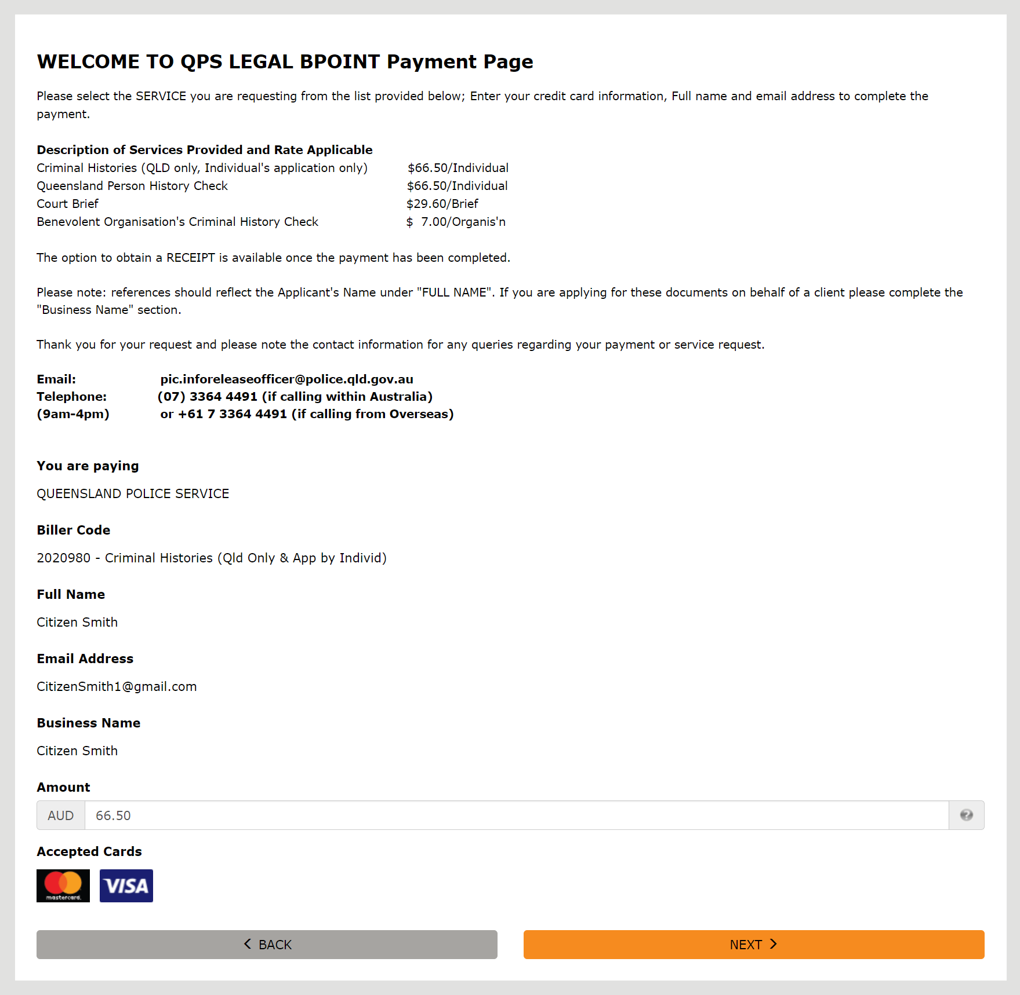

Step 3 – Payment Information:
Proceed with entering the payment information for your preferred banking providers card details. Then click “NEXT”.
** At this current stage, the only cards accepted through the BPOINT payment form are Mastercard or VISA
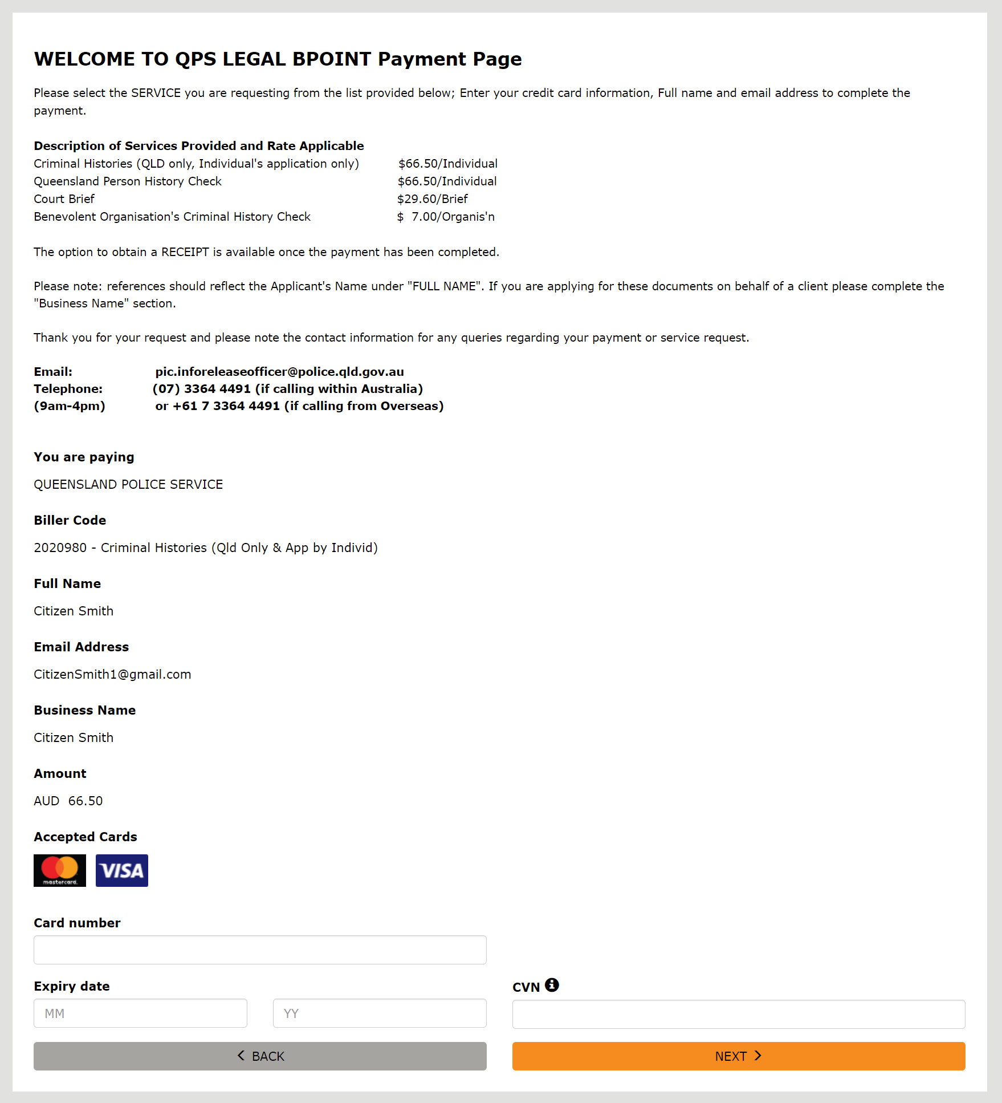

Step 4 – Confirm Information:
Confirm that all the information that you have selected and entered is correct and verify the captcha with clicking the checkbox (a green tick will appear). Finally, click the “PAY” button where this will take you to the confirmation screen.
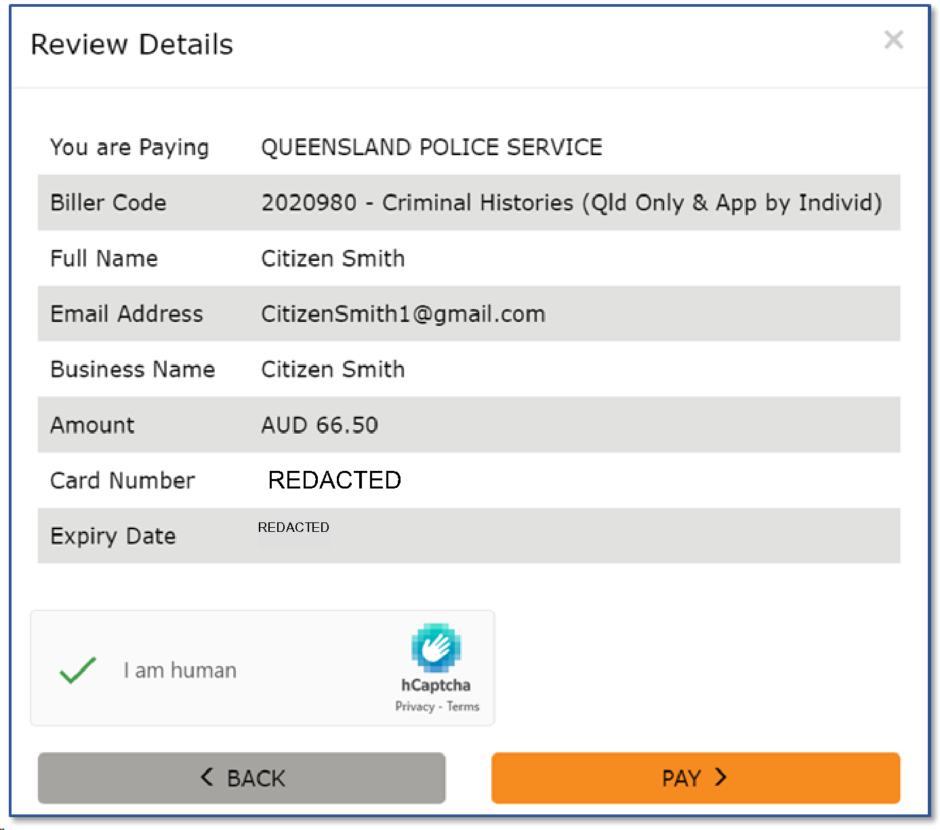

Step 5 - Approval:
Once payment has been finalised, an approval screen will appear showing confirmation alongside your receipt number. This number is required to be supplied with your application or request when emailing to Information Management Services (PIC.CoreBusiness@police.qld.gov.au) for processing.
** In addition to the receipt number being provided on the confirmation screen, an email is sent to your supplied email address with a receipt.

Step 6 – Email to Core Business Team Leader:
Services may vary with what information is required to be provided, please find the relevant information below on what is necessary when sending an email to “PIC.CoreBusiness@police.qld.gov.au”:
- Criminal Histories (QLD only, Individual's application only)
  - Completed Form QP 0349A (Application for a copy of own Queensland Criminal History)
  - Proof of identity
  - BPOINT Receipt Number
- Queensland Person History Check
  - Full name
    - Including any previous names
  - Date of birth
  - Photo of sufficient identification
    - E.g. Current driver’s licence, passport, or other photographic identity document
  - BPOINT Receipt Number
- Court Brief
  - Full name
    - Including any previous names
  - Date of birth
  - Photo of sufficient identification
    - E.g. Current driver’s licence, passport, or other photographic identity document
  - BPOINT Receipt Number
- Benevolent Organisation's Criminal History Check
  - Full name
    - Including any previous names
  - Date of birth
  - Photo of sufficient identification
    - E.g. Current driver’s licence, passport, or other photographic identity document
  - BPOINT Receipt Number
** Organisations acting on behalf of an individual will also have to attach signed authority and provide return email address

