Impact Analysis Statement
Summary IAS

Details

Lead department | Queensland Police Service
Name of the proposal | Emergency Services Reform Amendment Package
Submission type | Summary IAS
Title of related legislative or regulatory instrument | State Emergency Service Bill 2023
Date of issue | 11 September 2023

For proposals noted in table below

Proposal type | Details
Regulatory proposals where no RIA is required | The sustainability of the delivery of emergency services has been considered in a series of reviews including the ‘Independent review of Queensland Fire and Emergency Services’ which has made recommendations that have been accepted in principle by the Government (excepting recommendation 12). The Government has also accepted in principle the recommendations made by the Inspector- General of Emergency Management in the Review of Queensland’s Disaster Management Arrangements (QDMA). The proposed legislative reform to Queensland’s emergency services and disaster management arrangements meets these recommendations.  The reform will occur in two stages. This package is the first stage and consists of three Bills, namely the:  - Emergency Services Reform Amendment Bill 2023; and  - Marine Rescue Queensland Bill 2023; and  - State Emergency Service Bill 2023.  The Marine Rescue Queensland Bill 2023 will establish Marine Rescue Queensland (MRQ) as a marine rescue service for the State and will provide a framework outlining the purpose, functions and command structure of the MRQ and the appointment of its members.  The State Emergency Service Bill 2023 will establish the State Emergency Service (SES) in a standalone Act.  The Emergency Services Reform Amendment Bill 2023 (Amendment Bill) will align the MRQ and the SES under the control of the Queensland Police Service (QPS) and deem MRQ and SES members to be QPS staff members. The Amendment Bill will also formally establish the State Disaster Management Group (SDM group) within the Disaster Management Act 2003. The SDM group will provide strategic  oversight in the preparation for, and leading into, a disaster event. The SDM group

will act as a precursor to the convening of the Queensland Disaster Management Committee (QDMC) and may provide advice or recommendations about disaster management strategies and policies to the QDMC.

The QPS has assessed the amendments and determined that the following categories provide an exemption from undertaking further impact analysis:
- Regulatory proposals relating to police powers and administration, general criminal laws, the administration of courts and tribunals and corrective services;
- Regulatory proposals for the internal management of the public sector or statutory authority;
- Regulatory proposals that are of a machinery nature; and
- Regulatory proposals that make consequential amendments.

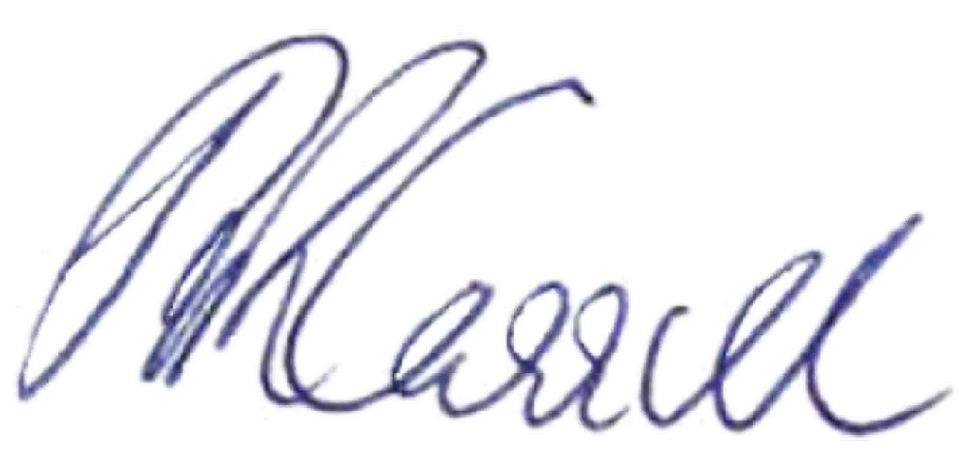
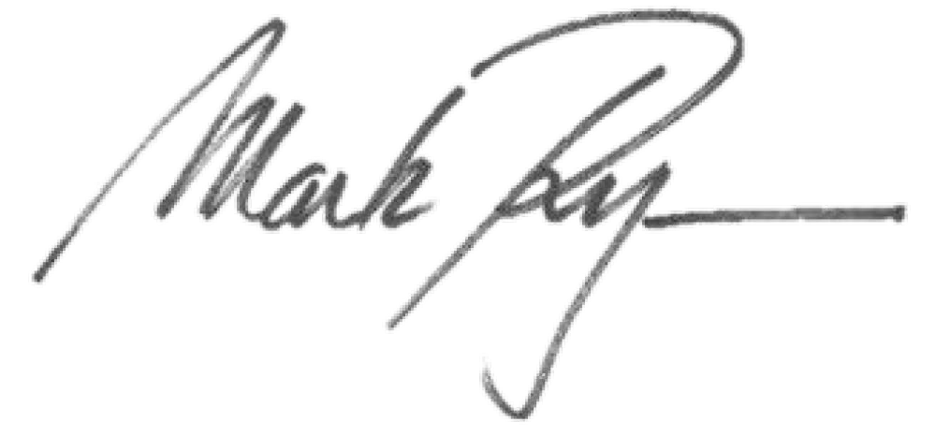
Signed

.................................................. ..................................................
Katarina Carroll Mark Ryan MP
Commissioner Minister for Police and Corrective Services and Queensland Police Service Minister for Fire and Emergency Services

Date: 24/11/2023 Date: 24/11/2023

