SUSPECTED MURDER

OF
MARC KRISTIAN MIETUS
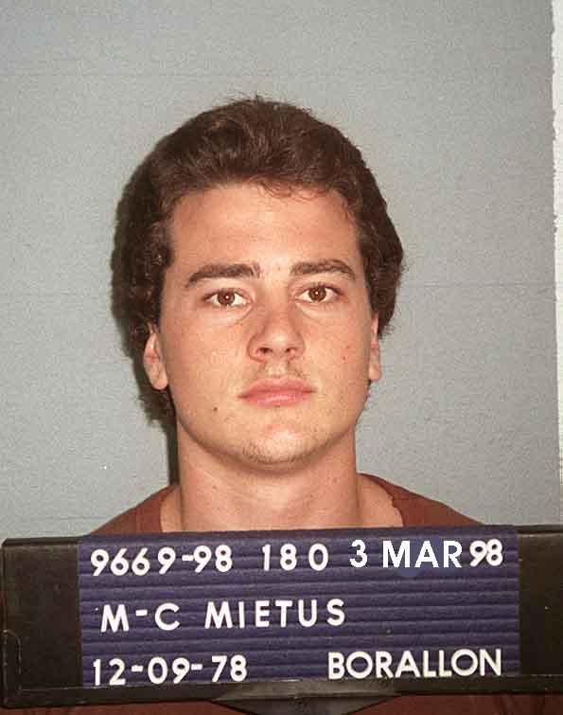
$500,000 REWARD
REWARD: The Minister for Police and Community Safety has approved a reward of $500,000 offered for information leading to the identification and conviction of the person or persons responsible for the suspected murder of Marc Kristian MIETUS, 21 years, at Booyal on or about 26 January 2000.

INDEMNITY FROM PROSECUTION: In the case of an offence being identified, an appropriate indemnity from prosecution will be recommended for any accomplice, not being the person who actually committed the crime, who first gives such information.

The allocation of the $500,000 reward will be at the sole discretion of the Commissioner of the Police Service.

CIRCUMSTANCES: On the 4 January 2000 Mietus moved from Melbourne to Brisbane to be closer to friends. He was last seen at 6:30am on 26 January 2000 at Booyal via Childers. It has been established that between his arrival in Queensland and his disappearance on 26 January 2000 Mietus was staying between a Kelvin Grove address and the Booyal address. On the afternoon of the 26 or 27 January 2000 he was picked up from the Booyal address by a group of unidentified men. He has not been seen since. Police have a reasonable suspicion that Mietus was murdered on or about 26 January 2000.

Any member of the public with information which could assist Police is asked to contact.

- Homicide Investigation Unit, Brisbane, Phone (07) 3364 4150;
- Any Police Station; or
- Crime Stoppers, Phone 1800 333 000

Commissioners Office  BRISBANE | KATARINA CARROLL APM COMMISSIONER

