Impact Analysis Statement
Summary IAS

Details

Lead department | Queensland Police Service
Name of the proposal | Summary Offences and Other Legislation Amendment Bill 2023
Submission type  (Summary IAS / Consultation IAS  / Decision IAS) | ATI
Title of related legislative or regulatory instrument | Summary Offences Act 2005
Date of issue | 24/11/2023

For proposals noted in table below

Proposal type | Details
Minor and machinery in nature | The proposal to require sellers of certain knives and other weapons to display signage advertising that the sale of these items to persons under the age of 18, is minor and has negligible regulatory costs.
Regulatory proposals where no RIA is required | Other than the proposal outlined above and below, the remaining proposals within the submission (such as prohibiting the sale of certain knives and other weapons to persons under the age of 18) relate to police powers and administration and/or general criminal laws. No regulatory impact analysis is required under the Better Regulation Policy.
*Refer to The Queensland Government Better Regulation Policy for regulatory proposals not requiring regulatory impact analysis (for example, public sector management, changes to existing criminal laws, taxation).

For all other proposals

What is the nature, size and scope of the problem? What are the objectives of government action?
Seller must securely store particular controlled items

The prevalence of knife crime and significant violent acts involving a knife is a serious concern amongst the community.

The Queensland Police Service (QPS) has implemented a number of strategies designed to combat knife crime, including running a successful education campaign ‘I live my life… without a knife’ which focused on raising awareness of knife possession laws and encouraging compliance through education about the associated risks
and penalties.

Promising results are also emerging following the recent expansion of the wanding trial which allows police officers to use hand-held metal detectors to detect knives in safe night precincts across Queensland, on public transport and at public transport hubs. The Police Powers and Responsibilities (Jack’s Law) Amendment Act 2023, which expanded the trial of these powers, was named after Jack Beasley, a teenager who tragically died in a knife attack in 2019. This incident inspired strong public support for greater laws and action to be taken to tackle knife crime in Queensland.

Since 30 March 2023 when Jack’s Law legislation extended and expanded the wanding trial, more than 2, 900 handheld scanner operations have been conducted, resulting in the QPS seizing 350 weapons in the first six months. The weapons seized have included dangerous items such as machetes, axes, and daggers. The unlawful possession of these dangerous weapons in public places leads to an increased risk of these items being used in the commission of a criminal offence.

Since 2019, knife related crime has increased by 18%, with 12,865 reported offences in the 2022-23 financial year where a knife was identified as the most serious weapon. Additionally, the number of offences actioned by police against persons under the age of eighteen where a knife was identified as the most serious weapon has increased by 22% in the last five years, with 1,784 offences reported in the 2018-19 financial year and 2,177 reported in the 2022-23 financial year.

Legislative reform is therefore proposed to introduce new laws and offences in the Summary Offences Act 2005 designed to protect the community and further combat knife crime and youth offending. This includes, for example, introducing a prohibition on the sale of ‘controlled items’ (including knifes and other potentially dangerous items) to juveniles.

As part of this reform, it is also proposed to introduce a new requirement for sellers to secure particular controlled items.

The objective of government action is to reduce the risk of dangerous weapons being inappropriately accessed by juveniles, including by theft.
What options were considered?
Seller must securely store particular controlled items
In determining which items should be encapsulated by the new proposed secure storage requirement, a wide range of bladed items were considered, including utilising the broad definition of ‘knife’ under section 51(7) of the Weapons Act 1990 (Weapons Act), which would capture everyday kitchen knives and other items with a sharpened point or blade that are not ordinarily considered to be a knife.
Acknowledging the significant financial impost this would have on a wide range of businesses, the proposed storage requirements will only apply to a limited range of prescribed controlled items which may present a risk of harm if used inappropriately and may be liable for use in the commission of a criminal offence.
The proposed amendment will require sellers of particular controlled items to securely store the item/s in their possession at all times, except when a person is in physical possession of the item.
Controlled items captured by this requirement include:
- A dagger that is a double-edged blade (which does not encompass most knives or daggers, as the majority of these items only have one sharpened edge);
- A knife with a blade at each end;
- A sword (as defined in schedule 2 of the Weapons Act), machete or axe (including a tomahawk);
- A sickle or scythe;
- A spear-gun;
- A spear; and
- A bladed item prescribed by regulation.

To securely store the item means the item is stored in a locked room, cage, cabinet or container, or securely tethered.
The particular items captured by the proposed secure storage requirements will therefore not apply to standard knives (such as kitchen knives which are sold at a wide range of retailers), thus will impact a smaller number of businesses, minimising the financial impost of this amendment.
Additionally, consideration was given as to whether the items should be securely stored (i.e. requiring the item to be stored in a locked cabinet or storage facility) or whether the proposed requirement would extend to securely tethering the item. Noting the cost associated with building cabinetry for larger items such as long spears, as opposed to providing the option to securely tether the item, the proposed amendment was designed to provide greater options to businesses to allow items to be tethered or securely stored.
What are the impacts?
Seller must securely store particular controlled items
Due to the important nature of the proposed legislative reform and need for timely action, a full IAS was not completed. Knife crime and youth offending is a matter of great significance that requires an immediate response to prevent injury and/or harm.
The proposed amendment requiring particular controlled items to be securely stored, will impact a variety of businesses which sell and display these items at retail outlets.
Affected businesses may include:
- Camping, fishing, and outdoor sporting stores, which may sell axes, daggers, machetes, spears and spear- guns, such as:
  - ‘Anaconda’ – 20 stores in QLD;
  - ‘BCF’ – 36 stores in QLD;
  - ‘4WD Supacentre’ – 6 stores in QLD;
  - ‘Outback Equipment’;
  - 'Tackle World’ – 3 stores in QLD;
  - Independent dive stores and spear fishing stores;
- Hunting stores, such as:
  - ‘Brisbane Hunting Supplies’;
  - ‘Apex Hunting’;
- Agricultural and trade stores, which sell machetes (i.e. inclusive of cane knives), sickles and/or scythes;
- Specialty knife stores, which may sell knives, daggers and machetes, such as:
  - ‘King of Knives’ – 3 stores in QLD;
  - ‘Knife Shop Australia’;
  - ‘Extac Australia’; and
- Specialty / independent stores, which sell novelty swords, knives and daggers;
- Hardware stores, which sell axes, machetes, and/or daggers, such as:
  - ‘Mitre 10’ – 104 stores in QLD;
  - ‘Bunnings’ – 64 stores in QLD;
  - ‘Home Hardware’ - 36 stores in QLD; and
- Smaller independent stores (for all categories).
The sale of swords is likely to affect a small number of retailers, however, may have a more significant impact on specialty stores that exclusively sell swords as novelty items or to collectors.
It is conservatively estimated that approximately 400 stores may be affected by the proposed storage requirements, acknowledging the large degree of uncertainty regarding the number of businesses which may be impacted.

The cost to install locked cabinets or other secure storage / display cases for these items will vary for each retailer depending on the size and quantity of each item sold. The cost of complying with this requirement will also depend on other storage facilities that may be available to the retailer, for example, whether the item can be stored off the shop floor in a secure back room and whether locked storage display units are already available in the store, noting many retailers already securely display and store such items. Additionally, retailers will have the option to securely tether the item, which may be more cost effective.
If the retailer cannot already securely store the affected item/s, the cost to install lockable cabinets or other secure storage facility may vary.
Depending on the size and range of inventory, and the number of stores, estimate costs can vary from:
- Security tethers: $100 - $400 each;
- Cabinet displays: $200 – upwards of $10,000 each;
- Dummy displays: $100 – upwards of $1,000 each;
- Individual security casings: $50 - $1,000 each;
- Behind the counter storage: $200 – upwards of $1,000 each.
Some options may require qualified tradespeople to install or rearrange shop fit outs. A new or full shop fit-out costs may also be around $2,000 - $2,500 / square metre in Queensland.

It is estimated that the implementation costs may range from $100 to $60 000 per store, depending on the retailer. This is noting that retailers are likely to implement the most cost-effective storage solution, which may for example include only displaying a few of the impacted items on the shop floor and retaining the remaining stock in a lockable storage room.
As many businesses likely only stock one or several affected items, and may already possess secure storage options, it is estimated that the average implementation cost of this initiative would be approximately $15,000 per store.
Therefore, the estimated total implementation cost of this initiative for retailers is $6,000,000 (400 x $15,000).
It is also noted that there will likely be some ongoing associated labour costs. For example, customers wishing to view or purchase securely stored items will require staff assistance to be able to access the item.
In calculating the ongoing labour costs associated with this initiative, it is estimated that on average, each store may incur approximately 30 minutes of staff time each day for a total of 3 hours per week or 156 hours per year (based on average operation hours and assumed average 6 days of trading per week, noting most businesses will operate between 5 to 7 days per week).
The average rate for non-managerial retail employees (based on the Australian Bureau of Statistics) is $31.20 per hour. To account for non-wage labour on-costs (for example, payroll tax and superannuation) and overhead costs, this is multiplied by 1.75 (as specified by the Australian Government Office of Impact Analysis Regulatory Burden Measurement Framework) to give $54.60 per hour.
Therefore, it is estimated that the ongoing cost of this initiative per retail store, per year is: $8517.60 ($54.60 x 156).
Based on the estimated number of impacted businesses, the ongoing costs of the initiative to the retail industry over the next 10 years is $25,604,697 (net present value of $8517.6 x 400 over 10 years)
However, in estimating the implementation and ongoing costs to retailers, there is a large degree of uncertainty which impacts upon the accuracy of any estimated costings. In particular:
- the exact number of retail locations affected by this proposal is unknown;
- the current number of retail locations which already possess secure storage or partially, meaning they would already be compliant or partially compliant with the proposal, is unknown;
- different retail locations may sell a different range of items, resulting in an inconsistent impact upon stores even amongst large retail chains;

- to securely store an item means storing it in a locked room, cage, cabinet, or container, or securely tethering it. This provides retailers with several storage options that have different associated costings which cannot be determined; and
- the exact storage requirements for each store or type of store are unknown, as each business may sell one or several items affected by the proposal and each item may vary is size which would impact the cost of any secure storage facility.
It is also noted that the proposal may have unintended consequences or impacts upon the community. For example, some businesses may elect to cease selling the impacted item rather than investing in secure storage. This may have a particularly adverse impact on remote and rural communities as these communities may only have one retail outlet in which to purchase an affected item.
Additionally, the retail industry is comprised of a broad range of businesses, from small mum-and-dad shops to large national chains. The ability of individual businesses to absorb costs will greatly vary, especially in the current retail environment.
Any costings to Government will be met through existing budgets, therefore are negligible.
Who was consulted?
Seller must securely store particular controlled items

A public consultation paper outlining the proposed amendment was distributed to key retail stakeholders, inviting them to provide feedback. Additionally, the views of retail stakeholders affected by the proposal were sought specifically regarding this amendment, with the following questions posed:
- What estimated cost and impact will this proposal have on your business?
- How will your business respond to this proposal and do you foresee any unintended consequences arising from this proposal?
- Alternatively, if the proposed requirement specified the item must be secured (for example, meaning it could be securely tethered, or, stored in a locked cabinet or container), how would this impact your business and what is your preferred option?
All responses received were considered during the development of the proposed initiative and legislative amendment.
What is the recommended option and why?
Seller must securely store particular controlled items
It is recommended to introduce a legislative requirement to ensure secure storage of certain controlled weapons which is to include the limited items as specified above. This approach is considered necessary and appropriate given the danger these items can present and access to these items should be limited to minimise the associated risks.
These measures will help prevent accidental injury due to inappropriately handling of the item. For example, a child may access a dagger or sword that is displayed for sale and cause accidental harm to themselves or others. Such items may be particularly appealing to a minor as it may resemble or remind the child of a toy. Secure storage will also reduce the likelihood that the item will be misappropriated or stolen. Given these items can be deadly weapons if used inappropriately, precautions should be taken to prevent unauthorised access. The risk of theft may also be increased given the concurrently proposed amendment which seeks to prohibit controlled items from being sold to minors.
Consideration was given as to whether the secure storage requirements should apply to a broader range of items, including all knives thus encompassing kitchen knives. However, the scope of items to be encapsulated by the proposed amendments was not expanded to this extent noting the significant financial impost this would
have on a wide range of businesses.

Impact assessment

All proposals – complete:

 | First full year | First 10 years
Direct costs – Compliance costs* | $9,407,040 | $31,604,697
Direct costs – Government costs | Nil | Nil

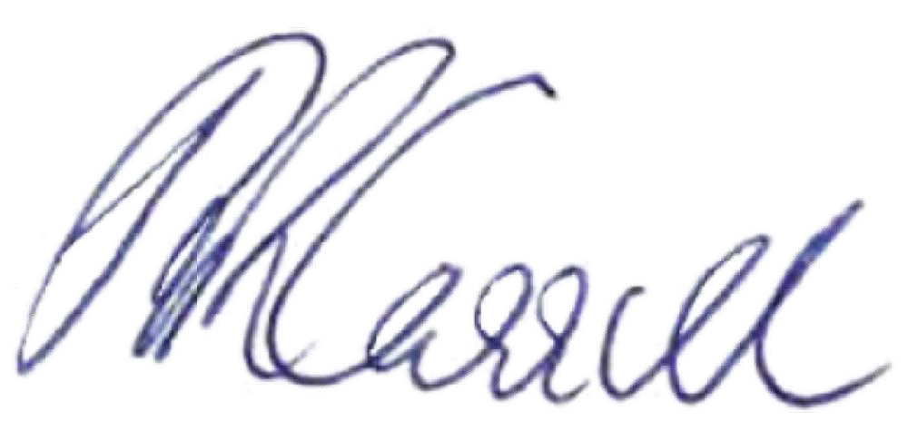
Signed

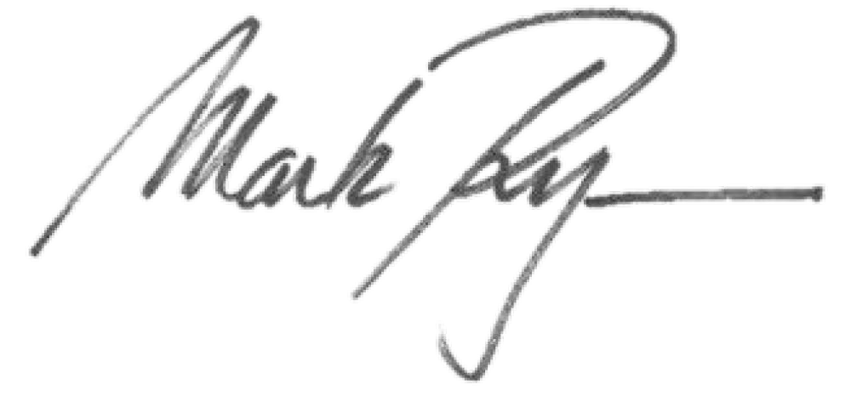
.................................................. ..................................................
Katarina Carroll Mark Ryan MP
Commissioner Minister for Police and Corrective Services and Queensland Police Service Minister for Fire and Emergency Services

Date: 24/11/2023 Date: 24/11/2023

