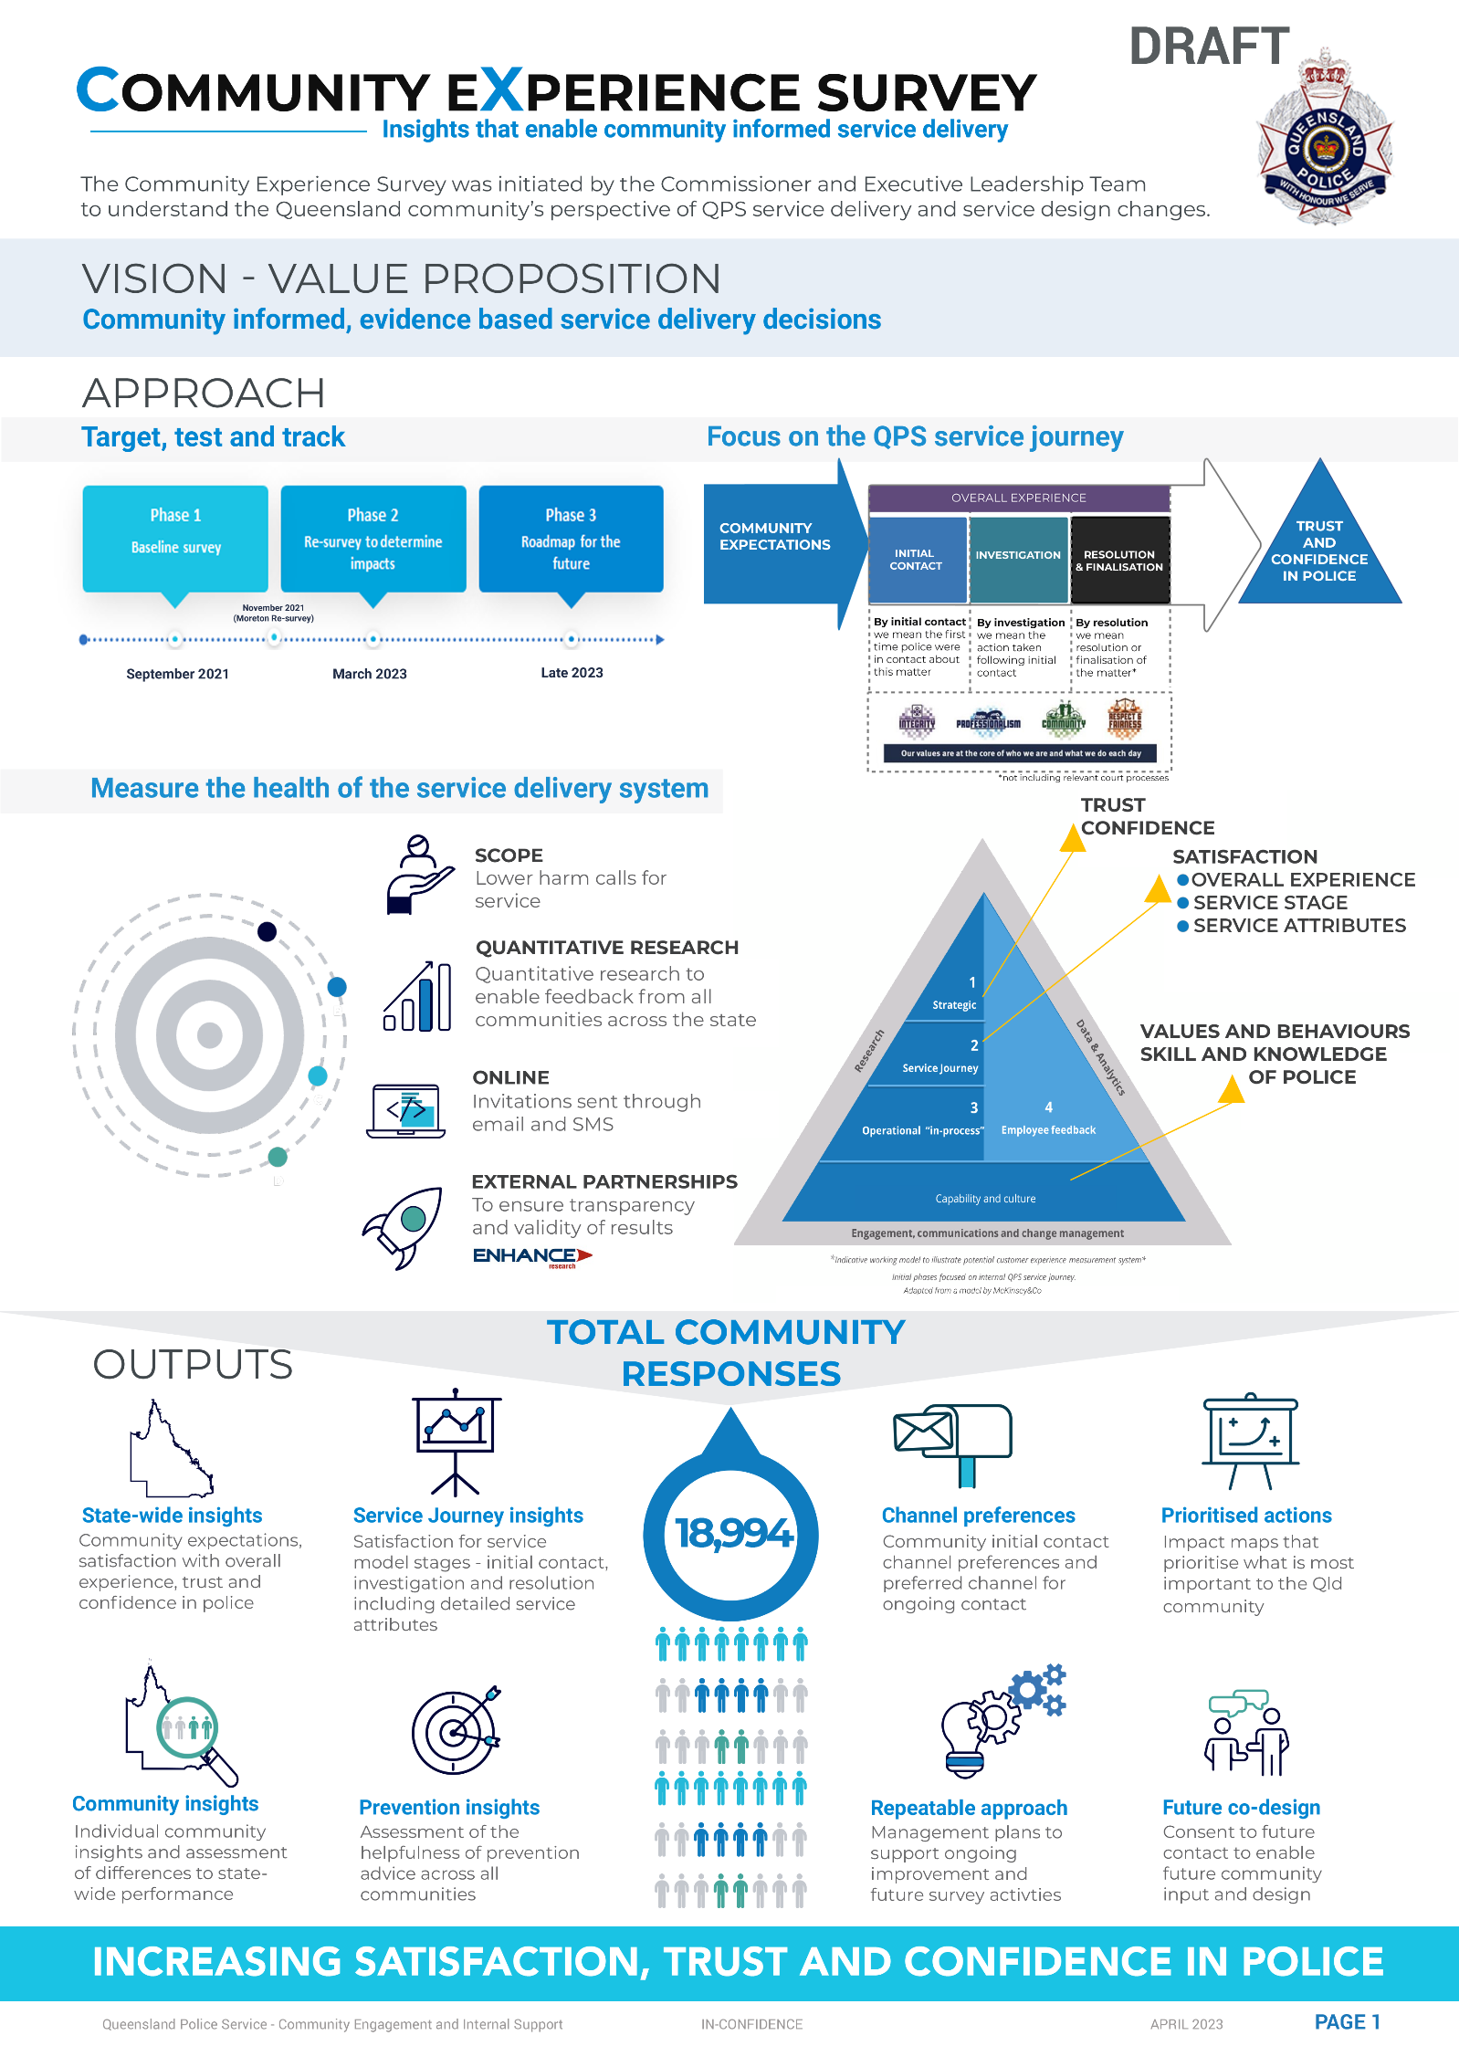

**September 2021 March 2023 Mid 2024**

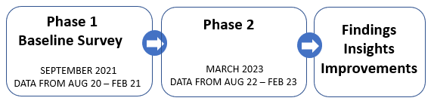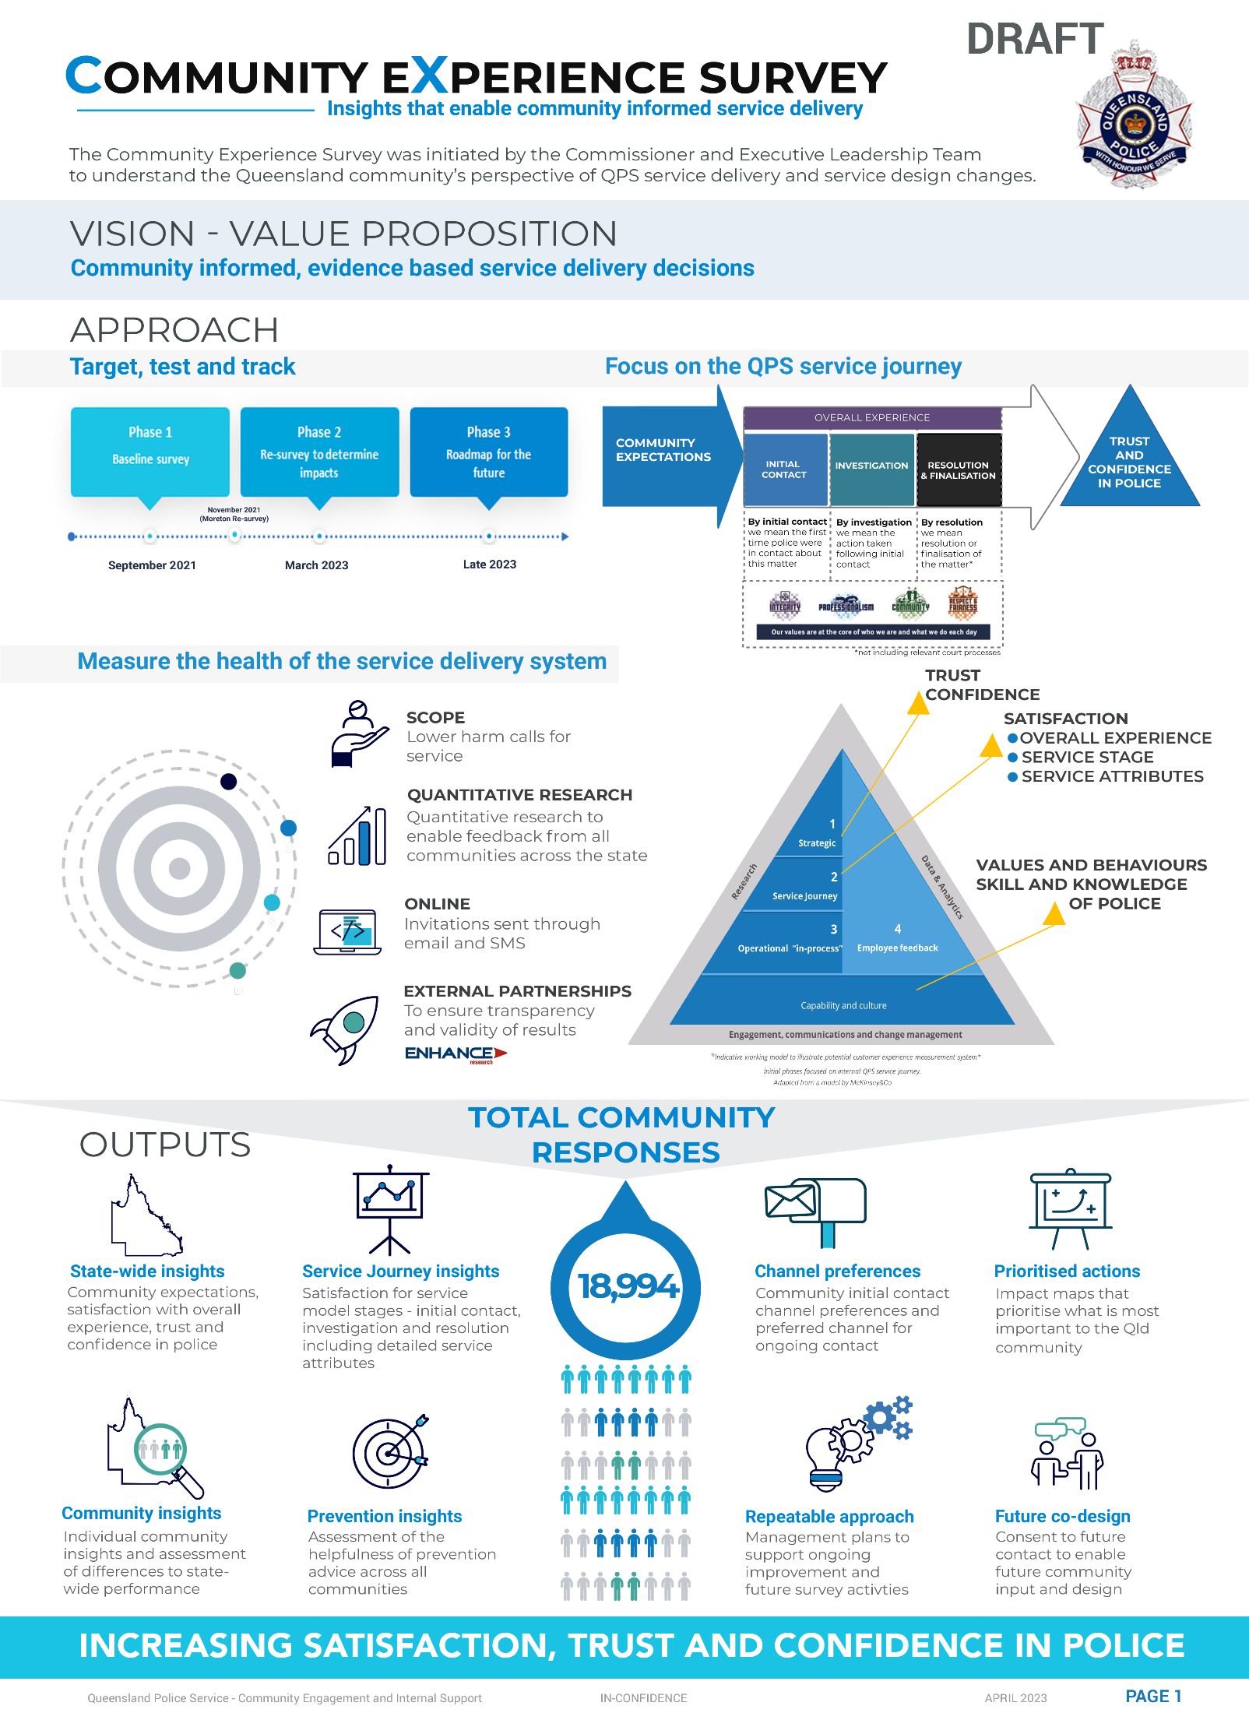

**SURVEY COMPARISON RESULTS**

**August 2021 to March 2023**

Focusing QPS customer service journey the survey provided an **overall experience** score and three targeted stages of service delivery.

**Baseline** survey reflective of Phase 1 - 2021 results, **Resurvey** survey is Phase 2 – 2023.

Phase 2 - State Wide Overall Means results

*The scope of the survey is community-initiated calls for service through 000, Policelink (phone and QPS Website) and stations.*

*High harm calls and certain vulnerable community members are not represented in these results.*



**results and outcomes**

**WHAT ARE THE SATISFACTION DRIVERS?**

You are most satisfied with:

* the politeness and helpfulness of police at the initial point of contact.
* the care shown for my situation.
* action taken by police following the initial contact.
* action taken by police to resolve the matter.
* time taken to reach the final outcome.

**WHERE ARE THE AREAS THAT WE CAN IMPROVE?**

You have told us that we can improve by:

* keeping you up to date on what is happening for your call for service.
* closing the loop and telling you the outcome (resolving or finalising your call for service).

**HOW WE PLAN TO IMPROVE….**

The **Close the Loop** initiative has been established to enhance community engagement and satisfaction. The Close the Loop initiative will:

* improve educational training products to be delivered to QPS members.
* increase service wide communication to improve officers’ knowledge of policy, procedures, and obligations of keeping our community up to date.
* facilitate further consideration regarding technical solutions.

*Thank you to those who participated in the survey and for supporting the Queensland Police to make our Queensland community safe.*