

This annual report provides information about the Queensland Police Services’ financial and non-financial performance information for 2022-23. It has been prepared in accordance with the *Financial Accountability Act 2009*, the *Financial and Performance Management Standard 2019* and the Annual report requirements for Queensland Government agencies.

**Enquiries and further information**

Telephone: (07) 3364 3616

Visit: [www.police.qld.gov.au](http://www.police.qld.gov.au)

Email: [QPS.Reporting@police.qld.gov.au](mailto:QPS.Reporting@police.qld.gov.au)

This annual report can be obtained in paper form by calling 13 QGOV (13 7468) or online at [www.police.qld.gov.au/corporatedocs/reportsPublications/annualReport/default.htm](http://www.police.qld.gov.au/corporatedocs/reportsPublications/annualReport/default.htm).

**Feedback**

Feedback on the annual report can be provided through the Get Involved website:

<https://www.getinvolved.qld.gov.au/gi/>

**Other languages and formats**

The Queensland Government is committed to providing accessible services to Queenslanders from all cultural and linguistic backgrounds. If you have difficulty understanding the annual report, you can contact us on telephone   
(07) 3364 3616 or free call the Translating and Interpreting Service (TIS National) on telephone number 131 450 and an interpreter will be arranged to communicate the report to you.

**Copyright**

© The State of Queensland, Queensland Police Service 2023

**Licence**

****This annual report is licensed by the State of Queensland, Queensland Police Service under a Create Common Attribution (CC BY) 4.0 Australian licence.

**CC BY Licence Summary Statement**

In essence, you are free to copy, communicate and adapt this annual report, as long as you attribute the work to the State of Queensland, Queensland Police Service. To view a copy of this licence, visit: [www.creativecommons.org/licenses/by/4.0](http://www.creativecommons.org/licenses/by/4.0)

**Attribution**

Content from this annual report should be attributed as: The State of Queensland, Queensland Police Service Annual Report 2022-2023.

**ISSN:**

Online: 1837-235X

Print: 1837-2341

|  |  |  |  |
| --- | --- | --- | --- |
| **Queensland Police Service (**[**www.police.qld.gov.au**](http://www.police.qld.gov.au)**)** | | | |
|  | [www.mypolice.qld.gov.au](http://www.mypolice.qld.gov.au) |  | [www.youtube.com/QueenslandPolice](https://www.youtube.com/user/QueenslandPolice) |
|  | [www.facebook.com.au/QueenslandPolice](http://www.facebook.com.au/QueenslandPolice) |  | [www.instagram.com/qldpolice](http://www.instagram.com/qldpolice) |
|  | [www.twitter.com/QldPolice](http://www.twitter.com/QldPolice) |  |  |

**Letter of compliance**

28 September 2023

The Honourable Mark Ryan MP

Minister for Police and Fire and Emergency Services and

Minister for Corrective Services

Level 35, 1 William Street

BRISBANE QLD 4000

Dear Minister,

I am pleased to submit for presentation to the Parliament the Annual Report 2022-2023 and financial statements for the Queensland Police Service.

I certify that this annual report complies with:

* the prescribed requirements of the *Financial Accountability Act 2009* and the *Financial and Performance Management Standard 2019*, and
* the detailed requirements set out in the Annual report requirements for Queensland Government agencies.

A checklist outlining the annual reporting requirements is provided at page 110 of this annual report.

Yours sincerely



Katarina Carroll APM

Commissioner

**Table of contents**

Letter of compliance 2

Table of contents 3

Acknowledgement of Country 4

Commissioner’s message 5

**About Us 7**

Organisational structure 17

QPS Regions Map 19

**Financial Summary 21**

Summary of financial performance 21

Summary of financial position 23

**Performance 25**

Key performance measures 25

2022-23 highlights 31

**Governance 43**

Executive management 43

Boards and committees 47

Government bodies 54

Ethics and code of conduct 54

Risk management and accountability 58

**Human Resources 62**

**Financial statements 68**

**Appendices 103**

Government bodies 103

Acronyms 108

Compliance checklist 110

Information about overseas travel consultancies and the *Queensland Language Services Policy* for 2022-23 is available on the Queensland Government Open Data Portal ([www.data.qld.gov.au](http://www.data.qld.gov.au)).

**Acknowledgement of Country**

The Queensland Police Service respectfully acknowledge First Nations peoples as the Traditional Owners and Custodians of Queensland. We recognise their connection to land, sea and community. We pay our respects to them, their cultures, and to their Elders, past, present and emerging.

**Commissioner’s message**

In my fourth year as Queensland’s Police Commissioner, changes in our society and the economic environment have presented many challenges to the Queensland Police Service (QPS) and all policing jurisdictions in Australia. In my four decades as a police officer, I have not seen demand and reform on such a scale and am proud of how the QPS has responded in this complex and constantly evolving environment.

The challenges of this year have been compounded by the unimaginable loss of two of our much loved and respected members. With a heavy heart we remember Constable Rachel McCrow, Constable Matthew Arnold and community member Alan Dare who were killed on 12 December 2022 at Wieambilla. This incident highlights that, on a daily basis, our frontline police put themselves in harm’s way to protect the community and keep Queenslanders safe.

In addition, the QPS has continued to work with partner agencies to implement the recommendations from the Independent Commission of Inquiry into QPS responses to domestic and family violence, and the Women’s Safety Justice Taskforce Reports One and Two. The QPS welcomes reform and is committed to continuous learning and improvement, working with partners across the Queensland Government and broader Queensland community.

In this period, the Queensland Government announced enhanced investment in fire and emergency services capabilities to ensure Queensland’s frontline officers, staff and volunteers are best positioned to respond to emergency situations and keep Queenslanders safe in a disaster. This included the expansion of the QPS to include the State Emergency Service (SES), disaster management and establishment of the new Marine Rescue Queensland (MRQ). The SES and MRQ will continue to function as separate identities under the QPS departmental umbrella.

To facilitate the changes, the Reform Implementation Taskforce (RIT), Marine Rescue Implementation Program (MRIP) and Emergency Management Coordination Command (EMCC) teams have been established under the leadership of the newly created Deputy Commissioner, Disaster and Emergency Management, whose portfolio also includes the Olympic and Paralympic Games Group.

The QPS continued to deliver outstanding frontline policing services and accomplish significant achievements as showcased by the exceptional work and dedication of our members throughout 2022-23. I am continually amazed by the unwavering commitment of our members to the Queensland community as the Service continues to meet the increasing demands placed on our organisation.

Achievements in 2022-23 included:

* over 90 per cent of all officers completed three-day domestic and family violence training, with a five-day specialist course being rolled out
* expanding recruit training to include 19 days of domestic and family violence focused training
* commencement of a three-day Cultural Capability Recruit Training (First Nations and Multicultural)
* preparation commenced for participation in Queensland’s First Nations Treaty Institute and Truth Telling and Healing Inquiry
* the continuing work of the Youth Crime Taskforce and the Youth Justice Unit, which includes a wide range of initiatives announced by the government in February, including Extreme High Visibility Policing (XHVP) and the expansion of Youth Co-Responder teams in Queensland
* success and expansion of Jack’s Law trial which provides police with the power to stop and scan persons for knives using a handheld metal detector in safe night precincts and public transport hubs
* a raft of recruitment strategies including an announcement in February of up to 500 new Queensland police to be recruited from overseas each year for five years, as part of a new international recruitment campaign
* supporting and promoting Lesbian, Gay, Bisexual, Transgender, Intersex+ pride within the QPS through the QPS LGBTI+ Support Network
* continuing to promote the ‘Our People Matter’ Strategy to support the health and wellbeing of QPS members
* conducting road policing operations to target the Fatal Five, curb negative road user behaviour and reduce Queensland’s road toll
* continuing to engage and improve communications with the community through various social media platforms.

The QPS has welcomed Deputy Chief Executive Sinead McCarthy to lead the Strategy and Corporate Services portfolio. In 2022-23 we farewelled former Assistant Commissioners Maurice Careless and Deb Platz as well as Executive Director Paul Friedman. All had long-standing careers with the QPS and collectively delivered invaluable services to the Queensland community. I wish them well in their future endeavours.

I am honoured to have led the QPS in 2022-23 through the many challenges and complexities inevitable with increasing service delivery demand. I would like to thank the QPS Executive Leadership Team and our 17,000 plus police and staff members for their exceptional service and ongoing dedication to our values of integrity, professionalism, community and respect and fairness, to make Queensland the safest state. I also extend my gratitude to all Queenslanders for working with the QPS to build a safer Queensland for all.



**Katarina Carroll**

**Commissioner**

**About the QPS**

The Queensland Police Service (QPS) is the primary law enforcement agency for Queensland. It fulfils this role throughout the state, 24 hours a day, seven days a week, 365 days a year, upholding the law and assisting the community, particularly in times of emergency, disaster and crisis.

***Our Vision:*** *Queensland – the safest State.*

***Our Purpose:*** *Together, we prevent, disrupt, respond and investigate.*

**Our Accountabilities**

Under the *Police Service Administration Act 1990*, the QPS is responsible for:

* preserving peace and good order in all areas of Queensland
* protecting and supporting the Queensland community
* preventing and detecting crime
* upholding the law
* administrating the law fairly and efficiently
* bringing offenders to justice.

**Our Values**

Consistent with the QPS Strategic Plan 2022-2026, QPS members value:

* ***Integrity:*** Is in everything we do. We are honest, trustworthy and hold each other to a high standard.
* ***Professionalism:*** Times are challenging but if we are professional in everything we do, our communities will continue to support us.
* ***Community:*** We support each other and lend a hand to ensure we can respond to community needs as well as the needs of our policing community.
* ***Respect and Fairness****:* We treat each other and our communities as we would like to be treated ourselves – with fairness, dignity and respect.

The QPS also shares the Queensland Public Service Values of:

|  |  |
| --- | --- |
|  | **Customers first**   * Know your customers * Deliver what matters * Make decisions with empathy |
|  | **Ideas into action**   * Challenge the norm and suggest solutions * Encourage and embrace new ideas * Work across boundaries |
|  | **Unleash potential**   * Expect greatness * Lead and set clear expectations * Seek, provide and act on feedback |
|  | **Be courageous**   * Own your actions, successes and mistakes * Take calculated risks * Act with transparency |
|  | **Empower people**   * Lead, empower and trust * Play to everyone’s strengths * Develop yourself and those around you |

**Our Objectives**

The QPS contributed to the government’s objectives for the community by delivering quality frontline services that supported safe, caring and connected communities, to ultimately make Queensland the safest state. The QPS did this through our focus on:

* **Our people** to build a connected, engaged and job-ready workforce, with the health, wellbeing, and safety of our people a priority
* **Our community** to build a safer Queensland
* **Our relationships** to create a safer community and provide better services through connected and engaged relationships
* **Our commitment** to embrace new ideas and innovation to strengthen our capability to prevent, disrupt, respond to and investigate crime and deliver safe and secure communities.

**Strategies**

The QPS achieves its objectives through a range of strategies:

**To build a connected, engaged and job-ready workforce, with the health, wellbeing, and safety of our people a priority, the QPS:**

* fostered and embedded a culture that aligns with our values
* delivered leadership that is visible, agile, authentic, courageous and supportive
* built a capable and sustainable workforce that is diverse, inclusive and reflective of the community we serve
* established and maintained collaborative partnerships to deliver positive outcomes
* enabled new ways of working and provided fit for purpose resources
* provided safe and healthy workplaces, embedding a shared responsibility in prioritising wellbeing.

**To build a safer Queensland together with our community, the QPS:**

* delivered timely and professional responses to calls for service to maintain and strengthen community confidence through a community-centred approach to policing and crime prevention
* partnered with the community and other agencies to respond to overrepresentation in the criminal justice system, of victims or offenders, including vulnerable persons, First Nations peoples, young people and victim survivors of domestic and family violence.

**To create a safer community and provide better services through connected and engaged relationships, the QPS:**

* protected the legitimacy of policing by setting and maintaining high standards of integrity and professionalism aimed at strengthening the community’s trust and willingness to engage
* maximised joint capability to prevent crime and enhance community safety through collaborative partnerships with government agencies, non-government organisations and community groups
* strengthened relationships to better support us into the future.

**To embrace new ideas and innovation to strengthen our capability to prevent, disrupt, respond, and investigate crime and deliver safe and secure communities, the QPS:**

* delivered safe and secure communities, including an effective policing response to the ongoing COVID-19 pandemic
* met growing demand by focusing and positioning our resources in the right place at the right time
* prevented crime together, by connecting our people, community and relationships to collectively build a community culture of prevention and harm minimisation
* disrupted crime by educating our people, community and relationships in strategies to identify and disrupt local, state, national and global crimes
* responded to crime by maturing our capabilities through streamlining, technology, improved models of service delivery, continuous learning, business optimisation and digital transformation
* investigated crime by developing our people, community and relationships to investigate crime in a global environment of complexity and ambiguity.

The QPS also contributed to a range of local, state and national strategies on matters, including youth justice, domestic and family violence and vulnerable people, mental health, road safety, child safety, drugs and alcohol, counter-terrorism and organised crime.

**Queensland Government objectives**

The QPS supports the government’s objectives for the community which are structured around building future prosperity and growth across the state:

**Good Jobs** – good secure jobs in our traditional and emerging industries

* Supporting jobs: Good, secure jobs in more industries to diversify the Queensland economy and build on existing strengths in agriculture, resources and tourism.
* Backing small business: Help small business, the backbone of the state’s economy, thrive in a changing environment.
* Making it for Queensland: Grow manufacturing across traditional and new industries, making new products in new ways and creating new jobs.
* Investing in skills: Ensure Queenslanders have the skills they need to find meaningful jobs and set up pathways for the future.

**Better Services** – deliver even better services right across Queensland

* Backing our frontline services: Deliver world-class frontline services in key areas such as health, education, transport and community safety.
* Keeping Queenslanders safe: Continue to keep Queenslanders safe as we learn to live with COVID-19 and ensure all Queenslanders can access world-class healthcare no matter where they live.
* Connecting Queensland: Drive the economic benefits, improve social outcomes and create greater social inclusion through digital technology and services.
* Educating for the future: Give our children the best start by investing in our teachers and schools.

**Great Lifestyle** – protect and enhance our Queensland lifestyle as we grow

* Protecting the environment: Protect and enhance our natural environment and heritage for future generations and achieve a 70% renewable energy target by 2032 and net zero emissions by 2050.
* Growing our regions: Help Queensland’s regions grow by attracting people, talent and investment, and driving sustainable economic prosperity.
* Building Queensland: Drive investment in the infrastructure that supports the State’s economy and jobs, builds resilience and underpins future prosperity.
* Honouring and embracing our rich and ancient cultural history: Create opportunities for First Nations Queenslanders to thrive in a modern Queensland.

**Our environment**

The Queensland policing environment continues to be characterised by rapid change, increasing complexity and increasing calls for service delivery. As a result, the QPS is being challenged to meet evolving demands. Current change is driven by shifting community expectations and rapid technological innovation, influencing our service delivery in a broader context. To keep pace with the rapidly evolving environment, the QPS will continue to explore opportunities to develop and maintain strong community relationships, harness advances in technology to deliver high quality best practice efficient policing services and develop collaborative and integrated service responses to increase community safety. The QPS will continue to remain agile to address the impact of new and emerging technologies on the criminal environment, respond to extreme weather events and climate change and leveraging the recommendations of recent reviews and inquiries to drive reform and build a diverse and inclusive organisational culture.

In response the QPS will:

* coordinate the implementation of recommendations from the Commission of Inquiry into QPS responses to domestic and family violence (DFV) that contribute to systemic reform
* coordinate the implementation of key recommendations from the Women’s Safety Justice Taskforce *Hear Her Voice* – Reports 1 and 2
* promote multi-agency initiatives and partnerships to address and manage youth crime and recidivism including whole of government initiatives and regional initiatives in collaboration with partner agencies and community
* develop and embed cultural training to enhance awareness and capability
* deliver modern, mobile and flexible policing across Queensland through the introduction of mobile police beat vans and a range of other police resources, including body-worn video cameras and integrated load-bearing ballistic vests
* establish a sentiment analysis and reporting platform to better inform the QPS in key policing and community issues
* coordinate implementation of recommendations from the Commission of Inquiry into DNA testing at Queensland Health Forensic and Scientific Services.

**Our challenges and opportunities in 2022-23**

The QPS acknowledges the importance of addressing a range of potential strategic challenges to ensure we keep Queenslanders safe. The Service identified these challenges and opportunities to respond to in 2022-23, linking them to its strategic objectives.

Key challenges for the QPS during 2022-23 included:

* maintaining an agile disaster management capability plan to prepare for and respond to an increase in the frequency and severity of extreme weather events and natural disasters
* advancing in the use of evidence-based policing strategies to deliver victim-centric, trauma-informed responses to victims and design strategic prevention activities
* adapting to and keeping pace with challenges presented by new and emerging technologies and their impacts on the criminal environment and regulation of online information
* strengthening the integrity and professionalism of police to enhance community satisfaction, trust and confidence in the QPS, in an environment of evolving community expectations
* working with each other, the community and partner agencies to strengthen our response to, and prevention of, domestic and family violence
* working with each other, the community and partner agencies to reduce youth offending
* strengthening partnerships, increasing prevention activities and enhancing capabilities to improve road safety in Queensland
* continuing to support and engage our people to create healthy, inclusive and safe workplaces
* responding to the needs of our communities by creating a victim-centric policing focus to prevent harm, trauma and crime
* facilitating an effective policing response to COVID-19 that upheld public health directives while maintaining strong community relationships
* delivering the best service to our community through continuous improvement and innovation.

To address these challenges, the following opportunities were identified to best position the QPS to make Queensland the safest state:

* leading the QPS service delivery model through a period of significant disruption by remaining agile to shifting demands and community safety needs
* facilitating collaborative approaches and promoting outcomes which are victim-centric and trauma-informed for vulnerable people and enhancing social cohesion and community safety
* identifying innovative applications for new and emerging technologies in policing, while upholding community expectations around transparency, privacy and ethics
* promoting a workforce which is flexible, inclusive and diverse, to enhance engagement and performance
* empowering the workforce by investing in safety, mental health and wellbeing, and by proactively developing organisational capabilities to keep pace with future challenges.

**2023-24 Outlook**

The QPS in 2023-24 will work towards:

* delivering efficient and effective policing services in the context of growing demand and challenging community safety issues, including domestic and family violence, youth crime, sexual violence and road trauma
* maintaining an agile disaster management capability to respond to an increase in the frequency and severity of extreme weather events, and prepare for the broader impacts
* strengthening the integrity and professionalism of police to enhance community satisfaction, trust and confidence in the QPS
* adapting and keeping pace with challenges presented by new and emerging technologies and their impact on the criminal environment and the regulation of online information
* attracting and retaining the right people and proactively developing organisational capabilities
* continuing to support and engage our people to create healthy and safe workplaces
* enhancing our cultural capability to improve relationships and achieve positive outcomes for First Nations and culturally diverse communities
* driving service delivery improvements through innovation, high standards of integrity, and community engagement.

For 2023-24, the QPS identified the following opportunities, including:

* facilitating collaborative and integrated service responses to achieve positive outcomes for vulnerable people, including First Nations peoples, and enhancing social cohesion and community safety
* leveraging the recommendations of recent reviews and inquiries to driving significant reform and building an inclusive and diverse organisational culture
* identifying innovative applications for new and emerging technologies in policing, while upholding community expectations around transparency, privacy and ethics
* advancing the use of evidence-based strategies to deliver victim-centric police services that prevent harm, trauma and crime
* empowering the workforce by investing in their safety, mental health and wellbeing.

***Human Rights Act 2019***

On 1 January 2020, the *Human Rights Act 2019* (Qld) (the Act) came into effect, creating obligations for public entities to act and make decisions in a way that is compatible with human rights, and to properly consider human rights when making a decision. The QPS has made a commitment to respect, protect and promote human rights in our decision-making and actions.

The QPS works tirelessly to ensure Queensland is the safest state, including exercising police powers embedded in legislation such as diversion, move on directions, detention and or arrest, in a way that least impacts on people’s rights while protecting the safety and security of the Queensland community.

As part of this commitment, the QPS has taken steps to further the objectives of the Act including:

* developing training products by Ethical Standards Command relating to the discipline process including instruction on human rights to reinforce the objectives of the *Human Rights Act 2019*
* incorporating human rights in the draft Police Recruiting Management Manual, staff orientation packages and various recruit training curriculum materials
* embedding human rights in regular reporting and decision-making through education, training and awareness.

Human Rights complaints

Since the commencement of the Act, the QPS had updated its complaints and grievance policies, procedures and mechanisms to ensure human rights complaints can be recorded, assessed and responded to appropriately. The QPS examines all complaints received by the QPS to ensure decisions made by the Service and its employees were compatible with the Act.

In 2022-23, the QPS recorded:

* 1,366 distinct complaints where it was identified that one or more human rights may have been engaged
* 1,788 individual human rights limitations connected to those complaints (one complaint can include more than one human rights limitation)
* 35 instances where human rights were unreasonably limited resulting in:
* 8 apologies
* 3 managerial resolutions
* 9 explanations
* 12 disciplinary actions
* 2 Human Rights not engaged
* 1 still open.
* 752 (of the 1,366) complaints were finalised as at 30 June 2023.

Each time the QPS received a complaint, human rights limitations were assessed to determine if any rights were unreasonably limited. The human rights aspect of each complaint was investigated along with the allegation/s, which assisted in determining the appropriate resolution. Of the 1,366 distinct complaints received, in most cases there was no further action taken as no human rights limitations were detected, or an explanation was provided to the complainant as the officers, actions were identified as being lawful and reasonable.

*Notes:*

1. A human rights complaint is a complaint about an alleged contravention of Section 58(1) of the Act by a public entity in relation to an act or decision of the public entity (i.e. that an act or decision is not compatible with human rights and/or that a decision did not properly consider relevant human rights).
2. It is expected that sometimes a complainant will not identify human rights matters within a complaint they make to the QPS. Where the QPS identifies that the complaint may include a contravention of Section 58(1) of the Act the QPS is expected to record this and respond appropriately.
3. The total number of human rights complaints includes all those identified by a complainant and the QPS. A human rights complaint is counted as one regardless of the number of alleged acts, decisions or human rights limited within a complaint made to the QPS.
4. The total number of complaints where one or more human rights were allegedly unreasonably limited relates to all complaints made to the QPS by both internal and external complainants (refer page 54).

**Information security attestation**

During the mandatory annual Information Security reporting process, the Commissioner attested to the appropriateness of the information security risk management within the QPS to the Queensland Government Chief Information Security Officer, noting that appropriate assurance activities have been undertaken to inform this opinion and the Service information security risk position.

**Our partners**

The QPS continued to foster strong relationships with its partners in the community, including the Queensland Police-Citizen Youth Welfare Association, Neighbourhood Watch Queensland and Crime Stoppers Queensland.

* **Queensland Police-Citizens Youth Welfare Association (QPCYWA)**

The QPCYWA, commonly known as Police-Citizens Youth Club (PCYC), is a non-government, not-for-profit organisation that provides appropriate, affordable and accessible youth development programs and services to support young people in making positive life choices.

PCYC Queensland delivers services through PCYCs located in various urban, rural and remote communities across the state. Each club is managed by a QPS Sergeant. This encourages positive relationships in the community and fosters unique interactions and experiences between QPS officers and young Queenslanders. First established in 1948, there are now 54 PCYC clubs with 78 sworn officers and four staff members supporting operations. For more information or to find a club near you, visit the PCYC website at [www.pcyc.org.au](http://www.pcyc.org.au).

* **Neighbourhood Watch Queensland (NHWQ)**

NHWQ is a partnership between the QPS and the Queensland community to enhance community safety. It encourages communities to join together in small informal groups to improve the safety of their families and other people who live, visit and do business in their neighbourhood. NHWQ is focused on enhancing home security, reducing the fear of crime and reporting suspicious activity to police. There are approximately 291 NHWQ groups located throughout Queensland.

For more information or to find your local NHW group, visit the NHWQ website at [www.nhwq.org](http://www.nhwq.org).

* **Crime Stoppers Queensland**

Crime Stoppers Queensland is a community volunteer organisation that encourages the community to help make a difference in solving and preventing crime. It provides an avenue for the community to assist police to solve crimes.

Crime Stoppers Queensland provides a telephone hotline and website for community members to provide anonymous information about criminal activity. This information is sent electronically to the relevant police establishment for investigation in the area where the crime is occurring.

The QPS assists Crime Stoppers Queensland through the following:

* the Assistant Commissioner, Crime and Intelligence Command is on the Board of Directors as the Commissioner’s representative
* a dedicated police unit manages the partnership deliverables, administers intelligence reports, handles investigator inquiries and assists Crime Stoppers State Office personnel with promotional displays and presentations as required
* police officers act as partnership representatives in many of the 24 Volunteer Area Committees spread throughout the state.

During 2022-23, the QPS Crime Stoppers Unit, in partnership with Crime Stoppers Queensland, continued to receive information from the public on criminal activity which resulted in:

* over 24,000 phone and more than 32,900 digital contacts from members of the public
* the apprehension of 900 people
* more than 3,400 charges laid
* the confiscation of more than $1.3 million worth of drugs
* the seizure of approximately $770,000 in proceeds of crime.

For more detailed information, visit the Crime Stoppers Queensland website at [www.crimestoppersqld.com.au](http://www.crimestoppersqld.com.au).

* **Queensland Homicide Victims Support Group**

Queensland Homicide Victims Support Group (QHVSG) delivers services to people who have lost a loved one to homicide and offers a truly unique service. For many living in the aftermath of homicide, healing is often accelerated by speaking with others who have ‘been there too’. Each year, QHVSG supports nearly 150 family members that experience first-hand the devastating effects of homicide. The Commissioner is the Patron of the QHVSG, and the group works closely with the QPS, liaising with families and providing first responder emotional support.

* **Volunteers in Policing**

The aim of the Volunteers in Policing (ViP) program is to recruit and train local community members to conduct a range of voluntary tasks that complement but not compete with the established responsibilities of police officers and other paid staff members. In general, these tasks assist police to deliver a range of services designed to enhance community safety. ViPs are based in local police establishments where they work with police to address customer service, community safety and crime prevention needs in the local area. ViPs also support victims of crime, often attending with police to speak with and provide support to people who have gone through difficult and traumatic experiences. ViPs also assist Police Recruiting with the overall recruiting process. There are approximately 224 ViPs throughout the state. For more information or to become a ViP, visit the QPS website [www.police.qld.gov.au/care](http://www.police.qld.gov.au/join/vip/default.htm)ers-with-the-qps/volunteers-in-policing

**Action plans and strategies**

The QPS works collaboratively with various government departments, including the Department of the Premier and Cabinet, Queensland Treasury, Department of Children, Youth Justice and Multicultural Affairs, Department of Justice and Attorney-General, Queensland Health, non-government and not-for-profit organisations and private sectors, to lead and/or contribute to whole-of-government action plans and strategies, and various other bodies of work.

The QPS provides regular input into Queensland Government action plans and strategies including, but not limited to:

* Culture and Reconciliation (CaR) reporting
* Many Voices: Queensland Aboriginal and Torres Strait Islander Languages Policy Action Plan 2023-2025, which continues implementation of the Many Voices: Queensland Aboriginal and Torres Strait Islander Languages Policy. Local Thriving Communities Action Plan 2022-24
* Queensland Government Regulator Performance Framework
* Better Care Together: A plan for Queensland’s state-funded mental health, alcohol, and other drug services to 2027
* HEALTHQ32: A vision for Queensland's health system
* Breaking Cycles: An action plan for Aboriginal and Torres Strait Islander children and families 2023-2025 (under development)
* Communities 2032 Action Plan 2022-25
* Towards ending homelessness for young Queenslanders 2022-2027
* Achieving Balance: The Queensland Alcohol and Other Drugs Plan 2022-2027
* Shifting minds: The Queensland Mental Health, Alcohol and Other Drugs, and Suicide Prevention Strategic Plan 2023–2028
* Domestic and Family Violence Prevention Strategy 2016-26 (Fourth Action Plan 2022-23 to 2025-26)
* Framework for stronger Community Justice Groups
* Queensland’s Disability Plan 2022–27: Together, a Better Queensland

The progress updates against the actions plans and strategies can be viewed on [www.police.qld.gov.au](http://www.police.qld.gov.au).

The QPS is also working with partner agencies to implement the recommendations from Royal Commissions and/or Commissions of Inquiry including:

* *Women’s Safety Justice Taskforce Report 1 – Hear her voice and Report 2 - Women and girls’ experiences across the criminal justice system.*
* *Royal Commission into Institutional Responses to Child Sexual Abuse*
* *Independent Commission of Inquiry into QPS responses to domestic and family violence*
* *Not Now, Not Ever: Putting an end to domestic and family violence in Queensland report.*

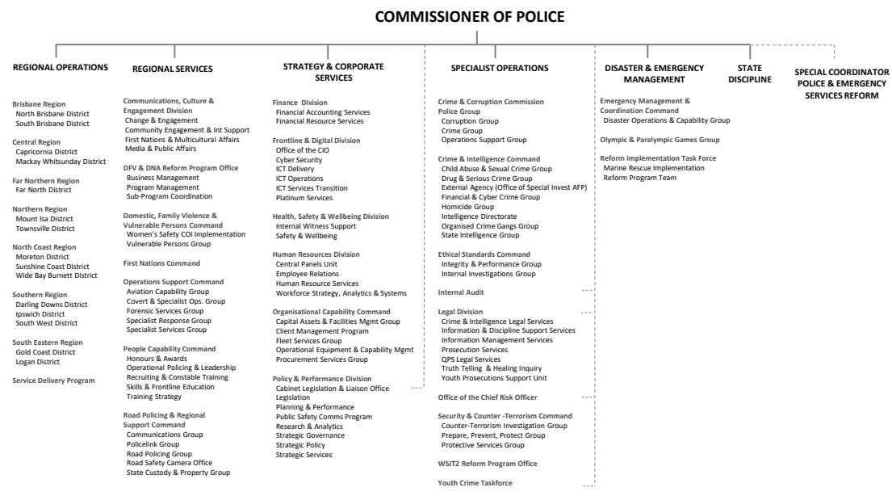**Organisational structure**

**Police and emergency services reforms**

The Police and Emergency Services Reform Program (PESRP) has been established to coordinate a large suite of reforms being undertaken across government, focussed on enhanced emergency services and disaster management arrangements, domestic and family violence and sexual assault reforms, and opportunities for improvement in the collection, testing and analysis of DNA in the criminal justice context in Queensland.

Mr Steve Gollschewski APM was appointed as the Special Coordinator for Police and Emergency Services Reform in November 2022, overseeing the multi-agency response to the following reports:

* ‘*A Call for Change’* report and companion report from the Commission of Inquiry into the Queensland Police Service response to domestic and family violence’s report
* Independent review of the Queensland Fire and Emergency Services (QFES) and its associated volunteer services, and enhancements to the disaster management arrangements - including implementation of recommendations from the Inspector-General of Emergency Management (IGEM) review of disaster management arrangements

and the QPS response to:

* Women’s Safety and Justice Taskforce’s ‘*Hear Her Voice* (reports 1 and 2),
* Independent review by Professor Lorraine Mazerolle (the Mazerolle Review) into investigations of police-related deaths and domestic and family violence deaths in Queensland
* the Commission of Inquiry into Forensic DNA Testing in Queensland.

**Machinery of government changes**

Following the suite of reforms to Queensland Fire and Emergency Services, announced in October 2022, the Queensland Volunteer Marine Rescue Service functions will transition to the QPS before 30 June 2024. The QPS is being expanded to include disaster management functions, Marine Rescue Queensland (MRQ), and the State Emergency Service (SES) to provide an all-hazards approach to disaster management.

MRQ and the SES will maintain their own identity, uniforms and procedures within the QPS.

The Reform Implementation Taskforce was established in January 2023 to deliver the disaster and emergency management reforms in a phased approach.

**Regional map**

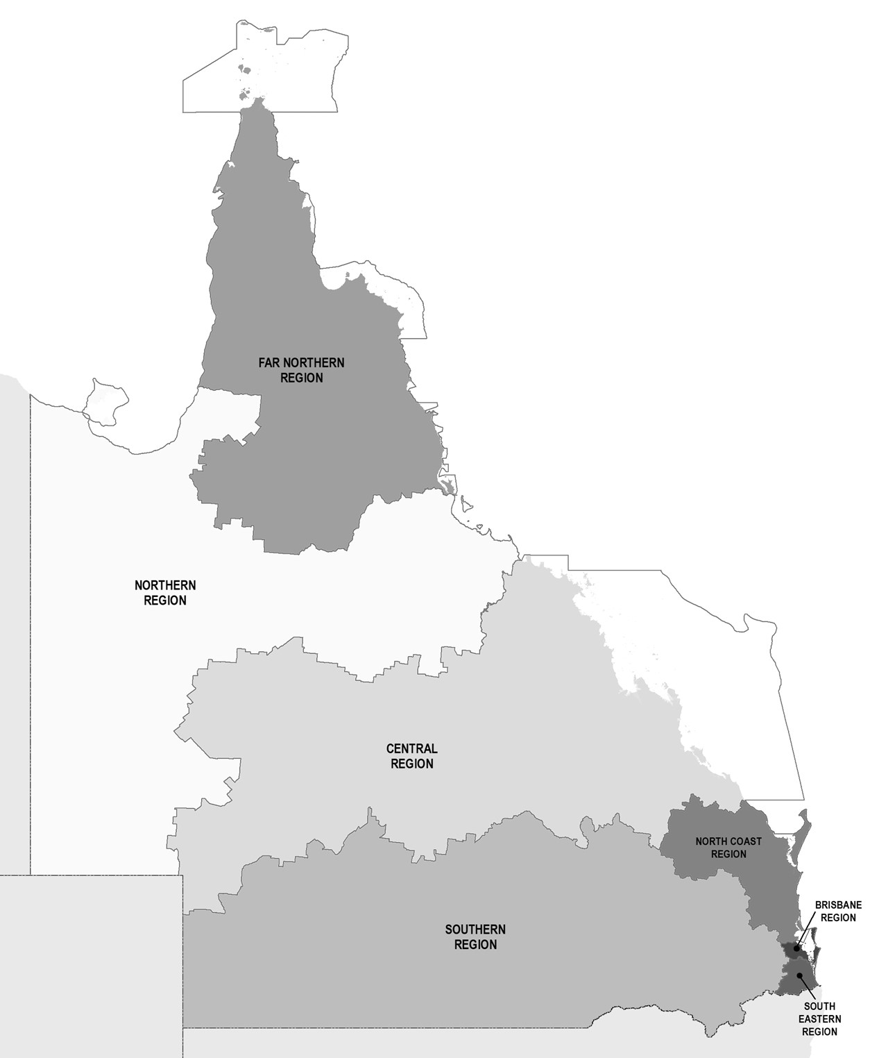

**Locations**

QPS delivers its services from various locations throughout the state including:

|  |  |
| --- | --- |
| * Police facilities | 340 |
| * Police watchhouses | 57 |
| * Police neighbourhood beats, shopfronts and mobile police beats | 61 |
| * District offices | 15 |
| * Headquarters and regional offices | 8 |
| * Communication centres | 14 |
| * Police academies located in Oxley and Townsville | 2 |
| * Policelink located in Brisbane (Zillmere) | 1 |
| * Rapid Action and Patrol Groups (RAPS) located at Gold Coast and Townsville | 2 |

In addition, each police district is supported by a range of specialist areas which may include the Child Protection and Investigation Unit, Criminal Investigation Branch, Intelligence Unit, Scenes of Crime and Scientific Units, Dog Squad Unit, Forensic Crash Unit, Road Policing Unit, Prosecutions Corp and Water Police Unit. There are also purpose-built investigation centres to respond to major incidents located at various stations and district offices throughout the state.

In 2022-23, the QPS delivered minor and medium capital works and major capital investment projects, including:

* upgrade of the Aurukun Police Facility
* replacement police facility at Burketown
* new Cairns West Police Facility.

**Financial Summary**

**Summary of financial performance**

The following table summarises the operating result and financial position for QPS 2022-23 and the previous financial year.

|  |  |  |
| --- | --- | --- |
| **Statement of comprehensive income** | **2022-23 $’000** | **2021-22 $’000** |
| Total income from continuing operations | 3,125,485 | 2,858,646 |
| Total expenses from continuing operations | 3,125,485 | 2,858,646 |
| Total other comprehensive income | 99,260 | 104,660 |
| **Total comprehensive income** | **99,260** | **104,660** |
| **Statement of financial position** | **2022-23 $’000** | **2021-22 $’000** |
| Total assets | 2,455,810 | 2,219,654 |
| Total liabilities | 243,601 | 139,463 |
| **Net assets/equity** | **2,212,210** | **2,080,190** |

**Income and expenses from continuing operations**

The QPS is funded to deliver timely, high quality and efficient policing services, in collaboration with community, government and non-government partners, to make Queensland safer. Funding for these services is received principally through parliamentary appropriations.

The QPS aims to deliver safety and secure communities through innovation, collaboration and best practice. The expenses incurred in the delivery of these services are summarised further below.

For 2022-23, the QPS received income from continuing operations totalling $3,125.485 million and incurred total expenditure from continuing operations of $3,125.485 million. This was comprised of:

**Income**

**Expenses**

Summary of financial position

The QPS was in a positive financial position at the end of the financial year. The total equity (assets less liabilities) of the QPS at the end of 2022-23 was $2,212.21 million. This is an increase from 2021-22 $2,080.19 million which includes $99.26 million increase in asset revaluation surplus. This was comprised predominantly of:

**Assets**

**Liabilities**

**Event occurring after balance date**

A number of Machinery-of-Government (MoG) activities are expected to occur during 2023-24 and beyond as a result of the Queensland Government’s response to the outcomes of an independent review of the Queensland Fire and Emergency Services (QFES). The resulting reform implementation include the transfer of functions of the State Emergency Service (SES) from QFES to the QPS, the establishment of a new single marine rescue service, and QPS being assigned to undertake primary responsibility to deliver world-class emergency and disaster management support to all Queenslanders.

Following the initial transfer of Road Safety Camera Office (RSCO), part of Camera Detected Offence Program (CDOP), from QPS to Queensland Treasury (QT) in 2021-22, the remaining functions of CDOP including the Fixed Camera Operations, Systems, Prosecutions Support and Calibration Lab are expected to be transferred to the Department of Transport and Main Roads (TMR) in 2023-24, with completion expected in 2024-25.

There were no other events occurring after balance date that management considers would have a material impact on the information disclosed in the financial statements.

**Performance**

**Key performance measures**

The services provided by the QPS focus on reducing and preventing the incidence of crime, public disorder and road trauma to build safe, caring and connected communities. These are delivered through one service area – Police Services.

The objective of the service area is to keep Queensland safe by providing services to the Queensland community designed to uphold and administer the law responsibly, fairly and efficiently; preserve peace and good order; protect and support the community; prevent, disrupt and respond to crime; to promote road safety and to work toward fair, just and lasting outcomes for the community. A range of services are provided by the QPS to support this, including:

* protecting property and personal safety through prevention, disruption, response and investigation
* maintaining public order and safety, including during major events and disasters
* working with partners to reduce demand on the criminal justice system by addressing over-representation among vulnerable groups, including First Nations peoples
* intervening in driver behaviours contributing to road trauma: speeding; red light offences; driving while distracted; driving under the influence of alcohol or drugs; driving while fatigued; and not wearing seatbelts.

The delivery of policing services to Queenslanders is supported by a range of activities designed to promote ethical behaviour, integrity and professional practice.

The following tables provide an overview of the key performance measures for the QPS for 2022-23. Data for 2022-23 is sourced from the Queensland Police Service 2021-2022 Annual Report unless otherwise stated in the Notes.

| **Service Area: Police Services** | | | | | | | |
| --- | --- | --- | --- | --- | --- | --- | --- |
| **Performance measures** | **Notes** | **Strategic Plan** | **2022-23 SDS** | **RoGS** | **2021-22 Actual** | **2022-23 Target**  **/Estimate** | **2022-23 Actual** |
| Percentage of personal safety offences cleared within 30 days: | 1,2 |  |  |  |  |  |  |
| * Homicide |  | 73.2% | 70-83% | 72.4% |
| * Assault |  | 58.9% | 54-63% | 57.0% |
| * Sexual assault | 3 | 38.4% | 48-57% | 34.2% |
| * Robbery |  | 62.3% | 60-68% | 60.7% |
| * Total personal safety |  | 55.5% | 54-61% | 52.7% |
| Percentage of property security offences cleared within 30 days: | 1,4 |  |  |  |  |  |  |
| * Unlawful entry |  |  |  |  | 24.0% | 18-21% | 22.0% |
| * Other property damage |  | 36.0% | 25-27% | 36.2% |
| * Motor vehicle theft |  | 43.1% | 36-40% | 40.7% |
| * Other theft (excluding unlawful entry) |  | 30.0% | 26-28% | 27.6% |
| * Total property security |  | 31.4% | 28-30% | 29.6% |
| Percentage of good order offences cleared within 30 days | 1,5 |  |  |  | 78.3% | 80-85% | 76.3% |
| Rate of crime victimisation per 1,000 population | 6 |  |  |  |  |  |  |
| * Total person offences | 7 | 12.2 | <6.3 | 14.5 |
| * Total property offences |  | 44.4 | <42.0 | 51.7 |
| Percentage of proceedings where young offenders were offered and accepted a diversion option | 8 |  |  |  | 38.8% | >40.0% | 40.7% |
| Percentage of proceedings where all offenders were offered and accepted a diversion option | 8, 9 |  |  |  | 15.4% | >10% | 14.6% |
| Proportion of young offenders who have another charged offence or are referred by the QPS to a Restorative Justice Conference within 12 months of an initial finalisation for a proven offence | 10 |  |  |  | New Measure | 66% | 69% |
| Public perception of safety | 11-14 |  |  |  |  |  |  |
| * Feelings of safety walking alone in neighbourhood during the night | 51.2% | >50% | 48.5% |
| * Feelings of safety travelling alone on public transport during the night | 30.5% | >30% | 29.6% |
| Satisfaction of members of the public who had contact with police in the last twelve months | 11, 14 |  |  |  | 74.5% | >85% | 75.0% |
| Public satisfaction with police dealing with emergencies and disasters | 11, 14 |  |  |  | 77.8% | >85% | 77.1% |
| Public perception of police integrity | 11, 14 |  |  |  |  |  |  |
| * Police perform their job professionally |  | 82.6% | >85% | 79.6% |
| * Police treat people fairly and equally |  | 67.5% | >75% | 64.3% |
| * Police are honest |  | 67.5% | >75% | 66.1% |
| * I do have confidence in the police |  | 78.3% | >85% | 75.6% |
| Rate of complaints against police per 100 sworn staff | 15 |  |  |  | 10.4 | <9.8 | 10.6 |
| Rate (per 100,000 people) of road crash fatalities | 16 |  |  |  | 5.57 | 4.30 | 5.09 |
| Rate (per 100,000 people) of people hospitalised following a road crash | 16, 17 |  |  |  | 150.09 | 110 | 140.07 |
| Percentage of code 1 and code 2 incidents attended within 12 minutes | 18 |  |  |  | 78.2% | >85% | 77.0% |
| Cost of police services per person | 19 |  |  |  | $511 | $517 | $539 |
| Agency engagement | 20 |  |  |  | 51% | >55% | 46% |
| Workforce diversity | 21-23 |  |  |  |  |  |  |
| * Women in SES or equivalent | 30.8% | 16.7% | 31.7% |
| * Women in SO or equivalent | 18.0% | 12.5% | 26.3% |
| * First Nations | 2.3% | 3.0% | 2.3% |
| * People with Disability | 1.2% | 5.0% | 3.1% |
| * People born overseas | 1.3% | 9.0% | 1.9% |
| * People from non-English speaking background | 4.0% | 9.0% | 1.2% |
| ***Discontinued measures*** |  |  |  |  |  |  |  |
| Proportion of young offenders who have another charged offence within 12 months of initial finalisation for a proven offence | 24 |  |  |  | 78% | N/A | Discontinued measure |

Notes

1. Performance is reported against a range rather than a single figure. The target ranges for 2022-23 consider recent results and any known factors that are likely to have an impact in the reporting period. Upper and lower values account for past variation from the recent historical average.
2. The offence categories reported separately are those classified as ‘violent’ crimes and are the most significant personal safety offence categories in terms of their impact on the community. The ‘total personal safety’ offences figure also includes the offence categories of extortion, kidnapping, abduction and deprivation of liberty and other offences against the person. Homicide includes the offence categories of murder, attempted murder and conspiracy to murder.
3. The variance from the 2022-23 target may be due to a combination of higher volumes of offences in this category together with a greater focus on the needs of victims, and unique characteristics of reported offences regarding quality and availability of evidence or evidentiary requirements affecting the investigation and finalisation of these offences.
4. The offence categories reported separately are considered high volume property security offences. The total property security offences figure also includes arson, fraud and handling stolen goods.
5. Good order offences include offences relating to public nuisance, obstructing police and other offences against good order. An increase in good order offences generally indicates an increase in policing activity around public spaces and major events, and a range of related proactive policing strategies often focusing on liquor-related enforcement.
6. The measure counts the number of people or addresses classed as a ‘victim’ of a personal or property offence in the preceding 12-month period and represents this as a rate per 1,000 population. The figure is separate and distinct from the rates of offending. It is possible to have a reduction of the number of victims without a reduction in offences.
7. From 1 July 2021 the QPS implemented a decision to enhance the consistent practice of recording criminal offences associated with domestic and family violence (DFV). The 2022-23 target estimate was set prior to the changes coming into full effect and could not be amended prior to publication of the 2022-23 SDS. By way of comparison, the revised targets for person and property crime victimisation as published in the 2023-24 SDS are, respectively, 12.0 and 44.0 victims per 1000 population.
8. The term ‘diversion’ includes diversions of all offenders away from the courts by way of community conference, cautioning by police, intoxication diversion, drug diversion or graffiti diversion. For adult offenders, only infringement notices (excluding traffic infringement notices) are included in the count of ‘diversions’.
9. Offender Diversions refers to the number of offenders (young offenders or adult offenders) who are diverted as a proportion of all offenders proceeded against by police.
10. The measure related to youth re-offending has been amended in consultation with the Department of Youth Justice, Employment, Small Business and Training. Repeat offenders now count young offenders who are referred by QPS to a Restorative Justice Conference in addition to those young offenders against whom charges are preferred.
11. Public satisfaction with police and perceptions of police are sourced from the results of the National Survey of Community Satisfaction with Policing. The National Survey of Community Satisfaction with Policing is a general community survey. Respondents to these questions may or may not have had contact with police in the last 12 months.
12. The figure refers to the percentage of Queensland survey respondents who selected “very safe” or “safe” for each of the following activities:

* walking alone in your neighbourhood during the night
* travelling alone on public transport during the night.

1. The measures for feelings of safety on public transport are based on the entire survey population and includes those participants who have not used public transport. The figure is reported to match the existing Report on Government Services (RoGS) standard.
2. Queensland results mirror that occurring at a national level, indicating national-level factors affecting satisfaction with police. The results are likely a mix of local and national factors affecting attitudes to police generally, though the impact of any one factor (or group of factors) on satisfaction with or perceptions of police cannot be confirmed based on available data. Attitudinal data in particular can be influenced in the short term by significantly adverse or highly publicised events. Point-in-time responses can vary from people's true underlying (or longer term) satisfaction with police and general community perceptions.
3. ‘Complaints’ are defined as statements by members of the public regarding police conduct, including officers on, off or unknown duty, when a person was in police custody or had voluntary or involuntary dealings with the police.  Sworn staff refers to a police officer employed by the QPS who has sworn the Oath of Office under the *Police Service Administration Act 1990*, delivering a police or police-related service to an external customer.
4. The QPS, in partnership with the Department of Transport and Main Roads, continues to implement various road safety initiatives and programs aimed at reducing lives lost and hospitalisations. The variance between the 2022-23 Actual and 2022-23 Target / Estimate was based on a number of societal influences that can vary throughout the year resulting in changes in numbers of road crashes.
5. The most recent data available is for the 12-month period ending 30 September 2022.
6. Code 1 and 2 incidents include very urgent matters when danger to human life is imminent and urgent matters involving injury or present threat of injury to person or property. The benchmark of 12 minutes was chosen for comparability with New South Wales Police who use similar methodology, business rules and systems. A review of the data identified an error in figures published in the 2021-22 and previous Annual Reports. Figures have been amended for the 2021-22 and 2022-23 periods.
7. Cost of police services per person is the total cost of delivering policing services divided by the estimated population of Queensland. This measure is reported in line with RoGS methodology.
8. Data for this measure is taken from responses of QPS employees to the whole-of-Government Working for Queensland survey, conducted annually. The measure describes employees’ level of engagement with the organisation in relation to motivation, inspiration and pride.
9. In early 2016, the Leadership Board of Directors-General introduced and committed to sector-wide diversity targets, working from the principle that our workforce should closely represent the community we serve.
10. Data is based on substantive placements and includes paid and unpaid employees, excluding staff members engaged on a casual relief basis. The definition of the non-English speaking background category has been superseded by the Culturally and Linguistically Diverse (CALD) category of ‘Speak a language other than English at home’ and may explain the variance from 2021-22 figures. Figures (including CALD categories) are based on self-reported data that is not mandatory which may result in under-reporting on at least some of the diversity categories included. Due to the operational requirements of police, the “People with disability” target is based on non-operational staff members only.
11. The QPS workforce generally changes at a slower rate compared to other agencies as it has a lower attrition rate, and regarding police officers, generally positions are filled internally only. Consequently, it is challenging to achieve changes to the workforce except over an extended period.
12. This measure of youth reoffending was used by QPS and then Department of Children, Youth Justice and Multicultural Affairs. The measure is discontinued as of 1 July 2022 owing to a change to data definition (refer note 10).

**Key**

RoGS – Report on Government Services

SDS – Service Delivery Statement

Strategic Plan – Queensland Police Service Strategic Plan 2022-2026

**Jack’s Law – Trial of police powers to scan for knives**

On 2 April 2023, the *Police Powers and Responsibilities (Jack’s Law) Amendment Act 2023* commenced. Jack’s Law is an extension of the 12-month trial on the Gold Coast that provided police with the power to stop and scan persons for knives using a handheld metal detector in the two safe night precincts.

Following the success of the trial, Jack’s Law now:

* extends the expiry date of the trial to 30 April 2025
* increases the scope of the relevant places for scanning to include all 15 safe night precincts and all public transport stations, including public transport vehicles
* strengthens the criteria that a senior police officer must consider before approving the use of a hand held scanner in a particular relevant place.

Since its inception to 30 June 2023, the QPS recorded the following information:

* number of hand held scanner authorities issued: 430
* number of people who were required to submit to the use of hand held scanners under the authorities: 3,650
* number of knives or other weapons that were detected using hand held scanners under the authorities: 56
* number of times a power to search a person without a warrant was exercised under chapter 2, part 2, division 2 as a result of the use of hand held scanners under the authorities: 0
* number and type of charges made against persons as a result of the use of hand held scanners under the authorities: 220.

The safe night precincts and public transport stations in which the authorities were issued were:

|  |  |  |
| --- | --- | --- |
| **Safe night precincts (SNP)** | **Public transport stations** | |
| Townsville SNP | Hyde Park Bus Stop | Goodna Railway Station |
| Toowoomba SNP | Stockland Bus Stop | Grovely Railway Station |
| Surfers Paradise SNP | Willows Shopping Centre Bus Stop | Helensvale Railway Station |
| Rockhampton SNP | Chermside Bus Interchange | Indooroopilly Railway Station |
| Maroochydore SNP | Beenleigh Railway Station | Kingston Railway Station |
| Mackay SNP | Bowen Hills Railway Station | Kippa Ring Railway Station |
| Ipswich SNP | Broadbeach South Light Rail Station | Loganlea Railway Station |
| Inner West Brisbane SNP | Caboolture Railway Station | Mango Hill Railway Station |
| Gladstone SNP | Central Railway Station | Manly Railway Station |
| Fortitude Valley SNP | Coomera Railway Station | Milton Railway Station |
| Caloundra SNP | Ferny Grove Railway Station | Morayfield Railway Station |
| Cairns SNP | Gold Coast University Hospital Light Rail Station | Northgate Railway Station |
| Broadbeach SNP | Parkwood East Light Rail Station | Park Road Railway Station |
| Brisbane SNP | Broadwater Parklands Light Rail Station | Petrie Railway Station |
| Airlie Beach SNP | Queen Street Light Rail Station | Redbank Railway Station |
|  | Nerang Street Light Rail Station | Roma Street Railway Station |
|  | Griffith University Light Rail Station | Southbank Railway Station |
|  | Southport Light Rail Station | Springfield Central Railway Station |
|  | Southport South Light Rail Station | Woodridge Railway Station |

**2022-23 Key Highlights**

This section reports on the objectives of the QPS Strategic Plan 2022-2026. To drive delivery of its objectives, the QPS focuses on four main strategies to make Queensland the safest state:

**Our people:** Build a connected, engaged and job-ready workforce, with the health, wellbeing and safety of our people a priority

**Our community:** Together with our community build a safer Queensland

**Our relationships:** Create a safer community and provide better services through connected and engaged relationships

**Our commitment:** Embrace new ideas and innovation to strengthen our capability to prevent, disrupt, respond and investigate crime and deliver safe and secure communities.

The below is a snapshot of the key performance highlights from 2022-23 and is not representative of all work undertaken during the reporting period. For more information and to keep up to date with QPS news, follow QPS on social media or Mypolice blog (refer to page 1).

**Protecting victims of domestic and family violence**

The QPS is committed to embracing new ideas and innovation to strengthen its capability to prevent, disrupt, respond to and investigate DFV. In 2022-23, the QPS Domestic, Family Violence and Vulnerable Persons Command commenced several initiatives including:

* continuing to support a 12-month DFV Video Recorded Evidence (VRE) trial in Ipswich and Gold Coast Districts to support video statements from adult victims to be used as evidence-in-chief
* trialing an embedded QPS officer pilot in two Domestic and Family Violence Support Services at Ipswich and South Brisbane. The six-month trial commenced in August 2022 with preliminary findings released to the QPS and involved NGOs in April 2023, indicating that embedded officers: (1) responded to increasing reporting rates of DFV to police in their district; (2) enhanced the timely provision of wrap-around services to victim-survivors; and (3) enhanced the collaborative relationship between DFV Support Services (NGOs) and QPS. An extension of the trial and a post evaluation analysis were recommended to explore longer term outcomes
* increasing the number of Domestic and Family Violence Coordinator (DFVC) positions within the Brisbane Police Communication Centre to provide near to 24-hour, 7 day per week support to frontline police responding to domestic and family violence incidents across the state
* supporting the expansion of High-Risk Teams across Queensland
* mandating that every police station or establishment is to have designated a private, safe and secure area, or areas, for members to use for all enquiries, discussions, reports, interviews and investigations with persons presenting to the station or establishment for domestic and family violence matters
* commencing updates to all DFV related documents, policies and procedures to prominently and clearly acknowledge that DFV can affect any person regardless of race, gender, age, beliefs, religion or socioeconomic or cultural background. The causes of DFV are complex, multi-faceted and influenced by broad and intersectional criminal justice, health and social issues
* continuing to support implementation of the Domestic and Family Violence Prevention Strategy 2016-2026 and contribute to the response to the Queensland Women’s Safety and Justice Taskforce, Hear her voice – Report one – addressing coercive control and domestic and family violence in Queensland, and recommendations from the Independent Commission of Inquiry into Queensland Police Service responses to DFV
* implementing a procedure to ensure frontline officers who attend DFV occurrences meet with a designated senior officer to receive feedback in relation to a sample of their body worn camera every six months
* collaborating with frontline members to develop a pocket-sized checklist to assist with investigating DFV incidents and support the decision-making process of officers responding to reports of DFV. The checklist provides members with the steps to be undertaken prior to, during, and after the incident and has been distributed statewide
* establishing a statewide calendar of events for Domestic and Family Violence Prevention Month with district Domestic, Family Violence and Vulnerable Persons Units, High Risk Teams (HRT) and DFVCs. This included participation in candle lighting ceremonies, walks, tree planting ceremonies, charity sporting events, engagements with sporting teams including the Brisbane Broncos, and concluded with the QPS being a major sponsor at the Challenge DV 2023 Darkness to Daylight Challenge
* producing the ‘Behind the Doors of Domestic Violence’ podcast series, released in May 2023 for Domestic and Family Violence Prevention Month to raise awareness, empower victim survivors and bystanders and change the behaviours of those who use abusive tactics within their relationships.

In November 2022, the Queensland Government announced a suite of initiatives and reforms to provide enhanced support and protections to victims of DFV.

This includes:

* rolling out 300 DFV support workers in police stations across Queensland, led by the Department of Justice and Attorney-General
* rolling out 30 additional DFV liaison officers across Queensland
* rolling out 30 additional Cultural Liaison Officers across Queensland
* rolling out 10 additional specialist Police Prosecutors for Circuit Court
* appointing a Special Coordinator for Police Reform.

**Referral services**

The QPS has many strategies to prevent, disrupt, respond and investigate DFV in Queensland. In addition, the Queensland Police Referral Service allows officers to connect at-risk and vulnerable persons with over 530 external support providers covering 67 different vulnerabilities including DFV, mental health, homelessness and victim support.

**Domestic and Family Violence and Vulnerable Persons Training Unit**

In response to the Commission of Inquiry into Queensland Police Service responses to domestic and family violence, the Women’s Safety and Justice Taskforce recommendations, and findings from DFV related Coronial Inquests, the QPS has developed and delivered a range of targeted training courses to personnel across the state including:

* development and delivery of the three-day face-to-face training product – DFV: The Holistic Approach user course. This was a foundational course focused on the use of the Domestic Violence Protective Assessment Framework (PAF) through investigations as a vital tool to identify risk factors and the person most in need of protection and to inform appropriate policing action in line with current legislation. This course included opportunities for participants to analyse policing DFV at the local level, investigations (Victim Centric Trauma Informed [VCTI] approach), coercive control, quality risk assessment and the impact of culture on DFV policing responses. This course was mandatory for all police officers up to and including Superintendent, and targeted unsworn members who have contact with members of the public. As of 30 June 2023, 13,543 personnel have completed this face-to-face training
* development and delivery of the five-day face to face Domestic, Family Violence and Vulnerable Persons Specialist Course. This course is mandatory for members of the Domestic, Family Violence and Vulnerable Persons Command, DFV Coordinators and Officers, Station DFV Liaison Officers, Specialist DFV Investigators, Specialist DFV Prosecutors and High-Risk Team members from across the state. This specialist course reinforces the adoption of a holistic approach when managing DFV incidents and has been developed by academics and specialists to ensure it is evidence-based and broad in its subject covering. It also builds on the knowledge provided in the three-day DFV: The Holistic Approach Course*.* As of 30 June 2023, 120 personnel have completed the five-day DFVVP Specialist Course
* development of the two-day DFV: The Holistic Approach Extension Course for statewide face-to-face delivery in the 2023-24 training year, commencing 1 July 2023. This training course builds upon the VCTI approaches established in the three-day Holistic Approach foundation course. The purpose of this course is to recognise and implement best practice holistic investigation to DFV that prioritises victim-survivor safety, perpetrator accountability and meets community expectations
* the development and delivery of Online Learning Products (OLP) including:
* Policing Enhancement Training OLP which includes the definition of domestic violence and relevant relationship in accordance with legislation, outlining and applying the legislative and procedural requirements and considerations when investigating domestic violence, applying relevant legislative provisions and the use of the PAF for a domestic violence incident in accordance with organisational procedures. As at 30 June 2023, 14,455 members have completed this OLP
* Coercive Control OLP which provides participants with an understanding of coercive control, the importance to view isolated incidents of DFV as potentially part of a broader pattern of behaviour designed to establish and maintain power and control over a victim, an understanding of the cumulative impacts of coercive control on adult and child victims and how this may impact decision-making behaviour, knowledge of perpetrator tactics and behaviours used to establish and maintain power and control over adult victims and children, and an understanding of how to identify and investigate coercive control within the current legislative framework. As of 30 June 2023, 16,281 members have completed this OLP.

**Tough new laws for child sex offenders**

Tough new laws to support police efforts to stop reportable offenders using the latest online technology to offend against children were introduced into Parliament in October 2022. The *Child Protection (Offenders Reporting and Offender Prohibition Order) and Other Legislation Amendment Bill 2022* targets technology-based offending. In a first for Australia, the new measures will seek to prevent and seriously disrupt these practices by:

* expanding police powers to enter the residence of a reportable offender to undertake a digital device inspection
* requiring reportable offenders to disclose the use of their anonymising software, vault and black hole applications
* introducing a new offence with penalties of up to five years imprisonment for failing to comply with a requirement to produce a digital device for a device inspection
* requiring reportable offenders who have been convicted of failing to comply with their reporting obligations to report those details to police within seven days.

These laws are an additional mechanism to monitor, disrupt and prevent repeat offending by reportable offenders.

**Protecting our children**

The Argos Unit is principally responsible for the investigation of organised child exploitation, including technology-facilitated offences to keep children safe and free from harm. Investigators proactively and reactively target a broad range of websites and mobile applications used by child sex offenders to prey on children. Argos staff also identify and implement new strategies to combat technology-facilitated crimes against children.

During the reporting period, Argos investigators:

* contributed to the identification of 321 children in circumstances of sexual harm nationally and internationally
* arrested 49 child sex offenders on 275 criminal charges
* referred 370 cases to law enforcement agencies nationally and internationally
* chair the National Covert Online Investigator’s Working Group which reports to Operation Griffin, the primary source of advice to the Serious Organised Crime Coordination Committee on all matters relating to child protection. The working group is focused on building consistent national capability for covert online operations and sharing technology and trends to shape approaches to preventing, disrupting and investigating online child exploitation
* hosted the Youth, Technology and Virtual Communities conference on the Gold Coast in April 2023 under the continuing theme of 'Prevent, Protect, Prosecute' with a focus topic of 'Disruption’. The event attracted 455 delegates from 126 different organisations and 15 countries, featuring a total of 58 guest speakers. The conference targeted practitioners working in various sectors such as law enforcement, prosecution, education, child protective services, social work, non-government support agencies and the technology industry and provided all delegates with valuable insights into the latest advancements and trends concerning technology facilitated crimes against children.

The QPS has, and will continue to, foster collaborative partnerships with national and international police jurisdictions to develop innovative and efficient approaches to preventing, disrupting, responding to, and investigating crime. The QPS has co-located Argos members, including covert online investigators, the victim identification team and an intelligence analyst at the Australian Centre to Counter Child Exploitation to build national capability and better align QPS and Australian Federal Police resources and functions, enhancing community safety. The Argos Unit is also a key member and contributor to international law enforcement forums and working groups including the Interpol Specialist Group on Crimes Against Children and the Europol European Multidisciplinary Platform Against Criminal Threats meetings on Global Covert Internet Investigations.

**Child Safety**

The QPS is one of the primary agencies that provides first response, around-the-clock services for child harm investigations. The state-wide Child Protection and Investigation Unit (CPIU) structure provides a specialist policing response to children, both as victims and offenders. The units are centrally supported by the QPS Child Safety Director and the Child Abuse and Sexual Crime Group (CASCG).

CASCG hosts and facilitates an annual conference for Officers of in Charge of CPIU and Criminal Investigation Branch and Suspected Child Abuse and Neglect representatives. The conferences aim to ensure currency and consistency of practice in child protection, youth justice and sexual violence response work. The 2023 conference focused on cultural change and topics included emerging technologies, organisational reform, domestic and family violence, youth crime, online offending, and working with technology and social media platforms.

The QPS is represented on national working groups advancing the *National Strategy to Prevent and Respond to Child Sexual Abuse* and continues to engage with the National Office of Child Safety to implement recommendations from the *Royal Commission into Institutional Responses to Child Sexual Abuse*.

The QPS contributed to the fifth and final annual reports of both the Queensland Government and the Australian Government on implementation of Royal Commission recommendations. The reports represent a significant body of work and substantial achievements during the past five years, which include legislative and policy change, investment in new programs and initiatives, and improvements to the way people who have experienced trauma are supported.

**Outcomes from the Sexual Violence Response Strategy 2021-2023**

In 2021, the QPS Sexual Violence Response Strategy 2021-2023 (the Strategy) was delivered to enhance the delivery of a victim-centric and trauma-informed response to victims of sexual violence.

Through the Strategy, the QPS delivered key actions including:

* the statewide roll-out of the Sexual Violence Liaison Officer (SVLO) model across the QPS
* the development and delivery of key training products for sexual violence responses including the ‘Child Sexual Abuse Fundamentals Education’ (CSAFE) and ‘Challenging Beliefs, Inferences, Attitudes, and Stereotypes’ courses
* continued delivery of the specialist training course ‘Investigating Sexual Assault – Corroborating and Understanding Relationship Evidence’ (ISACURE)
* continued support to victims through providing multiple avenues to report sexual violence through the online reporting form, phoning Policelink and the Alternative Reporting Option which victims can use to report a sexual offence anonymously without making a formal complaint
* development and release of a community educational video through QPS social media platforms, describing how to access support as a sexual violence victim, and how to make a report of sexual violence to the QPS
* conducted thematic Business Unit Reviews focusing on sexual violence responses in each police district to identify strategies for continuous improvement.

In 2022, the Women’s Safety and Justice Taskforce handed down its second report which examined the barriers faced by Queensland women and girls accessing the criminal justice system, both as victims of sexual violence and offenders. The QPS is leading or co-leading 30 recommendations from Report two. The Taskforce found that the QPS Sexual Violence Response Strategy 2021-2023 was an initiative that should continue.

In 2022, the QPS contracted the Griffith University Criminology Institute to undertake an independent evaluation of the Strategy. The evaluation focused on assessing the ongoing implementation of the Strategy and examining its short-term outcomes. To assess outcomes for victims, external stakeholders from the sexual violence service sector were engaged to provide valuable insights as victim representatives. From the perspective of these stakeholders and officers interviewed, learnings included:

* the QPS has been improving organisational awareness and understanding of a victim-centric, trauma-informed approach to sexual violence
* stakeholders were supportive of the QPS work to broaden options for victims to report sexual violence
* referrals for victims to support services had improved, with further enhancements to the referral system required to ensure victims are being referred to appropriate sexual assault support services
* the SVLO was regarded as a positive step and is highly beneficial to victim-survivors and external services
* through the SVLO role, engagement and partnerships between the QPS and support services has improved and become formalised
* the ISACURE course, available to investigators, is a beneficial course, and important training mechanism which has assisted investigators to gain a better understanding of trauma-informed and victim-centric approaches
* the CSAFE online training course available to all QPS members was seen as a beneficial course.

The evaluation made 16 recommendations to address identified areas of improvement and build on work already underway in key areas of education and training, policy and practice, online reporting, and measures for long-term evaluation of outcomes for victims. The QPS is committed to continuous improvement in its responses to victims of sexual violence and has commenced delivery of actions, including recommendations made by the evaluation team, through the QPS Sexual Violence Response Strategy 2023-2025 which will be launched in July 2023. Initial outcomes from initiatives in the Strategy 2023-2025 will be reported in the QPS Annual Report 2023-24.

**Cracking down on Outlaw Motorcycle Gangs**

The Organised Crime Gangs Group (OCGG) works in partnership with police districts and various government departments to target crime linked to organised crime gangs (OCG) including Outlaw Motorcycle Gangs (OMCG) to protect the community of Queensland through prevention, disruption, response to, and investigation of OCGs.

During 2022-23, the OCGG worked in partnership with the National Anti-Gang Squad Strike Team, Australian Federal Police and Australian Taxation Office to prevent, disrupt, respond to and investigate cross-jurisdictional gang related crime which resulted in:

* 746 OMCG participants arrested on 2,523 charges
* 78 official consorting notices issued, deterring recognised offenders from establishing, maintaining and expanding criminal networks
* 43 persons charged with wearing gang related prohibited items
* the QPS remaining committed to reducing OMCG recruitment, membership and community harm through the QPS Gangs Exit program. Since its inception to 30 June 2023, 53 former OMCG members have joined the program and gained access to tailored support services including drug and alcohol, employment and training, mentoring, family relationships and mental health services through community partners
* in 2022-23, Operations Uniform Dagobah and Uniform Mercury were conducted to target increased violence involving two factions of organised crime, both with significant links to OMCG. Both operations ran conjointly and used a variety of investigative and disruptive activities to prevent offences of violence which included shootings and serious assaults. The operations resulted in the total arrest of 72 offenders on 439 charges. Investigators seized numerous firearms, approximately $550,000 cash and over $3,000,000 in assets were restrained or seized. Operation Uniform Mercury also identified significant fraud committed against the federal government and the Australian Taxation Office.

**Project Booyah**

Project Booyah is the QPS’s premier frontline policing early intervention program for at-risk and disengaged youth aged between 14 and 17 years and seeks to address their disengagement with family, community and education, and address offending behaviour. The program has demonstrated its capacity to encourage young people to pursue further vocational pathways, gain meaningful employment and/or re-engage with education.

Project Booyah is a well-researched structured community inclusive program incorporating resilience, social skills, vocational pathways and development training. It is underpinned by a cognitive behavioural therapeutic model, police mentoring, youth support, functional literacy/numeracy education, employability skillsets and adventure-based activities to support identified disconnected young people regain a sense of their own self-worth, build resilience and enable them to make better life choices.

The Booyah program is currently operating in 10 sites across Queensland (Cairns, Townsville, Rockhampton, Sunshine Coast, Pine Rivers/Redcliffe, South Brisbane, Logan, Gold Coast, Ipswich and Mackay). A new site in Toowoomba will commence in July 2023.

Since the program’s inception in February 2016 to 30 June 2023, 1,204 young people have been accepted into the program statewide with 74% of participants graduating.

Project Booyah has proven to be successful, resulting in:

* 54% of participants who had committed an offence in the two-year period prior to entering the program did not reoffend after completing the intensive program
* 87% of participants with low engagement at school prior to entering the program had successfully demonstrated engagement with education and/or employment during the Framing the Future program.

**First Nations and Multicultural Affairs**

The First Nations and Multicultural Affairs Unit (FNMAU) was established in November 2020 to develop culturally responsive strategies to strengthen organisational cultural capability and the Service’s relationship with Queensland’s First Nations and diverse cultural communities.

The FNMAU directly oversees First Nations and Multicultural engagements and is linked to district and regional functions such as Police Liaison Officers (PLO), Torres Strait Island Police Liaison Officers (TSIPLO) and Cross-Cultural Liaison Officers (CCLO). In 2022-23, the FNMAU continued to progress significant bodies of work to build a culturally inclusive, responsive, and capable workforce, including:

* establishing the First Nations Advisory Group (FNAG) to build cultural capability through education, collaboration and implementation of objectives to improve policing outcomes for First Nations peoples and communities. The FNAG is designed to support the building of relationships between the QPS and First Nations peoples and communities within Queensland and the Torres Strait Islands. The FNAG aims to support the building of trust and transparency through processes including truth telling, sharing information and adopting collaborative approaches to prevent harm and together build a safer Queensland for all.
* the First Nations Mayors Summit (the Summit) provides an opportunity for the mayors from discrete communities and the Torres Strait Islands to raise any community concerns with the Commissioner, executive leaders, and external guests from across government. The Summit also provides an opportunity for QPS to share information and discuss current and emerging policing challenges that are impacting our communities across Queensland.

As an outcome from the 2022 Summit, the Commissioner made a commitment to hold two Summits per calendar year within six to nine months. Consistent feedback received from previous Summits had identified the necessity for an increase in availability of and yarning time with the Commissioner as the preferred method to discuss major ongoing and systemic issues. As a result, dates in March and September 2023 were identified through consultation with partner agency, the Local Government Association of Queensland.

Part of the proposed changes was the modification to the Summit format, which in the past had been a round table discussion. It was recommended that the September Summit format adopt an individual dialogue format with each council and a small panel comprising of relevant QPS ELT members led by the Commissioner.

* Cultural Capability Recruit Training is co-designed and co-facilitated with internal and external subject matter experts. After completing this unit, participants should be able to: -
  + explain the cultural, linguistic, religious and spiritual diversity dimensions that inform frontline police responses and investigations (including DFV)
  + identify the approach, resources and services to support the interactions and unique needs of First Nations and CALD members
  + explain and apply Trauma Informed Practice/Policing approaches to avoid re-traumatisation and support sense of security and cultural safety to First Nations Peoples and CALD members
* Cultural Capability Recruit Training was first delivered in April 2023. Since then, five intakes have participated in the training
* the QPS maintains the internal CALD Consultative Group (CG) to build and strengthen relationships with multicultural members of the QPS. The group currently has 16 members who are undertaking bodies of work which includes the establishment of the Multicultural Inclusion Network and enhanced cultural capability and responsiveness of internal support services for QPS employees. The CALD CG is on its second iteration with members continuing the important work of driving culturally inclusive practice and support within the organisation
* engaging an external provider to deliver Culturally Responsive Practice Workshops for Peer Support Officers and Mentors, aimed at enhancing the professional development and culturally responsive support for our multicultural workforce
* co-delivering a targeted cultural intelligence forum with community leaders from Queensland African Communities Council and PLOs to the QPS Executive Leadership Team to enhance cultural awareness and culturally responsive decision making
* commencing the establishment of the Police Multicultural Advisory Group which will be a state-level group supporting the delivery of culturally responsive services to our multicultural communities and individuals
* developing a targeted awareness and training product designed to enhance awareness and engagement of interpreters and multilingual members. This training product will be embedded across other training products for QPS members who engage with community with the intent of increasing accessibility of policing services to multicultural individuals and communities
* delivering the annual PLO, TSPLO and CCLO conference in May 2023, attended by 60 members from across the State. The conference focused on professional development, health and wellbeing and cultural responsiveness. The conference also offered opportunities for connection and networking as well as collaboration on the future direction of training and development.

**Amber Alerts**

The QPS values the information and assistance received from members of the public and strives to generate better outcomes for police and the people of Queensland. Amber Alerts are issued by police when they need urgent public assistance from the Queensland community to help locate abducted or high-risk missing children who are at imminent risk of death or serious harm. The alerts are broadcast to the public through secondary alerting partners including the media, commercial billboard companies, community groups and other government agency shared messaging, public transport messaging systems, a national emergency alerting company and on various social media platforms. The Amber Alert branding is now widely recognised by the community as an urgent ‘call to action’.

In 2022-23, three Amber Alerts were issued with all children safely located. Evidence shows the Amber Alerts played a significant role in the safe recovery of these children.

**Mobile Police Beats**

In keeping with our commitment to embrace new ideas and innovation to strengthen our capability to prevent, disrupt, respond to and investigate crime and deliver safe and secure communities, the QPS deployed five new mobile police beats (MPB) in 2022-23. The MPBs are available in North and South Brisbane, Logan, Ipswich, Gold Coast, Townsville, Moreton, Wide Bay Burnett, Darling Downs, Far North (Cairns), and Sunshine Coast Districts as part of a new local policing strategy. MPBs are the way of the future, delivering a highly visible policing presence when and where they are operationally needed.

The MPBs are equipped with police technology and equipment to provide a suite of services with the added advantage of mobility and flexibility to move around the local area, increasing visibility of the police presence and capability.

**New operational equipment**

The QPS is committed to ensuring the safety of our frontline officers and the community with the latest technology in officer safety equipment.

In 2022-23, approximately 9,200 Body Worn 3 Cameras (BW3) were deployed to regional Queensland, with a further 3,000 units to be provided to specialist units commencing 2023-24. This will bring the total fleet of cameras to 12,200. The BW3s have the added capability of live streaming which enables the QPS to obtain clear, accurate, real-time information during emergency situations. The new live-streaming capability has been used by officers with great results and has become a pillar of modern-day policing.

The next-generation integrated load-bearing vests are being rolled out to all frontline officers across the state in a major safety boost for police officers. The new combined ballistic and edged weapon safety features as part of their operational uniform for the first time in Queensland. The new vest incorporates technological advancements in textiles and design to improve the safety and comfort for frontline officers.

The QPS commenced fitting officers with new vests and as at 30 June 2023, 1,487 vests had been fitted and issued to frontline officers.

**Road policing and the Fatal Five**

Many road crashes involve at least one of the ‘Fatal Five’ high-risk road user behaviours which include speeding, drink and drug driving, not wearing a seat belt, driving while fatigued, and driver distraction and inattention.

The QPS is committed to ensuring the safety of all road user and pedestrians to keep Queenslanders safe and reduce lives lost on our roads through targeted covert and high visibility policing operations to detect drivers under the influence of alcohol and/or drugs.  In 2022-23, the QPS conducted:

* over 1.75 million random breath tests which detected approximately 16,490 drink driving offences
* over 55,960 roadside drug tests which detected approximately 11,682 drug driving offences.

**Hooning**

The QPS has been targeting hooning behaviour across the South-East as part of Operation Uniform Elderberry from June to October 2022.

The coordinated anti-hoon operation resulted in:

* 59 vehicles impounded
* 2,048 infringement notices issued, including 702 for speeding and 182 for vehicle defects
* 92 positive drug drivers
* 72 drink drivers.

The QPS has continued to investigate, prevent and disrupt hooning behaviour and where appropriate seizing vehicles under Queensland’s tough new anti-hooning legislation that were introduced in May 2023.

**QPS’s eye in the sky**

The two POLAIR helicopters, based in Brisbane and Gold Coast, provide tactical aerial support to police operations, improve officer and community safety and situational awareness of major events and critical incidents. From tracking offenders, to search and rescue, and providing real time situational awareness of major incidents, police helicopters help keep the community safe by providing quality support to frontline police. During 2022-23, the two POLAIR helicopters:

* were the first police resource on scene for 520 reported incidents
* were responsible for monitoring and recovering more than 374 stolen vehicles, aided by contemporary equipment and technology
* located 25 missing persons, assisted by state-of-the-art night vision and infra-red technology
* assisted in the location of 1,140 offenders
* participated in 29 counter-terrorism and covert surveillance operations.

A fleet of replacement aircraft to be delivered to the QPS Aviation Capability Group will provide enhanced life-saving organ retrieval capabilities and further bolster community safety across Queensland. The new aircraft will provide the operational capability to conduct organ retrieval flights to locations anywhere in Australia and New Zealand as well as specialist police operations, general transportation to remote areas and prisoner transfers.

**Protecting Queensland’s waterways**

The QPS helps make Queensland the safest state by patrolling not only on our roads and in the sky, but on our waterways too. The Queensland Water Police provides specialist support focusing on maritime incidents and operations, including:

* maritime safety, education and enforcement activity on our coastal and inland waterways to a distance of 200 nautical miles offshore
* drug and alcohol enforcement activity and intelligence gathering
* flood operations, anti-looting patrols, and logistical tasking in disaster events
* search and rescue with over 1,100 operations undertaken annually
* a dedicated statewide Dive Unit with over 150 deployments each year
* intercepting international and interstate vessels arriving in Queensland in collaboration with marine partners
* assisting with Queensland major events, security enforcement of military exclusion zones during planned exercises and international ship security during port visits
* providing a policing and biosecurity overlay to members of the community in remote locations including Torres Strait, Yarrabah, Palm Island and Mornington Island.

The Water Police operates from 11 main water police bases across Queensland and has a fleet of 64 vessels to ensure the safety of the marine community.

**What’s happening in the regions**

The QPS’s seven police regions, comprising 15 districts and 340 police stations, deliver first class frontline policing services to the communities of Queensland. Each region operates in partnership with the community to ensure the policing response is agile, adaptable and adequately targets the issues and crime trends affecting local communities.

The regional police officers play a pivotal role and are often the first response officers to crimes and calls for services. The regions include Brisbane, South Eastern, Southern, Northern, Far Northern, North Coast and Central. Refer to page 19 for a map of the police regions.

In addition to the services provided through Domestic, Family Violence and Vulnerable Persons Command, the regions worked with partners and the community to enhance their services to better manage DFV calls for service including the following actions.

* Creation of a dedicated Domestic and Family Violence and Vulnerable Persons Unit in Ipswich District to build the district’s capability to respond to the broader range of vulnerable persons in the community, including victims of DFV, elder and disability abuse and people suffering from a mental illness. The unit will include a Domestic Violence Coordinator, Liaison Officers, and a Mental Health Coordinator.
* Commencement of six-month **Domestic and Family Violence embedded officer pilot program** in Ipswich District in October 2022. The Program involves a specialist domestic violence police officer embedded within the Domestic Violence Action Centre (DVAC) at Ipswich to deliver timely, holistic and empathetic support to victims, whilst also improving victim experiences when reporting DFV to the QPS.
* Ipswich and Gold Coast Districts being selected as a pilot districts for the twelve-month **Video Recorded-Evidence (VRE) trial** which commenced on 12 September 2022. The video recorded evidence in chief statement is taken by a police officer, reducing the re-traumatising of victims of DFV when having to recall or re-tell their stories.
* Longreach Patrol Group in Central Region partnering with Telstra to create a sticker for phone boxes with important contact information for victims of DFV.

All regions have dedicated Road Policing Units that work to keep Queenslanders safe on our roads and curb negative road user behaviour including the Fatal Five with a selection of additional actions outlined below.

* In support of state-wide road safety campaigns, Highway Patrol delivered road safety and criminal enforcement activities, applying a combination of highly visible and covert police enforcement, supported by education activities during high volume travel periods across school and public holidays.
* In 2022, Ipswich District implemented **Learner Driver nights** which targets the fatal five and familiarises learner drivers with topics such as emergency vehicle interactions and roadside breath testing processes, using both a classroom environment and practical driving activities on the Queensland Raceway Circuit. This program is a collaboration between the QPS, QFES, QAS, DTMR and Drive Safely Australia. Since its inception to 30 June 2023, 70 participants have completed the program.
* Ipswich District commencing the multiagency **‘Keep it Upright’ program** that aims to improve motorcyclist road safety. This is achieved by providing riders with motorcycle safety with a QPS Forensic Crash Officer and QAS representative, together with a mentored ride with a trained riding instructor.
* Central and North Coast Regions joined forces with DTMR to conduct a high visibility, high impact road policing operation on the Bruce Highway from Maryborough to Mackay to prevent and disrupt offending behaviour on our roadways. During Queensland Road Safety Week in August 2022, a series of rolling, large scale stationary interception sites were established on the Bruce Highway at Maryborough, Gladstone, Rockhampton and Mackay. The Bruce Highway is frequently overrepresented in fatal and serious injury road crashes and is used by heavy haulage vehicles involved in the transport and freight industry as well as passenger vehicles. The operation was comprised of 124 officers from highway patrol, road policing, general duties and tactical crime squads and 12 DTMR Transport Inspectors. The operation resulted in:
* over 6890 roadside breath tests with 12 drink drivers detected
* more than 360 roadside drug tests with 30 drug drivers detected
* 216 infringement notices issued
* 460 heavy vehicle engagements and 56 motorcycle engagements.
* Mackay Whitsunday Patrol Group in Central Region participated in the joint road policing Operation Victor Overtake, comprising 22 general duties and traffic officers, officers from the Stock Squad and Road Policing Taskforce and four DTMR Transport Inspectors. Roadside interceptions were established resulting in:
* 3,450 random breath tests, of which four were positive
* 83 drug driver tests, of which four were positive
* 46 street checks resulting in three wanted persons located, one disqualified driver and two unlicensed drivers detected
* 32 traffic infringement notices
* detection of 16 truck driver logbook offences.

The Youth Justice Unit and Youth Crime Taskforce work to target youth crime and reoffending in Queensland. The regions have also implemented strategies and models to target local problems to address youth offending in their local areas, as outlined below.

* The **Toowoomba Youth Co-Responder Team** commenced in Toowoomba on 18May 2023. The Toowoomba Youth Co-Responder is resourced with officers and PLOs from the QPS and youth justice workers from Department of Youth Justice, Employment, Small Business and Training. They are co-located and undertake youth engagement activities across a 24/7 rostering capability.
* **Toowoomba Community Based Crime Action Committee** was established to empower local communities to respond to youth crime through implementation of local community-based solutions and prevention initiatives and evolved from the previous Community Policing Board. Funding was received to support the following projects – “Adapt Mentorship”, “Homework Help”, “Caring Dads”, “Restart/Team Up” and “Youth Education Program”.
* **Project BOOYAH** was launched in Toowoomba on 20 June 2023. The project will provide a 16-week community inclusive police mentoring program for 10-12 selected young persons including adventure-based learning, leadership skills, social and skill development training, community intervention, functional literacy/numeracy support and vocational scholarships to support identified disconnected young people regain a sense of their own self-worth, build resilience and enable them to feel a connection with their local community.
* On 21 June 2023 Mount Isa District launched the **Youth Co-Responder Team**, comprised of a police officer or Police Liaison Officer and an officer from the Department of Youth Justice, Employment, Small Business and Training to engage with the community and keep young people out of the justice system. This is a joint initiative between QPS and the Department of Youth Justice, Employment, Small Business and Training.

Ipswich District, Southern Region, commenced a **Repeat Offender Disruption Strategy (RODS) trial** for non-domestic and family violence matters, that aimed to reduce adult offender recidivism by increasing offender referrals. The trial involved randomly sending 506 text messages to offenders residing in the Ipswich District. An additional 859 offenders were randomly assigned to a ‘business as usual’ comparison group. Messages were received by 75% of offenders assigned to the intervention group, with 20% requesting a call back from police. In total 29 referrals were accepted, with the overall re-offending rate 67% lower for the intervention group, compared with the ‘business as usual’ group.

**Governance**

**Executive Management profiles**

The QPS Senior Executive Team is comprised of the following members (as at 30 June 2023):

|  |
| --- |
| **Katarina Carroll APM**  **Commissioner**  The Commissioner is responsible for the efficient and proper administration, management and functioning of the QPS.  The Commissioner provides the business direction and represents the organisation at local, community, state, national and international forums as well as ceremonial functions.  The Commissioner is a Chairperson, Council Member and Board Member on numerous national boards, committees, and professional organisations. She also performs the role of Patron and Ambassador for a number of police and community groups.  Significantly, the Commissioner is a representative on the Australian Criminal Intelligence Commission, Australia New Zealand Policing Advisory Agency and Australian Institute of Police Management Boards. |
| **Tracy Linford APM**  **Deputy Commissioner, Specialist Operations**  The Deputy Commissioner, Crime, Counter-Terrorism and Specialist Operations is responsible for the provision of specialist police services including Crime and Intelligence Command, Security and Counter-Terrorism Command, Ethical Standards Command, Youth Justice, Legal Division, Internal Audit, Chief Risk and the Crime and Corruption Commission (Police Group).  Nationally, the Deputy Commissioner is the QPS representative on the Australia-New Zealand Counter-Terrorism Committee (ANZCTC) and Chairs the Public Information Sub-Committee of ANZCTC. She is also a member of the Australian Centre to Counter Child Exploitation (ACCCE), Transnational, Serious, and Organised Crime Committee (TSOC) and National Criminal Intelligence System Steering Committee.  Deputy Commissioner Linford also represents the QPS on several intergovernmental and internal committees. |
| **Ben Marcus APM**  **Acting Deputy Commissioner, Regional Services**  The Deputy Commissioner Regional Services coordinates and delivers policing services attributed to Operations Support Command, Road Policing and Regional Support Command, Domestic, Family Violence and Vulnerable Persons Command, People Capability Command and the Communications, Culture and Engagement Division. These portfolios deliver a range of expert specialist, technical, training, logistical and operational support and advice to enhance frontline policing activities state-wide.  Acting Deputy Commissioner Marcus is a member of and represents the QPS on the Domestic and Family Violence Prevention Council and the Queensland Road Safety Board.  Additionally, Acting Deputy Commissioner Marcus represents the QPS on the Queensland Disability Reform and Implementation Interdepartmental Committee and the Coronial System Board, and several intergovernmental and internal committees. |
| **Mark Wheeler APM**  **Acting Deputy Commissioner, Regional Operations**  The Deputy Commissioner Regional Operations (DCRO) oversees operations associated with all Regions including Far Northern Region, Northern Region, Central Region, North Coast Region, Brisbane Region, Southern Region, and South Eastern Region. There are seven police regions and 15 police districts statewide.  The Deputy Commissioner Regional Queensland (DCRQ) portfolio transitioned to the DCRO portfolio on 27 February 2023. The new portfolio sought to amalgamate all regions into a single entity. The new portfolio unites frontline policing services to ensure greater collaboration and planning to address future demand.  The Regional Operations portfolio encompasses a broad cross-section of policing environments including rural/remote, metropolitan and First Nations communities, industry and mining, agriculture, and tourism.  In addition, governance responsibilities attributed to the DCRO extend to key internal and external committee’s and projects, including the statewide implementation of Operation Victor Unison Youth Crime Operation, the Queensland rollout of police wanding powers (‘Jack’s Law’); the Immobiliser Subsidy Trial in North Queensland, in addition to Board Member on the Youth Detention Facilities Program Board, Chair of the Regional Operations Governance Group and Chair of the QPS Independent Assessment Committee. |
| **Sinead McCarthy**  **Deputy Chief Executive, Strategy and Corporate Services**  The Deputy Chief Executive, Strategy and Corporate Services is responsible for continuous improvement and review, organisational efficiencies, and better service provision to the Queensland community. The Strategy and Corporate Services portfolio has direct responsibility for Policy and Performance Division, Organisational Capability Command, Finance Division, Frontline and Digital Division, Human Resources Division, and Health, Safety and Wellbeing Division.  The Deputy Chief Executive performs key governance roles on Boards and Committees including QPS Board of Management, QPS Audit, Risk and Compliance Committee, Executive Leadership Team, and the Demand and Capability Committee. The Deputy Chief Executive also chairs the Our People Matter Strategy Steering Committee. Deputy Chief Executive McCarthy also represents the QPS on several state intergovernmental committees. |
| **Steve Gollschewski APM**  **Special Coordinator, Police and Emergency Services Reform**  Steve Gollschewski APM was appointed the Special Coordinator for Police and Emergency Services Reform in November 2022 and has over 40 years’ experience in policing, disaster management, governance, and reform.  Mr Gollschewski coordinates the multi-agency response to the Commission of Inquiry into the Queensland Police Service response to domestic and family violence, and the independent review of the Queensland Fire and Emergency Services, its associated volunteer services, and enhancements to the disaster management arrangements. He is also coordinating the QPS response to the Women’s Safety and Justice Taskforce’s ‘Hear Her Voice’ (reports 1 and 2), the independent review by Professor Lorraine Mazerolle into investigations of police-related deaths and domestic and family violence deaths in Queensland, and the Commission of Inquiry into Forensic DNA Testing in Queensland.  He provides independent oversight of the reform activities which will better support and equip the frontline and enhance community safety. |
| **Shane Chelepy APM**  **Deputy Commissioner, Disaster and Emergency Management**  The Deputy Commissioner, Disaster and Emergency Management is responsible for overseeing the operations for disaster response in Queensland through the Emergency Management Coordination Command. The Deputy also oversees the Olympics and Paralympic Games Group and the Reform Implementation Taskforce, which is bringing disaster management functions, the State Emergency Service (SES) and the newly formed Marine Rescue Queensland into the QPS.  Deputy Commissioner Chelepy is the appointed State Disaster Coordinator along with performing other key governance roles including board member of the Queensland Reconstruction Authority and other State and National Committees. |
| **Darryl Johnson APM**  **Acting Assistant Commissioner, Office of State Discipline**  The Assistant Commissioner, State Discipline, is responsible for the implementation of the discipline hearing process for the QPS, ensuring the process is transparent, consistent, and compliant with legislative requirements. The Office of State Discipline is the peak discipline body within the QPS and is tasked with ensuring discipline outcomes meet the needs of the members, the organisation, and the community.  The Assistant Commissioner is a member of the Executive Leadership Team and is a Chair and/or member of several internal committees. |
| **Jenny Walker**  **External Member of Board of Management and Chair of Audit, Risk and Compliance Committee (ARCC)**  Jenny’s working life of more than 45 years includes experience in public, private and not-for-profit organisations. Her public sector experience includes Commonwealth, State and Local Government agencies where she had 25 years’ experience in line management and project management roles. While a salaried public sector employee, Jenny also served in the Army Reserve for 16 years in the Intelligence Corps. In her not-for-profit executive career, Jenny was the CEO of Legacy Australia Inc.  Since 1996 she has worked mainly as a management consultant helping public and private organisations in strategic and operational planning, performance review and change management, organisational reviews, corporate performance improvement, business planning, marketing, human resource strategy and management, and team development. More recently her specialty has been board and governance advisory.  Jenny has served on several public sector and not for profit boards and committees and is currently the Chair of the ARCC and member of the Board of Management for the Queensland Police Service. She is an Independent Director of Australian War Widows (Qld), Chair of the Service Personnel Anglican Help Society operating St George’s Defence Holiday Suites and has also spent the past 10 years as a Services Member on the Veterans’ Review Board.  She is a graduate of the Australian Institute of Company Directors and has tertiary qualifications in Business (Marketing, Human Resources and Government), Market Research and a background in land and engineering survey drafting and cartography. |
| **Geoff Waite**  **External Member of ARCC**  Geoff joined Queensland Treasury in 1984 and enjoyed a long career as a senior executive in Treasury, retiring in 2021 from his role as Head of Corporate. During that time, he worked in State Budget roles, as Director of Finance, Assistant Under Treasurer and Head of the Office of Government Owned Corporations. In the middle of this Treasury experience, he left for a number of years and worked in his own business providing management consulting services.  Geoff has a keen interest in risk management and in encouraging sound organisational and financial management. He has a Bachelor of Arts from the University of Queensland, a Bachelor of Business from QUT, is a Fellow of the Australian Institute of Management and a Graduate of the Australian Institute of Company Directors. |

**Boards and committees**

The QPS Governance Framework as at 30 June 2023:

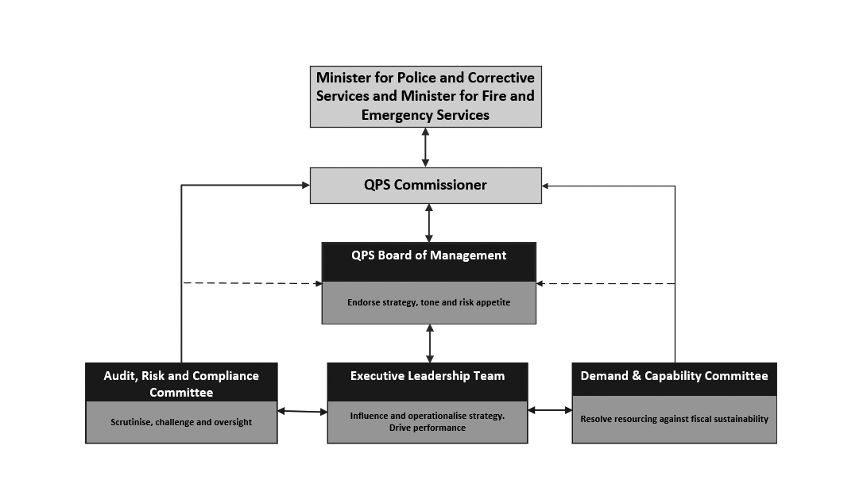

|  |
| --- |
| **QPS Board of Management (BoM)** |
| The purpose of the BoM is to endorse strategy, tone, and risk appetite for the Service.  The role of the BoM is to support and provide expert advice and endorsement to the Commissioner in making key decisions that deliver strategic or Service-wide impact. In doing so, the BoM advises on and oversees performance against strategic and organisational priorities. The BoM meetings are chaired by the QPS Commissioner.  The BoM meets every second month or as determined by the Chair. In 2022-23, the BoM met on five occasions, with one of these meetings occurring out-of-session. The BoM considered a further 15 matters out of session.  The independent external member received $7,440.75 in remuneration in 2022-23. |
| **Board members**   * Commissioner Katarina Carroll (Chair) * Deputy Commissioner Tracy Linford, Specialist Operations * Deputy Commissioner Shane Chelepy, Disaster and Emergency Management * Acting Deputy Commissioner Ben Marcus, Regional Services * Acting Deputy Commissioner Mark Wheeler, Regional Operations * Deputy Chief Executive Sinead McCarthy, Strategy and Corporate Services * External Member – Jenny Walker |
| **Achievements**  During 2022-23, the BoM overviewed and discussed strategic matters relating to financial reporting, human resources reporting, information, communication & technology reporting, performance reporting and risk reporting. The BoM considered a number of significant matters including:   * Vehicle Identification Platform – Enforcement Response Program – Whole of Service Capability * 2023 QPS Environment Scan * QPS Strategic Plan 2023-2027 and QPS Operational Plan 2023-2024 * Replacement fleet management system * Statement of Ethics * Domestic and Family Violence Action Plan * Government Employee Housing Plan * Client Management System program * QPS Wellbeing Strategy * Organisational Insights Platform (OIP) Data Lake Project * body worn camera live streaming capability * psychosocial hazards * QPRIME Niche Core Upgrade Project * QPS Olympic Games Group * extension of recruit training course length * Service Delivery Program * audit, risk and compliance * performance, crime statistics, complaints and corporate reporting. |
| **QPS Demand and Capability Committee (DCC)** |
| The Demand and Capability Committee’s purpose is to resolve resourcing against fiscal sustainability.  The role of the DCC is to:   * control the organisational prioritisation of resources in a fiscally sustainable manner * direct and endorse strategies, plans, assessments and reviews to address resource capability planning and delivery and monitor performance to ensure benefits realisation * lead and ensure continual application of the committee’s responsibilities, including by requiring appropriate reporting * identify and resolve any relevant emerging issues and trends relevant to its role.   The committee meets monthly or as determined by the Chair.  The DCC met on nine occasions and considered five matters out-of-session in 2022-23. |
| **Committee members**   * Deputy Commissioner Tracy Linford, Specialist Operations (Chair) * Deputy Commissioner Shane Chelepy, Disaster and Emergency Management * Acting Deputy Commissioner Ben Marcus, Regional Services * Acting Deputy Commissioner Mark Wheeler, Regional Operations * Deputy Chief Executive Sinead McCarthy, Strategy and Corporate Services |
| **Achievements**  In 2022-23, the DCC overviewed matters relating to finance performance, human resources, ICT, assets, procurement, and projects. The DCC considered significant matters including:   * Machinery of Government changes * QPS portfolio reporting * Client Management System * Capability Framework * Strategic Governance Manual and submissions * Capital Works Program * leave management * demand reporting * crime statistics * safety and wellbeing data * Automatic Number Plate Recognition capability * 2023-24 Budget Allocation and 5-year financial plan * 2023-24 ICT Investment Plan and ICT Strategy * asset reporting * financial sustainability * procurement and logistics reporting * cyber security * Vehicle Identification Platform – Enforcement Response Program – whole of service core capability * QPS Agency Specific Diversity Targets 2023-24 * vessel fuel costs and consumption * body worn camera live streaming capability funding * QPS service delivery * Protective Services Group Business Optimisation and Future Operating Model. |

|  |
| --- |
| **QPS Audit, Risk and Compliance Committee (ARCC)** |
| The purpose of the ARCC is to scrutinise, challenge and oversee the Commissioners legislated management responsibilities.  The role of the ARCC is independent oversight for, and assurance to, the Commissioner and BoM relevant to:  (i) risk management, performance, policy settings and framework  (ii) internal control and compliance environment  (iii) financial performance, planning, compliance and integrity  (iv) the internal and external audit functions.  The committee meets quarterly or as determined by the Chair. During 2022-23, the committee met on three occasions. The two independent external members collectively received $8,471 in remuneration. |
| **Committee members**   * External Member – Jenny Walker (Chair) * External Member – Geoff Waite * Deputy Chief Executive Sinead McCarthy, Strategy and Corporate Services * Assistant Commissioner Cheryl Scanlon, Ethical Standards Command * Acting Assistant Commissioner Matthew Vanderbyl, Organisational Capability Command |
| **Achievements**  During 2022-23, the ARCC provided strategic advice and support to the QPS BoM by considering matters of risk management, internal control and compliance, financial compliance, and auditing and reporting. The ARCC considered the significant matters including:   * ARCC Charter and ARCC Workplan * QPS portfolio reporting * QPS Strategic Risk Register * Risk Appetite Statement * cyber security reporting * procurement reporting * Corporate Card Automation * health safety and injury management reporting * Workcover premiums * strategic risks and opportunities * Compliance and Inspections Program Findings * ESC Annual Inspections Plan * fraud and corruption reporting, plan and policy * Annual Financial Statements * financial accounting and compliance * CFO Statement of Assurance * fraud and losses reporting * Strategic Internal Audit Plan 2023-27 * Internal Audit Charter * open internal audit recommendations * Queensland Audit Office (QAO) reports * QPS Environmental Scan. |

|  |
| --- |
| **QPS Executive Leadership Team (ELT)** |
| The purpose of the ELT is to influence and operationalise strategy and to drive performance.  The role of the ELT is to:   * + influence strategic and operational planning development   + oversee the development of strategies and frameworks that support the Service which are not subject to another strategic governance committee   + oversee and guide Service-wide activities to improve policing operations, responses and capabilities   + operationalise strategies with a coordinated approach and steer the organisation towards achievement of strategic goals and objectives   + identify and address strategic operational issues and risks collectively   + oversee and guide organisational change management for matters of strategic importance   + drive performance with a focus of benefits realisation.   The ELT meets via video conference weekly and in-person as determined by the Commissioner.  During 2022-23, the ELT met on seven occasions (in-person) including meetings at Police Headquarters in Brisbane City, Oxley Academy, Redcliffe and Townsville. |
| **ELT members**  As at 30 June 2023, ELT consisted of the following members, noting there were periods of time during 2022-23 that these positions were filled by another member:   * Commissioner Katarina Carroll (Chair) * Deputy Commissioner Tracy Linford, Specialist Operations * Deputy Commissioner Shane Chelepy, Disaster and Emergency Management * Deputy Chief Executive Sinead McCarthy, Strategy and Corporate Services * Acting Deputy Commissioner Ben Marcus, Regional Services * Acting Deputy Commissioner Mark Wheeler, Regional Operations * Assistant Commissioner Brian Codd, Operation Support Command * Assistant Commissioner Brian Connors, North Coast Region * Assistant Commissioner Kevin Guteridge, Central Region * Assistant Commissioner Cameron Harsley, Brisbane Region * Assistant Commissioner Kath Innes, Crime and Intelligence Command * Assistant Commissioner Mark Kelly, People Capability Command * Assistant Commissioner Charysse Pond, Southern Region * Assistant Commissioner Brett Schafferius, Far Northern Region * Assistant Commissioner Cheryl Scanlon, Ethical Standards Command * Assistant Commissioner Brian Swan, South Eastern Region * Acting Assistant Commissioner Marcus Hill, Disaster and Emergency Management * Acting Assistant Commissioner Darryl Johnson. State Discipline * Acting Assistant Commissioner Glenn Morris, Northern Region * Acting Assistant Commissioner Chris Jory, Security and Counter-Terrorism Command * Acting Assistant Commissioner George Marchesini, Youth Crime Taskforce * Acting Assistant Commissioner Virginia Nelson, Domestic, Family Violence and Vulnerable Persons Command * Acting Assistant Commissioner Chris Stream, Road Policing and Regional Support Command * Acting Assistant Commissioner Rhys Wildman. Domestic and Family Violence and DNA Reform * Acting Assistant Commissioner Matthew Vanderbyl, Organisational Capability Command * Chief Superintendent Roger Lowe, Crime and Corruption Commission * Chief Information Officer Cameron Allen, Frontline and Digital Division * Executive Director Anthony Brown, Policy and Performance Division * Executive Director Belinda Dryden, Health, Safety and Wellbeing Division * Executive Director Carolyn Harrison, Legal Division * Chief Risk Officer Michelle Holland * Executive Director Deb Paterson, Human Resources Division * Chief Finance Officer Nick Viles, Finance Division * Acting Executive Director Simon Kelly, Communications, Culture and Engagement Division   Standing Attendees   * Stephan Gollschewski, Special Coordinator for Reform * Superintendent Paul Hart, Chief of Staff, Commissioner’s Office * Acting Director Todd Saunders, Media and Public Affairs Unit |
| **Achievements**  During 2022-23, the ELT considered a number of significant matters, including:   * QPS response and strategy for DFV * DFV Roadmap * QPS DFV Advisory Group * QPS Commission of Inquiry Recommendations, Reforms and Transformation * Lateral Vascular Neck Restraint removal as a Use of Force option * QPS Strategic Plan 2023-27 and Operational Plan 2023-24 * inappropriate use of social media * inappropriate access to information /information release * vacancy management * 2023-24 compulsory training calendar * financial reporting * managing the risk of work-related psychosocial hazards * road safety strategies * strategic focus roadmap * 2022 Working for Queensland survey results * audit, risk and compliance functions * Oath of Service and Oath of Officer Review * crime statistics * Operation Theta Evaluation * recruiting * prevention and disruption * QLite NextGen * performance reporting * crime statistics reporting * Environmental Scan * complaints reporting * property and exhibit management * ICT reporting. |

**Government bodies**

* Commissioner for Police Service Reviews
* Controlled Operations Committee
* Public Interest Monitor

For further information about the Government Bodies refer to page 103 within the appendices.

**Ethics and code of conduct**

The delivery of professional policing services must be underpinned by ethical decisions and actions. These ethical decisions and actions provide the QPS with its most valuable asset, namely its reputation and the confidence and trust that such a reputation inspires in the community. The QPS has a broad range of programs, policies and initiatives that support professional and ethical practice including a robust internal complaints system, policies on declarable associations, gifts and benefits as well as discipline and ethical awareness training. The QPS Integrity Framework and Standard of Professional Practice supplement the Queensland Government values and the Code of Conduct for the Queensland Public Service and outlines the standards of conduct and professional practice expected of all QPS employees.

Members of the QPS operate under the Service’s Integrity Framework that promotes the principles of Values, Leadership and Accountability which underpin integrity and ethics in the QPS. The framework seeks to ensure the integrity of the organisation is maintained through four key actions that apply to all levels of the organisation. These actions are: Know what is expected, Educate and guide others, Ensure we do the right thing, and Protect our standards. The framework seeks to promote an actionable process of thinking about integrity and then integrating that thinking into all planning, implementation, monitoring and evaluation processes across the QPS.

Ethical Standards Command’s (ESC) purpose is to protect the high standards of integrity and professionalism necessary to maintain the trust and support of our community. In 2022-23, ESC continued to promote, monitor and enforce ethical behaviour, integrity and professional practice through education, deterrence and systems improvements. ESC continued to be the conduit between QPS and oversight bodies such as the Crime and Corruption Commission.

Reported complaints are continually monitored and reviewed by the QPS to identify primary contributing factors and/or trends which may arise from complaint types and/or the complaint data more generally. All complaints are considered, actioned and investigated as required. In 2022-23, the QPS received 1,292 complaints by members of the public against officers on or off duty. This figure counts the number of distinct individuals who have either lodged a complaint or lodged a complaint on behalf of another person even if it relates to the same incident. When applying relevant context to this figure, the QPS undertakes millions of interactions with people in the community each day and moreover, each year. Comparatively, very few of those interactions result in complaints relating to the conduct of police.

As part of its monitoring role, ESC undertakes a range of inspections and evaluations of police facilities including their functions and duties. During 2021-22 ESC undertook a review of the inspections process to validate the appropriateness of existing compliance processes. ESC is currently implementing a number of business improvements to underpin a compliance culture across the QPS. ESC also analysed the compliance inspections conducted independently by regions and commands to determine key compliance issues and trends across the state. The outcomes of the inspections are reported to the ELT and the QPS ARCC.

**Discipline outcomes**

ESC is responsible for the management of all complaints of misconduct and disciplinable conduct reported to the QPS. All complaints are considered, actioned and investigated as required.

In 2022-23, the QPS recorded 2,096 complaints with 5,574 allegations from internal QPS members and members of the public. A breakdown of the complaint categories and discipline outcomes is included in the below table.

In 2022-23, Local Management Resolution was used as an outcome on 769 occasions across 68 allegation categories.

|  |  |  |
| --- | --- | --- |
| **Allegation Category** | **Total number of Allegations** | **Allegation**  **outcome** |
| Failure of Duty | 2093 | 1086 No Further Action  594 Open  384 LMR  25 Hearing  2 7A Process  2 ADP |
| Unprofessional Conduct | 867 | 397 No Further Action  257 Open  170 LMR  33 Hearing  6 7A Process  3 ADP  1 188A Process |
| Assault/Excessive Use of Force | 619 | 420 No Further Action  155 Open  40 LMR  4 Hearing |
| Misuse of Information | 383 | 234 No Further Action  99 Open  37 LMR  12 Hearing  1 ADP |
| Misuse of Authority | 364 | 231 No Further Action  99 Open  27 LMR  7 Hearing |
| Unlawful or Unauthorised operational practice | 238 | 119 No Further Action  66 Open  45 LMR  6 Hearing  2 ADP |
| Interfere with or undermine and Investigation, legal process or conduct matter | 231 | 143 No Further Action  80 Open  6 LMR  2 Hearing |
| Inappropriate Exercise of operational discretion | 215 | 173 No Further Action  34 Open  8 LMR |
| Professional Conduct | 130 | 63 No Further Action  41 Open  22 LMR  3 Hearing  1 ADP |
| Other Offence | 126 | 82 No Further Action  31 Open  9 LMR  1 Hearing  3 7A Process |
| Misappropriation or unauthorised use of resources | 101 | 33 No Further Action  46 Open  19 LMR  1 Hearing  2 7A Process |
| Discrimination/Sexual Harassment | 95 | 48 No Further Action  23 Open  2 LMR  21 Hearing  1 7A Process |
| Drug-Related Offences | 48 | 28 No Further Action  17 Open  3 Hearing |
| Sexual Offence | 47 | 34 No Further Action  12 Open  1 7A Process |
| Bribery/Secret Commissions | 10 | 7 No Further Action  3 Open |
| Police related Death | 3 | 3 Open |
| Extortion | 2 | 2 No Further Action |
| Blank | 1 | 1 Open |
| Significant Event | 1 | 1 Open |

The Office of State Discipline (OSD), led by an Assistant Commissioner, is an independent central unit responsible for conducting most of the disciplinary proceedings for the QPS, and is separate and distinct from ESC.

Under amendments to Part 7 of the *Police Service Administration Act 1990* (the Act) the Assistant Commissioner OSD is conferred the powers of a Deputy Commissioner to impose any disciplinary sanction provided for by the Act including dismissal, suspension without pay (up to 12 months), probation (up to 12 months) and the comprehensive transfer of a member.

Disciplinary Hearings can include a full disciplinary proceeding, an Abbreviated Disciplinary Proceeding (ADP), and where members have separated from the service, there is provision under Part 7A of the *Police Service Administration Act 1990* or Part 8, Division 3 of the *Public Sector Act 2002*, for a Post-Separation Disciplinary Declaration (PSDD) to be made (previously section 188A of the PSA).

|  |  |  |
| --- | --- | --- |
| **Discipline matter breakdown – hearing outcome** | | |
| **Discipline Matter - Hearing Type** | **Hearing Outcome** | **Sanction Types** |
| 5 x ADP | 2 x Invalid 7.10 LMR Appeal | 1 Local Transfer |
| 3 x Substantiated | 1 Disciplinary Probation  1 Local Transfer  1 Performance of Community Service  1 Personal Development Strategies  1 PSE – Reprimand  1 Reprimand |
| 58 x Discipline Proceeding Sworn | 7 x Invalid 7.10 LMR 2023 Appeal | Nil Sanctions |
| 40 x Invalid 7.10 NFA 2023 Appeal | Nil Sanctions |
| 1 x Not Substantiated | Nil Sanctions |
| 10 x Substantiated | 1 Demotion – Temporary  2 Dismissal  1 Local Transfer  3 Penalty Units  3 Performance of Community Service  1 Personal Development Strategies  2 Reprimand |
| 15 x Discipline Proceeding Unsworn | 2 x Not Substantiated | Nil Sanctions |
| 13 x Substantiated | 9 Dismissal  2 Personal Development Strategies  2 PSE – Paypoint Reduction  1 Reprimand |

**Risk Management and Accountability**

**Enterprise risk management**

The Commissioner and senior executives are committed to the management of internal and external risks which may influence strategic or operational objectives. Risk management is integral to management functions and is a requirement of all Queensland Government departments, including the QPS under section 61 the *Financial Accountability Act 2009*. The QPS has implemented an Enterprise Risk Management Framework, adopting the principles and processes outlined in Australian Standard ISO 31000:2018 Risk Management – Guidelines. This approach integrates risk-based decision making into the management processes of the organisation and articulates governance and accountability for risk management activities.

Risk management supports the QPS Strategic Plan and Operational Plans, aligning the achievement of organisational objectives to consideration of risks within the context of the QPS Risk Appetite Statement (the Statement). The Statement provides clarity and sets the tone around acceptable and unacceptable risks to the organisation, supporting policy and investment decision making at all levels. Risk Reports provide an overview of strategic and operational risks impacting the achievement of QPS objectives. The BoM establishes the mandate and commitment set by the QPS executives that underpins the risk management framework. The ARCC is responsible for reviewing the adequacy and application of the QPS risk management framework.

Responsibilities for risk management are maintained through executive portfolios across operational and strategic levels of the organisation. The Office of the Chief Risk Officer sets the framework, promotes best practice, scans for emerging risk trends and provides advice and support for risk management.

**External scrutiny**

This section provides information about external agencies and processes, which examined the operations of QPS or other agencies with findings/issues requiring consideration by, or impacting on, the QPS:

**Queensland Audit Office (QAO)**

The QAO supports the role of the Auditor-General of Queensland in providing the Parliament with an independent assessment of the financial management and performance activities of public sector entities. The QAO provides an independent audit service and reports to the Parliament to enhance public sector accountability. QAO reports are available online at [www.qao.qld.gov.au/reports-resources/parliament](http://www.qao.qld.gov.au/reports-resources/parliament). The QPS remains committed to identifying opportunities for efficiencies in all areas of service delivery.

**Report 5: Keeping people safe from domestic and family violence**

DFV is a complex societal problem that needs a comprehensive, coordinated response. The complexity arises because of the mix of victims, perpetrators, types of violence, involvement of children, and the sheer scale of the problem.

This audit examined how effectively state public sector entities keep people safe from DFV, prevent it from occurring, and rehabilitate perpetrators to minimise re-offending. The QAO also assessed how they coordinate with non-government DFV services.

The QAO made 21 recommendations aimed at enhancing responses, training, case management, interagency coordination, preventing domestic and family violence, and to better support young people and tackle intergenerational violence.

**Women’s Safety Justice Taskforce Report 2 – Hear her voice – Women and girls’ experiences across the criminal justice system**

On 1 July 2022, the Women’s Safety and Justice Taskforce released its second report – *Hear her voice 2* – on the second part of its work examining and reviewing the experiences of women and girls across Queensland's criminal justice system.

Report 2 proposed 188 recommendations to improve Queensland’s criminal justice system for women and girls who are victim-survivors of sexual violence, or who are accused persons or offenders. It follows extensive consultation across Queensland by the Women’s Safety and Justice Taskforce.

The Queensland Government’s response to Report 2 was published on 22 November 2022 and is available at <https://www.justice.qld.gov.au/initiatives/queensland-government-response-womens-safety-justice-taskforce-recommendations/response-to-report-two-from-the-taskforce>.

**Queensland Coroner**

During 2022-23, four recommendations arising from two coronial inquests were directed to the QPS as either a lead or supporting agency. The Findings of Inquest and the government’s responses are available at [www.courts.qld.gov.au/courts/coroners-court/findings](http://www.courts.qld.gov.au/courts/coroners-court/findings).

**Internal audit**

The QPS Internal Audit Unit operates under a portfolio service delivery model providing internal audit services to QPS and Office of the Inspector-General Emergency Management (IGEM). As at 1 January 2023, the QFES Internal Audit function was handed back to that agency.

Internal Audit continues to provide advice across a wide range of disciplines including risk, assurance, information technology, finance, compliance, and general consulting activities for the QPS and IGEM. The Head of Internal Audit for QPS is also the nominated Head of Internal Audit for the Office of the IGEM in accordance with the *Financial Accountability Act 2009*.

The work of the Internal Audit Unit is undertaken in accordance with the Institute of Internal Auditors’ standards and under an approved charter consistent with relevant audit and ethical standards.

In accordance with the Financial and Performance Management Standard 2019, an annual internal audit plan and three-year strategic audit plan sets the direction of the unit. A detailed audit planning and risk assessment process was completed in devising this plan. The Annual Internal Audit Plan 2022-23 and Strategic Internal Audit Plan 2023-26 was endorsed by the QPS ARCC and approved by the Commissioner on 27 June 2022. The Internal Audit Unit reports regularly to the QPS ARCC which reviews the work of the internal audit function. The relationship with the committee is based on Queensland Treasury’s Audit Committee Guidelines.

Under its approved charter, the unit reviews compliance (effectiveness), performance (efficiency), financial management and information technology to identify areas of risk and to improve outcomes for the Service. The unit has systems in place to ensure the effective, efficient and economic operation of the audit function.

In 2022-23, the unit delivered the activities in the approved Annual Internal Audit Plan 2022-23 using in-house and sourced delivery methods including the engagement of Deloitte. Whilst fieldwork was completed for the majority of audits as at 30 June 2023, two reviews (fleet and motor vehicle allowances) will be carried over to 2023-24 due to the timing or nature of the work. It is expected all final reports will be delivered by 31 October 2023.

Achievements specific to the QPS for 2022-23 include:

* delivery of the approved annual internal audit plan with specific QPS audit coverage including:
* flexible work arrangements
* training compliance modeling
* weapons licensing
* capital works and infrastructure
* data assets discovery exercise
* personally identifiable information and personal information data mapping
* vetting processes
* body-worn cameras and dashcams
* fraud and corruption risks.

**Information systems and recordkeeping**

The QPS Information Management Unit (IMU) operates and manages information and recordkeeping systems to support a number of specific recordkeeping functions in QPS, QFES, IGEM, QAS and Queensland Shared Services. This unit also provides strategic recordkeeping advice to QPS and QFES.

The QPS IMU records management team provided advice and assistance to the QPS during the reporting period resulting in improved efficiencies including:

* ongoing training of QPS staff to facilitate the capture and management of records using the Objective electronic Document Records Management System (eDRMS) to meet legislative obligations and broader recordkeeping responsibilities
* working with QPS business units to identify opportunities to reduce reliance on hardcopy documents and transition to fully electronic processes, delivering business efficiencies
* completion of over 490 support jobs to provide administrative and system support in use of the Objective eDRMS
* streamlining catalogue fields in eDRMS resulting in operational efficiencies for the Right to Information (RTI) Unit Subpoena Team. This included simplifying the process to access information and enable reports to be generated from within the system
* completing a project to upgrade to the Objective eDRMS to ensure security and currency of the platform and provide access to a simplified web browser interface, enabling all key functionalities to be more easily accessed
* supporting the creation of over one million electronic documents and 300,000 files associated with Weapons Licensing functions, and more than 15,000 administrative files for general use
* completion and submission of revised QPS Retention and Disposal Schedule to Queensland State Archives (QSA). Pending any updates/changes required from the State Archivist or QSA Retention and Disposal Committee, the schedule will be approved and implemented for use in QPS. Aligning the format to the whole of government standard will vastly simplify the process of classifying all records managed by QPS, irrespective of whether they are referenced within the Agency Specific (QPS) Schedule or the whole of government General Retention and Disposal Schedule
* a significant archiving project was undertaken for the Mackay–Whitsunday District, involving a detailed assessment of a large quantity of inactive records held on-site, and extensive consultation with an accredited commercial secondary storage provider (accessible under a whole of government Standing Offer Arrangement). Following a large body of work primarily actioned by district staff, optimising how records were stored and indexed, a significant proportion of these materials were relocated to the commercial provider. This resulted in a significant expansion of space available to support on-site district functions
* commencing a project to assist the RTI Unit to archive a high volume of inactive physical records. This cataloguing and storage process will enable space currently used to store this content to be repurposed as office space to accommodate new team members.

There were no known breaches of information security with respect to records managed within the Objective eDRMS during the reporting period. Approval for disposal of records submitted through the Corporate Records Retention and Disposal Program managed by the IMU were sentenced in line with retention periods set out within the QPS or whole of government Retention and Disposal Schedules.

Public records relating to the Normanton Police Station and QPS personnel files were transferred to Queensland State Archives during the reporting period.

**Human Resources**

**Strategic workforce planning and performance**

**Workforce profile**

The QPS workforce comprises more than 17,000 members including police officers and staff members. In addition, the QPS enlists the help of volunteers to enhance community safety.

QPS workforce data presented below aligns with Minimum Obligatory Human Resource Information (MOHRI). MOHRI workforce data is based on data Queensland Government agencies provide to the Public Sector Commission for the biannual Queensland public sector workforce profile report. The MOHRI methodology changed in 2019, in line with recommendations from the 2018 Review into Queensland public sector workforce (Coaldrake review). There was a shift from calculating data based on public sector employees by substantive appointment, to calculating data based on public sector employees actually paid. Another key change related to leave without pay (LWOP) and leave on half pay. The pre-Coaldrake review methodology excluded officers on LWOP only after 8 weeks continual absence. The current methodology excludes all employees on LWOP in the relevant snapshot fortnight and reduces the FTE of employees on leave on half pay. These changes impact direct comparisons with MOHRI workforce data prior to the methodology changes being implemented in 2019.

**MOHRI workforce profile data (June 2023 reporting quarter)**

|  |  |
| --- | --- |
| **Total workforce** | |
| Headcount | 17,534 |
| MOHRI paid FTE | 16,722.96 |
| **Occupation Types by FTE – reported as a % of total staffing** | |
| Corporate | 6.26% |
| Frontline and Frontline Support | 93.74% |
| **Appointment Type by FTE – reported as a % of total staffing** | |
| Permanent | 93.62% |
| Temporary | 4.03% |
| Casual | 0.29% |
| Contract | 2.06% |
| **Employment Status by Headcount – reported as a % of total staffing** | |
| Full-time | 93.62% |
| Part-time | 6.10% |
| Casual | 0.28% |

Between 1 July 2022 and 30 June 2023, the QPS permanent separation rate was 5.6% for police officers and 10.7% for permanent staff members (excluding temporary and casual employees).

The QPS has various policies and processes in place that promote flexible working arrangements and a healthy work-life balance for all QPS employees. These policies are periodically reviewed to ensure they meet the needs of the service and its employees.

The QPS also has a dedicated Leadership Centre that facilitates and encourages learning and development of police officers and staff members at all levels of the organisation (see page 64 for more information).

**Diversity target groups profile data (June 2023 reporting quarter)1**

***Gender***

|  |  |  |
| --- | --- | --- |
| **Group** | **Group substantive headcount** | **% of total workforce substantive headcount** |
| Woman | 6,534 | 37.27% |
| Man | 10,991 | 62.68% |
| Non-binary | 9 | 0.05% |

***Diversity Groups***

|  |  |  |
| --- | --- | --- |
| **Group** | **Group substantive headcount** | **% of total workforce substantive headcount** |
| Women | 6,534 | 37.27% |
| Aboriginal Peoples and Torres Strait Islander Peoples | 397 | 2.26% |
| People with disability2  (approved staffing inclusions for target alignment) | 134 | 3.11% |
| Culturally and Linguistically Diverse  (Speak a language at home other than English3) | 327 | 1.86% |

***Women in Leadership Roles***

|  |  |  |
| --- | --- | --- |
| **Group** | **Group substantive headcount** | **% of total leadership substantive headcount** |
| Chief Executive  (engaged under the *Police Service Administration Act 1990)* | 1 | 100.00% |
| Senior Executive Service  (classified and s122 equivalent combined for police and staff members) | 12 | 30.00% |
| Senior Officers  (classified and s122 equivalent combined for police and staff members) | 133 | 26.30% |

1. To ensure privacy, in tables where there are less than 5 respondents in a category, specific numbers should be replaced by <5
2. This includes Aboriginal and Torres Strait Islander languages or Australian South Sea Islander languages spoken at home.
3. Disability percentage is calculated on non-operational staff members. It excludes staff members engaged in “operational roles’, including Police Officers, Recruits, Watchhouse Officers, Police and TSI Liaison Officers, Protective Services roles, and employees in the Police Pipe & Drums Band.

**Attraction and Retention**

QPS’s People Capability Command (PCAP) is primarily responsible for the police academies in Oxley, Wacol and Townsville, education and training and police recruiting. In support of the Government’s commitment to boost police numbers by 2025, the QPS has undertaken various recruitment activities, including:

* targeted professional marketing campaigns to drive police recruitment within diverse communities, regional and remote areas and broad demographic groups
* a revised Recruit Training Program, extending the academy training from 27 to 34 weeks with renewed focus on youth justice, mental health, prevention and disruption and DFV response. The program now features co-facilitation of DFV and cultural training using industry experts, persons from culturally diverse backgrounds and lived experience
* modified training facilities at the Oxley and Townsville academies to increase capacity and support greater recruit numbers
* recruitment of serving and recently served international police officers under a new labour agreement between the Queensland and Commonwealth Governments. The QPS can recruit up to 500 international police officers each year for five years without the prerequisite of being an Australian citizen or permanent resident. Depending on compatibility and recency of policing experience, these recruits either undertake the Police Abridged Competency Education (PACE) program or the mainstream Recruit Training Program to ensure that they can achieve the high standards for QPS entry
* Special Constables (state officers) to boost frontline policing in times of demand and at short notice throughout Queensland. Special Constables are former QPS officers who have recently resigned or retired and are willing to continue casual employment as a police officer. Special Constables have full police powers and perform frontline duty where needed, particularly during times of peak demand or to support disaster response and major events
* waiving police applicant costs, introduction of a cost-of-living allowance for police recruits and the waiving of live-in costs for recruits residing at the academies, a relocation allowance of up to $20,000 to assist experienced interstate and overseas recruits and HECS-HELP debt relief of up to $20,000 for 400 graduates of tertiary degrees in priority disciplines (psychology, criminology, social work (or equivalent), counselling or other human services-related fields)
* professional marketing strategies including a new broader-audience advertising campaign ‘*Challenging. Rewarding. Policing*’ and a complementary campaign in partnership with the Queensland Police Union of Employees called ‘*Try It On.’*

**Leadership and professional development opportunities**

The QPS offered a range of opportunities and pathways to access professional development to police officers and staff members in 2022-23, including:

* the Leadership Capability Program (LCP) provides a three-stage program for next-level development embracing education, experience and effective mentoring. The LCP was created to provide a fit-for-purpose program focussed on developing leaders who can meet the challenges of policing in an ever-changing environment
* the QPS Leadership Centre aims to drive a culture of leadership at all levels of the organisation, and to build leadership capability through the fusion of education, effective mentoring, and workplace experience. With a dedicated staff from diverse backgrounds, the Leadership Centre delivers and coordinates a range of fit-for-purpose, contemporary development programs and learning opportunities to support QPS personnel as they build their leadership capability
* Q-Learn is a digital education platform that provides access to thousands of blended learning resources focused on leadership, professional development and wellbeing. Q-Learn provides a self-paced, short-shot learning resource that can be tailored to individual development needs or interests
* the Leadership, Engagement and Development (LEAD) Program is targeted at Constables, Senior Constables and staff members at AO3/AO4 (or equivalent) and provides foundational skills in leadership, problem solving, conflict management, change management and mental health and resilience. The LEAD program involves a two-day, face-to-face workshop that is offered across the state
* staff members (up to OO6/AO4) may undertake external qualification studies in leadership and management at Certificate IV, Diploma, and Advanced Diploma levels, depending on their eligibility. Staff Member Training also offer bespoke courses for all QPS members on topics such as emotional intelligence, leadership, communication, problem solving, team building and difficult conversations
* professional development opportunities for senior leaders including the Australian Institute of Police Management, Australian and New Zealand School of Government, Australian Institute of Management, Australian Institute of Company Directors and many universities.

**Our People Matter**

The ‘Our People Matter’ Strategy continued to directly support QPS members across the state for a fifth consecutive year, delivering initiatives based on four pillars: *Healthy Bodies, Healthy Minds, Safe Workplaces, Fair and Positive Workplaces*. The strategy is a collaboration between the QPS, five employee unions and two corporate sponsors, who jointly promote the pillars to improve organisational culture, engagement, empowerment, and participation at all levels.

District ‘Our People Matter’ Champions, comprised of police and civilian personnel, promote the strategy in their respective regions, driven by frontline ideas to improve the physical and mental health, and the safety and wellbeing of members and their families.

Key achievements for 2022-23 include:

* a record number of funding applications (over 300) received from members to support local initiatives promoting the health and wellbeing of QPS members. Over 120 applications were approved resulting in over $230,000 in funding to support local initiatives
* successful rollout of the “Speaker Series” in Logan and Moreton with guest speakers Roger Sutherland, Professor Selena Bartlett, FORTEM, QBank and QSuper. These sessions were also livestreamed to QPS members across the state via Workplace
* successful campaign to increase the number of Principal Workplace Champions and Workplace Champions to locally promote the Our People Matter Strategy across the state. There has been a 64% increase in the Champion Network, which is now comprised of 35 Principal Workplace Champions and 94 Workplace Champions
* a ‘Community of Practice’ was established to better connect the Our People Matter Champion Network with monthly meetings to share ideas and promote the strategy
* ongoing collaboration with FORTEM Australia’s Beyond Brave Virtual Summits and Thank A First Responder initiatives.

**Inclusion and Diversity**

The QPS is committed to building an inclusive and diverse workplace in which all employees feel valued, included and welcome and have equal access to opportunities.

Key achievements for 2022-23 include:

* commencing a review of the QPS Inclusion and Diversity Strategy 2020-2025 which involved comprehensive consultation with a range of QPS stakeholders including Human Resources, People Capability Command, Policy and Performance Division and the QPS’s five Diversity Network coordinators
* establishing a Community of Practice to connect and support the QPS’s five Diversity Networks, including First Nations, Pride, Leading Women, Multicultural and Accessibility Support. This community of practice involves monthly meetings with Network Coordinators
* representing the QPS on Public Service Commission ‘Inclusion and Diversity Working Groups’.

**Workforce Culture**

The QPS is in the second year of delivering a bespoke, fit for purpose cultural transformation program, designed to build a connected, engaged and inclusive workforce, with the conclusion of the Juniper Program in 2021.

The Workforce Assessment and Support Team (WAST) within the Communications, Culture and Engagement Division is a fit for purpose model that has amalgamated the assessment and diagnosis of workplace culture and the cultural transformation teams under one governance structure. This enables the two components of conducting in-depth analysis of workplaces and the design of a bespoke workshop “*Building and Sustaining High Performance Teams*’ to work conjointly. Coupled with the Conflict Coaching and Mediation Services, as part of the WAST, it maximises productivity to provide a holistic approach to improving workplace culture.

Recent bolstering of permanent positions within the WAST, will enable the team to evolve and engage with as many workplaces as practicable, to restore and improve workplace culture across the organisation.

**Working for Queensland**

Working for Queensland (WfQ) is an annual survey that measures employee perceptions of their work, manager, team and the QPS. The survey is administered by the Public Service Commission and explores our people’s perceptions of their workplace climate in key areas.

Results from the WfQ survey drive workplace changes across the Service and helps the QPS measure how the Service is progressing towards the QPS’s strategic objective to build a connected, engaged and job-ready workforce with the health, wellbeing, and safety of our people a priority.

Key achievements for 2022-23 include:

* continuing to place a strong emphasis on supporting leaders to engage with the WfQ results and developing people-focused strategies to support members through the development of WfQ Action Plans. All Region, Command and Division Action Plans were received and collated by the WfQ team with results presented to the Executive Leadership Team in April 2023. This presentation highlighted organisational priorities arising from the 2022 WfQ survey results and action items undertaken to address these priorities and benefits/outcomes gained
* reviewing over 6,200 free text comments from the 2022 WfQ survey free text question. The executive team and senior leaders were provided with information packs containing free text comments from their members. The comments were themed and compared against themes and sentiments from across the QPS, providing leaders with a better understanding of workforce perspectives
* establishing a WfQ Key Points of Contact (KPOC) ‘Community of Practice’ to facilitate enhanced communication to and from the WfQ team and ensure KPOCs are supported in their role with the necessary information, training and resources
* seeking input from executive and senior leaders and WfQ KPOCs to recommend 2023 WfQ survey agency specific questions and free text questions, which were then endorsed by the Commissioner.

The 2023 WfQ survey will be conducted across Queensland Government agencies and will commence on 21 August 2023.

**QPS LGBTI+ Support Network**

The QPS Pride Network, previously known as the QPS LGBTI+ Support Network, promotes and advocates Lesbian, Gay, Bisexual, Transgender, Intersex+ pride within the QPS providing a dedicated support framework to its members statewide.

The network is made up of volunteer members who work to ensure LGBTIQ+ people in the QPS have access to support, resources, tools, and assistance. The Network seeks to:

* engage QPS members promoting LGBTIQ+ pride and advocate for issues affecting LGBTIQ+ employees
* celebrate days of significance, with social events, targeted communications and internal education
* provide employees with LGBTIQ+ appropriate, internal and external support services
* promote the QPS as an employer who embraces workplace inclusion and diversity
* build partnerships internally with other QPS Networks and external LGBTIQ+
* review and provide advice on all QPS policies and procedures affecting LGBTIQ+ employees.

Key achievements for 2022-23 include:

* advocating for and working collaboratively with QPS members and LGBTIQ+ communities to develop an Apology and Statement of Regret
* QPS Apology and Statement of Regret to LGBTIQ+ Communities for Historical Mistreatment was delivered by the Commissioner on 20 January 2023 to LGBTIQ+ communities and past and present QPS employees. The focus is now on continuing to build an inclusive and representative policing service
* designing and producing the new QPS Progress Pride Flag to be flown throughout Queensland at Police Headquarters, the academies and other major regional centres on days of significance, such as IDAHOBIT, Wear it Purple and Pride Month
* coordinating ‘International Day Against Homophobia, Biphobia and Transphobia’ (IDAHOBIT Day) events on 17 May 2023 to raise awareness for the work still needed to combat discrimination
* developing educational and training material for managers and recruits on matters affecting LGBTIQ+ staff to improve inclusion and sense of belonging.

**Enterprise Bargaining Agreement**

The *QPS Certified Agreement 2022* was negotiated in 2022 and came into effect on   
15 November 2022. The *QPS Protective Services Officers Agreement 2019* nominally expired on 30 June 2022 and is currently under negotiation with the Together Union for a replacement QPS Protective Services Officers Agreement in accordance with the Government's Public Sector Wages Policy.

**Early retirement, redundancy and retrenchment**

No early retirement, redundancy or retrenchment packages were paid to QPS employees during 2022-23.

**Financial Statements**

**Table of contents**

Statement of comprehensive income 69

Statement of financial position 70

Statement of changes in equity 71

Statement of cash flows (including notes to the statement of cash flows) 72

Notes to the financial statements 73

Management Certificate 98

Independent Audit Report 99

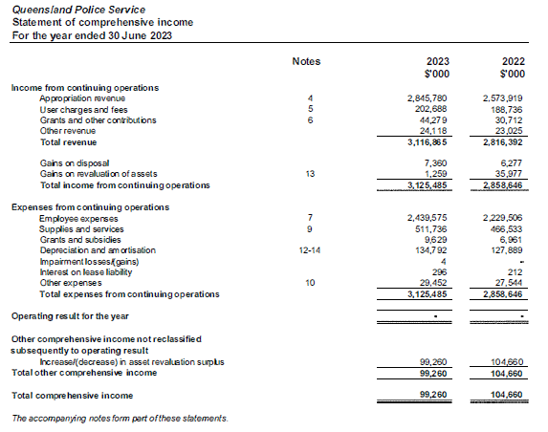

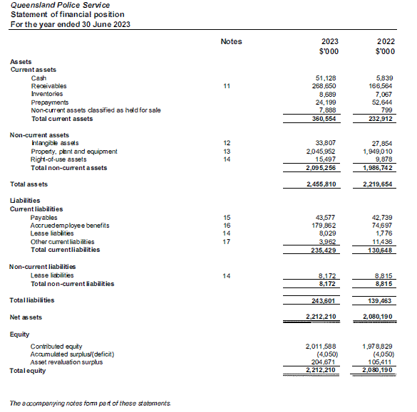

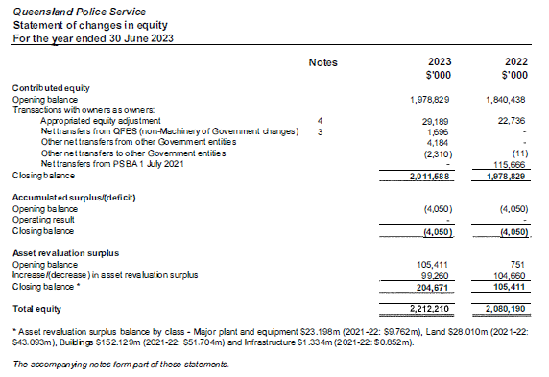

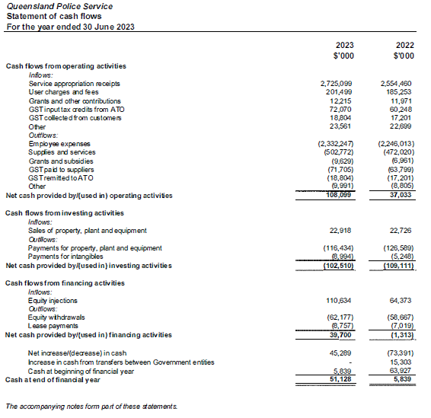

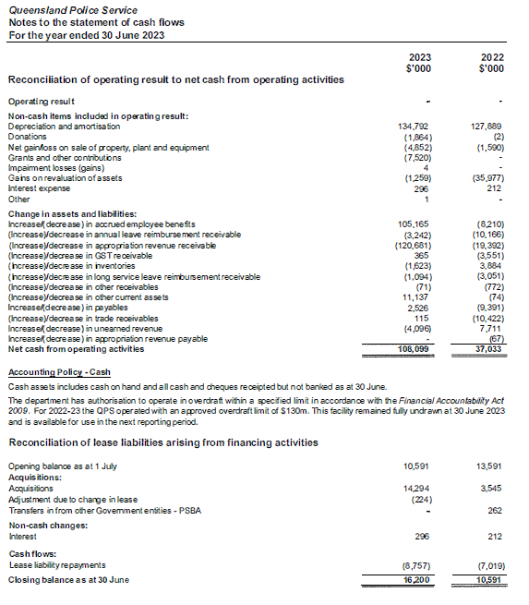

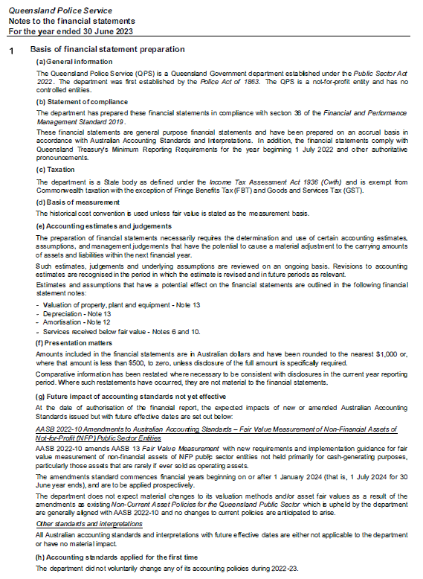

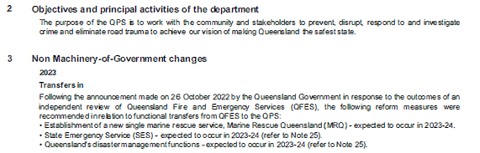

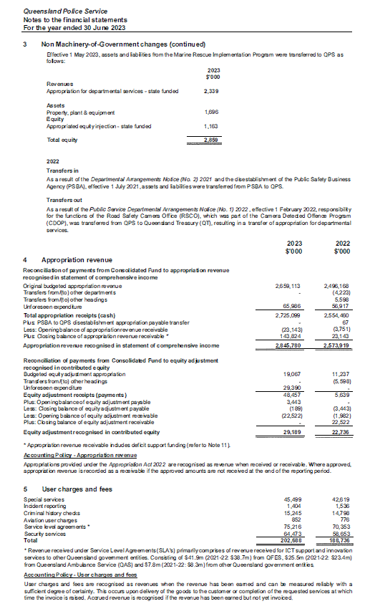

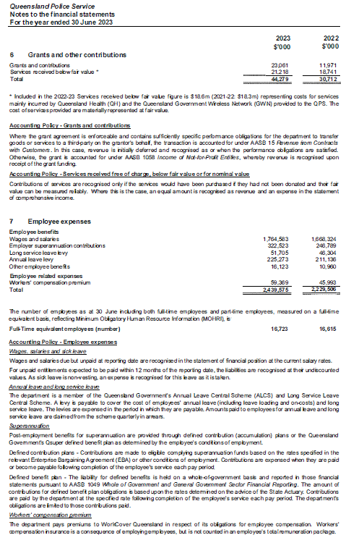

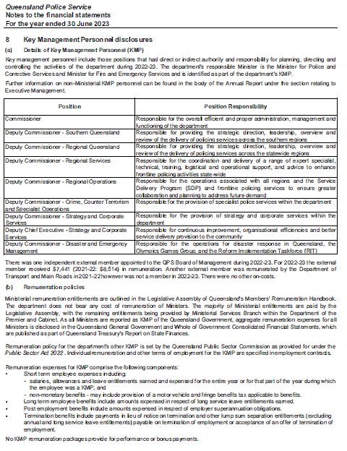

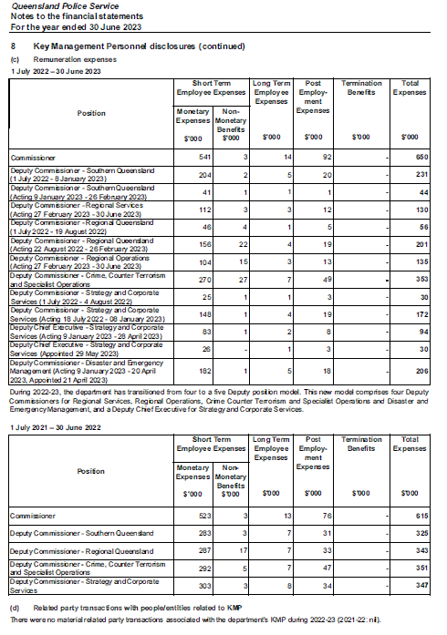

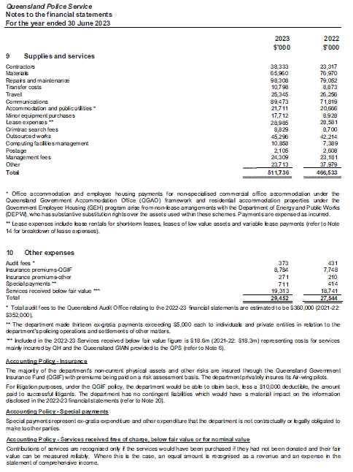

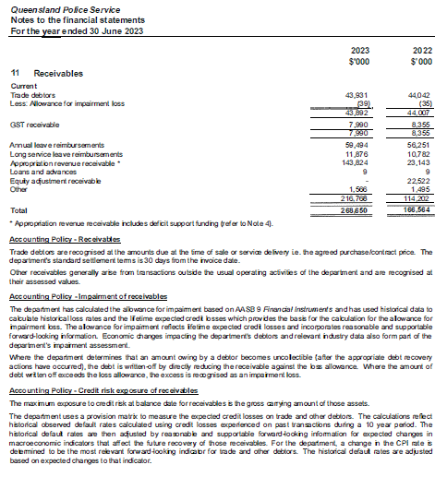

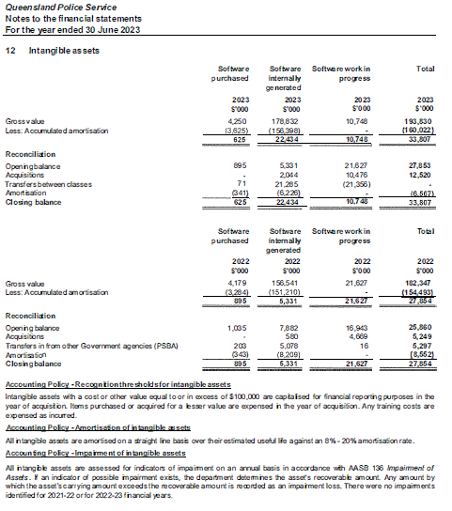

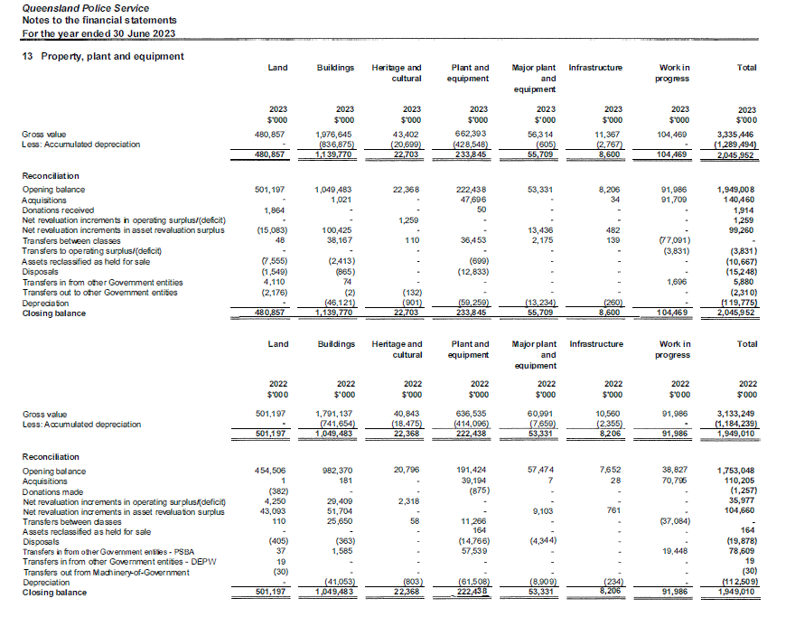

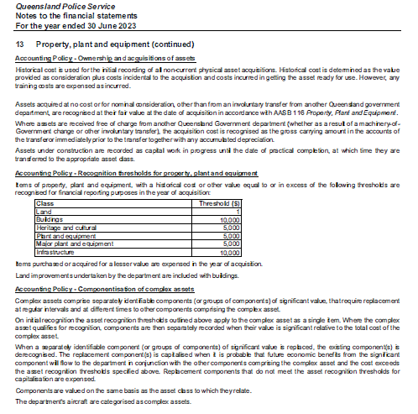

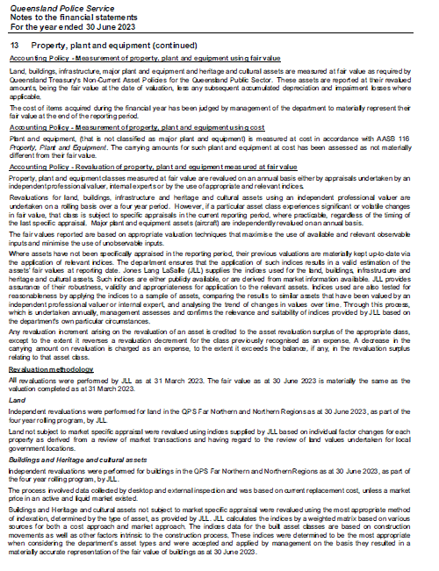

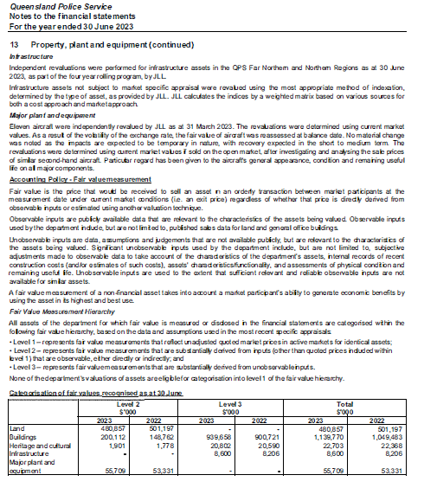

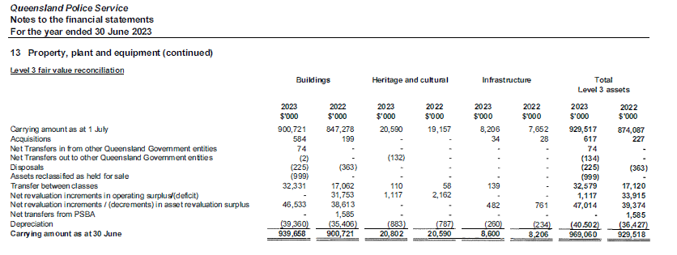

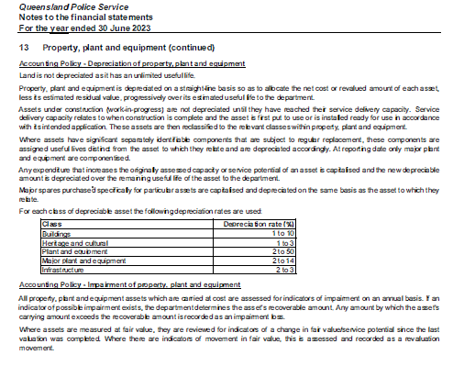

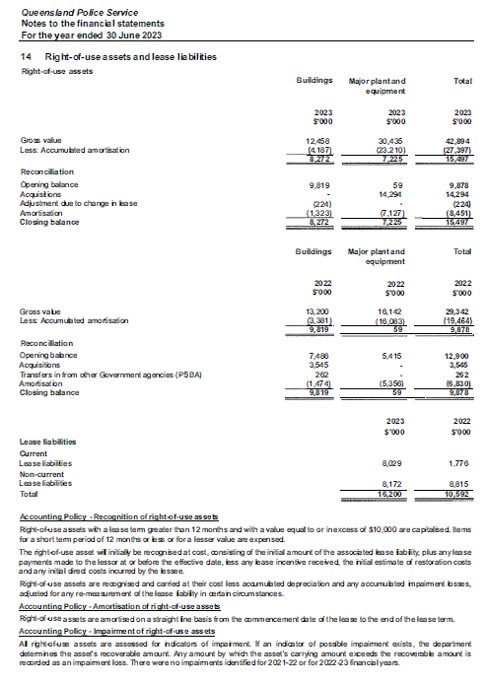

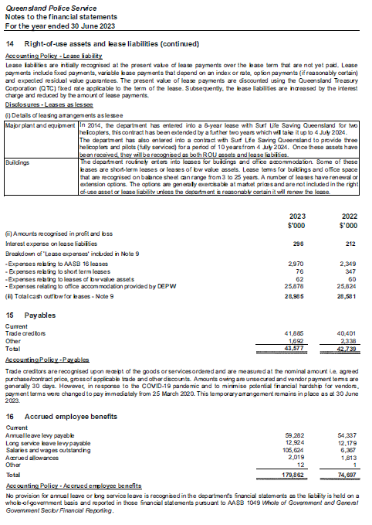

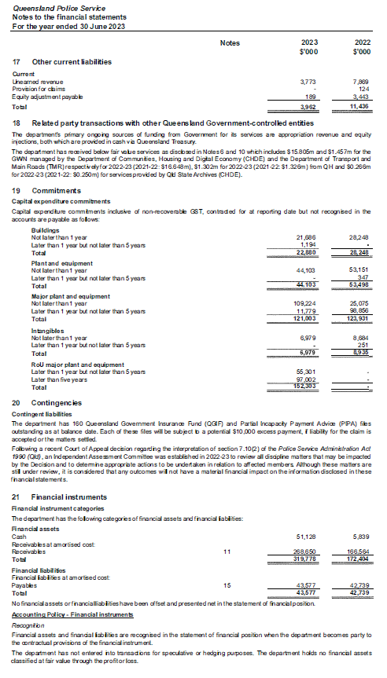

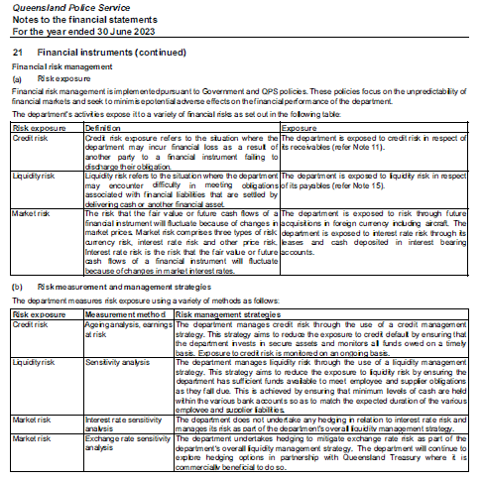

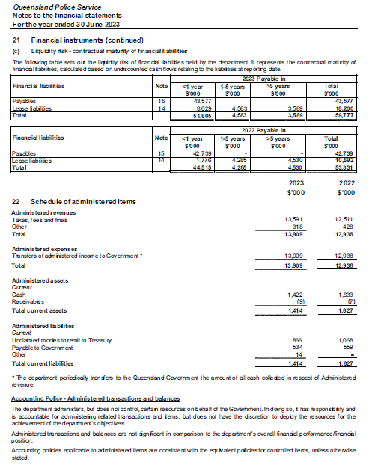

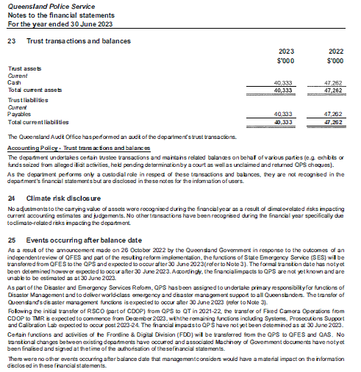

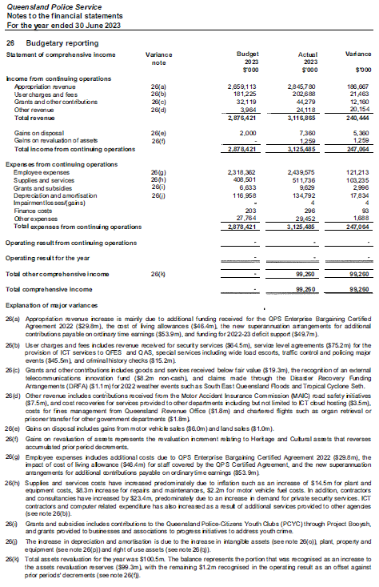

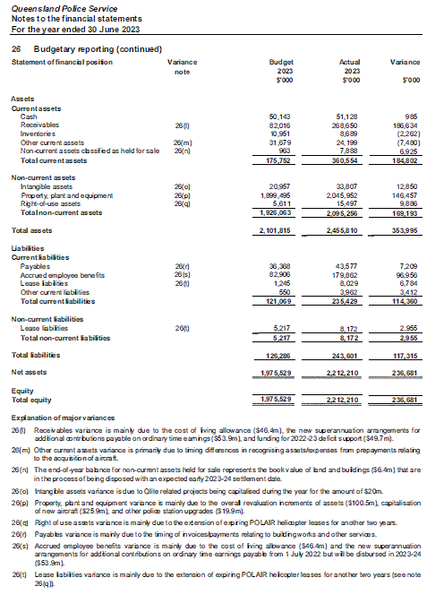

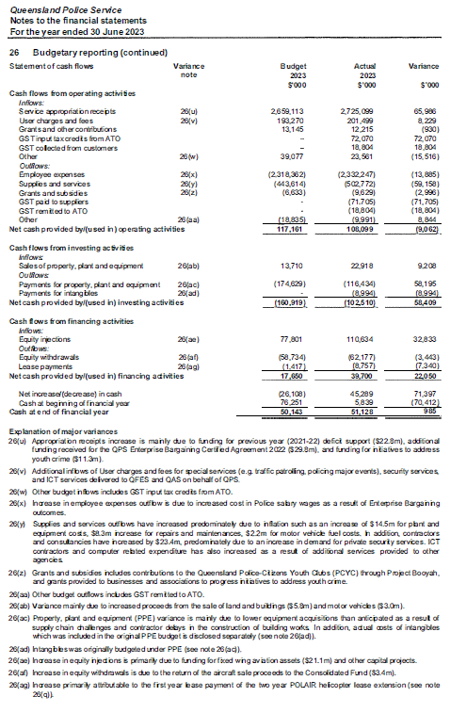

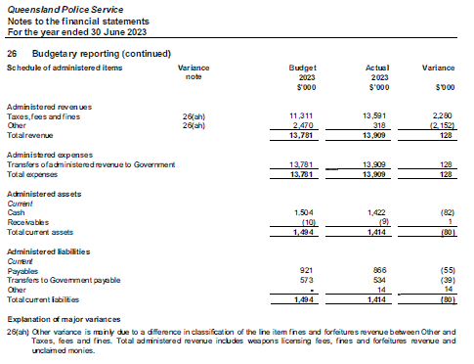

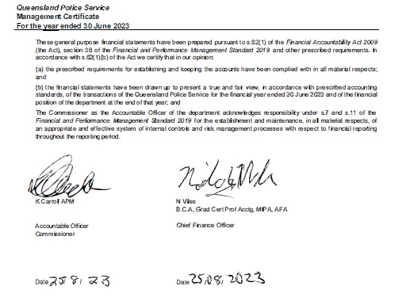

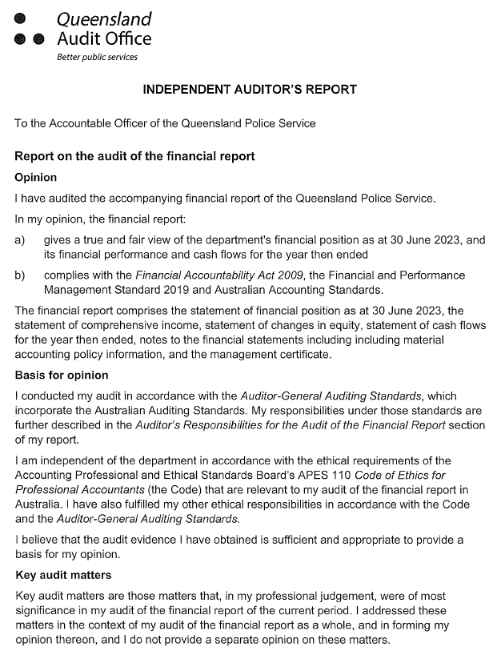

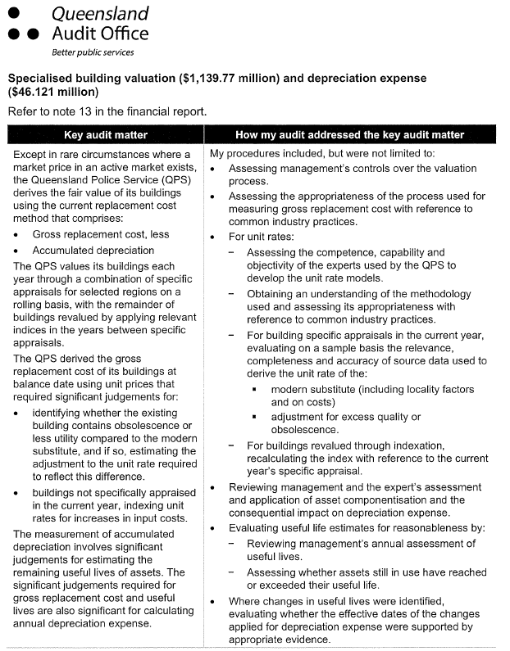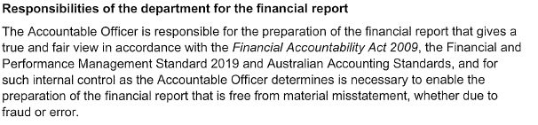

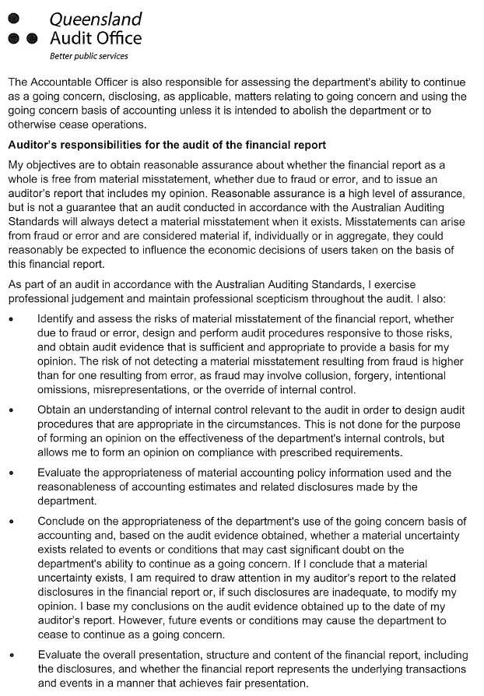



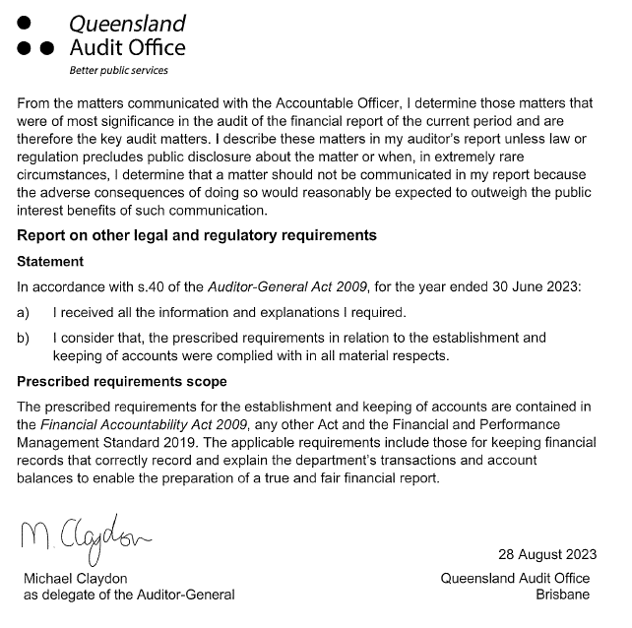

**Appendices**

**Government bodies**

|  |  |  |  |  |  |  |
| --- | --- | --- | --- | --- | --- | --- |
| **Commissioner for Police Service Reviews** | | | | | | |
| Act/instrument | The Commissioner for Police Service Reviews is established under the *Police Service Administration Act 1990* and *Police Service Administration Regulation 2016*. | | | | | |
| Functions | The Review Commissioner is responsible for hearing grievances from police officers relating to appointments, promotions, transfers or disciplinary actions made under the Act.  Appeals are heard before a Review Commissioner nominated by the Crime and Corruption Commission yet otherwise independent of the Crime and Corruption Commission and the QPS. Where a matter progresses to a hearing, the Review Commissioner will consider the material presented and prepare written recommendations for the Police Commissioner who will make the final decision. Where the Police Commissioner does not implement the recommendation, reasons must be provided to the Review Commissioner and the parties to review.  The Crime and Corruption Commission provides secretariat support to the review function. | | | | | |
| Further information about the Commissioner for Police Service Reviews is available at [www.ccc.qld.gov.au/](http://www.ccc.qld.gov.au/). | | | | | | |
| **Controlled Operations Committee** | | | | | | |
| Act | The Controlled Operations Committee is established under the *Police Powers and Responsibilities Act 2000.* | | | | | |
| Functions | The Controlled Operations Committee is responsible for considering and making recommendations about applications for an authority, or variation to an authority, to conduct a controlled operation under Chapter 11 of the *Police Powers and Responsibilities Act 2000.* | | | | | |
| Achievements | The committee provides its own annual report after 30 June each year, detailing the work and activities of the QPS under Chapter 11 Controlled Operations of the Act for the preceding 12 months.  The committee’s annual report is available online at [www.parliament.qld.gov.au/work-of-assembly/tabled-papers](http://www.parliament.qld.gov.au/work-of-assembly/tabled-papers). | | | | | |
| Financial reporting | Records are inspected by the Chairperson of the Controlled Operations Committee. Transactions of the entity are accounted for in the QPS financial statements which are certified by the Auditor-General of Queensland. | | | | | |
| **Controlled Operations Committee (cont’d)** | | | | | | |
| **Remuneration** | | | | | | |
| Position | | Name | Meetings | Approved fee | Approved sub-committee fees | Actual fees received |
| Independent Member and Chairperson | | The Honourable Roslyn Atkinson AO | 15 (Includes annual inspection) | $520 | n/a | $8,320* |
| Member (QPS Commissioner’s nominee) | | Detective Chief Superintendent Christopher Jory | 3 | n/a | n/a | n/a |
| Member (QPS Commissioner’s nominee) | | Acting Detective Chief Superintendent  Craig Morrow | 7 | n/a | n/a | n/a |
| Member (QPS Commissioner’s nominee) | | Acting Detective Chief Superintendent Denzil Clark | 3 | n/a | n/a | n/a |
| Member (QPS Commissioner’s nominee) | | Acting Detective Chief Superintendent Michael O’Dowd | 1 | n/a | n/a | n/a |
| Member (CCC Chairperson) | | Bruce Barbour | 14 | n/a | n/a | n/a |
| No. of scheduled meetings | | 15 (Includes annual inspection) | | | | |
| Total out of pocket expenses | | $8,320  \**includes payment of $520 paid in the 2022-2023 reporting period for a meeting that was conducted in the 2021-2022 financial year.* | | | | |

|  |  |  |  |  |
| --- | --- | --- | --- | --- |
| **Public Interest Monitor** | | | | |
| Act | The Public Interest Monitor is appointed under the *Police Powers and Responsibilities Act 2000* and the *Crime and Corruption Act 2001*. | | | |
| Functions | The Public Interest Monitor has the following functions for surveillance device warrants, retrieval warrants, approvals of the use of surveillance devices under emergency authorisations, and covert search warrants:   1. to monitor compliance by police officers with chapter 9 of the *Police Powers and Responsibilities Act 2000* (the Act) in relation to matters concerning applications for covert search warrants 2. to monitor compliance by law enforcement officers with chapter 13 of the Act in relation to matters concerning applications for surveillance device warrants, retrieval warrants and approvals of the use of surveillance devices under emergency authorisations 3. to appear at any hearing of an application to a Supreme Court judge for a warrant or approval mentioned in paragraph a) or b), or to a magistrate for a warrant mentioned in paragraph b), to test the validity of the application, and for that purpose at the hearing, to– 4. present questions for the applicant to answer and examine or cross-examine any witness 5. make submissions on the appropriateness of granting the application to appear at a consideration of a report made to a Supreme Court judge or a magistrate or given to the monitor and referred to a judge or magistrate under section 357 of the Act 6. to appear at a consideration of a report made to a Supreme Court judge or a magistrate or given to the monitor and referred to a judge or magistrate under section 357 of the Act 7. to gather statistical information about the use and effectiveness of covert search warrants, surveillance device warrants, control orders, preventative detention orders, official warnings for consorting and public safety orders. 8. to report as required by the Act on any matter about which the Act expressly requires the Public Interest Monitor to report 9. whenever the Public Interest Monitor considers it appropriate 10. to give to the Commissioner a report on noncompliance by police officers with Chapter 9 of the Act; or 11. to give to the chief executive officer of a law enforcement agency a report on noncompliance by law enforcement officers of the law enforcement agency with Chapter 13 of the Act.   The Public Interest Monitor also has the following functions:   1. under the Criminal Code 1995 (Cth), to exercise the power conferred on the monitor under the following sections –  * section 104.12 (Service, explanation and notification of an interim control order) * section 104.12A (Election to confirm control order) * section 104.14 (Confirming an interim control order) * section 104.18 (Application by the person for a revocation or variation of a control order) * section 104.17 (Service of a declaration, or a revocation, variation or confirmation of a control order) * section 104.19 (Application by the Australian Federal Police Commissioner for a revocation or variation of a control order) * section 104.23 (Application by the Australian Federal Police Commissioner for addition of obligations, prohibitions or restrictions)  1. under the *Terrorism (Preventative Detention) Act 2005*, to exercise the power conferred on the monitor under the following sections –  * section 14 (General provisions that apply if the Public Interest Monitor must be notified about an application to the issuing authority) * section 73 (Supreme Court hearing and decision). | | | |
| **Public Interest Monitor (cont’d)** | | | | |
| Functions (cont’d) | 1. to gather statistical information about the use and effectiveness of control orders and preventative detention orders under the Acts mentioned in paragraphs a) and b) 2. whenever the Public Interest Monitor considers it appropriate – to give to the Commissioner a report on noncompliance by police officers with the *Terrorism (Preventative Detention) Act 2005*.   The Public Interest Monitor must also report in relation to:  official warnings for consorting (“OWFC”) issued by QPS officers; and  public safety orders made by QPS commissioned officers under the *Peace and Good Behaviour Act 1982*.  The Public Interest Monitor is required to report on the following matters:  the number of OWFC given during the year;  the number of times the giving of an OWFC led to a person committing an offence against:  section 790 PPRA (assault or obstruct police officer); or  section 791 PPRA (contravene direction or requirement of police officer);   * the extent of compliance by the QPS with chapter 2, part 6A of the PPRA; and * the use of OWFC generally.   The Public Interest Monitor is responsible for the recording, reporting and inspection regime for telecommunications interception in accordance with the *Telecommunications Interception Act 2009* which enables the use by the QPS and the Crime and Corruption Commission of Commonwealth telecommunications interception powers as a tool for the investigation of serious offences.  The Public Interest Monitor is entitled to appear at the hearing of the application for a telecommunications interception warrant to test the validity of the application and, for that purpose at the hearing, to –   1. ask questions of any person giving information to the eligible Judge or nominated Administrative Appeals Tribunal member; and 2. make submissions to the eligible Judge or nominated Administrative Appeals Tribunal member about the following maters –    1. in relation to an application for a warrant in relation to a telecommunications service    2. in relation to an application for a warrant in relation to a person.   In addition, the Public Interest Monitor has record-keeping oversight to ensure eligible authorities keep documents connected with the issue of warrants in accordance with the *Telecommunications Interception Act 2009*.  As the inspecting entity for the QPS, the Public Interest Monitor:   1. must inspect the eligible authority’s records as required under section 23 of the legislation to ascertain the extent of compliance by the authority’s officers 2. must report in writing to the Minister about the results of the inspections 3. may do anything necessary or convenient for the performance of the functions mentioned in (a) and (b). | | | |
| Achievements | The annual report of the Public Interest Monitor is available at [www.parliament.qld.gov.au/work-of-assembly/tabled-papers](http://www.parliament.qld.gov.au/work-of-assembly/tabled-papers). | | | |
| Financial reporting | Financial transactions made with the Public Interest Monitor are accounted for in the QPS financial statements which are certified by the Auditor-General of Queensland. | | | |
| **Remuneration** | | | | |
| Position | Meetings* | Approved fee | Approved sub-committee fees | Actual fees received** |
| Public Interest Monitor David Adsett | 79 | A service fee of $450.00 per hour to a maximum of $2,250.00 per day | n/a | $215,109.00 |
| Deputy Public Interest Monitor Patricia Kirkman-Scroope | 10 | A service fee of $450.00 per hour to a maximum of $2,250.00 per day | n/a | $23,182.50 |
| Deputy Public Interest Monitor Gail Hartridge | 42 | A service fee of $450.00 per hour to a maximum of $2,250.00 per day | n/a | $67,518.00 |
| Deputy Public Interest Monitor Gavin Rebetzke | 1 | A service fee of $450.00 per hour to a maximum of $2,250.00 per day | n/a | $0.00 |
| **Public Interest Monitor (cont’d)** | | | | |
| No. of scheduled meetings | 132 | | | |
| Total out of pocket expenses | $305,809.50 | | | |

*\* number of meetings refers to the number of court/tribunal appearances (where there may be one or multiple applications) and excludes inspections and incidental meetings.*

*\*\* Actual fees received includes all fees related to the Public Interest Monitor functions including applications, inspections, incidental meetings and report preparation.*

**Acronyms**

|  |  |  |  |  |
| --- | --- | --- | --- | --- |
| ARCC | Audit, Risk and Compliance Committee |  | MOHRI | Minimum Obligatory Human Resource Information |
| ACCCE | Australian Centre to Counter Child Exploitation |  | MPB | Mobile Police Beats |
| ANZCTC | Australia-New Zealand Counter-Terrorism Committee |  | NHWQ | Neighbourhood Watch Queensland |
| BoM | Board of Management |  | OLP | Online Learning Product |
| CSAFE | Child Sexual Abuse Fundamentals Education |  | OCG | Organised Crime Gangs |
| DTMR | Department of Transport and Main Roads |  | OCCG | Organised Crime Gangs Group |
| DFV | Domestic and Family Violence |  | PCAP | People Capability Command |
| DFVC | Domestic Family Coordinator |  | PACE | Police Abridged Competency Education |
| ELT | Executive Leadership Team |  | PLO | Police Liaison Officer |
| FNMAU | First Nations and Multicultural Affairs Unit |  | PCYC | Police-Citizens Youth Club |
| FTE | Full-time Equivalent |  | QAO | Queensland Audit Office |
| ICT | Information and Communication Technology |  | QFES | Queensland Fire and Emergency Services |
| IMU | Information Management Unit |  | QHVSG | Queensland Homicide Victims Support Group |
| IGEM | Inspector-General Emergency Management |  | QPCYWA | Queensland Police- Citizens Youth Welfare Association |
| ISACURE | Investigating Sexual Assault Corroborating and Understanding Relationship Evidence |  | QPS | Queensland Police Service |
| KPOC | Key Points of Contact |  | QPCYWA | Queensland Police- Citizens Youth Welfare Association |
| LEAD | Leadership, Engagement and Development |  | QSA | Queensland State Archives |
| LWOP | Leave Without Pay |  | QUT | Queensland University of Technology |
| RoGS | Report on Government Services |  | VCTI | Victim Centre Trauma Informed |
| RTI | Right to Information |  | ViP | Volunteers in Policing |
| SDS | Service Delivery Statement |  | WFQ | Working for Queensland |
| SVLO | Sexual Violence Liaison Officer |  | WAST | Workplace Assessment and Support Team |
| TSIPLO | Torres Strait Island Police Liaison Officer |  |  |  |

**Compliance checklist**

| **Summary of requirement** | | **Basis for requirement** | **Annual report reference** |
| --- | --- | --- | --- |
| **Letter of compliance** | * **A letter of compliance from the accountable officer or statutory body to the relevant Minister/s** | ARRs *–* section 7 | 2 |
| **Accessibility** | * **Table of contents** * **Glossary** | ARRs – section 9.1 | 3, 108 |
| * **Public availability** | ARRs – section 9.2 | 1 |
| * **Interpreter service statement** | *Queensland Government Language Services Policy*  ARRs – section 9.3 | 1 |
| * **Copyright notice** | *Copyright Act 1968*  ARRs – section 9.4 | 1 |
| * **Information Licensing** | *QGEA – Information Licensing*  ARRs – section 9.5 | 1 |
| **General information** | * **Introductory Information** | ARRs – section 10 | 1, 7-20 |
| **Non-financial performance** | * **Government’s objectives for the community and whole-of-government plans/specific actions** | ARRs – section 11.1 | 8-10 |
| * **Agency objectives and performance indicators** | ARRs – section 11.2 | 25-42 |
| * **Agency service areas and service standards** | ARRs – section 11.3 | 25-42 |
| **Financial performance** | * **Summary of financial performance** | ARRs – section 12.1 | 21-24 |
| **Governance – management and structure** | * **Organisational structure** | ARRs – section 13.1 | 17 |
| * **Executive management** | ARRs – section 13.2 | 43 |
| * **Government bodies (statutory bodies and other entities)** | ARRs – section 13.3 | 103-107 |
| * **Public Sector Ethics** | *Public Sector Ethics Act 1994*  ARRs – section 13.4 | 54 |
| * **Human Rights** | *Human Rights Act 2019*  ARRs – section 13.5 | 12-13 |
| * **Queensland public service values** | ARRs – section 13.6 | 7-8 |
| **Governance – risk management and accountability** | * **Risk management** | ARRs – section 14.1 | 58 |
| * **Audit committee** | ARRs – section 14.2 | 50-51 |
| * **Internal audit** | ARRs – section 14.3 | 60 |
| * **External scrutiny** | ARRs – section 14.4 | 59 |
| * **Information systems and recordkeeping** | ARRs – section 14.5 | 61 |
| * **Information Security attestation** | ARRs – section 14.6 | 13 |
| **Governance – human resources** | * **Strategic workforce planning and performance** | ARRs – section 15.1 | 62 |
| * **Early retirement, redundancy and retrenchment** | Directive No.04/18 *Early Retirement, Redundancy and Retrenchment*  ARRs – section 15.2 | 67 |
| **Open Data** | * **Statement advising publication of information** | ARRs – section 16 | 3 |
| * **Consultancies** | ARRs – section 31.1 | [www.data.qld.gov.au](http://www.data.qld.gov.au) |
| * **Overseas travel** | ARRs – section 31.2 | [www.data.qld.gov.au](http://www.data.qld.gov.au) |
| * **Queensland Language Services Policy** | ARRs – section 31.3 | [www.data.qld.gov.au](http://www.data.qld.gov.au) |
| **Financial statements** | * **Certification of financial statements** | FAA – section 62  FPMS – sections 38, 39 and 46  ARRs – section 17.1 | 99 |
| * **Independent Auditor’s Report** | FAA – section 62  FPMS – section 46  ARRs – section 17.2 | 103 |

FAA *Financial Accountability Act 2009*

FPMS *Financial and Performance Management Standard 2019*

ARRs *Annual report requirements for Queensland Government agencies*

Annual Report 2022–23

**Queensland Police Service**

www.police.qld.gov.au