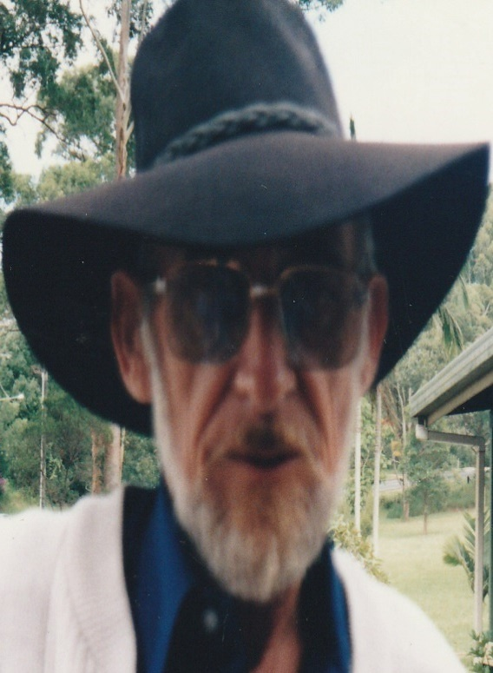

MURDER of
Frederick Hugh ROSSON
aka Charles Alexander “Slim” JOHNSTON
$500,000 REWARD

REWARD: The Minister for Police and The Minister for Corrective Services has approved a reward of $500,000 be offered for information which leads to the apprehension and conviction of the person or persons responsible for the murder of Frederick Hugh ROSSON aka Charles Alexander “Slim” JOHNSTON on the 14th of March 2002 at Mount Nathan.

INDEMNITY FROM PROSECUTION: In addition, an appropriate indemnity from prosecution will be recommended for any accomplice, not being the person who actually committed the crime, who first gives such information.

The allocation of the $500,000 reward will be at the sole discretion of the Commissioner of the Police Service.

CIRCUMSTANCES: On Thursday the 14th day of March 2002, between 11.30am and 12.30pm, Frederick Hugh ROSSON aka Charles Alexander “Slim” JOHNSTON died as a result of a gunshot wound. Police believe he was shot at his Mount Nathan home by a person unknown to him. Investigating Police have initiated an Investigation Centre at the Burleigh Police Station to investigate the homicide of Mr ROSSON and are appealing for public assistance to identify person/s responsible for his murder.

Any member of the public with information which could assist Police is asked to contact:

- Burleigh Criminal Investigations Branch, Phone (07) 5586 0444;
- Homicide Investigation Unit, Brisbane, Phone (07) 3364 4150;
- any Police Station; or
- Crime Stoppers, Phone 1800 333 000.

Commissioner’s Office, KATARINA CARROLL APM
BRISBANE COMMISSIONER

