

**Queensland Police Service**



**ANNUAL  
REPORT**

2021–2022

This annual report provides information about the Queensland Police Services’ financial and non-financial performance information for 2021-22. It has been prepared in accordance with the *Financial Accountability Act 2009*, the *Financial and Performance Management Standard 2019* and the Annual report requirements for Queensland Government agencies.

**Enquiries and further information**

Telephone: (07) 3364 3616

Visit: [www.police.qld.gov.au](http://www.police.qld.gov.au)

Email: [QPS.Reporting@police.qld.gov.au](mailto:QPS.Reporting@police.qld.gov.au)

This annual report can be obtained in paper form by calling 13 QGOV (13 7468) or online at [www.police.qld.gov.au/corporatedocs/reportsPublications/annualReport/default.htm](http://www.police.qld.gov.au/corporatedocs/reportsPublications/annualReport/default.htm).

**Feedback**

Feedback on the annual report can be provided through the Get Involved website:

<https://www.getinvolved.qld.gov.au/gi/>

**Other languages and formats**

The Queensland Government is committed to providing accessible services to Queenslanders from all cultural and linguistic backgrounds. If you have difficulty understanding the annual report, you can contact us on telephone   
(07) 3364 3616 or freecall the Translating and Interpreting Service (TIS National) on telephone number 131 450 and an interpreter will be arranged to communicate the report to you.

|  |  |  |  |
| --- | --- | --- | --- |
| **Queensland Police Service (**[**www.police.qld.gov.au**](http://www.police.qld.gov.au)**)** | | | |
|  | [www.mypolice.qld.gov.au](http://www.mypolice.qld.gov.au) |  | [www.youtube.com/QueenslandPolice](https://www.youtube.com/user/QueenslandPolice) |
|  | [www.facebook.com.au/QueenslandPolice](http://www.facebook.com.au/QueenslandPolice) |  | [www.instagram.com/qldpolice](http://www.instagram.com/qldpolice) |
|  | [www.twitter.com/QldPolice](http://www.twitter.com/QldPolice) |  |  |

**Copyright**

© The State of Queensland, Queensland Police Service 2022

**Licence**

****This annual report is licensed by the State of Queensland, Queensland Police Service under a Create Common Attribution (CC BY) 4.0 Australian licence.

**CC BY Licence Summary Statement**

In essence, you are free to copy, communicate and adapt this annual report, as long as you attribute the work to the State of Queensland, Queensland Police Service. To view a copy of this licence, visit: [www.creativecommons.org/licenses/by/4.0](http://www.creativecommons.org/licenses/by/4.0)

**Attribution**

Content from this annual report should be attributed as: The State of Queensland, Queensland Police Service Annual Report 2021-2022.

**ISSN:**

Online: 1837-235X

Print: 1837-2341

**Letter of compliance**

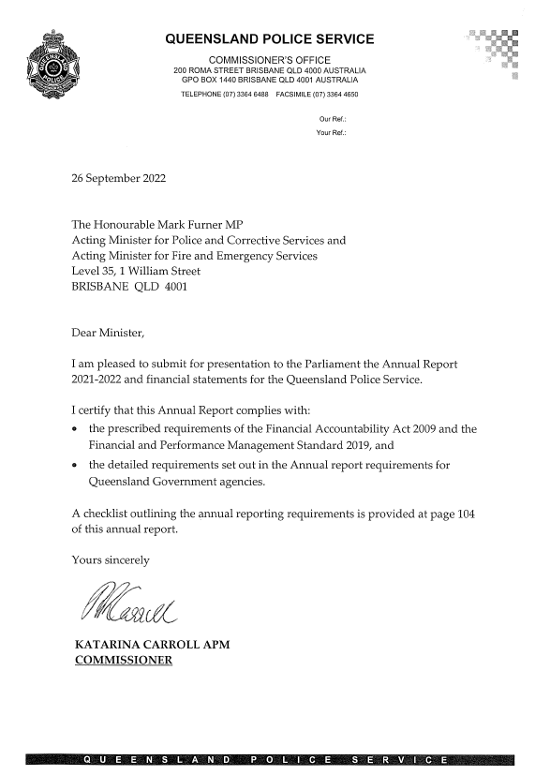

**Table of contents**

Letter of compliance 2

Table of contents 3

Acknowledgement of Country 4

Commissioner’s message 5

**About Us 7**

Organisational structure 16

QPS Regions Map 17

Service Delivery Program 19

QPS response to COVID-19 20

**Financial Summary 21**

Summary of financial performance 21

Summary of financial position 23

**Performance 25**

Key performance measures 25

2021-22 highlights 30

**Governance 40**

Executive management 40

Boards and committees 45

Government bodies 51

Ethics and code of conduct 51

Risk management and accountability 52

**Human Resources 56**

**Financial statements 62**

**Appendices 97**

Government bodies 97

Acronyms 102

Compliance checklist 104

Information about overseas travel and the *Queensland Language Services Policy* for 2021-22 is available on the Queensland Government Open Data Portal ([www.data.qld.gov.au](http://www.data.qld.gov.au)).

The QPS did not engage any consultants in 2021-22.

Acknowledgement of Country

The Queensland Police Service respectfully acknowledge First Nations peoples as the Traditional Owners and Custodians of Queensland. We recognise their connection to land, sea and community. We pay our respects to them, their cultures, and to their Elders, past, present and emerging.

**Commissioner’s message**

In my third year as Queensland’s Police Commissioner, I feel incredibly proud of how the QPS has responded to a constantly evolving and complex policing environment.

The first report from the Women’s Safety Justice Taskforce, containing 89 recommendations, was released in December 2021. The QPS welcomes reform and is committed to continuous learning and improvement and will be working with the Queensland Government to implement the recommendations to improve policing responses to domestic and family violence. The second report from the Taskforce was released on 1 July 2022 and contains 188 recommendations.

The QPS Service Alignment Program, which has since transitioned to the Service Delivery Program, commenced implementing the recommendations arising out of the QPS Strategic Review, released in 2020. Among other things, the review highlighted the significant increase in demand for policing services and QPS resources being stretched across large geographical areas is not sustainable. This resulted in the establishment of the Regional Alignment Project which examined regional boundaries, identified benefits and opportunities and optimised service delivery to meet the demands of a growing Queensland. On 1 July 2021, the Service created the North Coast and Far Northern Regions to gain longer term efficiencies in terms of capacity, people, and performance where service delivery is aimed at prevention, disruption, response and investigation.

The QPS continued to deliver outstanding frontline policing services and accomplish significant achievements that showcased the exceptional work and dedication of our members throughout 2021-22. I am continually amazed by the tremendous dedication of all members as the Service continues to meet the significant and increasing demands placed on our organisation.

Achievements for 2021-22 included:

* the Domestic, Family Violence and Vulnerable Persons Command delivering various bodies of work including:
* the development and release of a High Risk, High Harm Dashboard to provide officers with analytics to identify and target high risk, high harm perpetrators
* partnering with the Department of Justice and Attorney-General (DJAG) to introduce legislative changes to limit the trauma involved in the criminal justice process and allow officers to use body worn cameras to obtain victim statements
* collaborating with DJAG to trial and evaluate a co-responder model involving joint responses between QPS and domestic violence specialists
* continuing to support and enhance policing responses to mental health
* QPS referring over 78,000 people to various support services
* establishment of the Youth Justice Unit within the Crime and Intelligence Command to deliver the QPS-specific work of the Youth Justice Taskforce. The existing Youth Justice Taskforce will focus on multi-agency collaboration and whole-of-government responses and reform to target youth offending in Queensland
* launching the *Sexual Violence Response Strategy 2021-2023* to enhance the QPS’s capacity to prevent, disrupt, respond to, and investigate sexual violence and to hold perpetrators to account
* leveraging technology and providing a more agile policing response through the rollout of 10 mobile police beats to various locations across the state
* celebrating 25 years of civilian call centre operators which represents more than half of the total communication centre workforce
* getting tough new laws and harsher penalties to protect police dogs and horses who work alongside our frontline officers to protect the community
* commissioning the Queensland Police Vessel (QPV) *Sally Urquhart* in honour of fallen police officer Sally Urquhart to honour Sally’s life and ensure her service to the QPS and community is never forgotten
* supporting and promoting Lesbian, Gay, Bisexual, Transgender, Intersex, Queer+ pride within the QPS through the QPS Pride Network
* QPS being formally reaccredited as a White Ribbon workplace for a further three years in October 2021
* continuing to promote the ‘Our People Matter’ Strategy to support QPS members and delivering initiatives based on four pillars of *Healthy Bodies, Healthy Minds, Safe Workplaces, Fair and Positive Workplaces*
* conducting road policing operations to target the Fatal Five, curb negative road user behaviour and reduce Queensland’s road toll
* continuing to engage and improve communications with the community through various social media platforms.

Since early 2020, when the COVID-19 pandemic was first declared, the QPS provided a first-class policing response to reduce the spread and severity of COVID-19, while largely maintaining business-as-usual policing operations, including:

* standing up and deploying resources to the State Disaster Coordination Centre (SDCC) and Taskforce Sierra Linnet
* conducting border patrols at the state’s road border entries and at domestic and international airports including passenger screening
* conducting home quarantine checks and supporting Queensland Health’s contact tracing activities
* providing a security overlay at quarantine hotels
* the development and implementation of the border pass system that facilitated entry into Queensland
* rapid response planning and coordination to contain outbreaks of COVID-19.

In 2022, various restrictions were eased by the Queensland Government resulting in the stand down of the SDCC and closure of Taskforce Sierra Linnet with COVID-related response activities transitioning to business-as-usual functions. I am grateful to all Queenslanders who worked with police and complied with directions during this challenging time.

The staff and functions from the disestablished Public Safety Business Agency (PSBA) transitioned to the QPS and Queensland Fire and Emergency Services (QFES) on 1 July 2021. I welcomed the former PSBA staff that transitioned to the QPS and to the staff that transitioned to QFES, I offered my well wishes for their future careers.

We also farewelled former Assistant Commissioners Brian Wilkins and Mike Condon in 2021-22. They had long-standing careers with the QPS spanning over 35 years each. They collectively delivered invaluable services to the community of Queensland, and I wish them well in their future endeavours.

I am honoured to have led the QPS in 2021-22. I would like to thank the QPS Executive Leadership Team and our 17,000 plus members, police and staff alike, for their exceptional service, extraordinary dedication and commitment to our values of integrity, professionalism, community and respect and fairness to make Queensland the safest state.

I also extend my gratitude to all Queenslanders for working in partnership with the QPS to build a safer Queensland for all.

**Katarina Carroll**

**Commissioner**

**About the QPS**

The Queensland Police Service (QPS) is the primary law enforcement agency for Queensland. It fulfils this role throughout the state, 24 hours a day, seven days a week, 365 days a year, upholding the law and providing assistance to the community, particularly in times of emergency, disaster and crisis.

***Our Vision:*** *Queensland – the safest State.*

***Our Purpose:*** *Together, we prevent, disrupt, respond and investigate.*

**Our Accountabilities**

Under the *Police Service Administration Act 1990*, the QPS is responsible for:

* preserving peace and good order in all areas of Queensland
* protecting and supporting the Queensland community
* preventing and detecting crime
* upholding the law
* administrating the law fairly and efficiently
* bringing offenders to justice.

**Our Values**

Consistent with the QPS Strategic Plan 2021-2025, QPS members value:

* ***Integrity:*** Is in everything we do. We are honest, trustworthy and hold each other to a high standard.
* ***Professionalism:*** Times are challenging but if we are professional in everything we do, our communities will continue to support us.
* ***Community:*** We support each other and lend a hand to ensure we can respond to community needs as well as the needs of our policing community.
* ***Respect and Fairness****:* We treat each other and our communities as we would like to be treated ourselves – with fairness, dignity and respect.

The QPS also shares the Queensland Public Service Values of:

|  |  |
| --- | --- |
|  | **Customers first**   * Know your customers * Deliver what matters * Make decisions with empathy |
|  | **Ideas into action**   * Challenge the norm and suggest solutions * Encourage and embrace new ideas * Work across boundaries |
|  | **Unleash potential**   * Expect greatness * Lead and set clear expectations * Seek, provide and act on feedback |
|  | **Be courageous**   * Own your actions, successes and mistakes * Take calculated risks * Act with transparency |
|  | **Empower people**   * Lead, empower and trust * Play to everyone’s strengths * Develop yourself and those around you |

**Our Objectives**

The QPS contributed to the government’s objectives for the community by delivering quality frontline services that supported safe, caring and connected communities, to ultimately make Queensland the safest state. The QPS did this through our focus on:

* **Our people** to build a connected, engaged and job-ready workforce, with the health, wellbeing, and safety of our people a priority
* **Our community** to build a safer Queensland
* **Our relationships** to create a safer community and provide better services through connected and engaged relationships
* **Our commitment** to embrace new ideas and innovation to strengthen our capability to prevent, disrupt, respond to and investigate crime and deliver safe and secure communities

**Strategies**

The QPS achieves its objectives through a range of strategies:

To **build a connected, engaged and job-ready workforce, with the health, wellbeing, and safety of our people a priority**, the QPS:

* delivered leadership that was agile, authentic, supportive, courageous, innovative, and visible
* established and maintained strong partnerships, openness, awareness, and accessibility
* delivered healthy, safe, positive, and inclusive workplaces with a diverse workforce that reflected the community we serve
* prioritised physical, mental and social wellbeing
* provided fit for purpose resources to support all our staff.

To **build a safer Queensland together with our community**, the QPS:

* delivered timely and professional responses to calls for service to maintain and strengthen community confidence through a community-centred approach to policing and crime prevention
* partnered with the community and other agencies to respond to overrepresentation in the criminal justice system, of victims and offenders, including vulnerable persons, young people, and victims of domestic and family violence.

To **create a safer community and provide better services through connected and engaged relationships**, the QPS:

* maximised opportunities to prevent crime and enhance community safety through collaborative partnerships with government agencies, non-government organisations and community groups
* strengthened relationships with our people to better support us into the future
* protected the legitimacy of policing through fair and ethical service delivery.

To **embrace new ideas and innovation to strengthen our capability to prevent, disrupt, respond, and investigate crime and deliver safe and secure communities**, the QPS:

* delivered sustainable, effective, innovative, and efficient approaches to preventing, disrupting, responding, and investigating crime and delivering safe and secure communities
* prevented crime together by connecting our people, community, and relationships to collectively build a community culture of prevention and harm minimisation
* disrupted crime together by educating our people, community, and relationships in strategies to identify and disrupt local, state, national and global crimes
* responded to crime together by improving our response capability through streamlining, technology, improved models of service delivery, continuous learning, business optimisation and digital transformation
* investigated crime together by developing our people, community, and relationships to investigate crime in a global environment of complexity and ambiguity.

The QPS also contributed to a range of local, state and national strategies on matters, including youth justice, domestic and family violence and vulnerable people, mental health, road safety, child safety, drugs and alcohol, counter-terrorism and organised crime.

**Queensland Government objectives**

The QPS supports the government’s objectives for the community which are built around Unite and Recover – Queensland’s Economic Recovery Plan.

* Safeguarding our health: Safeguard people’s health and jobs by keeping Queensland pandemic-ready.
* Supporting jobs: Support increased jobs in more industries to diversify the Queensland economy and build on existing strengths in agriculture, resources and tourism.
* Backing small business: Help small business, the backbone of the state’s economy, thrive in a changing environment.
* Making it for Queensland: Grow manufacturing across traditional and new industries, making new products in new ways and creating new jobs.
* Building Queensland: Drive investment in the infrastructure that supports our recovery, resilience and future prosperity.
* Growing our regions: Help Queensland’s regions grow by attracting people, talent and investment, and driving sustainable economic prosperity.
* Investing in skills: Ensure Queenslanders have the skills they need to find meaningful jobs and set up pathways for the future.
* Backing our frontline services: Deliver world-class frontline services in key areas such as health, education and community safety.
* Protecting the environment: Protect and enhance our natural environment and heritage for future generations and achieve a 50 per cent renewable energy target by 2030.

**Our environment**

The policing environment in Queensland continues to be characterised by rapid change and increasing complexity. As a result, our services are being challenged to meet evolving demands. The change in our environment is driven by shifting community expectations and rapid technological innovation, influencing our service delivery in a broader context. To keep pace with the rapidly evolving environment, police will continue to explore opportunities to develop and maintain strong community relationships, harness advances in technology to deliver high quality efficient policing services and develop collaborative approaches to increase community safety. Further, as a service we will continue to remain agile with our response to severe weather events, climate change and emerging technologies impacting the criminal environment.

In response, the QPS will:

* maintain an agile partnership-oriented disaster management capability to plan for and respond to extreme weather events
* establish a specialist capability to enhance the QPS response to proactively target Money Laundering
* continue to support the implementation and monitoring of the Third Action Plan of the *Domestic and Family Violence Prevention Strategy 2016-2026* and contribute to the response to the Women’s Safety and Justice Taskforce First Report – *Hear her voice*
* promote multi-agency initiatives and partnerships to address and manage youth crime and recidivism including the Youth Justice Five Point Plan and regional initiatives in collaboration with the Department of Children, Youth Justice and Multicultural Affairs (DCYJMA)
* develop an Organised Crime Strategy 2022-26 to coordinate prevention, disruption, investigation and other responses to organised crime and associated harms impacting Queensland
* conduct research into victimology of persons who are victims of cybercrime to drive prevention and community resilience opportunities
* support inter-agency relationships to increase the proportion of offenders, particularly young people and vulnerable persons, diverted from the criminal justice system
* utilise and identify emerging technologies to benefit police, by improving interoperability between public safety agencies and enhancing operational effectiveness
* deliver modern, mobile and flexible policing through the introduction of mobile police beat vans and a range of other police resources.

**Our challenges and opportunities in 2021-22**

The QPS acknowledges the importance of addressing a range of potential strategic challenges to ensure we keep Queenslanders safe. The Service identified these challenges and opportunities to respond to in 2021-22, linking them to the strategic objectives.

Key challenges for the QPS during 2021-22 included:

* delivering an effective policing response to the ongoing COVID-19 pandemic that upholds public health directives while maintaining strong community relationships
* maintaining an agile disaster management capability to plan for and respond to an increase in the frequency and/or severity of extreme weather events and natural disasters
* adapting to economic conditions while continuing to deliver high quality and efficient policing services
* adapting to keep pace with challenges presented by new and emerging technologies and their impact on the criminal environment and regulation of online information
* strengthening the integrity and professionalism of police to enhance community satisfaction, trust and confidence in the QPS, in an environment of evolving community expectations.

To address these challenges, the QPS identified the following opportunities to best position the QPS to make Queensland the safest State:

* leading the QPS service delivery model through a period of significant disruption by remaining agile to shifting demands and community safety needs
* championing collaborative approaches to promote outcomes for vulnerable people, and enhance social cohesion and community safety
* building upon organisational learning and experience from the COVID-19 pandemic response to improve business continuity during future significant events
* promoting a workforce which is flexible, inclusive and diverse, to enhance engagement and performance
* empowering the workforce by investing in their safety, mental health and wellbeing, and by proactively developing organisational capabilities to keep pace with future challenges.

**2022-23 Outlook**

The QPS in 2022-23 will work towards:

* adapting to keep pace with challenges presented by new and emerging technologies and their impact on the criminal environment and regulation of online information
* strengthening the integrity and professionalism of police to enhance community satisfaction, trust and confidence in the QPS, in an environment of evolving community expectations
* delivering an effective policing response to COVID-19 that upholds public health directives while maintaining strong community relationships
* maintaining an agile disaster management capability to plan for and respond to an increase in the frequency and/or severity of extreme weather events and natural disasters
* advancing the use of evidence-based policing strategies to deliver victim-centric, trauma-informed responses to victims and design strategic prevention activities
* continuing to support implementation of the Domestic and Family Violence Prevention Strategy 2016-2026 and contribute to the response to the first report of the Queensland Women’s Safety and Justice Taskforce, *Hear her voice* – Report one – Addressing coercive control and domestic and family violence in Queensland
* continuing to support the Queensland Government’s *Youth Justice Strategy 2019-23* – Working Together, Changing the Story, to assist young Queenslanders to make positive life choices through crime prevention and early intervention
* continuing to implement recommendations from *the Royal Commission into Institutional Responses to Child Sexual Abuse*
* continuing to support the *Queensland Road Safety Strategy 2022-31* through proven road safety interventions.

For 2022-23, the QPS identified the following opportunities, including:

* championing collaborative approaches to promote outcomes which are victim-centric and trauma-informed for vulnerable people, and enhance social cohesion and community safety
* promoting a workforce which is flexible, inclusive and diverse, to enhance engagement and performance
* empowering the workforce by investing in their safety, mental health and wellbeing, and by proactively developing organisational capabilities to keep pace with future challenges
* leading the QPS service delivery model through a period if significant disruption by remaining agile to shifting demands and community safety needs
* identifying innovative applications for new and emerging technologies in policing, while upholding community expectations around transparency, privacy and ethics.

***Human Rights Act 2019***

On 1 January 2020, the *Human Rights Act 2019* (Qld) (the Act) came into effect, creating obligations for public entities to act and make decisions in a way that is compatible with human rights, and to give proper consideration to human rights when making a decision. The QPS has made a commitment to respect, protect and promote human rights in our decision-making and actions.

The QPS works tirelessly to ensure Queensland is the safest state, including exercising police powers embedded in legislation such as diversion, move on directions, detention and or arrest, in a way that least impacts on people’s rights while protecting the safety and security of the Queensland community.

As part of this commitment, the QPS has taken steps to further the objectives of the Act including:

* + - * developing training products by Ethical Standards Command relating to the discipline process including instruction on human rights to reinforce the objectives of the *Human Rights Act 2019*
* incorporating human rights in the draft Police Recruiting Management Manual, staff orientation packages and various recruit training curriculum materials
* embedding human rights in regular reporting and decision making through education, training and awareness.

Human Rights complaints

Since the commencement of the Act, the QPS had updated its complaints and grievance policies, procedures and mechanisms to ensure human rights complaints can be recorded, assessed and responded to appropriately. The QPS examines all complaints received by the QPS to ensure decisions made by the Service and its employees were compatible with the Act.

In 2021-22, the QPS recorded:

* 1,184 complaints where it was identified that one or more human rights may have been unreasonably limited
* 1,552 possible human rights limitations (one complaint can include more than one human rights limitation)
* 48 instances where human rights were unreasonably limited resulting in:
* 12 apologies
* 1 managerial resolution
* 19 explanations
* 16 disciplinary actions
* However, in most cases, there was no further action taken as no human rights limitations were detected, or an explanation was provided to the complainant as the officers’ actions were identified as being lawful and reasonable.
* 757 (of the 1,184) complaints were finalised as at 30 June 2022.

Each time the QPS received a complaint, human rights limitations were assessed to determine if any rights were unreasonably limited. The human rights aspect of each complaint was investigated along with the allegation/s, which assisted in determining the appropriate resolution.

*Notes:*

1. A human rights complaint is a complaint about an alleged contravention of Section 58(1) of the Act by a public entity in relation to an act or decision of the public entity (i.e. that an act or decision is not compatible with human rights and/or that a decision did not properly consider relevant human rights).
2. It is expected that sometimes a complainant will not identify human rights matters within a complaint they make to the QPS. Where the QPS identifies that the complaint may include a contravention of Section 58 of the Act the QPS is expected to record this and respond appropriately.
3. The total number of human rights complaints includes all those identified by a complainant and the QPS. A human rights complaint is counted as one regardless of the number of alleged acts, decisions or human rights limited within a complaint made to the QPS.
4. The total number of complaints where one or more human rights were allegedly unreasonably limited relates to all complaints made to the QPS by both internal and external complainants (refer page 51).
5. As a result of the QPS refining the process and methodology for identifying and recording complaints involving a human rights component, the 2021-22 data cannot be compared with the previous financial year.

**Information security attestation**

During the mandatory annual Information Security reporting process, the Commissioner attested to the appropriateness of the information security risk management within the QPS to the Queensland Government Chief Information Security Officer, noting that appropriate assurance activities have been undertaken to inform this opinion and the Service information security risk position.

**Machinery of government changes**

Pursuant to the *Public Service Departmental Arrangements Notice (No.1) 2022*, the responsibility and functions of the Road Safety Camera Office (CDOP) was transferred from the QPS to Queensland Treasury in February 2022.

**Our partners**

The QPS continued to foster strong relationships with its partners in the community, including the Queensland Police-Citizen Youth Welfare Association, Neighbourhood Watch Queensland and Crime Stoppers Queensland.

* **Queensland Police-Citizens Youth Welfare Association (QPCYWA)**

The QPCYWA, commonly known as Police-Citizens Youth Club (PCYC), is a non-government, not-for-profit organisation that provides appropriate, affordable and accessible youth development programs and services to support young people in making positive life choices.

PCYC Queensland delivers services through Police-Citizen Youth Clubs located in various urban, rurual and remote communities across the state. Each club is managed by a QPS Sergeant. This encourages positive relationships in the community and fosters unique interactions and experiences between QPS officers and young Queenslanders. First established in 1948, there are now 54 PCYC clubs with 75 sworn officers and four staff members supporting operations. For more information or to find a club near you, visit the PCYC website at [www.pcyc.org.au](http://www.pcyc.org.au).

* **Neighbourhood Watch Queensland (NHWQ)**

NHWQ is a partnership between the QPS and the Queensland community to enhance community safety. It encourages communities to join together in small informal groups to improve the safety of their families and other people who live, visit and do business in their neighbourhood. NHWQ is focused on enhancing home security, reducing the fear of crime and reporting suspicious activity to police. There are approximately 331 NHWQ groups located throughout Queensland.

The NHWQ blog provides daily NHWQ information from around the state. For more information or to find your local NHW group, visit the NHWQ website at www.nhwq.org.

* **Crime Stoppers Queensland**

Crime Stoppers Queensland is a community volunteer organisation that encourages the community to help make a difference in solving and preventing crime. It provides an avenue for the community to assist police to solve crimes.

Crime Stoppers Queensland provides a telephone hotline and website for community members to provide anonymous information about criminal activity. This information is sent electronically to the relevant police establishment for investigation in the area where the crime is occurring.

The QPS assists Crime Stoppers Queensland through the following:

* the Assistant Commissioner, Crime and Intelligence Command is on the Board of Directors as the Commissioner’s representative
* a dedicated police unit manages the partnership deliverables, administers intelligence reports, handles investigator inquiries and assists Crime Stoppers State Office personnel with promotional displays and presentations as required
* police officers act as partnership representatives in many of the 24 Volunteer Area Committees spread throughout the state.

During 2021-22, the QPS Crime Stoppers Unit, in partnership with Crime Stoppers Queensland, continued to receive information from the public on criminal activity which resulted in:

* over 12,500 phone and more than 16,600 digital contacts from members of the public
* the apprehension of 682 people
* more than 2,820 charges laid
* the confiscation of more than $792,000 worth of drugs
* the seizure of approximately $394,400 in proceeds of crime.

For more detailed information, visit the Crime Stoppers Queensland website at [www.qld.crimestoppers.com.au](http://www.qld.crimestoppers.com.au).

* **Queensland Homicide Victims Support Group**

Queensland Homicide Victims Support Group (QHVSG) delivers services to people who have lost a loved one to homicide and offers a truly unique service. For many living in the aftermath of homicide, healing is often accelerated by speaking with others who have ‘been there too’. Each year, QHVSG supports nearly 150 family members that experience first-hand the devastating effects of homicide.  The Commissioner is the Patron of the QHVSG, and the group works closely with the QPS, liaising with families and providing first responder emotional support.

* **Volunteers in Policing**

The aim of the Volunteers in Policing (ViP) program is to recruit and train local community members to carry out a range of voluntary tasks that complement but not compete with the established responsibilities of police officers and other paid staff members. In general, these tasks assist police to deliver a range of services designed to enhance community safety. ViPs are based in local police establishments where they work with police to address customer service, community safety and crime prevention needs in the local area. ViPs also support victims of crime, often attending with police to speak with and provide support to people who have gone through difficult and traumatic experiences. ViPs also assist Police Recruiting with the overall recruiting process. There are approximately 252 ViPs throughout the state. For more information or to become a ViP, visit the QPS website [www.police.qld.gov.au/join/vip/default.htm](http://www.police.qld.gov.au/join/vip/default.htm).

**Action plans and strategies**

The QPS works collaboratively with various government departments, including the Department of Premier and Cabinet, Queensland Treasury, Department of Children, Youth Justice and Multicultural Affairs, Department of Justice and Attorney-General, Queensland Health, non-government and not-for-profit organisations and private sectors, to lead and/or contribute to whole-of-government action plans and strategies, and various other bodies of work.

The QPS provides regular input into Queensland Government action plans and strategies including, but not limited to:

* Queensland Youth Justice Strategy (2019-23) and Action Plan (2019-2021) – being updated
* Queensland Youth Justice and Youth Engagement Charter Reporting (2020-21)
* Culture and Reconciliation and Moving Ahead (CARMA)
* Many Voices – Queensland Aboriginal and Torres Strait Islander Languages Policy Action Plan 2020-2022
* Local Thriving Communities Action Plan 2020-22
* Disability Services Plan (2020-21) – (being updated)
* Queensland Government Regulator Performance Framework
* Sexual Violence Prevention Framework and Action Plan (2021-22) – being updated
* Domestic and Family Violence Prevention Strategy 2016-2026

The progress updates against the actions plans and strategies can be viewed on [www.police.qld.gov.au](http://www.police.qld.gov.au).

The QPS is also working with partner agencies to implement the recommendations from Royal Commissions and/or Commissions of Inquiry including:

* *Women’s Safety Justice Taskforce Report 1 – Hear her voice*
* *Royal Commission into Institutional Responses to Child Sexual Abuse*
* *Not Now, Not Ever: Putting an end to domestic and family violence in Queensland report.*

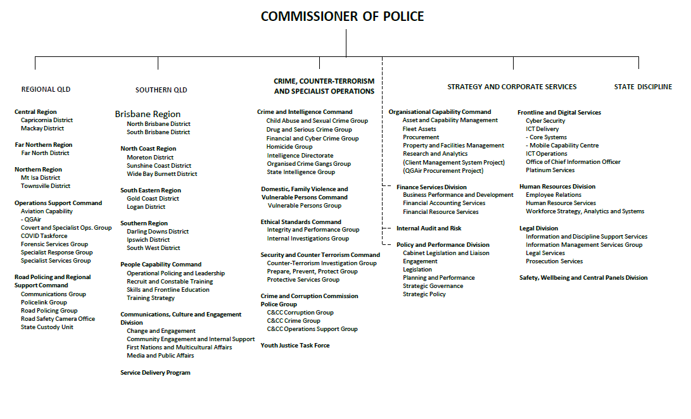**Organisational structure**

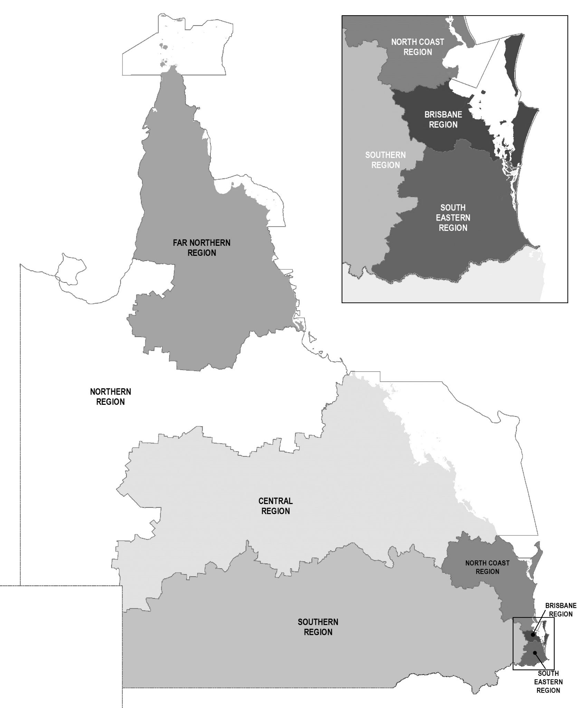**Regional Map**

**Locations**

QPS delivers its services from various locations throughout the state including:

|  |  |
| --- | --- |
| * Police facilities | 341 |
| * Police watchhouses | 57 |
| * Police neighbourhood beats, shopfronts and mobile police beats | 64 |
| * District offices | 15 |
| * Headquarters and regional offices | 8 |
| * Communication centres | 14 |
| * Police academies located in Oxley and Townsville | 2 |
| * Policelink located in Brisbane (Zillmere) | 1 |
| * Rapid Action and Patrol Groups (RAPS) located at Gold Coast and Townsville | 2 |

In addition, each police district is supported by a range of specialist areas which may include the Child Protection and Investigation Unit, Criminal Investigation Branch, Intelligence Unit, Scenes of Crime and Scientific Units, Dog Squad Unit, Forensic Crash Unit, Road Policing Unit, Prosecutions Corp and Water Police Unit. There are also purpose-built investigation centres to respond to major incidents located at various stations and district offices throughout the state.

The QPS delivered minor and medium capital works and major capital investment projects.   
In 2021-22, the QPS delivered the following capital projects:

* Beaudesert replacement police facility
* Biloela replacement police facility
* Pimpama new police facility
* Pormpuraaw replacement police facility and watchhouse
* Nambour replacement police facility.

**Service Delivery Program**

In January 2020, the Service Alignment Program (SAP) was established to implement the 22 recommendations resulting from the QPS Strategic Review, initiated by the Commissioner in September 2019. While SAP transitioned to a business-as-usual model in July 2021, the Service Delivery Program (SDP) is continuing the implementation of the new service delivery model across the Service.

One of the final actions of the SAP was the realignment of the existing five regions resulting in the creation of two new regions. The QPS now has seven regions including the North Coast (based on Moreton, Sunshine Coast and Wide Bay-Burnett Districts) and Far North (based on Cairns and Cape York Peninsula areas) Regions as of 1 July 2021.

The 2019 QPS Strategic Review highlighted the significant increase in demand on the Service and the stretch on resources across large geographical spans could not be sustained. As a result, the Regional Alignment Project was established to examine regional boundaries to identify benefits and opportunities to optimise service delivery to meet the demand of a growing Queensland. This project considered strategic, structural, and situational challenges and opportunities to deliver policing services across the state, along with local government, disaster management and the Australian Bureau of Statistics Census Data mesh block boundaries. The creation of these two new regions provided the opportunity to gain longer term efficiencies in terms of capacity, people, performance and community where service delivery is aimed at prevention together, disruption, response and investigation.

The SDP is intended to drive service delivery reform throughout the state, centred around a purpose-built end-to-end service delivery model. The primary aim of the SDP is to create a connected, engaged and job ready workforce that maintains and strengthens community confidence by delivering timely and professional responses to calls for service.

The Service Delivery Redesign Project (SDRP) was established to explore, design and test a new frontline service delivery model in a trial location to confirm the viability and scalability of the model prior to a statewide rollout. Moreton District was selected as the trial location in early 2020. The trial concluded in October 2021 and resulted in the creation of a new service delivery model to be rolled out into districts.

The service delivery model is based on a core foundational structure. Each police district works with the SDP team to customise the service delivery model to reflect local needs and nuances. The service delivery model was trialled in Moreton District in North Coast Region with key learnings informing future implementation. This work has led to a statewide rollout with the design phase to commence in Logan District in August 2022.

**QPS response to COVID-19**

The QPS continued to provide ongoing and widespread support in 2021-22 as part of Queensland’s response to the COVID-19 public health emergency. The QPS undertook multiple roles focused on educating the community and ensuring compliance with essential public health measures, taking enforcement action as appropriate.

The prolonged QPS response was coordinated through the dedicated Taskforce Sierra Linnet which operated from the State Police Operations Centre (SPOC) in Brisbane. The Taskforce was initially stood up on 6 March 2020 and ceased operations on 29 April 2022.

Throughout 2021-22, the QPS continued to provide the following essential functions:

* border pass application processing and approvals
* domestic and international border controls (including at road borders and airports)
* issuing of quarantine direction notices and investigation of any breaches in relation to these directions
* security overlay at government-nominated quarantine facilities, including at the Queensland Regional Accommodation Centre (QRAC)
* community compliance checks for individuals and businesses regarding the public health and social measures linked to vaccination status and mask-wearing requirements.

After almost two years of tireless QPS effort on Queensland’s road borders and at domestic airports, including the 60 iterations of the public health directions that restricted entry into Queensland, all domestic border controls were removed on 15 January 2022.

Between 26 March 2020 and 15 January 2022, approximately 10 million border passes were issued for entry into Queensland. During this period at Queensland’s road borders, the QPS:

* intercepted more than 3.7 million vehicles
* over 35,900 vehicles were turned around
* directed more than 20,240 people to quarantine.

For the same period at Queensland’s domestic airports:

* almost 29,700 flights were met by police
* more than 1.8 million passengers were processed
* over 4,450 passengers were refused entry
* more than 64,480 passengers were directed to quarantine.

In response to increased vaccination rates and the changing public health environment, restrictions for international travel into Queensland were gradually eased in stages on 22 January 2022 and 28 April 2022, before finally being removed on 30 June 2022. The QPS withdrew from activities at international airports on 28 April 2022. Between 27 March 2020 and this time:

* more than 291,400 passengers were processed
* over 77,840 international passengers were placed into hotel quarantine (excluding flight crew and exempt persons such as seasonal workers and seafarers).

In relation to other activities, throughout the pandemic, the QPS:

* conducted more than 34,450 self-quarantine compliance visitations (6 February 2020 to 22 January 2022)
* conducted almost 15,500 business compliance visits (26 February 2020 to 22 January 2022)
* handed out more than 17,100 masks to members of the community (29 June 2021 to 4 March 2022)
* responded to over 37,300 calls for service related to COVID-19 (1 March 2020 to 29 April 2022).

The QPS acknowledges the COVID-19 pandemic may continue for the foreseeable future. Following the reduction in the level of QPS involvement required for the whole-of-government response and the subsequent closure of Taskforce Sierra Linnet on 29 April 2022, the management of all COVID-19 related response activities transitioned to business-as-usual functions after this date.

**Financial Summary**

**Summary of financial performance**

The following table summarises the operating result and financial position for QPS 2021-22 and the previous financial year.

|  |  |  |
| --- | --- | --- |
| **Statement of comprehensive income** | **2021-22 $’000** | **2020-21 $’000** |
| Total income from continuing operations | 2,858,646 | 2,551,428 |
| Total expenses from continuing operations | 2,858,646 | 2,653,432 |
| Total other comprehensive income | 104,660 | (43) |
| **Total comprehensive income** | **104,660** | **(102,048)** |
| **Statement of financial position** | **2021-22 $’000** | **2020-21 $’000** |
| Total assets | 2,219,654 | 1,967,114 |
| Total liabilities | 139,463 | 129,975 |
| **Net assets/equity** | **2,080,190** | **1,837,139** |

As a result of the Departmental Arrangements Notice (No. 2) 2021 and the disestablishment of the Public Safety Business Agency (PSBA), PSBA assets and liabilities were transferred to QPS, effective 1 July 2021, net assets $115.666 million.

**Income and expenses from continuing operations**

QPS is funded to deliver timely, high quality and efficient policing services, in collaboration with community, government and non-government partners, to make Queensland safer. Funding for these services is received principally through parliamentary appropriations.

QPS aims to deliver safety and secure communities through innovation, collaboration and best practice. The expenses incurred in the delivery of these services are summarised further below.

For 2021-22, QPS received income from continuing operations totalling $2,858.646 million and incurred total expenditure from continuing operations of $2,858.646 million. This was comprised of:

**Income**

**Expenses**

**Summary of financial position**

QPS was in a positive financial position at the end of the financial year. The total equity (assets less liabilities) of QPS at the end of 2021-22 was $2,080.19 million. This is an increase from 2020-21 $1,837.14 million which includes $104.66 million increase in asset revaluation surplus and $115.666 million net asset and liability transfer of operational assets and PSBA functions as at 1 July 2021, from PSBA to QPS. This was comprised predominantly of:

**Assets**

**Liabilities**

**Event occurring after balance date**

There were no significant events after balance date that could be expected to impact the reported operating result for QPS for the year ended 30 June 2022.

**Performance**

**Key performance measures**

The services provided by the QPS focus on reducing and preventing the incidence of crime, public disorder and road trauma to build safe, caring and connected communities. These are delivered through one service area – Police Services.

The objective of the service area is to keep Queensland safe by working with the community and our partners to prevent, disrupt, respond and investigate crime and eliminate road trauma. A range of services are provided by the QPS to support this, including:

* protecting property and personal safety through prevention, disruption, response to and investigation.
* maintaining public order and safety, including during major events and disasters
* working with partners to reduce demand on the criminal justice system by addressing over-representation among vulnerable groups, including First Nations peoples
* Preventing, disrupting, responding and investigating driver behaviours contributing to road trauma: speeding; red light offences; driving while distracted; driving under the influence of alcohol or drugs; driving while fatigued; and not wearing seatbelts.

The delivery of policing services to Queenslanders is supported by a range of activities designed to promote ethical behaviour, integrity and professional practice.

The impact of the COVID-19 health pandemic had a significant impact on Queenslanders. The QPS ongoing response to the COVID-19 health pandemic included the allocation of resources at various locations across the state.

The following tables provide an overview of the key performance measures for the QPS for 2021-22. Data for 2020-21 is sourced from the Queensland Police Service 2020-21 Annual Report unless otherwise stated in the Notes.

|  |  |  |  |  |  |  |  |
| --- | --- | --- | --- | --- | --- | --- | --- |
| **Service Area: Police Services** | | | | | | | |
| **Performance measures** | **Notes** | **Strategic Plan** | **2021-22 SDS** | **RoGS** | **2020-21 Actual** | **2021-22 Target**  **/Estimate** | **2021-22 Actual** |
| Percentage of personal safety offences cleared within 30 days: | 1,4 | P | P |  |  |  |  |
| * Homicide |  | 86% | 70-83% | 73.2% |
| * Assault |  | 53% | 54-63% | 58.9% |
| * Sexual assault | 5 | 45% | 48-57% | 38.4% |
| * Robbery |  | 64% | 57-62% | 62.3% |
| * Total personal safety |  | 52% | 54-61% | 55.5% |
| Percentage of property security offences cleared within 30 days: | 2, 4 |  |  |  |  |  |  |
| * Unlawful entry |  | 22% | 18-21% | 24.0% |
| * Other property damage |  | 29% | 25-27% | 36.0% |
| * Motor vehicle theft |  |  |  |  | 42% | 36-39% | 43.1% |
| **Performance measures** | **Notes** | **Strategic Plan** | **2021-22 SDS** | **RoGS** | **2020-21 Actual** | **2021-22 Target**  **/Estimate** | **2021-22 Actual** |
| * Other theft (excluding unlawful entry) |  |  |  |  | 30% | 26-28% | 30.0% |
| * Total property security |  | 30% | 28-30% | 31.4% |
| Percentage of good order offences cleared within 30 days | 3, 4 |  |  |  | 79% | 80-85% | 78.3% |
| Rate of crime victimisation per 1,000 population | 6 |  |  |  |  |  |  |
| * Total person offences | 7 | 7.5 | <6.3 | 12.2 |
| * Total property offences |  | 40.1 | <42.3 | 44.4 |
| Percentage of proceedings where young offenders were offered and accepted a diversion option | 8, 9 | P |  |  | 39.2% | >40% | 38.8% |
| Percentage of proceedings where all offenders were offered and accepted a diversion option | 8, 9 |  |  |  | 14.8% | >10% | 15.4% |
| Public perception of safety | 10-13 | P | P | P |  |  |  |
| * Feelings of safety walking alone in neighbourhood during the night | 52.3% | >50% | 51.2% |
| * Feelings of safety travelling alone on public transport during the night | 30.8% | >25% | 30.5% |
| Satisfaction of members of the public who had contact with police in the last twelve months | 10, 13 |  |  |  | 82.5% | >85% | 74.5% |
| Public satisfaction with police dealing with emergencies and disasters | 10, 13 |  |  |  | 83.8% | >85% | 77.8% |
| Public perception of police integrity | 10, 13 |  |  |  |  |  |  |
| * Police perform their job professionally | P | 87.7% | >85% | 82.6% |
| * Police treat people fairly and equally |  | 72.9% | >75% | 67.5% |
| * Police are honest |  | 72.7% | >75% | 67.5% |
| * I do have confidence in the police |  | 83.7% | >85% | 78.3% |
| Rate of complaints against police per 100 sworn staff | 14 |  |  |  | 9.5 | <9.8 | 10.4 |
| **Performance measures** | **Notes** | **Strategic Plan** | **2021-22 SDS** | **RoGS** | **2020-21 Actual** | **2021-22 Target**  **/Estimate** | **2021-22 Actual** |
| Rate (per 100,000 people) of road crash fatalities | 15, 16 |  |  |  | 5.66 | 4.3 | 5.57 |
| Rate (per 100,000 people) of people hospitalised following a road crash | 15, 16 |  |  |  | 134.16 | 110 | 150.09 |
| Percentage of code 1 and code 2 incidents attended within 12 minutes | 17 | P | P | P | 86.0% | >85% | 85.3% |
| Cost of police services per person | 18 |  |  | P | $490 | $494 | $502 |
| Agency engagement | 19 |  |  |  | 55% | 55% | 51% |
| Workforce diversity | 20-22 |  |  |  |  |  |  |
| * Women in SO, SES and above | 16.3% | 16.7% | 18.0% |
| * First nations | 2.2% | 3.0% | 2.3% |
| * People with Disability | 2.9% | 5.0% | 1.2% |
| * People from non-English speaking background | 6.6% | 9.0% | 4.0% |
| ***Discontinued measures*** |  |  |  |  |  |  |  |
| Proportion of young offenders who have another charged offence within 12 months of initial finalisation for a proven offence | 23, 24 |  |  |  | 75% | TBA | TBA |

Notes

1. The offence categories reported separately are those classified as ‘violent’ crimes and are the most significant personal safety offence categories in terms of their impact on the community. The ‘total personal safety’ offences figure also includes the offence categories of extortion, kidnapping, abduction and deprivation of liberty and other offences against the person. Homicide includes the offence categories of murder, attempted murder and conspiracy to murder.
2. The offence categories reported separately are considered high volume property security offences. The total property security offences figure also includes arson, fraud and handling stolen goods.
3. Good order offences include offences relating to public nuisance, obstructing police and other offences against good order. An increase in good order offences generally indicates an increase in policing activity around public spaces and major events, and a range of related proactive policing strategies often focusing on liquor-related enforcement.
4. Performance is reported against a range rather than a single figure. The target ranges for 2021-22 consider recent results and any known factors that are likely to have an impact in the reporting period. Upper and lower values account for past variation from the recent historical average.
5. The complexity and protracted nature of sexual assault investigations, coupled with characteristics of the offence reported may impact the proportion of crimes cleared within a set timeframe. Therefore, a definitive explanation for the variance between the 2021–22 Target/Estimate and 2021–22 Actual for sexual assault offences is not feasible.
6. The measure counts the number of people or addresses classed as a ‘victim’ of a personal or property offence in the preceding 12-month period and represents this as a rate per 1,000 population. The figure is separate and distinct from the rates of offending. It is possible to have a reduction of the number of victims without a reduction in offences.
7. From 1 July 2021 the QPS implemented a decision to enhance the consistent practice of recording criminal offences associated with domestic and family violence (DFV) investigations across the state within the QPS QPRIME computer system. When responding to and investigating a DFV occurrence, police across the state are now consistently recording all offences identified in the same incident in the QPRIME system. This means that police districts will likely see a statistical increase in a number of DFV related offence categories – for example DFV related assault, strangulation or wilful damage.
8. Offender Diversions refers to the number of offenders (young offenders or adult offenders) who are diverted as a proportion of all offenders proceeded against by police.
9. The term ‘diverted’ includes diversions of all offenders away from the courts by way of community conference, cautioning by police, intoxication diversion, drug diversion or graffiti diversion. For adult offenders, only infringement notices (excluding traffic infringement notices) are included in the count of ‘diversions’.
10. Public satisfaction with police and perceptions of police are sourced from the results of the National Survey of Community Satisfaction with Policing. The National Survey of Community Satisfaction with Policing is a general community survey. Respondents to these questions may or may not have had contact with police in the last 12 months.
11. The figure refers to the percentage of Queensland survey respondents who selected “very safe” or “safe” for each of the following activities:

* walking alone in your neighbourhood during the night
* travelling alone on public transport during the night.

1. The measures for feelings of safety on public transport are based on the entire survey population and includes those participants who have not used public transport. The figure is reported to match the existing Report on Government Services (RoGS) standard.
2. Queensland results mirror that occurring at a national level, indicating national-level factors affecting satisfaction with police. The results are likely a mix of local and national factors affecting attitudes to police generally, though the impact of any one factor (or group of factors) on satisfaction with or perceptions of police cannot be confirmed based on available data. Attitudinal data in particular can be influenced in the short term by significantly adverse or highly publicised events. Point-in-time responses can vary from people's true underlying (or longer term) satisfaction with police and general community perceptions.
3. ‘Complaints’ are defined as statements by members of the public regarding police conduct, including officers on, off or unknown duty, when a person was in police custody or had voluntary or involuntary dealings with the police.  Sworn staff refers to a police officer employed by the QPS who has sworn the Oath of Office under the *Police Service Administration Act 1990*, delivering a police or police-related service to an external customer.
4. The variance between the 2021–22 Actual and 2021–22 Target / Estimate was based on a number of societal influences that can vary throughout the year resulting in changes in numbers of road crashes.
5. The QPS, in partnership with the Department of Transport and Main Roads, continues to implement various road safety initiatives and programs aimed at reducing lives lost and hospitalisations. The variance between the 2021–22 Actual and 2021–22 Target / Estimate was based on a number of societal influences that can vary throughout the year resulting in changes in numbers of road crashes.
6. Code 1 and 2 incidents include very urgent matters when danger to human life is imminent and urgent matters involving injury or present threat of injury to person or property. The benchmark of 12 minutes was chosen for comparability with New South Wales Police who use similar methodology, business rules and systems.
7. Cost of police services per person is the total cost of delivering policing services divided by the estimated population of Queensland. This measure is reported in line with RoGS methodology.
8. Data for this measure is taken from responses of QPS employees to the whole-of-Government Working for Queensland survey, conducted annually. The measure describes employees’ level of engagement with the organisation in relation to motivation, inspiration and pride.
9. In early 2016, the Leadership Board of Directors-General introduced and committed to sector-wide diversity targets, working from the principle that our workforce should closely represent the community we serve.
10. Data is based on substantive placements and includes paid and unpaid employees, excluding staff members engaged on a casual relief basis. Figures are based on self-reported data that is not mandatory which may result in under-reporting on at least some of the diversity categories included. Due to the operational requirements of police, the “People with disability” target is based on non-operational staff members only.
11. The QPS workforce generally changes at a slower rate compared to other agencies as it has a lower attrition rate, and regarding police officers, generally positions are filled internally only. Consequently, it is challenging to achieve changes to the workforce except over an extended period.
12. This measure of youth reoffending is currently used by QPS and the Department of Children, Youth Justice and Multicultural Affairs. The measure is discontinued as of 1 July 2022 owing to a change to data definition to include the 10-17 year cohort in calculation of youth reoffending.
13. Data is not currently available and is expected to the published on the Department of Children, Youth Justice and Multicultural Affairs website in October 2022.

**Key**

RoGS – Report on Government Services

SDS – Service Delivery Statement

Strategic Plan – Queensland Police Service Strategic Plan 2021-2025

**2021-22 Key Highlights**

This section reports on the objectives of the QPS Strategic Plan 2021-2025. To drive delivery of its objectives, the QPS focuses on four main strategies to make Queensland the safest state:

**Our people:** Build a connected, engaged and job-ready workforce, with the health, wellbeing and safety of our people a priority

**Our community:** Together with our community build a safer Queensland

**Our relationships:** Create a safer community and provide better services through connected and engaged relationships

**Our commitment:** Embrace new ideas and innovation to strengthen our capability to prevent, disrupt, respond and investigate crime and deliver safe and secure communities.

The below is a snapshot of the key performance highlights from 2021-22 and is not representative of all work undertaken during the reporting period. For more information and to keep up to date with QPS news, follow QPS on social media or Mypolice blog (refer to page 1).

**Road Policing and the Fatal Five**

Many road crashes involve at least one of the ‘Fatal Five’ high-risk road user behaviours which include speeding, drink and drug driving, not wearing a seat belt, driving while fatigued, and driver distraction and inattention. The QPS is committed to reducing these numbers by conducting multiple statewide road policing enforcement and education campaigns to influence driver behaviour and target offending on Queensland roads.

Road Policing and Regional Support Command have, in addition to road enforcement operations, partnered with rider groups and the Department of Transport and Main Roads to better educate riders as to the causes of motorcycle crashes and rider safety in general.

In 2021-22, the QPS delivered various high visibility road safety operations to target the Fatal Five high-risk road user behaviours and reduce lives lost on the roads which resulted in:

* more than 113,500 speeding infringement notices issued (excluding camera detected offences)
* approximately 4,700 infringement notices issued for not wearing seat belts
* more than 3,700 infringement notices issued for using mobile phones while driving
* over 1.47 million random breath tests which detected approximately 16,600 drink driving offences
* over 52,100 roadside drug tests which detected approximately 10,200 drug driving offences.

**Mobile Police Beats**

In keeping with our commitment to embrace new ideas and innovation to strengthen our capability to prevent, disrupt, respond to and investigate crime and deliver safe and secure communities, the QPS deployed 10 new mobile police beats (MPB) in 2021-22. The MPBs are available in South Brisbane, Logan, North Brisbane, Ipswich, Gold Coast, Townsville, Moreton, Wide Bay Burnett and Darling Downs Districts as part of a new local policing strategy. Mobile Police Beats are the way of the future, delivering a highly visibile policing presence when and where they are operationally needed.

The Mobile Police Beats are equipped with police technology and equipment to provide a suite of services with the added advantage of mobility and flexibility to move around the local area, increasing visibility of the police presence and capability.

**Referral services**

The QPS has many strategies to prevent, disrupt, respond to and investigate domestic and family violence (DFV) in Queensland. In addition, the Queensland Police Referral Service allows officers to connect at-risk and vulnerable persons with over 530 external support providers covering 65 different vulnerabilities including DFV, mental health, homelessness and victim support. In 2020-21, the QPS referred over 78,000 people to external support providers.

**Protecting victims of domestic and family violence**

The QPS is committed to embracing new ideas and innovation to strengthen its capability to prevent, disrupt, respond to and investigate domestic and family violence. In 2021-22, the QPS Domestic, Family Violence and Vulnerable Persons Command commenced several initiatives including:

* the development and release of a High Risk, High Harm Dashboard to provide officers with analytics to identify and target high risk, high harm perpetrators. Training in the use of the dashboard has been delivered to all 15 QPS districts to enable officers to identify these high risk, high harm offenders along with engagement with victims, in a safe and appropriate manner to provide support and referral pathways to service providers.
* partnering with the Department of Justice and Attorney-General to introduce legislative changes to limit the trauma involved in the criminal justice process. The legislative changes will enable trained police officers to use body worn cameras to obtain victim statements from victims of DFV and for these to be used as the evidence-in-chief in court. The *Evidence and Other Legislation Amendment Bill* passed in parliament in May 2022, with proclamation set for late August 2022. The QPS have commenced training staff in preparation of a pilot trial, anticipated to commence in late 2022, in two police districts. The training incorporates the application of victim-centric, trauma informed practices and has been developed in consultation with subject matters experts.
* in collaboration with the Department of Justice and Attorney-General, planning is underway to trial and evaluate a co-responder model involving joint responses between QPS and specialist DFV services. The model aims to improve victim safety by better identifying and responding to patterns of behaviour over time that constitute DFV violence, reduce the misidentification of the person most in need of protection, engage early with victims to connect them with services and hold perpetrators accountable. It also aims to improve service system integration, including a better understanding of agency roles and responsibilities.

**White Ribbon Accreditation**

In October 2021, the QPS was formally re-accredited as a White Ribbon Australia Workplace for a further three years. To meet accreditation the QPS met 15 criteria across three accreditation standards of Leadership and Commitment, Prevention of Violence Against Woman, and Responses to Violence Against Women to demonstrate organisational commitment to addressing gender-based violence, abuse and harassment of women in the workplace. The accreditation demonstrates the QPS commitment to enhancing policies, programs and training to improve understanding of DFV and support affected employees.

**Police response to Mental Health Crisis**

The QPS continues to support and enhance policing responses to the mental health crisis in the community through the implementation of the Mental Health Intervention Program Review recommendations. A comprehensive training needs analysis to identify opportunities for the development and strengthening of cross-agency mental health training has commenced. In addition, two Mental Health Co-Responder Evaluations are being undertaken to determine the outcomes, benefits, and efficacy of co-responder models in Queensland.

To guide the QPS response to the mental health crisis, the State Domestic, Family Violence and Vulnerable Persons Unit has also developed the QPS Mental Health Response Strategy. The strategy aims to guide the delivery of progressive and dynamic policing practices that reduce harm and enhance the safety of persons impacted by or experiencing mental health crises within the community.

**Youth Justice Unit**

In April 2022, the QPS created a Youth Justice Unit within the Crime and Intelligence Command to continue to deliver the QPS-specific work of the Youth Justice Taskforce. The unit will also implement strategies, policies and training to reduce youth reoffending in Queensland.

Assistant Commissioner Cheryl Scanlon continues to lead the Youth Justice Taskforce with a focus on multi-agency collaboration and whole-of-government responses and reform to target youth offending in Queensland. This includes engaging with First Nations leaders, community members, non-government organisations and partner government agencies on a wide range of issues including prevention and disruption strategies to break the cycle of youth reoffending.

During the reporting period, Assistant Commissioner Scanlon continued to Chair the Senior Officers Reference Group to provide whole-of-government strategic leadership and advice to inform the Government’s response to target recidivist youth offenders. Assistant Commissioner Scanlon also represents the QPS on the Youth Justice Taskforce Operational Leaders Group with the DCYJMA to deliver reforms to the frontline.

**Multi-agency Case Management Model to reduce youth re-offending**

The Youth Justice Unit, in partnership with the DCYJMA, has developed the framework for an ‘Intensive Multi-Agency Case Management’ model to establish an effective and more cohesive multi-agency approach for serious repeat offenders with particular focus on post detention management. Phase two of the Youth Justice Taskforce reform agenda was launched in October 2021 and focuses on the implementation of strategies to reduce youth reoffending including:

* the establishment of 18 multi agency collaborative panels in 15 police districts
* the implementation of a unique 72-hour release from detention plan to support and monitor serious repeat offenders upon their release from detention centres
* the release of a monthly serious repeat offender index to provide greater vision regarding the most serious repeat young offenders
* a Memorandum of Understanding and Guide to improve communication and information sharing regarding serious repeat offenders across government.

**Youth Justice Five Point Action Plan**

The QPS continues to work collaboratively with DCYJMA and other key stakeholders to undertake the activities of the Youth Justice Five Point Plan (announced March 2020). Each action works to provide a holistic response with intersections across the multiple actions providing an amplified effect. Actions undertaken in 2021-22 include:

1. Tougher action on bail. Offenders posing a risk to the community should not get bail.

This initiative provides targeted local case and place-based responses to at-risk youth released on bail through proactive strategies including home bail compliance checks, proactive youth engagement and patrols of known hot spots, as well as referral services. This action has strengthened policing responses to serious high-risk recidivist youth offenders. This activity is undertaken in Cairns, Townsville, Mackay, Rockhampton, Moreton, North Brisbane, Ipswich, South Brisbane, Gold Coast and Logan. In 2021-22, there were over 9,000 police interactions with young people on bail.

1. Police blitz on bail, appealing children’s court decisions where appropriate. QPS Specialist Bail Prosecutors advocate in the Children’s Court on complicated bail matters, take carriage of bail reviews, provide advice and support for operational police and other prosecutors in respect to the application of new legislation when preparing objections to bail, show cause determinations and electronic monitoring device conditions in addition to providing an ‘on call’ service for out of hours state-wide assistance. In 2021-22, 11 Prosecutors provided service to 13 districts reviewing over 3,440 matters where a young person was arrested.
2. 24/7 Co-responder Team, a police/youth justice worker partnership targeting high-risk offenders. The youth co-responder teams work in dedicated police vehicles providing a rapid response capability to young people who come into contact with the criminal justice system or are at risk of doing so. This initiative proactively engages young people and provides them with culturally appropriate prevention and diversion responses (including support from Legal Advocacy and Bail Support Services), facilitate appropriate custodial arrangements, monitor and support bail compliance, connect young people and families with community supports and interventions to address the causes of offending. This action is undertaken in Cairns, Townsville, Mackay, Rockhampton, Moreton, North Brisbane, Logan and Gold Coast. In 2021-22, Youth Co-Responder Teams interacted with young people more than 18,550 times and with parents, carers, education, health and other stakeholders over 22,000 times. The top seven referral types in 2021-22 were education, sporting/recreation, accommodation/housing, cultural connectedness, employment/job network, youth and family support services and Transition to Success.
3. Culture-based rehabilitation for indigenous offenders through new On Country initiatives.   
   This action is led by DCYJMA in Townsville, Cairns and Mount Isa using cultural knowledge and skills to provide supportive and therapeutic responses, with an aim to support high risk repeat offenders return to work or education. The courts and QPS can refer high risk Aboriginal and Torres Strait Islander offenders aged 10-17 years to the program.
4. Empowering local communities with $2 million for community-based organisations for local community-based solutions. Locally established committees allocate funds to deliver prevention initiatives that meet the needs of the community across 12 locations including Cairns, Townsville, Mount Isa, Ipswich, Gold Coast, Toowoomba, Logan, Rockhampton, Caboolture, Mackay, South Brisbane, and North Brisbane. The funding supplements agency activities and programmes that support community driven responses to high-risk youth as well as addressing complex cultural, social and economic factors that contribute to offending. In 2021-22, 135 applications for funding were supported that contributed to positive outcomes for the youth and their local communities.

**Youth Justice Strategy**

The QPS continues to work collaboratively across the state to implement the Queensland Government Youth Justice Strategy – Working Together Changing the Story 2019-2023 Action Plan.

The QPS is the lead agency for two ongoing actions in the Action Plan:

1. Increasing police diversions of young offenders with an emphasis on building more robust processes to divert young people away from the youth justice system in appropriate circumstances. QPS diversion activities include Restorative Justice referrals, administering cautions, Protected Admissions Scheme, referral to drug and graffiti diversions. In 2021-22, over 12,500 young people were cautioned, more than 1,400 were referred to Restorative Justice Conferencing and over 9,200 were referred for drug and graffiti diversion.
2. Framing the Future is a dedicated mentoring and support program for graduates of Project Booyah and the Booyah Respect program. Young people are being supported through the Project Booyah Framing the Future program across nine locations in Queensland. As at 30 June 2022, there were 226 participants engaged with 62% being re-engaged with education, 33% obtaining employment, 10% obtaining a work experience and 12% a vocation qualification.

**QPS’s eye in the sky**

The two POLAIR helicopters, based in Brisbane and Gold Coast, provide tactical aerial support to police operations, improve officer and community safety and situational awareness of major events and critical incidents. From tracking offenders, to search and rescue, and providing real time situational awareness of major incidents, police helicopters help keep the community safe by providing quality support to frontline police. During 2021-22, the two POLAIR helicopters:

* were the first police resource on scene for 553 reported incidents
* were responsible for monitoring and recovering more than 338 stolen vehicles, aided by contemporary equipment and technology
* located 55 missing persons, assisted by state-of-the-art night vision and infra-red technology
* located 1,208 offenders in the course of POLAIR assistance provided to frontline officers
* participated in 64 counter-terrorism and covert surveillance operations.

**Keeping our Queensland waterways safe**

The QPS helps make Queensland the safest state by patrolling not only on our roads and in the sky, but on our waterways too. The Queensland Water Police provides specialist support focussing on maritime incidents and operations, including:

* maritime safety and enforcement activity on our coastal and inland waterways to a distance of 200 nautical miles offshore
* drug and alcohol enforcement activity and intelligence gathering
* search and rescue with approximately 750 operations undertaken annually
* a dedicated statewide Dive Unit with approximately 150 deployments each year
* providing ongoing on-water response to COVID threats across the state
* intercepting international and interstate vessels arriving in Queensland in collaboration with marine partners
* providing a policing and biosecurity overlay to members of the community in remote locations including Torres Strait, Yarrabah, Palm Island and Mornington Island.

The Water Police operates from 11 main water police bases across Queensland and has a fleet of 63 vessels to ensure the safety of the marine community.

The QPS officially commissioned the Queensland Police Vessel (QPV) Sally Urquhart in July 2021. QPV *Sally Urquhart* is named in honour of fallen police officer Sally Urquhart who sadly died in a plane crash on 7 May 2005 while travelling to Townsville for policing duties. Naming the QPV in Sally’s honour was an important way for the Queensland community to continue to honour Sally’s life and ensure her service to the QPS and community was never forgotten. QPV *Sally Urquhart* will be utilised in the provision and response to policing incidents across the Gold Coast and Logan, including search and rescue operations.

**New laws to protect police dogs and horses**

Police dogs and horses play a vital role in serving to protect the Queensland community. They work alongside police officers and should be protected from anyone who tries to harm them. Tough new laws have been imposed to protect police dogs and horses and impose harsher penalties on those who seriously injure our faithful servants.

In December 2021, Parliament passed amendments to the *Police Service Administration Act 1990.* The amendments include a new indictable offence targeting people who seriously injure or kill a police dog or horse with a maximum penalty of up to five years imprisonment. In addition, new meritorious service award for police dogs will be established to acknowledge the important community safety work they do.

**Queensland Police Dogs honoured at monument launch**

In July 2021, the QPS launched the Police Dog Service Monument at the Brisbane Dog Squad Offices and Kennels in Oxley. The monument was designed by students at Stanthorpe State High School and consists of more than 300 engraved stones, which were funded by members of the community, local businesses and QPS officers, and honours all police dogs that have served the Queensland community since 1972, recognising their loyalty and commitment to keeping Queensland safe.

More than 437 police dogs have served in the QPS since the Dog Squad was established 50 years ago. Police dogs are critical members of the Service, supporting our frontline police from tracking offenders on foot to locating hidden drugs. There are 15 Dog Squads and 86 dog teams across the state.

The bond between a dog and handler is incredible and this monument had been a great opportunity to bring together our members and the community to share stories and acknowledge their contribution.

**First Nations and Multicultural Affairs Unit**

The First Nations and Multicultural Affairs Unit (FNMAU) was established in November 2020 to develop culturally responsive strategies to strengthen organisational cultural capability and the Service’s relationship with Queensland’s First Nations and diverse cultural communities.

The FNMAU directly oversees First Nations and Multicultural engagements and is linked to district and regional functions such as Police Liaison Officers (PLO), Torres Strait Island Police Liaison Officers (TSIPLO) and Cross-Cultural Liaison Officers (CCLO). In 2021-22, the FNMAU continued to progress significant bodies of work to build a culturally inclusive, responsive and capable workforce, including:

* establishing the CCLO network to enhance support and advocacy for CCLOs, PLOs and TSIPLOs
* reviewing and promoting the engagement of translation and interpreter services statewide to increase accessibility of policing services and trust in the community
* coordinating mentoring programs for the Multicultural Recruit Program
* developing and facilitating culturally appropriate and sensitive separations interview processes for Culturally and Linguistically Diverse and First Nations members separating from the QPS
* building partnerships with external non-government agencies to promote and advertise the Indigenous Recruit Preparation Program and MultiCultural Recruit Program
* strengthening partnerships with the Department of Aboriginal and Torres Strait Islander Policy (DATSIP), Multicultural Affairs, Youth Justice, Queensland Health, Queensland Correctional Services and other partner agencies to respond to overrepresentation in the criminal justice system of victims or offenders, including vulnerable persons, young people and victims of domestic and family violence.

**Amber Alert**

The QPS values the information and assistance received from members of the public and strives to generate better outcomes for police and the people of Queensland. Amber Alerts are issued by police when they need urgent public assistance from the Queensland community to help locate abducted or high-risk missing children who are at imminent risk of death or serious harm. The alerts are broadcast to the public through secondary alerting partners including the media, commercial billboard companies, community groups and other government agency shared messaging, public transport messaging systems, a national emergency alerting company and on various social media platforms. The Amber Alert branding is now widely recognised by the community as an urgent ‘call to action’.

In 2021-22, five Amber Alerts were issued with all children safely located. Evidence shows the Amber Alerts played a significant role in the safe recovery of these children.

**Authorisations made relating to a terrorist act or threat**

In terms of the *Police Service Administration Act 1990* section 5.17(15) Authorisation of non-state police officers, no authorisations were made relating to a terrorist act or threat during 2021-22.

**Protecting our children**

The Argos Unit is principally responsible for the investigation of organised child exploitation, including computer-facilitated offences to keep children safe and free from harm. Investigators proactively and reactively target a broad range of websites and mobile applications used by child sex offenders to prey on children. Argos staff also identify and implement new strategies to combat computer-facilitated crimes against children.

During the reporting period, Argos investigators:

* contributed to the identification of 417 children in circumstances of sexual harm nationally and internationally
* arrested 29 child sex offenders on 145 criminal charges
* referred 279 cases to law enforcement agencies nationally and internationally.

The QPS has, and will continue to, foster collaborative partnerships with national and international police jurisdictions to develop innovative and efficient approaches to preventing, disrupting, responding to, and investigating crime. The QPS has co-located Argos members, including covert online investigators, the victim identification team and an intelligence analyst at the Australian Centre to Counter Child Exploitation to build national capability and better align QPS and Australian Federal Police resources and functions, enhancing community safety. The Argos Unit is also a key member and contributor to international law enforcement forums and working groups including the Interpol Specialist Group on Crimes Against Children and the Europol European Multidisciplinary Platform Against Criminal Threats meetings on Global Covert Internet Investigations.

**Combatting sexual violence**

In October 2021, the QPS launched its *Sexual Violence Response Strategy 2021-2023* (the Strategy) to enhance the QPS’s capacity to prevent, disrupt, respond to, and investigate sexual violence and to hold perpetrators to account. Through the Strategy’s 25 actions, the QPS will empower the community and reduce harm through proactive engagement, education and by providing enhanced access to victim support services. The QPS has also commenced the statewide rollout of Sexual Violence Liaison Officers and also expanding victim-survivor reporting options. The QPS completed the statewide rollout of the Sexual Violence Liaison Officer roles in 2021-22. The Officers in Charge of Criminal Investigation Branches and Child Protection and Investigation Units (93 in total) are designated Sexual Violence Liaison Officers.

Adult victims of sexual violence who do not wish to make a formal complaint to police can use the QPS online alternative reporting option (ARO) to provide police with crucial intelligence about sexual crimes and other predatory sexual behaviours. Introduced in 2010, the ARO was one of the first reporting programs of its kind in the world, empowering sexual violence survivors to anonymously report their lived experiences which is used to solve other reported crimes and protect further victims from harm.

**QPS recognised at Mumbrella CommsCon Award**

The QPS Media and Public Affairs Team was awarded the ‘Best In-house Public Relations Team’ at the Mumbrella CommsCon Awards – one of the communications industry’s biggest events, celebrating and recognising top talent across Australia and New Zealand.

This award recognises the hard work and dedication by the Media and Public Affairs Team which work around the clock with officers across the state to communicate critical information, assist with complex investigations, build platforms to engage with audiences and develop campaigns that contribute towards creating a safer Queensland.

**QPS and Tinder match up to develop safety campaign**

On 18 November 2021, the QPS launched a joint safety campaign with Tinder, an online dating platform. The Crime and Intelligence Command and Media and Public Affairs Team collaborated to develop a safety campaign aimed at preventing internet facilitated sexual assaults and raising awareness of personal safety, offender behaviour, sexual violence reporting and support options.

The campaign also publicised to potential offenders that QPS will protect the safety within the online environment and unwanted or criminal behaviour will not be tolerated. The campaign was highly successful and reached three million people.

**Taskforce to target criminal street gangs**

In February 2022, the QPS established Taskforce Uniform Knot to address unlawful activity by criminal street gangs including serious personal violence offences, property and weapons offences, serious fraud offences and public disturbances. The Taskforce is comprised of officers from Organised Crime Gangs Group, Southern and South Eastern Police Regions and the QPS First Nations and Multicultural Affairs Group. Taskforce Uniform Knot brings together key capabilities to tackle criminal street gangs in South East Queensland with a focus on prevention and disruption and diverting young people away from the criminal justice system.

Since its establishment to 30 June 2022, the Taskforce has:

* served 37 Consorting Notices with five further notices to be served
* attended 105 family residences of known members to offer support and intervention to dissuade members from offending behaviours
* charged 30 offenders with 86 offences.

The Crime and Intelligence Command also developed the Risk Assessment of Violence in Network to support the Taskforce in identifying, triaging and prioritising the targeting of known criminal street gang members. This will assist with the effective allocation of resources to disrupt criminal street gang offending.

**QPS celebrates milestone for Police Communication civilian operators**

In December 2021, the QPS celebrated 25 years of civilian police communication operators. Prior to 1996, the police communication operators were sworn police officers answering the phones and despatching police. In 1996, a decision was made to civilianise the roles resulting in two training courses and the commencement of civilian radio and call operators. The first group of civilian operators was a small cohort of just 40 employees which has since grown to over 270 operators and accounts for over half of the communications group.

Police communication operators play a critical role in ensuring triple zero calls are answered and responded to in a timely manner and are often the first point of contact in emergency situations.

**What’s happening in the regions**

The QPS’s seven police regions, comprising 15 districts and 341 police stations, deliver first class frontline policing services to the communities of Queensland. Each region operates in partnership with the community to ensure the policing response is agile, adaptable and adequately targets the issues and crime trends affecting local communities.

The regional police officers play a pivotal role and are often the first response officers to crimes and calls for services. The regions include Brisbane, South Eastern, Southern, Northern, Far Northern, North Coast and Central. Refer to page 17 for a map of the police regions.

In addition to the services provided through Domestic, Family Violence and Vulnerable Persons Command (refer to page 31 for more information), the regions worked with partners and the community to enhance their services to better manage domestic and family violence calls for service. This includes:

* creation of a new Domestic Violence and Vulnerable Persons facility in April 2022 in Toowoomba, providing a safe place for persons to attend and liaise with police officers away from the main police station. The facility includes a Vulnerable Persons Liaison Officer, Domestic and Family Violence Coordinator, Domestic and Family Violence Officer and Mental Health Liaison Officer
* Moreton District in North Coast Region establishing a dedicated Domestic, Family Violence and Vulnerable Persons Unit to increase the regions capacity to respond to, and support victims of domestic violence
* Watchhouse Respondent Assistance Program in Ipswich District to identify early intervention strategies and suitable referral pathways with respondents in custody to influence positive behaviour changes
* North Brisbane District in Brisbane Region established the Serious Violence Investigation Team in December 2021 to investigate domestic and family violence criminal offences
* Logan District in South Eastern Region partnering with Centre for Women, also based in Logan, to operate a domestic violence co-responder model to provide comprehensive risk assessment and safety planning and streamlining referral services.

In addition to QPS launching the *Sexual Violence Strategy 2021-2023*, Northern Region established a multi-agency Sexual Assault Response Team providing a holistic, sensitive and timely response to victims of sexual violence. The specialist team is comprised of workers from Sexual Assault Support Service, QPS investigators from Townsville Criminal Investigation Branch, Townsville University Hospital and Office of the Director of Public Prosecutions.

The Fortitude Valley Bike Squad in Brisbane Region received a new fleet of bicycles to provide greater agility, mobility and policing presence in the inner-city area. The capability of the bicycles allows access to areas not generally available to general duties such as bikeways, bushlands and off-road terrains and facilitates a rapid response to incidents and calls for assistance within the Safe Night Precinct on Friday and Saturday nights when vehicular and pedestrian traffic pose challenges.

All regions have dedicated Road Policing Units that work to keep Queenslanders safe on our roads and curb negative road user behaviour including the Fatal Five (refer page 30 for more information) which include:

* Moreton District in North Coast Region established the Road Safety Focus Group to target hooning through coordinated policing operations and targeted patrols resulting in impounding/immobilising offending vehicles. The group works closely with the Moreton Bay Regional Council to locate CCTV and number plate recognition cameras to gather evidence and deter offending
* Ipswich District Road Safety Committee collaborated with Neighbourhood Watch Australia to launch a road safety cinema advertisement named ‘There’s nothing more we can do’ at the Ipswich and Tivoli Drive cinemas during September and October 2021. The initiative focussed on the Fatal Five and that road safety is everyone’s responsibility

Far Northern Region continues to work closely with First Nations Communities through partner projects. Yarrie Yarns took out first place in the 2022 Premiers Reconciliation Award, in collaboration with the Yarrabah Shire Council and Wugu Nyambil Employment Services. Yarrie Yarns is a social media project aspiring towards social change for the Yarrabah community. It shares First Nations stories, otherwise known as yarns, to inspire, motivate, educate, empower and promote reconciliation The project continually highlights the achievements of the Yarrabah community and its people.

Capricornia District in Central Region and QPS Fleet Assets donated two decommissioned Isuzu dual cab four-wheel drive utilities to the Woorabinda Aboriginal Shire Council Ranger Program. The council is extending its current Ranger Program to include the PCYC initiative ‘Redbank’ Junior Ranger Program to provide opportunities for local young people to gain qualifications and employment pathways, learn Indigenous language and culture, care for their land, and divert them from anti-social behaviour. The vehicle donation will support the Ranger programs to reach their full potential, provide participants and the community with opportunities to engage with their culture, land and historical sites by undertaking special projects to care for the environment and develop appealing recreational areas in the community.

The newly established Youth Justice Unit and existing Youth Justice Taskforce work to target youth crime and reoffending in Queensland (refer page 32 for more information). The regions have also implemented strategies and models to target local problems to address youth offending in their local areas, which include:

* Mackay District in Central Region established the Youth Justice Co-responder Team, comprising of police officers and Police Liaison Officers working with identified at risk youths and their families to offer additional support, and also initiate case management and stakeholder meetings with partner agencies for emerging youth at risk of offending
* the North Brisbane Youth Co-Responder Team in Brisbane Region completing its first full year of   
  24-hour, seven days a week operation involving dedicated police officers and social workers from DCYJMA. The team continues to actively engage with the Youth Justice Taskforce and Youth Justice Unit to address youth offending and promote positive behaviours
* North Brisbane District, partnering with the Jack Beasley Foundation, a non-profit organisation based on the Gold Coast, to present the ‘One Moment’ violence education program in secondary schools. The One Moment program aims to educate young people on situational awareness to reduce victimisation, reduce knife-related crime, raise awareness of the ‘I live my life without a knife’ and ‘Once punch can kill’ campaigns.
* Southern Region in Darling Downs District established significant cross border partnerships and arrangements in response to an increase in cross border offending by juveniles from New South Wales.

**Cracking down on Outlaw Motorcycle Gangs**

The Organised Crime Gangs Group (OCGG) works in partnership with police districts and various government departments to target crime linked to organised crime gangs (OCG) including Outlaw Motorcycle Gangs (OMCG) to protect the community of Queensland through prevention, disruption, response to, and investigation of OCGs.

During 2021-22, the OCGG worked in partnership with the National Anti-Gang Squad Strike Team, Australian Federal Police and Australian Taxation Office to prevent, disrupt, respond to and investigate cross-jurisdictional gang related crime which resulted in:

* 285 OMCG participants arrested on 1,483 charges
* 213 official consorting notices issued, deterring recognised offenders from establishing, maintaining and expanding criminal networks
* 68 persons charged with wearing gang related prohibited items
* from March 2015 until 30 June 2022 in partnership with the Crime and Corruption Commission, 67 restraining orders have been obtained over property to the value of $20.614 million, in addition to various ATO tax assessments being levied from operations identifying unexplained income.

The QPS is committed to reducing OMCG recruitment, membership and community harm. The OMCG Exit program, delivered and managed through community organisations and alongside government partners, provides for adult ex-gang members to access tailored support services including drug and alcohol, employment and training, mentoring, family relationships and mental health services. Since its inception to 30 June 2022, 31 former OMCG members have joined the program which has changed many individual lives and benefited the community through reduced crime.

**Governance**

**Executive Management profiles**

The QPS Board of Management is comprised of the following members (as at 30 June 2022):

|  |
| --- |
| **Katarina Carroll APM**  **Commissioner**  The Commissioner is responsible for the efficient and proper administration, management and functioning of the QPS.  The Commissioner provides the business direction and represents the organisation at local, community, state, national and international forums as well as ceremonial functions.  The Commissioner is a Chairperson, Council Member and Board Member on numerous national boards, committees and professional organisations. She also performs the role of Patron and Ambassador for a number of police and community groups.  Significantly, the Commissioner is a representative on the Australian Criminal Intelligence Commission, Australia New Zealand Policing Advisory Agency and Australian Institute of Police Management Boards. |
| **Tracy Linford APM**  **Deputy Commissioner, Crime, Counter-Terrorism and Specialist Operations**  The Deputy Commissioner, Crime, Counter-Terrorism and Specialist Operations is responsible for the provision of specialist police services including Crime and Intelligence Command, Security and Counter-Terrorism Command, Ethical Standards Command, Domestic Family Violence and Vulnerable Persons Command and the Crime and Corruption Commission (Police Group).  Nationally, the Deputy Commissioner is the QPS representative on the Australia-New Zealand Counter-Terrorism Committee (ANZCTC) and Chairs the Public Information Sub-Committee of ANZCTC.  She is also a member of the Australian Centre to Counter Child Exploitation (ACCCE), Transnational, Serious and Organised Crime Committee (TSOC) and National Criminal Intelligence System Steering Committee.  Deputy Commissioner Linford is a member of, and represents the QPS at Domestic and Family Violence Prevention Council and Women’s Safety and Justice Taskforce.  Deputy Commissioner Linford also represents the QPS on several intergovernmental and internal committees. |
| **Steve Gollschewski APM**  **Deputy Commissioner, Southern Queensland**  The Deputy Commissioner, Southern Queensland is responsible for supporting service delivery throughout the Southern Queensland portfolio across the Brisbane, North Coast, South Eastern and Southern police regions, as well as People Capability Command and Communications, Culture and Engagement Division. The Deputy Commissioner provides leadership to the Assistant Commissioners and Executive Director of the portfolio to facilitate the effective management of their areas of responsibility including promotion and maintenance of an ethical and professional organisational climate.  Deputy Commissioner Gollschewski is the State Disaster Coordinator for Queensland responsible for coordinating overall Government response to ongoing weather related emergencies. He is presently leading the QPS reform through the Service Delivery Program and Service Delivery Redesign Project which are delivering improved organisational and operational business models across the agency that will improve community safety and organisational effectiveness. The Deputy Commissioner performs key governance roles within the QPS including the QPS Board of Management, Demand and Capability Committee and Executive Leadership Team and is the QPS champion for Inclusion and Diversity. |
| **Paul Taylor APM**  **Deputy Commissioner, Regional Queensland**  Deputy Commissioner Paul Taylor was appointed to the role of Deputy Commissioner, Regional Queensland (Townsville) in early 2020, following QPS transition to a four Deputy Commissioner model. The Deputy Commissioner Regional Queensland portfolio oversees operations associated with the Road Policing and Regional Support Command, Operations Support Command, Far Northern Region, Northern Region and Central Region, representing a total workforce of more than 5,000 employees.  The Regional Queensland portfolio encompasses a broad cross section of policing environments including rural and remote communities, industry and mining, agriculture and tourism. The portfolio also includes the delivery of policing services attributed to custody, policelink, communications and road policing.  With more than 40 years policing experience in Queensland, Deputy Commissioner Paul Taylor has made significant contributions to regional stewardship and as a member of the Executive Leadership Team (ELT). Deputy Commissioner Taylor is a graduate of LinCT and has significant national experience in developing counter terrorism capability. His command experience includes service as Deputy Commander for the G20 Brisbane and Commander for both the G20 Finance Minister’s Meeting and the Pacific Islands Forum. For more than 6 years, Deputy Commissioner Taylor has been committed to the establishment of international partnerships involving the Solomon Islands and Papua New Guinea, resulting in being awarded the prestigious Queen’s Diamond Jubilee by the Commissioner, Royal Papua New Guinea Constabulary. He has also been the recipient of the Australian Police Medal in 2001. |
| **Doug Smith APM**  **Deputy Commissioner, Strategy and Corporate Services**  The Deputy Commissioner, Strategy and Corporate Services is responsible for continuous improvement and review, organisational efficiencies and better service provision to the Queensland community. The Strategy and Corporate Services portfolio has direct responsibility for Policy and Performance Division, Organisational Capability Command, Finance Division, Frontline and Digital Division, Human Resources Division, Safety, Wellbeing and Central Panels Division and Internal Audit.  The Deputy Commissioner performs key governance roles on Boards and Committees including QPS Board of Management, QPS Audit, Risk and Compliance Committee, Executive Leadership Team, and the Demand and Capability Committee. The Deputy Commissioner also chairs the Our People Matter Strategy Steering Committee, State Honours and Awards Committee and is the QPS representative on the National Police Memorial Coordination Committee. Deputy Commissioner Smith also represents the QPS on several state and national intergovernmental committees. |
| **Jenny Walker**  **External Member**  Jenny’s working life of more than 45 years includes experience in public, private and not-for-profit organisations. Her public sector experience includes Commonwealth, State and Local Government agencies where she had 25 years’ experience in line management and project management roles. While a salaried public sector employee, Jenny also served in the Army Reserve for 16 years in the Intelligence Corps. In her not-for-profit executive career, Jenny was the CEO of Legacy Australia Inc.  Since 1996 she has worked mainly as a management consultant helping public and private organisations in strategic and operational planning, performance review and change management, organisational reviews, corporate performance improvement, business planning, marketing, human resource strategy and management, and team development. These days her specialty is board and governance advisory.  Jenny has served on several public sector and not for profit boards and committees and is currently the Chair of the Audit and Risk Management Committee and member of the Board of Management for the Queensland Police Service. She is an Independent Director of Australian War Widows (Qld), Chair of the Service Personnel Anglican Help Society operating St George’s Defence Holiday Suites and is also a Services Member on the Veterans’ Review Board.  She is a graduate of the Australian Institute of Company Directors and has tertiary qualifications in Business (Marketing, Human Resources and Government), Market Research and a background in land and engineering survey drafting and cartography. |
| **Sandra Slater**  **External member**  As Chief Information Officer for the Department of Transport and Main Roads (TMR), Sandra leads a team of more than 400 staff and contractors. She is responsible for delivering a significant Information and Communication Technology (ICT) program to improve customer experience and deliver better digital business outcomes for the department.  Sandra has proudly dedicated her 30-year career to TMR, working predominantly in ICT roles. She has led the development of ICT strategies and solutions and led teams to deliver many large-scale business and ICT change projects. Sandra is an experienced ICT executive across all elements of ICT planning, delivery, operations and governance, maintaining strong engagements with customers, stakeholders, vendors and industry.  Sandra started her career as an engineer and is a proud champion of gender diversity in technical professions and regularly lends her time to mentoring programs and creating opportunities for women in the workplace. In 2018, Sandra was the recipient of Women in Technology’s 2018 ICT Outstanding Achievement Award and in 2019 was admitted as a graduate of the Australian Institute of Company Directors. |
| **Glenn Poole**  **External Member**  Glenn is a professional and successful senior executive and Board member, with over thirty years’ experience in strategic leadership, governance and management across both the public and not-for-profit sectors.  With experience on the boards of several commercially focussed organisations and a network of key business executives, Glenn is able to make a strategic contribution to entities in many industry sectors.  Apart from the extensive experience through the Board appointments detailed in this profile, he was the Chief Executive Officer of the Queensland Audit Office (QAO) and Queensland’s Auditor-General from 2004 to 2011. QAO had an annual budget of $45m and 250 professional and support staff and was responsible for the external audits of all entities within the Queensland public sector. Glenn was a senior executive in the Queensland Treasury Department for over fifteen years.  Glenn is currently providing strategic advice in the public and not-for-profit sectors through his roles on Audit Committees and as an Executive in Residence at the Australian Centre for Philanthropy and Non-profit Studies at the Queensland University of Technology (QUT) Business School.  He also provided strategic advice in the review of the Western Australian Audit Office undertaken in 2016 for the Joint Standing Committee on Audit of the Parliament of Western Australia.  Glenn holds a Bachelor of Economics degree from James Cook University, a Graduate Diploma in Business Administration from QUT and the following memberships/affiliations:   * Fellow, Australian Institute of Company Directors * Fellow, CPA Australia * Fellow, Chartered Accountants Australia and New Zealand   Glenn received the award of Doctor of the University from QUT in 2011. |
| **Geoff Waite**  **External Member**  Geoff joined Queensland Treasury in 1984 and enjoyed a long career as a senior executive in Treasury, retiring in 2021 from his role as Head of Corporate. During that time, he worked in State Budget roles, as Director of Finance, Assistant Under Treasurer and Head of the Office of Government Owned Corporations. In the middle of this Treasury experience, he left for a number of years and worked in his own business providing management consulting services.  Geoff has a keen interest in risk management and in encouraging sound organisational and financial management. He has a Bachelor of Arts from the University of Queensland, a Bachelor of Business from QUT, is a Fellow of the Australian Institute of Management and a Graduate of the Australian Institute of Company Directors. |

**Boards and committees**

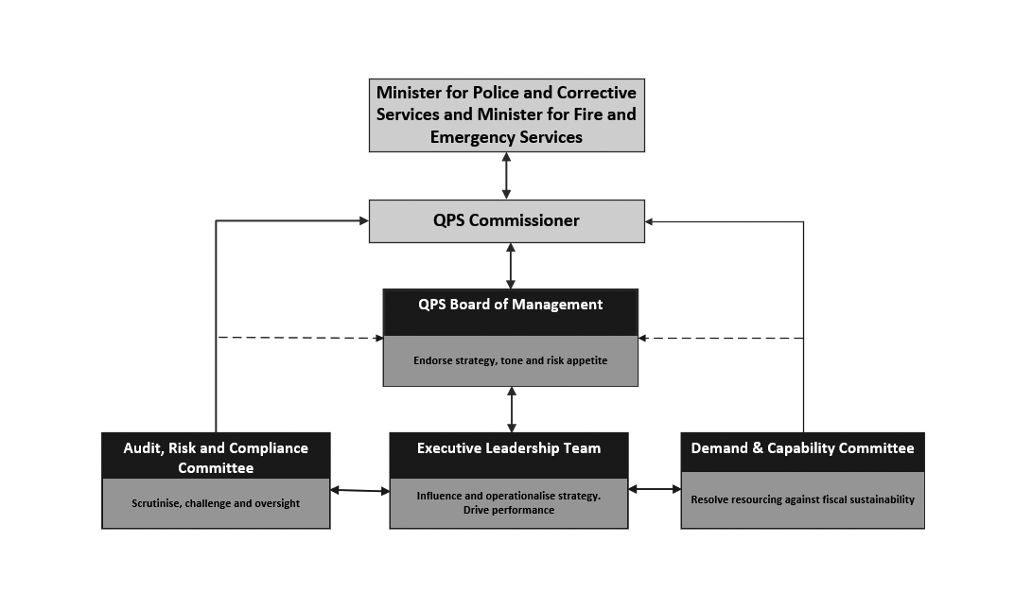The QPS Governance Framework (as at 30 June 2022) is as follows:

|  |
| --- |
| **QPS Board of Management (BoM)** |
| The purpose of the BoM is to endorse strategy, tone, and risk appetite for the Service.  The roleof the BoM is to support and provide expert advice and endorsement to the Commissioner in making key decisions that deliver strategic or Service-wide impact. In doing so, the BoM advises on and oversees performance against strategic and organisational priorities.  The BoM meetings are chaired by the QPS Commissioner.  The BoM meets every second month or as determined by the Chair. In 2021-22, the BoM met on five occasions and considered 24 matters out-of-session.  The independent external members collectively received $9,030 in remuneration in 2021-22. |
| **BoM members**   * Commissioner Katarina Carroll (Chair) * Deputy Commissioner Doug Smith, Strategy and Corporate Services * Deputy Commissioner Paul Taylor, Regional Queensland * Deputy Commissioner Tracy Linford, Crime, Counter Terrorism and Specialist Operations * Deputy Commissioner Stephan Gollschewski, Southern Queensland * External Member – Jenny Walker * External Member – Sandra Slater |
| **Achievements**  During 2021-22, the BoM overviewed and discussed strategic matters relating to financial reporting, human resources reporting, information, communication & technology reporting, performance reporting and risk reporting. The BoM considered a number of significant matters including:   * QPS Strategic Plan 2022-2026 and Operational Plan 2022-2023 * Forward Capital Works Program 2022-23, Strategic Asset Management Plan * Budget Strategy including budget development assumptions, parameters and plan * ICT Investment Program 2021-22 * Strategic workforce plan, recruitment campaign * *QPS Domestic and Family Violence Strategy 2021-23* and domestic and family violence matters * Service Delivery Program * QPS’s response to COVID-19 * QPS Suicide Management Framework * Natural Hazards and Disaster Resilience Research Institute Program, disaster management preparedness * Working for Queensland Survey * Strategic Governance Manual including Charters * Crime Prevention * Performance Reporting * Wellbeing Strategy, health safety and wellbeing matters * Internal Audit Charter and Plans, Inspections Teams Internal Audit Function Charter and Plan * Risk Appetite Statement, and audit, risk and compliance * Media relations and external communications. |
| **QPS Demand and Capability Committee (DCC)** |
| The Demand and Capability Committee’s purpose is to resolve resourcing against fiscal sustainability. The roleof the DCC is to:   * control the organisational prioritisation of resources in a fiscally sustainable manner * direct and endorse strategies, plans, assessments and reviews to address resource capability planning and delivery and monitor performance to ensure benefits realisation * lead and ensure continual application of the committee’s responsibilities, including by requiring appropriate reporting * identify and resolve any relevant emerging issues and trends relevant to its role.   The committee meets monthly or as determined by the Chair.  The committee was established in September 2021 and held its inaugural meeting on 6 September 2021. The DCC met on seven occasions and considered five matters out-of-session in 2021-22. |
| **Committee members**   * Deputy Commissioner Doug Smith, Strategy and Corporate Services (Chair) * Deputy Commissioner Paul Taylor, Regional Queensland * Deputy Commissioner Tracy Linford, Crime, Counter Terrorism and Specialist Operations * Deputy Commissioner Stephan Gollschewski, Southern Queensland |
| **Achievements**  In 2021-22, the DCC overviewed matters relating to finance performance, human resources, ICT, assets, procurement and projects. The DCC considered significant matters including:   * machinery of government transfers * organisational structure regarding aviation capability * flexible work arrangements * police growth allocations and integrated workforce strategy * approved strength growth plan * performance reporting * Client Management System * capability framework * capital works program * leave management * QPS Research Committee * crime statistics * funding requests for initiatives including QPS Self Refer Program * safety and wellbeing data * ICT Strategy * Automatic Number Plate Recognition capability * 2022-23 Budget Strategy * financial sustainability * subcommittee charters and reporting for Workforce Allocation Subcommittee, Service Delivery Subcommittee and ICT Subcommittee |
| **QPS Audit, Risk and Compliance Committee (ARCC)** |
| The purposeof the ARCC is to scrutinise, challenge and oversee the Commissioners legislated management responsibilities.  This includes management responsibilities imposed on the Commissioner under the *Police Service Administration Act 1990*, the *Financial Accountability Act 2009* and the *Financial and Performance Management Standard 2019*.  The roleof the ARCC is independent oversight for, and assurance to, the Commissioner and BoM relevant to:  (i) risk management, performance, policy settings and framework  (ii) internal control and compliance environment  (iii) financial performance, planning, compliance and integrity  (iv) the internal and external audit functions.  The committee meets quarterly or as determined by the Chair. During 2021-22, the committee met on four occasions. The three independent external members collectively received $13,759 in remuneration. |
| **Committee members**   * External Member – Jenny Walker (Chair) * External Member – Glenn Poole * External Member – Geoff Waite * Deputy Commissioner Doug Smith, Strategy and Corporate Services * A/Assistant Commissioner, Matthew Vanderbyl Organisational Capability Command (note; this position was also significantly filled by Assistant Commissioner Cameron Harsley during the financial year) * Assistant Commissioner Cheryl Scanlon, Ethical Standards Command (note; this position was also significantly filled by A/Assistant Commissioner Virginia Nelson during the financial year) |
| **Achievements**  During 2021-22, the ARCC provided strategic advice and support to the QPS BoM by considering matters of risk management, internal control and compliance, financial compliance, and auditing and reporting. The ARCC considered the significant matters including:   * ARCC Charter and ARCC Workplan * QPS Strategic Risk Register and Risk Appetite Statement * cyber security reports * health safety and injury management report * strategic risks and opportunities for the 2022-23 Strategic Plan * Compliance and Inspections Program findings and ESC Annual Inspections Plan * fraud and corruption reporting, plan and policy, fraud and losses reporting * Annual Financial Statements, financial accounting and compliance and Chief Financial Officer Statement of Assurance * Annual Internal Audit Plan 2022-23, Strategic Internal Audit Plan 2023-26 and Internal Audit Charter * open internal audit recommendations * security themed review – declarable associations * QAO Reports |
| **QPS Executive Leadership Team (ELT)** |
| The Commissioner has established the ELT to be a decision-making body, as part of the strategic level governance framework.  The purpose of the ELT is to influence and operationalise strategy and to drive performance.  The roleof the ELT is to:   * influence strategic and operational planning development * oversee the development of strategies and frameworks that support the Service which are not subject to another strategic governance committee * oversee and guide Service-wide activities to improve policing operations, responses and capabilities * operationalise strategies with a coordinated approach and steer the organisation towards achievement of strategic goals and objectives * identify and address strategic operational issues and risks collectively * oversee and guide organisational change management for matters of strategic importance * drive performance with a focus of benefits realisation.   The ELT meets via video conference weekly and in person on a monthly basis, or as determined by the Commissioner.  During 2021-22, the ELT met on 11 occasions (in-person) including meetings at the Oxley Academy, Wacol Complex and Hervey Bay. |
| **ELT members**  The following were ELT members as at 30 June 2022, noting there were periods of time during the financial period that these positions were filled by another member:   * Commissioner Katarina Carroll (Chair) * Deputy Commissioner Doug Smith, Strategy and Corporate Services * Deputy Commissioner Paul Taylor, Regional Queensland * Deputy Commissioner Tracy Linford, Crime, Counter Terrorism and Specialist Operations * Deputy Commissioner Stephan Gollschewski, Southern Queensland * Assistant Commissioner Maurice Carless, State Discipline * Assistant Commissioner Shane Chelepy, Operations Support Command * Assistant Commissioner Brian Codd, Domestic, Family Violence and Vulnerable Persons Command * Assistant Commissioner Brian Connors, North Coast Region * Assistant Commissioner Kevin Guteridge, Central Region * Assistant Commissioner Cameron Harsley, Brisbane Region * Assistant Commissioner Kath Innes, Crime and Intelligence Command * Assistant Commissioner Ben Marcus, Road Policing and Regional Support Command * Assistant Commissioner Debbie Platz, Security and Counter Terrorism Command * Assistant Commissioner Charysse Pond, Southern Region * Assistant Commissioner Cheryl Scanlon, Ethical Standards Command * Assistant Commissioner Brett Schafferius, Far Northern Region * Assistant Commissioner Brian Swan, South Eastern Region * Assistant Commissioner Mark Wheeler, Northern Region * Assistant Commissioner Chris Jory, Commission of Inquiry into QPS responses to domestic and family violence * Executive Director Cameron Allen, Frontline and Digital Division * Executive Director Louise Barrett, Safety, Wellbeing and Central Panels Division * Executive Director Wayne Brummer, Finance Services Division * Executive Director Paul Friedman, Policy and Performance Division * Executive Director Carolyn Harrison, Legal Division * Chief Superintendent Roger Lowe, Crime and Corruption Commission: * A/Assistant Commissioner Matthew Vanderbyl, Organisational Capability Command * A/Assistant Commissioner Mark Kelly, People Capability Command * A/Executive Director Debbie Patterson, Human Resources Division * A/Executive Director Kerry Johnson, Communications, Culture and Engagement Division   Standing Attendees   * A/Superintendent Alisa LaPila, Chief of Staff, Commissioners Office * Director Simon Kelly, Media and Public Affairs, Communications, Culture and Engagement * Senior officers on a rotational basis as determined by the Commissioner |
| **Achievements**  During 2021-22, the ELT considered a number of significant matters, including:   * Cybercrime Strategy 2021-22 * youth justice * Women’s Safety and Justice Taskforce and QPS response and strategy for Domestic and Family Violence * road safety * Safe Night Precincts * QPS COVID-19 response * prevention and disruption * Red Tape Reduction Committee initiatives * education, training and recruitment, and QPS lateral transfers and promotions * Performance Management Framework, Leadership Capability Program * safety and wellbeing, QPS Suicide Management Framework * Working for Queensland Survey Results * performance, crime statistics and complaints reporting, Client Management System * capability framework * Workforce Planning and Workforce Allocation Subcommittee * Service Delivery Program * QPS 2022-2026 Strategic Plan, 2022-23 Operational Plan and Environmental Scan * 2022-23 Capital Works Program, 2032 Brisbane Olympic Games. |
| **QPS Assets Committee (now disestablished)** |
| The Assets Committee aligns the prioritisation of the Services’ assets and project portfolio with the QPS Strategic Plan, government priorities and QPS demand modelling needs. The Committee monitors and approves QPS prioritisation, planning and management of QPS strategic asset and project portfolios within the Service; delivers appropriate advice on planning, product delivery, stakeholder engagement and prioritisation activities across the QPS asset and project portfolios; endorses business strategy and capability across the Service to meet current and future QPS strategic asset portfolio demand and resource needs; and ensures value through financial prioritisation and planning, and ongoing benefits realisation  The committee met monthly or as determined by the Chair. The committee met on three occasions in 2021-22 before it was disestablished on 11 August 2021. |
| **Committee members**  The following were the Committee members prior to disestablishment:   * Deputy Commissioner Doug Smith, Strategy and Corporate Services * A/Assistant Commissioner Matthew Vanderbyl, Organisational Capability Command * Chief Superintendent Daryl Johnson, Crime and Corruption Commission |
| **Achievements**  In 2021-22, prior to its disestablishment, the Committee considered matters including:   * proposed staffing model and vehicle allocation for Pimpama Station * increase of QPS Fleet – Torres Straight Island Police Liaison Officers * QPS ICT Investment Program 2021-22. |

|  |
| --- |
| **QPS People Committee (now disestablished)** |
| The People Committee aligns the prioritisation of the Services’ people with the QPS Strategic Plan, government priorities and QPS demand modelling needs. The Committee builds a positive organisational governance culture that reflects the values of the QPS, addresses significant emerging people, culture and safety issues and trends, endorses strategies for improving workforce capacity and capability across the service to meet current and future service demand and address resource constraints, and ensures value through prioritisation and planning of QPS resource allocations.  The committee met monthly or as determined by the Chair. The committee met on one occasion in 2021-22 before it was disestablished on 22 July 2021. |
| **Committee members**   * Deputy Commissioner Tracy Linford, Crime Counter- Terrorism and Specialist Operations * Assistant Commissioner Charysse Pond, People Capability Command * Assistant Commissioner Kevin Guteridge, Central Region |
| **Achievements**  In 2021-22, prior to its disestablishment, the Committee considered matters including:   * staff member full-time equivalent * police growth allocations * training report * organisational structure change regarding Service Alignment Program. |

**Government Bodies**

* Commissioner for Police Service Reviews
* Controlled Operations Committee
* Public Interest Monitor

For further information about the Government Bodies refer to page 97 within the appendices.

**Ethics and code of conduct**

The delivery of professional policing services must be underpinned by ethical decisions and actions. These ethical decisions and actions provide the QPS with its most valuable asset, namely its reputation and the confidence and trust that such a reputation inspires in the community. The QPS has a broad range of programs, policies and initiatives that support professional and ethical practice including a robust internal complaints system, policies on declarable associations, gifts and benefits as well as discipline and ethical awareness training. The QPS Integrity Framework and Standard of Professional Practice supplement the Queensland Government values and the Code of Conduct for the Queensland Public Service and outlines the standards of conduct and professional practice expected of all QPS employees.

Members of the QPS operate under the Service’s Integrity Framework that promotes the principles of Values, Leadership and Accountability which underpin integrity and ethics in the QPS. The framework seeks to ensure the integrity of the organisation is maintained through four key actions that apply to all levels of the organisation. These actions are: Know what is expected, Educate and guide others, Ensure we do the right thing, and Protect our standards. The framework seeks to promote an actionable process of thinking about integrity and then integrating that thinking into all planning, implementation, monitoring and evaluation processes across the QPS.

Ethical Standards Command’s (ESC) purpose is to protect the high standards of integrity and professionalism necessary to maintain the trust and support of our community. In 2021-22, ESC continued to promote, monitor and enforce ethical behaviour, integrity and professional practice through education, deterrence and systems improvements. ESC continued to be the conduit between QPS and oversight bodies such as the Crime and Corruption Commission.

Reported complaints are continually monitored and reviewed by the QPS to identify primary contributing factors and/or trends which may arise from complaint types and/or the complaint data more generally. All complaints are considered, actioned and investigated as required. In 2021-22, the QPS received 1,218 complaints by members of the public against officers on or off duty. This figure counts the number of distinct individuals who have either lodged a complaint or lodged a complaint on behalf of another person even if it relates to the same incident. When applying relevant context to this figure, the QPS undertakes millions of interactions with people in the community each day and moreover, each year. Comparatively, very few of those interactions result in complaints relating to the conduct of police.

As part of its monitoring role, ESC undertakes a range of inspections and evaluations of police facilities including their functions and duties. During 2021-22 ESC undertook a review of the inspections process to validate the appropriateness of existing compliance processes. ESC is currently implementing a number of business improvements to underpin a compliance culture across the QPS. ESC also analysed the compliance inspections conducted independently by regions and commands to determine key compliance issues and trends across the state. The outcomes of the inspections are reported to the ELT and the QPS ARCC.

**Risk management and accountability**

**Risk management**

The Commissioner and senior executives are committed to the management of internal and external risks which may influence strategic objectives. Risk management is integral to management functions and is a requirement of all Queensland Government departments, including the QPS under section 61 the *Financial Accountability Act 2009*. The QPS has implemented an Enterprise Risk Management Framework, adopting the principles and processes outlined in Australian Standard ISO 31000:2018 Risk Management – Guidelines. This approach integrates risk assessment into the management processes of the organisation and supports compliance with legislative requirements and Queensland Government guidelines.

Risk management supports the QPS Strategic Plan and Operational Plan, aligning the achievement of organisational objectives to strategic risks and the organisation’s appetite for risk. The QPS maintains a risk appetite statement and summary within the Enterprise Risk Management Framework. The statement and summary are intended to provide clarity and set the tone around acceptable and unacceptable risks to the organisation, and support decision making around enterprise risk management at all levels. A quarterly Strategic Risk Report is also generated to provide an overview of strategic risks impacting the achievement of QPS objectives. The Board of Management establishes the mandate and commitment set by the QPS executives that underpins the risk management framework. The Audit, Risk and Compliance Committee is responsible for reviewing the adequacy and application of the QPS risk management framework.

Responsibilities for risk management are generally maintained through Executive Leadership Team portfolios across operational and strategic levels of the organisation. The Strategic Risk and Business Continuity capability promote best practice, scan for emerging risk trends and provide advice and support on risk management practices.

**External Scrutiny**

This section provides information about external agencies and processes, which examined the operations of QPS or other agencies with findings/issues requiring consideration by, or impacting on, QPS:

**Queensland Audit Office (QAO)**

The QAO supports the role of the Auditor-General of Queensland in providing the Parliament with an independent assessment of the financial management and performance activities of public sector entities. The QAO provides an independent audit service and reports to the Parliament to enhance public sector accountability. QAO reports are available online at [www.qao.qld.gov.au/reports-resources/parliament](http://www.qao.qld.gov.au/reports-resources/parliament). The QPS remains committed to identifying opportunities for efficiencies in all areas of service delivery.

**Report 4: 2021-22 – 2021 status of Auditor-General’s recommendations**

The QAO makes recommendations to state and local government entities to support better delivery of public services and make a difference to the lives of Queenslanders. The QAO prepared a report on the entities’ self-assessed progress in implementing the performance audit recommendations from the 2015-16, 2016-17 and 2017-18 reports to Parliament.

The report examined 50 entities, 447 individual recommendations and 32 reports to Parliament. The QPS was responsible for 31 recommendations from six reports, of which 29 are fully implemented and one was partially implemented, and one was no longer applicable

**Queensland Coroner**

During 2021-22, 20 recommendations arising from eight coronial inquests were directed to the QPS as either a lead or supporting agency. The Findings of Inquest and the Government’s response are available at [www.courts.qld.gov.au/courts/coroners-court/findings](http://www.courts.qld.gov.au/courts/coroners-court/findings).

**Women’s Safety Justice Taskforce**

The Women’s Safety and Justice Taskforce (the taskforce), chaired by the Honourable Margaret McMurdo AC, was established in March 2021 to examine coercive control and review the need for a specific offence of domestic violence and the experience of women across the criminal justice system. The first report from the taskforce was released in December 2021 and made 89 recommendations that seek to further reform the justice and domestic and family violence specialist service systems to ensure they keep victims safe and hold perpetrators to account.

In response to recommendation 41the QPS has commenced work to ensure legal staff participate in regular domestic and family violence training and also consider longer term solutions to ensure legal staff undertake regular tailored domestic and family violence training to support the knowledge and understanding of domestic and family violence and its impact on relevant law.

The Queensland Government has accepted all 89 recommendations. The QPS will continue to work with government agencies to implement the recommendations.

**Independent Commission of Inquiry into QPS responses to domestic and family violence**

On 10 May 2022, the Queensland Government announced an independent Commission of Inquiry into QPS responses to domestic and family violence as recommended by the Women’s Safety Justice Taskforce report *‘Hear her voice’*.

The Commission is examining Queensland policing responses to domestic and family violence, and to ensure full public confidence in the ability of QPS officers to protect victims and hold perpetrators to account.

**Commission of inquiry relating to the Crime and Corruption Commission**

The Commission of Inquiry relating to the Crime and Corruption Commission (CCC) commenced on 7 February 2022. The Honourable Gerald Edward (Tony) Fitzgerald AC QC was appointed Chairperson and the Honourable Alan Wilson QC was appointed Commissioner for the Commission of Inquiry. Under the Terms of Reference the Commission of Inquiry is required to inquire into, report and make recommendations with respect to the following matters relating to the CCC:

* the adequacy and appropriateness of the structure of the CCC in relation to use of seconded police officers
* the adequacy and appropriateness of legislation, procedures, practices and processes relating to the charging and prosecution of criminal offences for serious crime and corruption in the context of CCC investigations
* the adequacy and appropriateness of section 49 of the [*Crime and Corruption Act 2001*](https://www.legislation.qld.gov.au/view/html/inforce/current/act-2001-069).

The Report of the Commission of Inquiry is due to be handed down by 9 August 2022.

**Commission of Inquiry into Forensic DNA Testing in Queensland**

On 6 June 2022, the Queensland Government announced an independent Commission of Inquiry into Forensic DNA Testing in Queensland, conducted by former President of the Court of Appeal, retired judge Mr Walter Sofronoff QC.

The Commission is being established to ensure transparency, identify opportunities for improvement and ensure public confidence in the collection, testing and analysis of DNA in Queensland, and in the criminal justice system more broadly. The Report of the Commission of Inquiry is due to be handed down by 13 December 2022.

**The Independent Review of Deaths in Custody, Deaths in Police Operations and DV Related Homicides with Prior Police Involvement**

On 22 January 2021, in making his findings with respect to the Inquest into the death of Cindy Leigh Miller, State Coroner Terry Ryan recommended the Government consider commissioning an independent review of the current arrangements for the investigation of police-related deaths on behalf of the coroner and the oversight of those investigations. The Government engaged Professor Lorraine Mazerolle as the Chief Investigator with Professor Elena Marchetti, Professor Janet Ransley and Mr Lincoln Crowley QC (prior to this judicial appointment) as Co-Chief Investigators.

The review was completed and provided to Government in July 2022.

**Internal audit**

The QPS Internal Audit Unit operates under a portfolio service delivery model providing internal audit services to QPS, Office of the Inspector-General Emergency Management (IGEM) and Queensland Fire and Emergency Services (QFES). It is expected QFES will stand up its own Internal Audit Function in 2022-23.

Internal Audit continues to provide advice across a wide range of disciplines including risk, assurance, information technology, finance, compliance and general consulting activities for the QPS, IGEM and QFES. The Head of Internal Audit for QPS is also the nominated Head of Internal Audit for the Office of the IGEM and QFES in accordance with the *Financial Accountability Act 2009*.

The work of the Internal Audit Unit is undertaken in accordance with the Institute of Internal Auditors’ standards and under an approved charter consistent with relevant audit and ethical standards.

In accordance with the *Financial and Performance Management Standard 2019*, an annual internal audit plan and three-year strategic audit plan sets the direction of the unit. A detailed audit planning and risk assessment process was completed in devising this plan. The Annual Internal Audit Plan 2021-22 and Strategic Internal Audit Plan 2022-25 was endorsed by the QPS Audit, Risk and Compliance Committee and approved by the Commissioner on 13 July 2021. The Internal Audit Unit reports regularly to the QPS Audit, Risk and Compliance Committee which reviews the work of the internal audit function. The relationship with the committee is based on Queensland Treasury’s Audit Committee Guidelines.

Under its approved charter, the unit reviews compliance (effectiveness), performance (efficiency), financial management and information technology to identify areas of risk and to improve outcomes for the Service. The unit has systems in place to ensure the effective, efficient and economic operation of the audit function.

In 2021-22, the unit delivered the activities in the approved Annual Internal Audit Plan 2021-2022 using in-house and sourced delivery methods including the engagement of Deloitte. Whilst fieldwork was completed for the majority of audits as at 30 June 2022, two reviews will be carried over to  
2022-23 due to the timing or nature of the work. It is expected all final reports will be delivered by   
31 October 2022.

Achievements specific to QPS for 2021-22 include:

* delivery of the approved annual internal audit plan with specific QPS audit coverage including:
* Business Continuity Management – Lessons Identified
* Victorian Government Department of Transport – Information Protection Agreement
* Security Themed Review – Information Access
* ICT Vendor Management
* IT General Controls
* PMO Structure Review
* Prosecutions Outcomes Review.
* Public Safety Agencies wide reviews for 2021-22 include:
* Enterprise Architecture
* Core Controls.
* unprogrammed reviews undertaken including those carried forward to 2022-23 due to the timing or nature of the work include:
* Safety Wellbeing and Central Panels Governance Review
* Collaborative Payroll Review (carried forward)
* Transfer Costs (carried forward)
* ISMA Review (carried forward).

**Information systems and recordkeeping**

Following the formal disestablishment of Public Safety Business Agency, the QPS Information Management Unit (IMU) operates and manages Information and Recordkeeping systems to support a number of specific recordkeeping functions in QPS, QFES, IGEM, Queensland Ambulance Service and Queensland Shared Services. This unit also provides strategic recordkeeping advice to QPS and QFES.

The QPS IMU records management team, provided advice and assistance to QPS during the reporting period resulting in improved efficiencies including:

* providing training to QPS Strategy and Corporate Services staff to facilitate the capture and management of records relating to ‘executive decision making’ via use of the Objective electronic Document Records Management System (eDRMS) to meet the organisations legislative obligations and broader recordkeeping responsibilitiesworking with QPS business units to identify opportunities to reduce reliance on hardcopy documents and transition to fully electronic processes, delivering business efficiencies
* completion of 441 support jobs during the reporting period, (submitted via ‘BOSS’ tasking software), to provide administrative and system support in use of the Objective eDRMS
* commencing a body of work to optimise use of catalogue fields in the Objective eDRMS that will enable electronic filing processes, utilised by Right to Information Subpoena team, to be streamlined. Once implemented, this change will deliver operational efficiencies with respect to use and access of information required to support functioning of this work unit
* updating of recordkeeping resources provided to regionally based Education and Training Support staff, including provision of access to offsite storage services, to deliver efficiencies in how this function is supported, enabling these staff to operate in a more autonomous capacity
* commencing of a project to upgrade the Objective eDRMS, which will deliver numerous efficiencies, including access to a simplified web browser interface, enabling all key functionalities to be securely accessed across a wide range of devices by end-users
* supporting the creation of 922,541 electronic documents and 210,274 files associated with Weapons Licensing functions, and over 20,000 administrative files for general use
* submission of a fully revised QPS Retention and Disposal Schedule to QPS Organisational Capability Command for review and approval. The structure of the new document is aligned to the whole of government General Retention and Disposal Schedule which will enable both resources to be utilised interchangeably when required. A key benefit of these changes is that future updates to the Schedule will require significantly reduced lead time and minimal structural changes. It is expected that the schedule will be endorsed internally, and formally approved for use by the State Archivist during the next reporting period
* no known breaches of information security with respect to records managed within the Objective eDRMS during the reporting period
* disposal of records submitted through the Corporate Records Retention and Disposal Program managed by the IMU were sentenced in line with retention periods set out within the whole of government or the QPS Retention and Disposal Schedule
* no transfers of public records to Queensland State Archives were made during the reporting period.

**Human resources**

**Strategic workforce planning and performance**

**Workforce profile**

The total number of full-time equivalent (FTE) staff in QPS was 16,615.1 as at 30 June 2022. The FTE figure is calculated using the Minimum Obligatory Human Resource Information (MOHRI) aligned information.

MOHRI is FTE workforce data Queensland Government agencies provide for the biannual Queensland public sector workforce profile report. The MORHI FTE methodology changed in 2019, in line with recommendations from the 2018 Review into Queensland public sector workforce (Coaldrake review). There was a shift from calculating the FTE of public sector employees by their substantive appointment, to calculating the FTE of public sector employees actually paid. Another key change related to leave without pay (LWOP) and leave on half pay. The pre-Coaldrake review methodology excluded officers on LWOP only after 8 weeks continual absence. The current methodology excludes all employees on LWOP in the relevant snapshot fortnight and reduces the FTE of employees on leave on half pay. These changes impact direct comparisons with MOHRI workforce data prior to the methodology changes being implemented in 2019.

Between 1 July 2021 and 30 June 2022, the QPS permanent separation rate was 3.8% for police officers and 11.5% for permanent staff members (excluding temporary and casual employees).

The QPS has various policies and processes in place that promote flexible working arrangements and a healthy work-life balance for all QPS employees. These policies are periodically reviewed to ensure they meet the needs of the service and its employees.

The QPS also has a dedicated Leadership Centre that facilitates and encourages learning and development of police officers and staff members at all levels of the organisation (see page 57 for more information).

***Figure 2: Target group data1***

|  |  |  |
| --- | --- | --- |
| **Gender** | **Number**  **(Headcount)** | **Percentage of total workforce**  **(Calculated on headcount)** |
| Woman | 6,406 | 36.68% |
| Man | 11,037 | 63.19% |
| Non-binary | 6 | 0.03% |
| **Diversity Groups** | **Number**  **(Headcount)** | **Percentage of total workforce**  **(Calculated on headcount)** |
| Women | 6407 | 36.69% |
| Aboriginal Peoples and Torres Strait Islander Peoples | 400 | 2.29% |
| People with disability | 211 | 1.21% |
| Culturally and Linguistically Diverse – Born overseas in a mainly non-English speaking country | 225 | 1.29% |
| Culturally and Linguistically Diverse – Speak a language at home other than English including ATSI/ASSI languages | 704 | 4.03% |
|  | **Number**  **(Headcount)** | **Percentage of total Leadership Cohort**  **(Calculated on headcount)** |
| Women in Leadership Roles2 | 69 | 18.60% |

1. To ensure privacy, in tables where there are less than 5 respondents in a category, specific numbers should be replaced by <5
2. Women in Leadership Roles are considered those positions that are Senior Officer and equivalent and above.

**Attraction and Retention**

People Capability Command (PCAP) is primarily responsible for the police academies in Oxley, Wacol and Townsville, education and training and the police recruiting. During 2021-22, PCAP delivered various activities, including:

* additional recruitment activities including targeted professional marketing campaigns to diverse communities, regional and remote areas and broad demographic groups
* launched the *‘You’re Made For It’* campaign in November 2021 to showcase the unique lived experiences of four serving police officers to inspire potential applicants
* recruitment of additional Queensland Government Protective Service Officers to support the QPS’s response to COVID-19 health pandemic.

Additionally, the QPS commemorated the 50th anniversary of the opening of the Oxley Police Academy with the first intake of police cadets. The opening of the Oxley Police Academy in 1972 revolutionised the police training delivered to recruits. Since then, recruit training has been at the forefront of policing methods, using technology for applied learning in real world scenarios, and focusing on help for victims, professional service and values.

Over the past 50 years, the thousands of recruits who have passed through the Oxley and Townsville academies have made a significant contribution to the culture of QPS, excellence and agility which defines the QPS.

**Leadership and professional development opportunities**

The QPS offered a range of opportunities and pathways to access professional development to police officers and staff members in 2021-22, including:

* the Leadership Capability Program (LCP), launched in January 2022, provides a three-stage program for the next-level development embracing education, experience and effective mentoring. The LCP was developed to provide a fit-for-purpose program focussed on developing leaders who can meet the challenges of policing in an ever-changing environment. In its first six months of operation, more than 2,600 police officers and staff members have commenced their leadership journey through LCP
* the QPS Leadership Centre aims to drive a culture of leadership at all levels of the organisation, and to build leadership capability through the fusion of education, effective mentoring, and workplace experience. With a dedicated staff from diverse backgrounds, the Leadership Centre delivers and coordinates a range of fit-for-purpose, contemporary development programs and learning opportunities to support QPS personnel as they build their leadership capability. The Centre also administers scholarship programs provided by RACQ, Suncorp, Public Sector Management Program through QUT
* QPS partnering with Skillsoft to launch Q-Learn in January 2022, a digital education platform that provides access to thousands of blended learning resources focused on leadership, professional development and wellbeing. Q-Learn provides a self-paced, short-shot learning resource that can be tailored to individual development needs or interests
* the Leadership, Engagement and Development (LEAD) program is targeted at Constables, Senior Constables and staff members at AO3/AO4 (or equivalent) and provides foundational skills in leadership, problem solving, conflict management, change management and mental health and resilience. The LEAD program involves a three-day, face-to-face workshop that was offered under a limited schedule in 2021-22 due to COVID-19
* staff members (up to OO6/AO4) can undertake TAFE studies in leadership and management at Certificate IV, Diploma, and Advanced Diploma levels. Staff Member Training also offer bespoke courses for all QPS members on topics such as emotional intelligence, leadership, communication, problem solving, team building and difficult conversations
* professional development opportunities for senior leaders including the Australian Institute of Police Management, Australian and New Zealand School of Government, Australian Institute of Management, Australian Institute of Company Directors and a number of universities.

**Our People Matter**

The ‘Our People Matter’ Strategy continued to directly support QPS members across the state for a fifth consecutive year, delivering initiatives based on four pillars: *Healthy Bodies, Healthy Minds, Safe Workplaces, Fair and Positive Workplaces*. The strategy is a collaboration between the QPS, five employee unions and two corporate sponsors, who jointly promote the pillars to improve organisational culture, engagement, empowerment, and participation at all levels.

District ‘Our People Matter’ Champions, made up of police and civilian personnel, promote the strategy in their respective regions, driven by frontline ideas to improve the physical and mental health, and the safety and wellbeing of members and their families.

Key achievements for 2021-22 include:

* statewide QPS Police Commissioner Speaking Series, also livestreamed to Workplace to enable virtual participation
* statewide ‘Life Beyond the Service’ and ‘Transition to Retirement’ seminars
* mental health awareness and improvement seminars, supported by QPS Psychologists, Chaplains and HealthStart professionals
* environmental improvements in workspaces (examples include furniture for recreational areas, essential gym equipment for isolated stations)
* member and family fun days
* sporting activities.

**Inclusion and Diversity**

The QPS is committed to building an inclusive and diverse workplace in which all employees feel valued, included and welcome and have equal access to opportunities. To ensure the organisation maintains a strong focus on inclusion and diversity, the QPS revitalised the ‘Inclusion and Diversity Restorative Engagement and Cultural Reform Program’, transitioning from ‘Juniper’ to the ‘Workplace Assessment and Support Team’ (WAST) and the ‘Cultural Transformation Team’ (CTT).

During the reporting period, WAST and CTT:

* assisted 15 individual work units through the bespoke cultural reform program
* addressed issues in the workplace based on the Working for Queensland Survey, face-to-face interviews and a multifactional leadership survey
* held tailored workshops to directly address areas of opportunity
* provided support to current serving and past members by strengthening procedures for members to be afforded an exemption for reporting under the defined sections of the *Anti-Discrimination Act 1991*
* in collaboration with the QPS advocacy networks, supported the QPS Inclusion and Diversity Plan 2021/2025 with ‘action-plans’ delivered by the networks
* implemented the SBS Inclusion Program –seven diversity online learning products (OLP) designed to be completed over a three-year period by all QPS employees.

**Safety, Injury Management and Wellbeing Services**

The QPS has a comprehensive management system for the identification and management of risks and hazards. This includes a strong consultative framework for health and safety, which includes 32 Health and Safety Committees across the state representing all workers within groups, districts, regions and commands. There are also 106 elected Health and Safety representatives who provide representation for all workers within their group on health and safety matters. These committees and representatives are complemented by 242 trained Safety Advisors who provide advice and assistance to management in fulfilling health and safety obligations. The QPS Health and Safety team has played a significant role in the COVID-19 response, providing advice and support to QPS members as a member of the COVID Command.

The QPS continues to focus on destigmatising mental health issues and promoting and encouraging members to seek help and counselling services either internally or externally from the Service. The number of police accessing free counselling services through external providers decreased from 998 in 2020-21 to 593 in 2021-22. A further 413 staff members and recruits also accessed these external counselling services during the same period, an increase from 337 in the previous reporting period, which is a positive trend supporting QPS efforts to destigmatise mental health and encourage people to seek help. Utilisation of 1800 ASSIST, a 24-hour employee assistance telephone service provided by Benestar was 1.8% in 2021-22, a slight increase from 1.7% in the previous year. The utilisation rate for internal counselling services via QPS psychologists and social workers remains relatively stable, averaging approximately 900 client contacts per month. The Employee Assistance Service helps prevent and manage mental health issues for employees by providing strategic advice, short term interventions, manager coaching and referral to external services for a wide range of organisational and personal issues.

The Psychological Assessment Unit (PAU) provides psychological assessment services to the QPS and undertakes psychological assessments for police recruits and specialist work units. It has expanded its scope to implement and review members self-psychological screening services through the Psych Health Screen (PHS) platform. The PHS, an early-intervention and referral service, was approved for implementation across the Service in April 2020. The PHS process involves an internet-based mental health screen and provides an opportunity for members to have a follow-up interview with an occupational psychologist. During 2021-22, 672 members completed this initiative with 293 members referred for further support.

For the same period, the PAU conducted 1,623 psychological assessments of persons applying to become police recruits and a further 443 selection assessments were conducted on persons applying for identified ‘high risk roles’ in the QPS. The PAU has also conducted workshops regarding personality and mental health as part of leadership development and specialist training courses.

**Internal confidential support services**

The QPS has various internal confidential support services available for its members which include Senior Psychologists/Senior Social Workers, Peer Support Officers and Chaplains.

These services are available free of charge to all QPS members including police officers, recruits and staff members. QPS members are able to seek these services for work and/or personal issues.

Senior Psychologists/Senior Social Workers, formerly known as Human Services Officers, enhance employee wellbeing through provision of organisational psychological services to reduce the risk of psychological harm in the workplace.

Peer Support Officers are police officers and staff members of the QPS who volunteer their time to assist and support colleagues experiencing personal and/or work-related difficulties.

QPS Chaplains provide a ‘safe place’ for all current and former QPS members and their immediate families to seek support for either personal or workplace matters. Police Chaplains regularly visit police establishments, offering face-to-face support for any issues that may be impacting QPS employees.

**Working for Queensland**

Working for Queensland (WFQ) is an annual survey that measures employee perceptions of their work, manager, team and the QPS. The survey is administered by the Public Service Commission and explores our people’s perceptions of their workplace climate in key areas.

Results from the WFQ survey drive workplace changes across the Service and helps the QPS measure how the Service is progressing towards the QPS’s strategic objective to build a connected, engaged and job-ready workforce with the health, wellbeing, and safety of our people a priority.

During 2020-21, the QPS placed a strong emphasis on supporting leaders to engage with the WFQ results and developing people-focussed strategies to support members through changes associated with strategic programs and the COVID-19 response. To support these strategies, the QPS concentrated on leadership development including change management and effective communication, ensuring a human centric approach was undertaken to improve how our people experienced work.

The QPS utilised the Workplace internal communications platform to facilitate two-way communication across the state and increase transparency of information, encourage strong participation in the survey and enabling our leadership to be active and visible to all ranks.

In 2021, the WFQ strategic objective results were:

* agency engagement 51%
* organisational leadership 41%
* innovation 50%

The full 2021 WFQ survey results are available to view at [www.forgov.qld.gov.au/working-queensland-survey](http://www.forgov.qld.gov.au/working-queensland-survey).

The 2022 WFQ survey will be conducted across Queensland Government agencies in September 2022.

**QPS Pride Network**

The QPS Pride Network, previously known as the QPS LGBTI+ Network, promotes Lesbian, Gay, Bisexual, Transgender, Intersex+ pride within the QPS providing a dedicated support framework to its members statewide.

The network is made up volunteer members who work to ensure LGBTIQ+ people in the QPS have access to support, resources, tools, and assistance.

Key achievements during the reporting period include:

* endorsement to change the name of the QPS LGBTI+ Support Network to ‘QPS Pride Network’
* attending external educational events through the QPS’ membership of Pride in Diversity
* developing an action plan to focus on enhancing support to regional members, staff members, and gender diverse members of the QPS
* participation in inclusion and diversity workshops held by Change and Engagement Unit within Communication, Culture and Engagement Division
* maintaining a strong visible presence on the QPS Workplace platform.

**Central Panels Unit**

The purpose of the Central Panels Unit (CPU) is to provide an independent, centralised and coordinated approach to state-wide promotional panels, initially to the ranks of Sergeant and Senior Sergeant to improve transparency, consistency, and fairness. The CPU commenced operations on  
4 January 2021 and has conducted all selection processes from that time for the rank of Sergeant and Senior Sergeant.

In 2021-22, CPU have officiated on 304 selection panels and assessed over 4,000 applications. The CPU workload is continuing to surge due to the recommencement in advertising commissioned officer positions (Police Inspector and above) and projected increases in retirements and separations, which will make meeting the demand a challenge.

The CPU is committed to ensuring promotional appointments are based on merit, impartiality, and ethical decision-making. The CPU have become highly skilled in this area and subsequently review numbers and rates for reassessments of selection panels has fallen dramatically. Only four reviews proceeded to hearing during 2021-22, showing that members have confidence in the integrity of the selection processes.

The CPU continue to assist officers around the state in their career development through feedback sessions, presentations, and anecdotal advice via Workplace. The CPU also provided statewide education during the transition to the Leadership Competencies for Queensland competencies and the new merit selection policy which was implemented in July 2021.

**Enterprise Bargaining Agreement**

The *QPS Certified Agreement 2019* and *QPS Protective Services Officers Agreement 2019* both nominally expired on 30 June 2022. The QPS are currently negotiating with the Queensland Police Union of Employees and the Queensland Police Commissioned Officers Union for a replacement QPS Agreement and the Together Union for a replacement QPS PSO Agreement in accordance with the Government's Public Sector Wages Policy.

**Early retirement, redundancy and retrenchment**

No early retirement, redundancy or retrenchment packages were paid to QPS employees during 2021-22.

**Financial Statements**

**Table of contents**

Statement of comprehensive income 63

Statement of financial position 64

Statement of changes in equity 65

Statement of cash flows (including notes to the statement of cash flows) 66

Notes to the financial statements 67

Management Certificate 92

Independent Audit Report 93

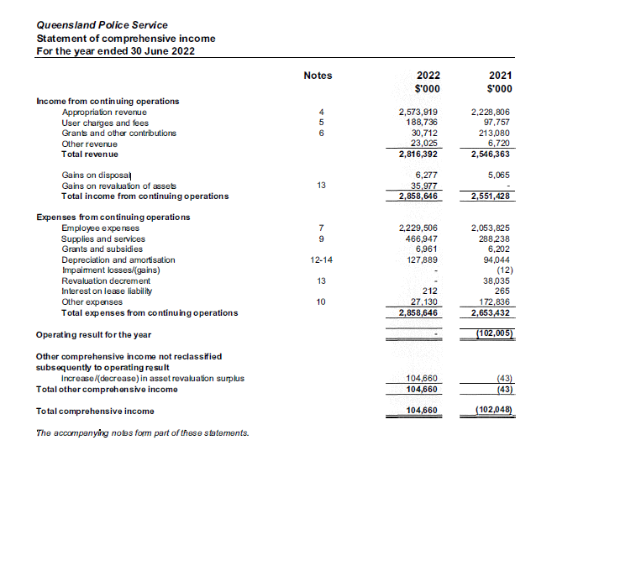

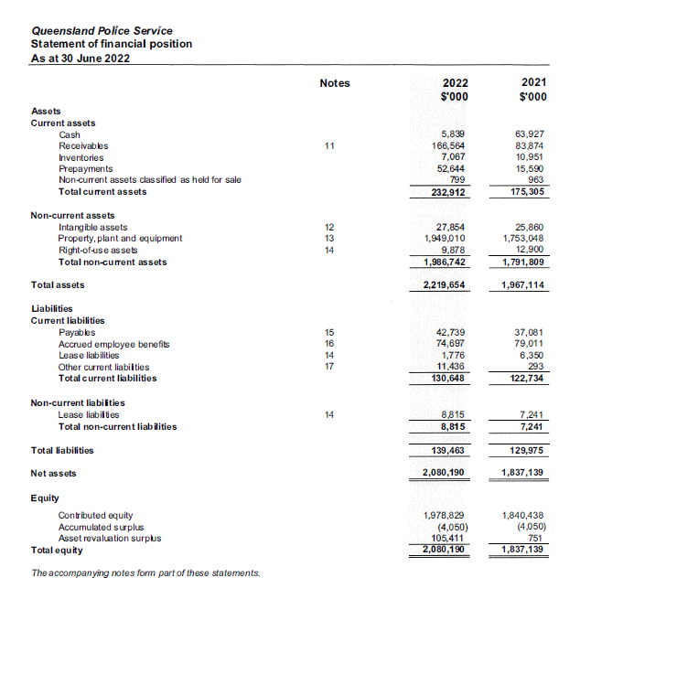

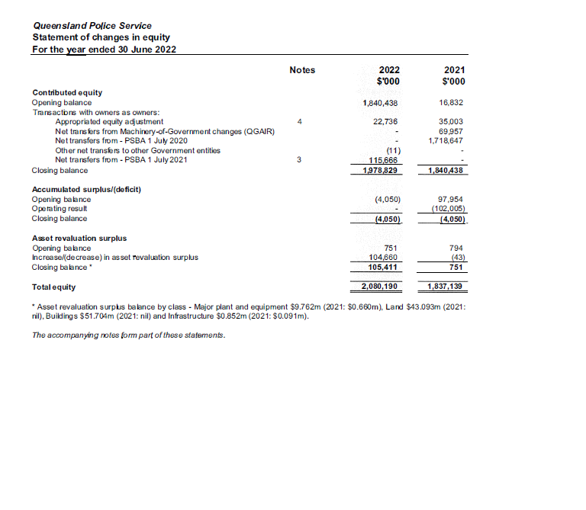

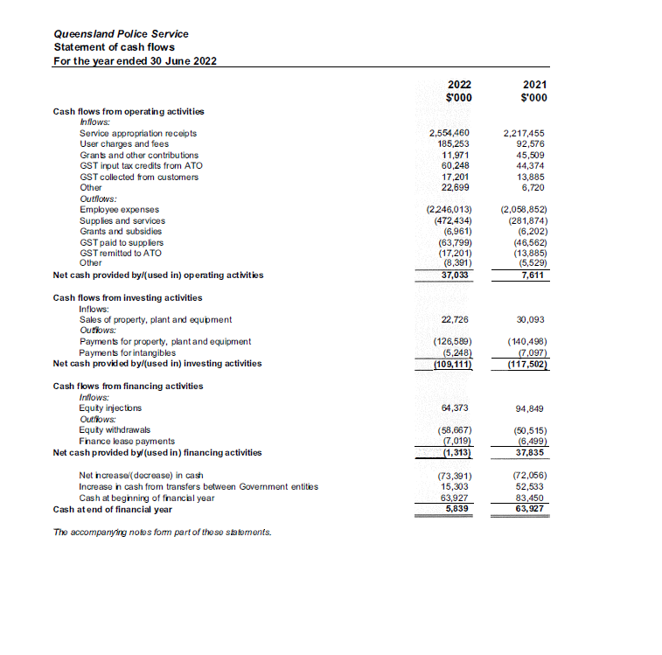

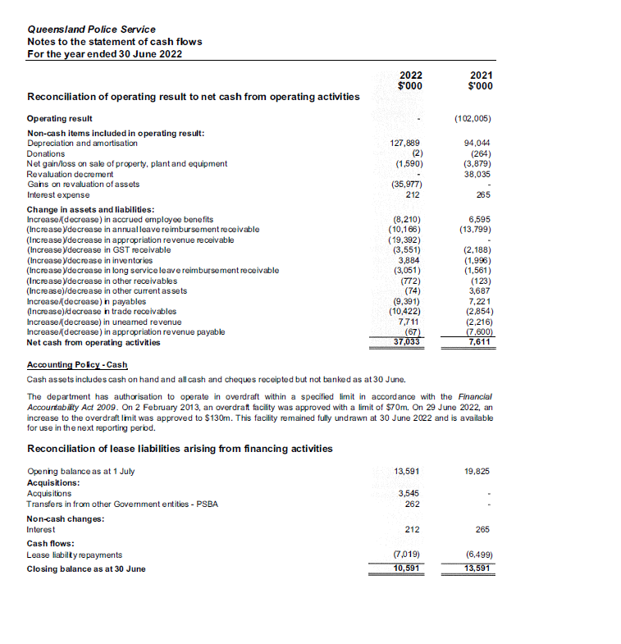

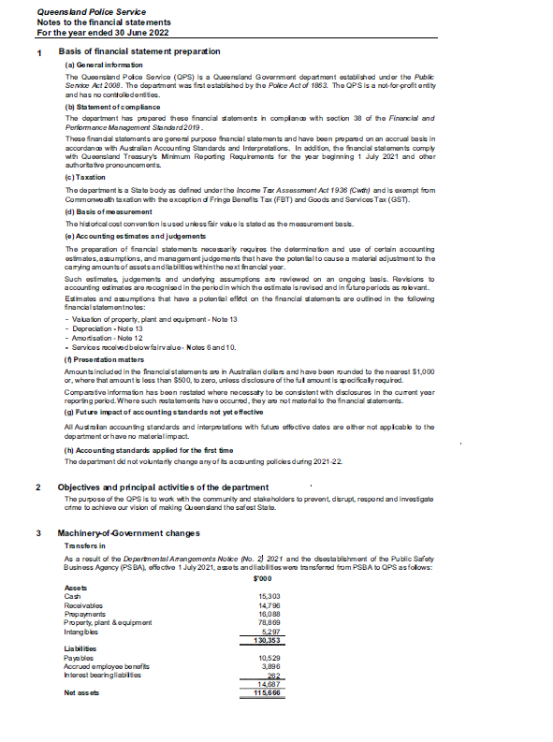

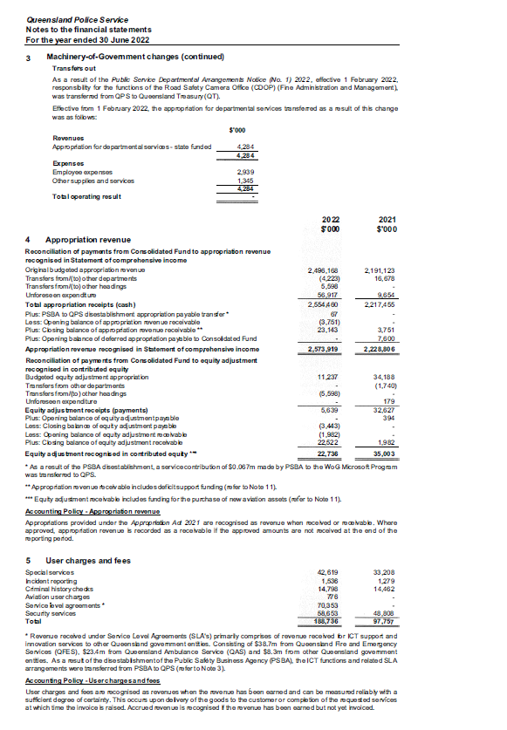

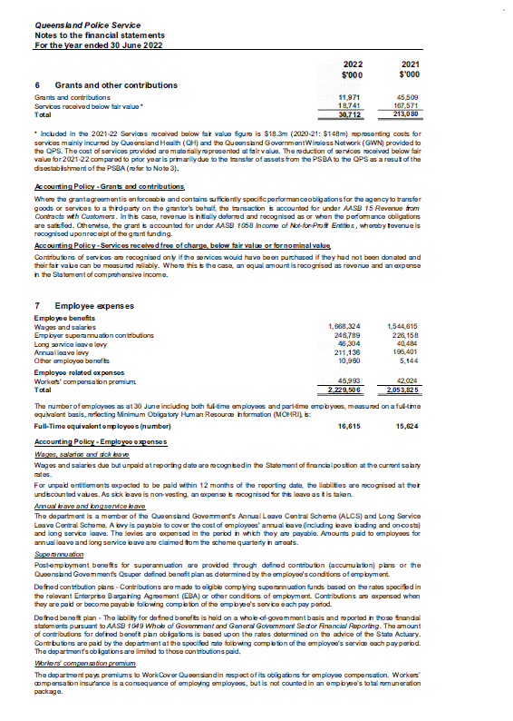

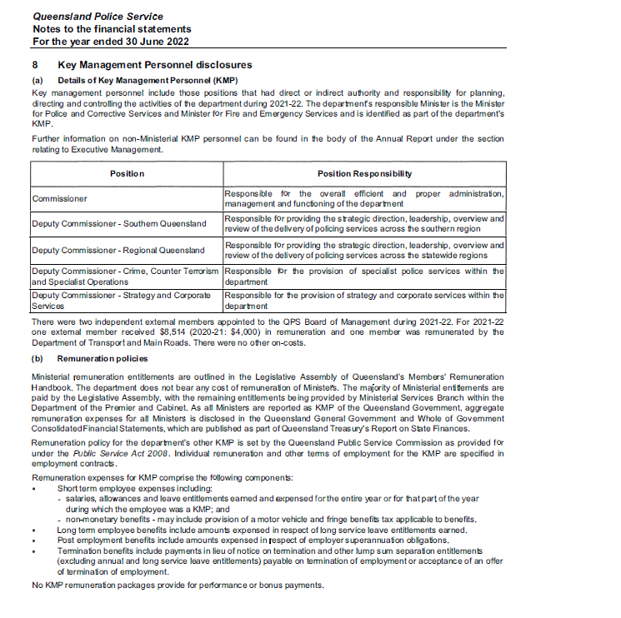

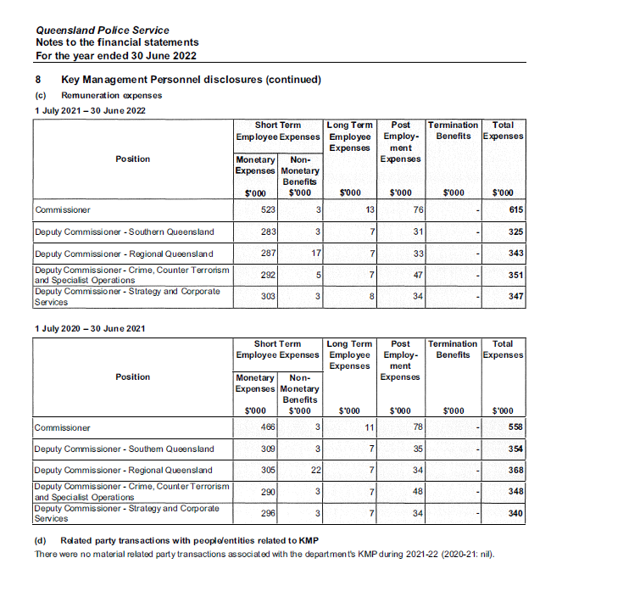

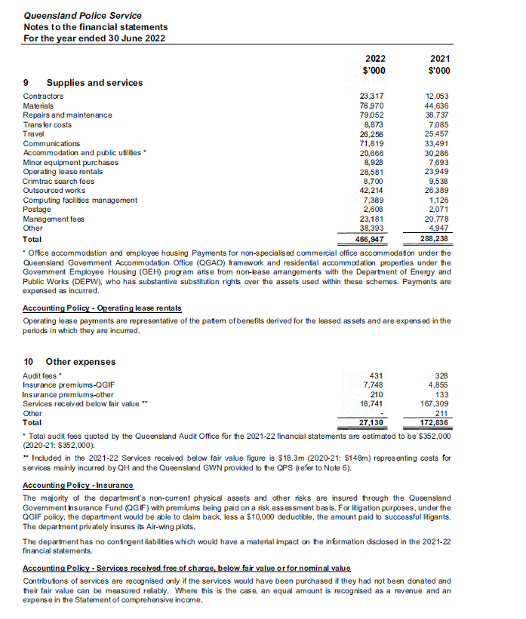

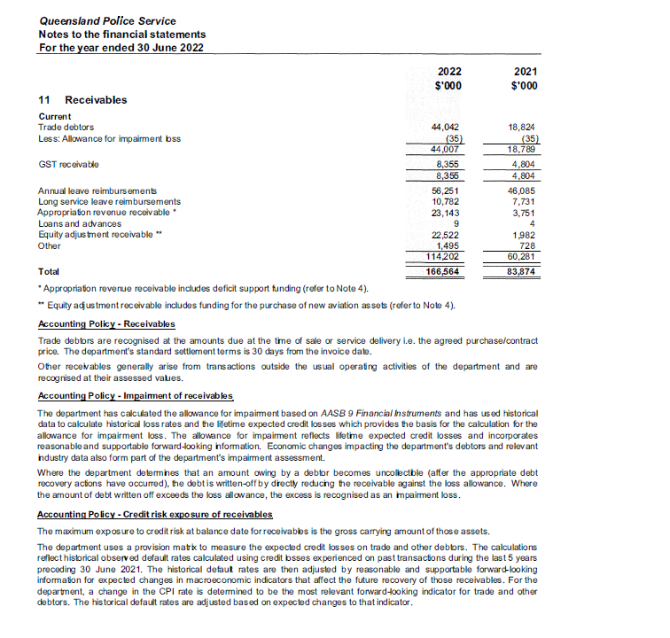

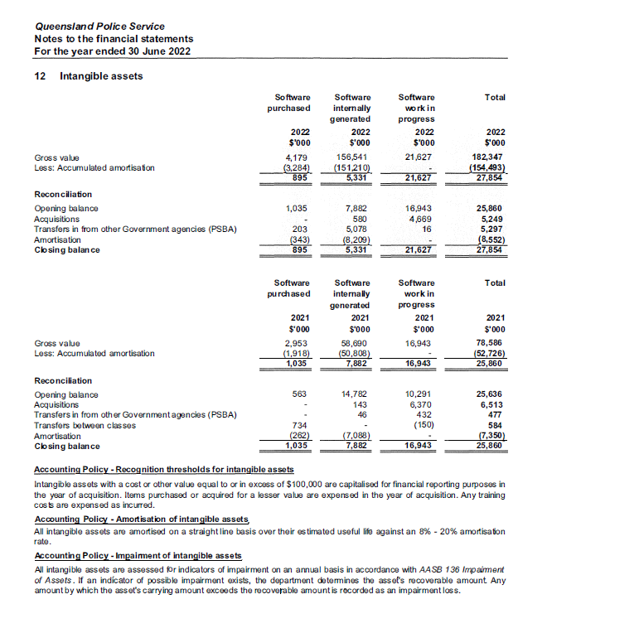

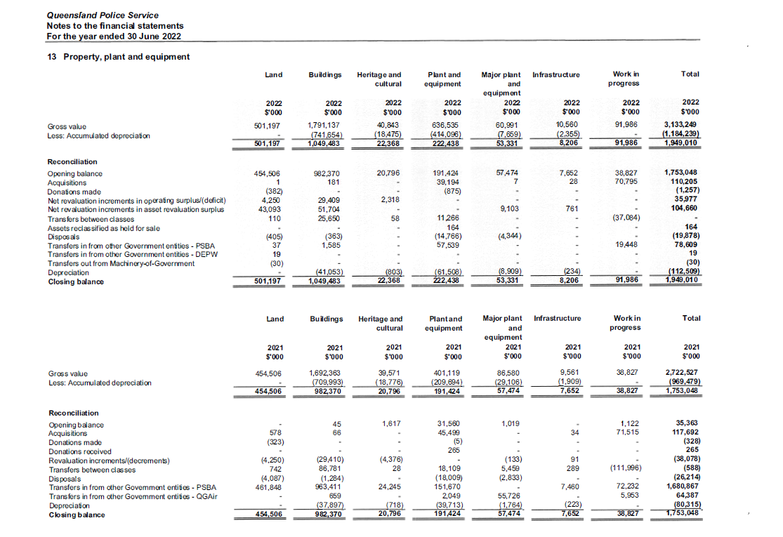

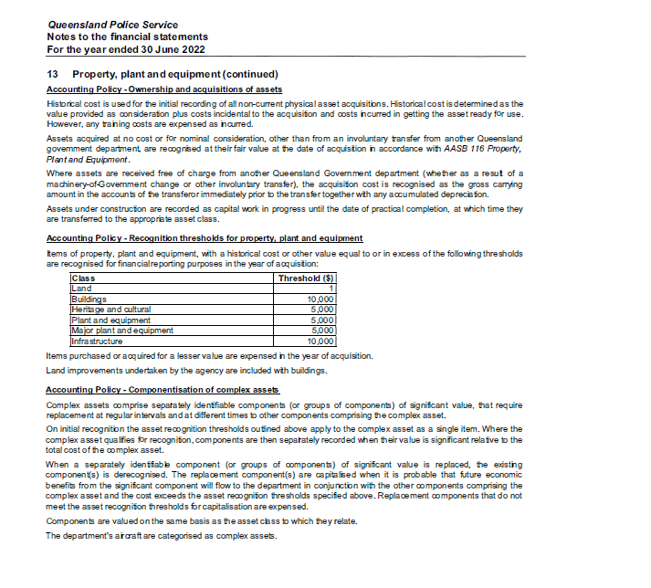

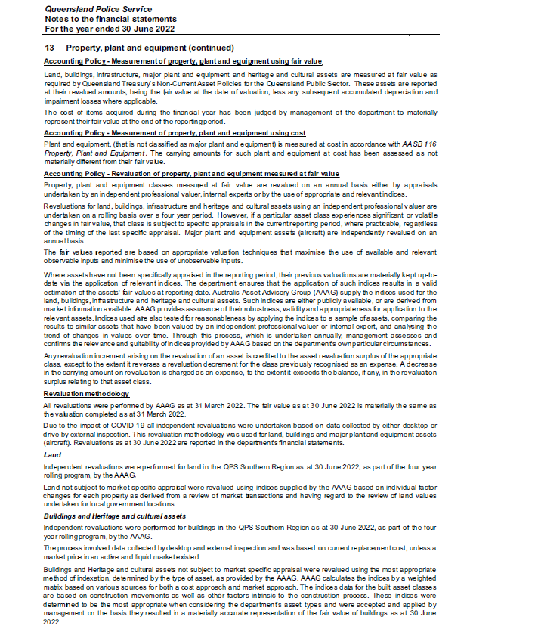

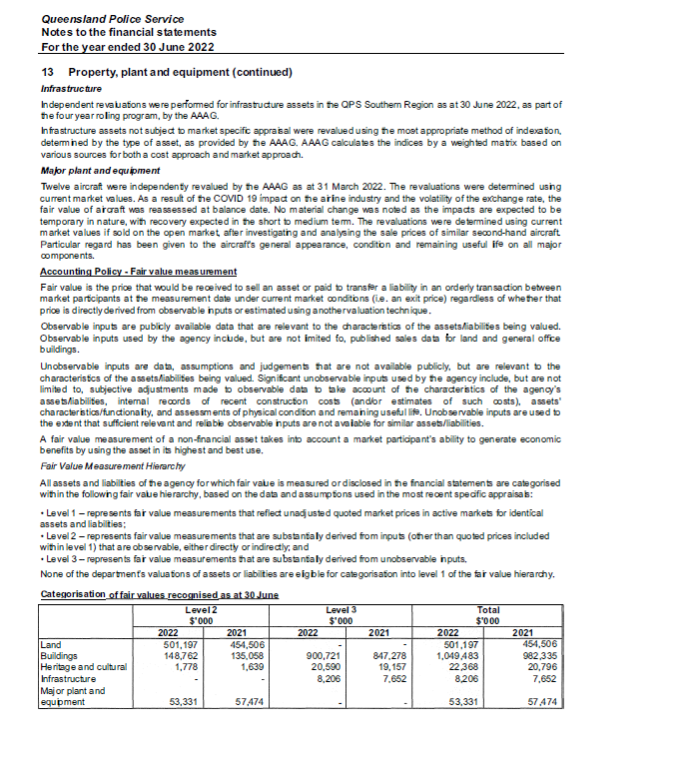

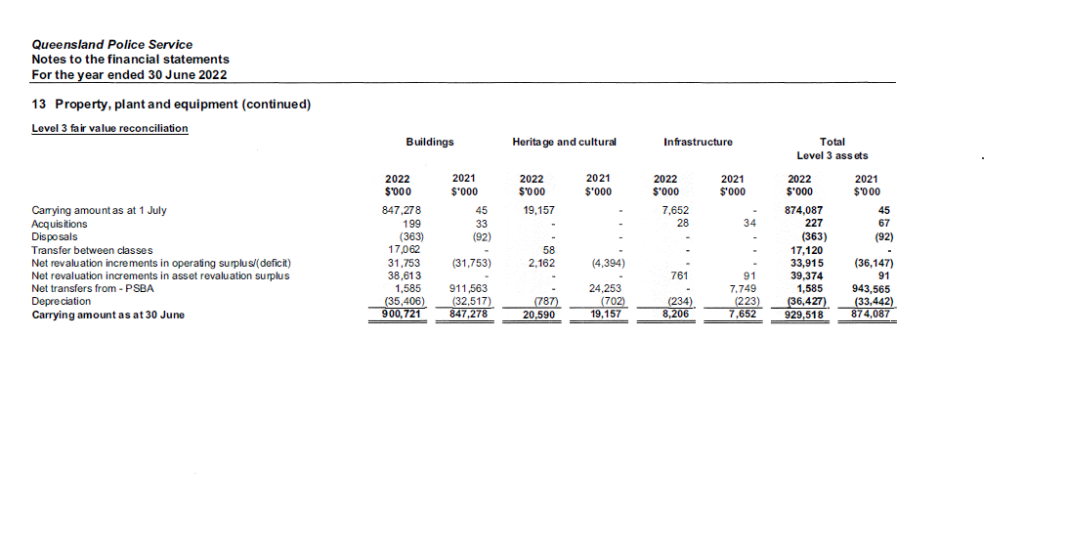

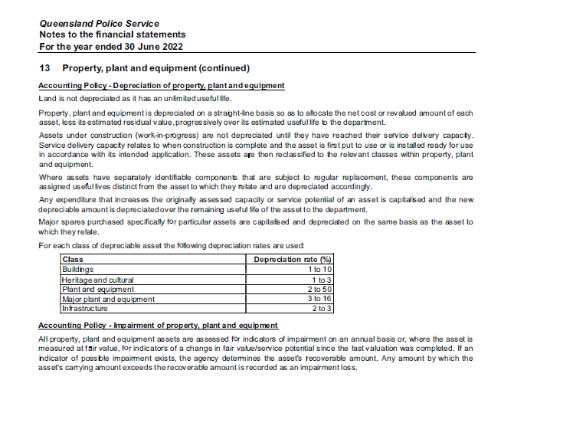

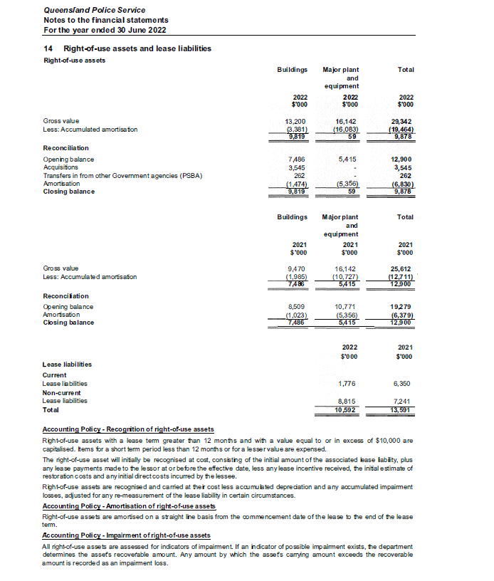

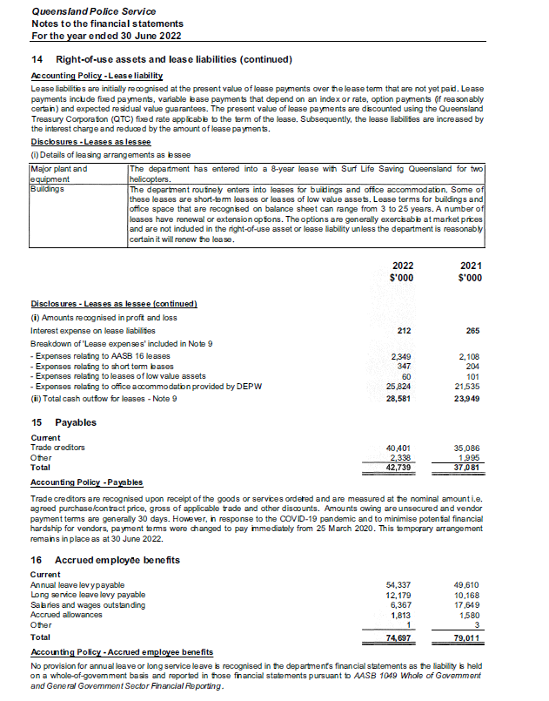

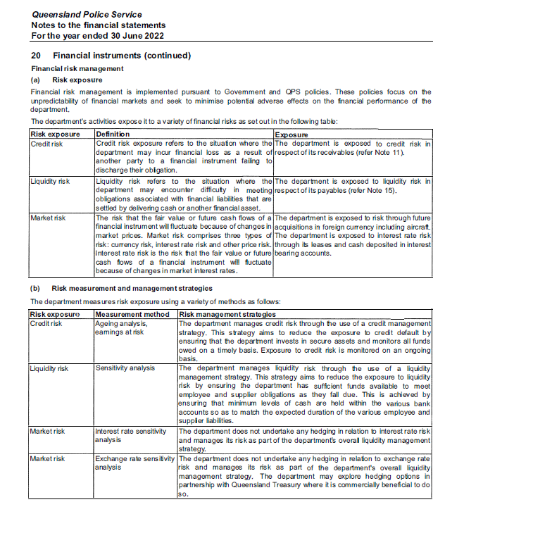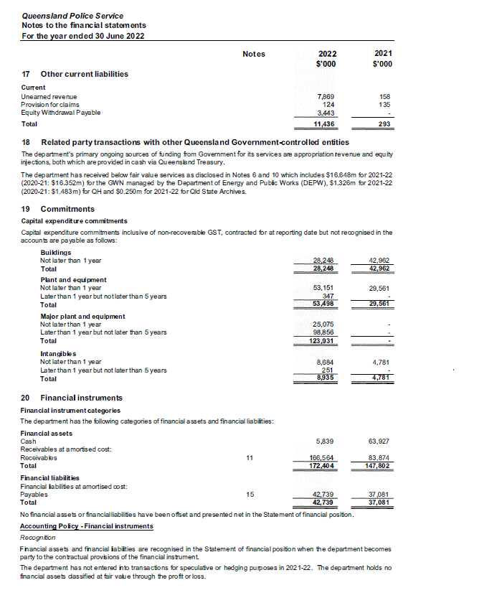

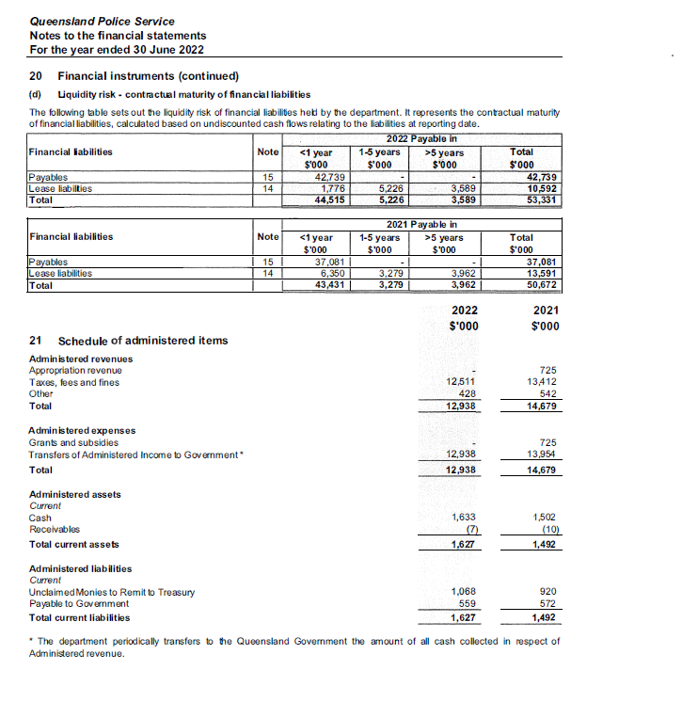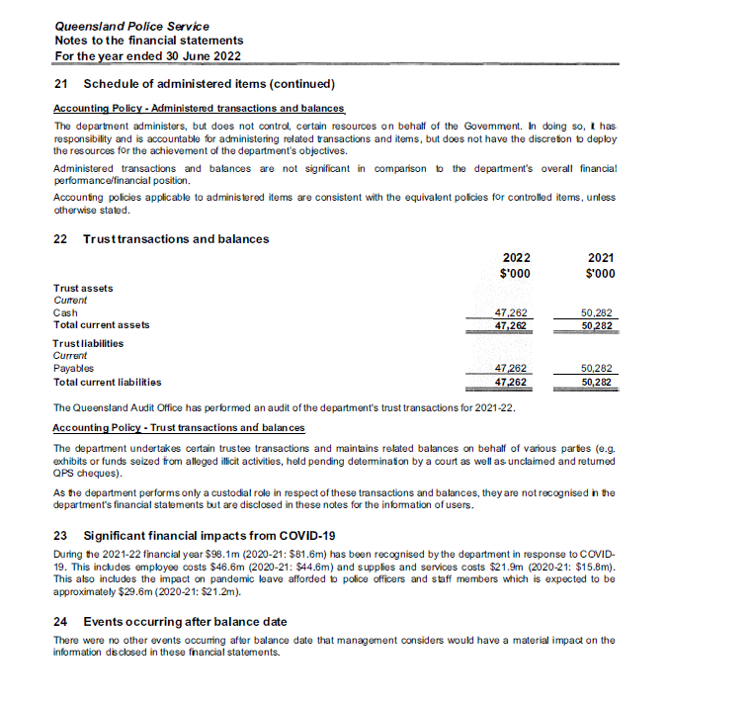

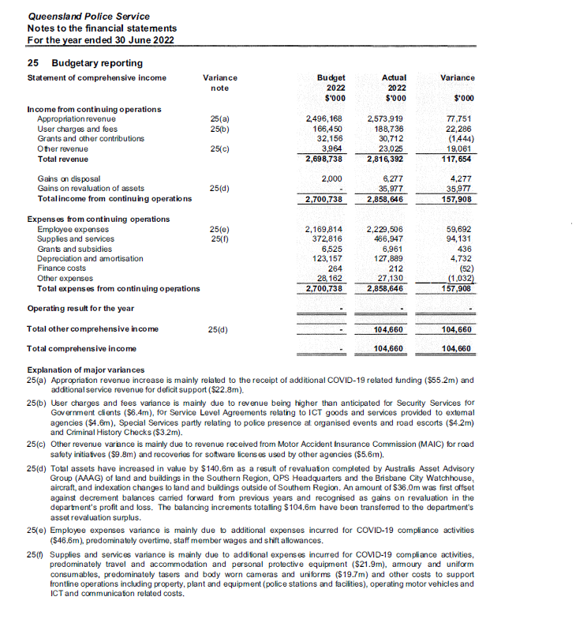

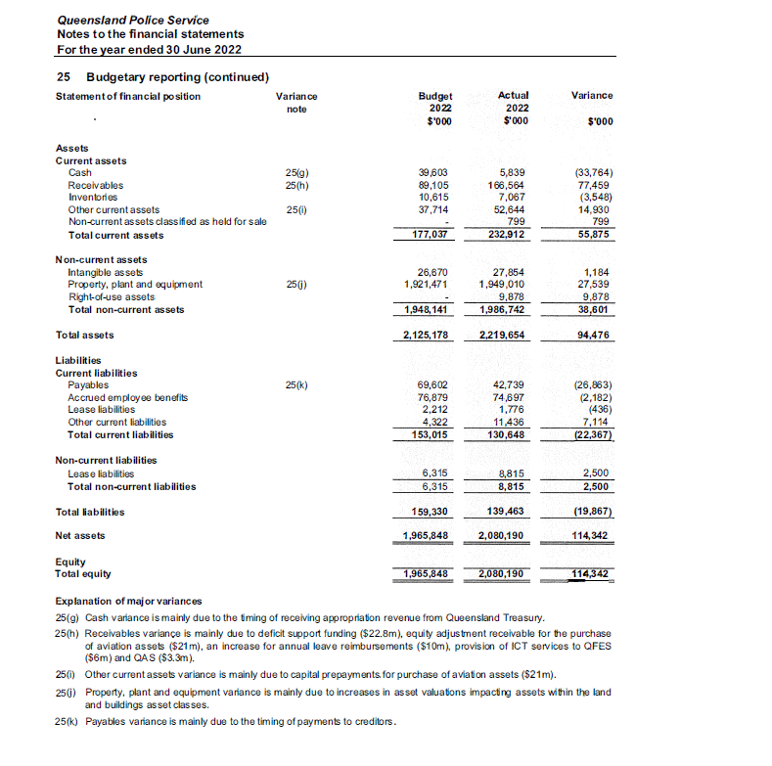

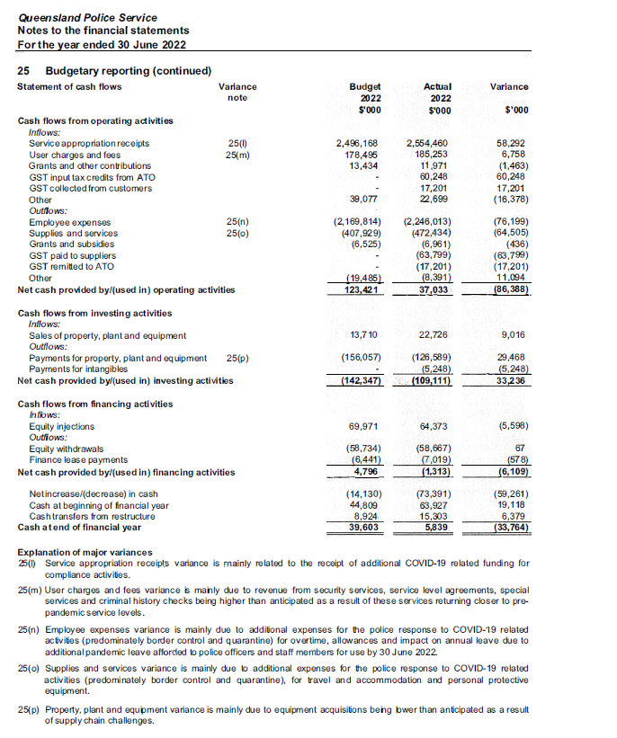

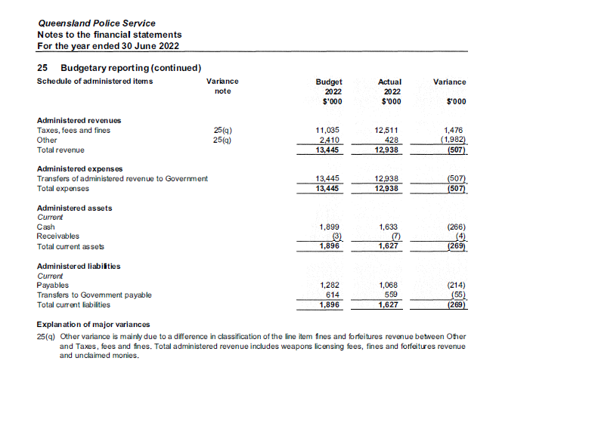

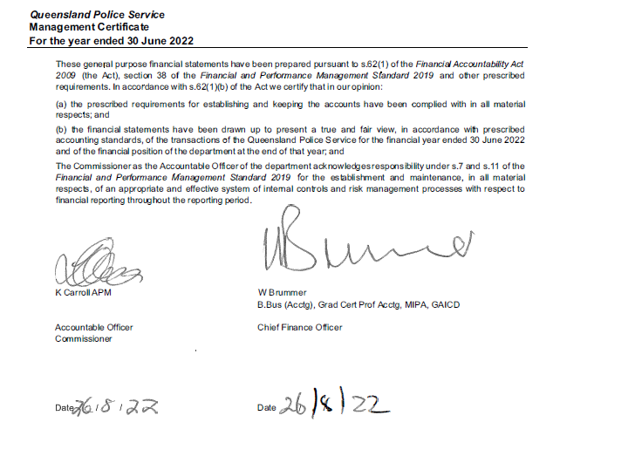

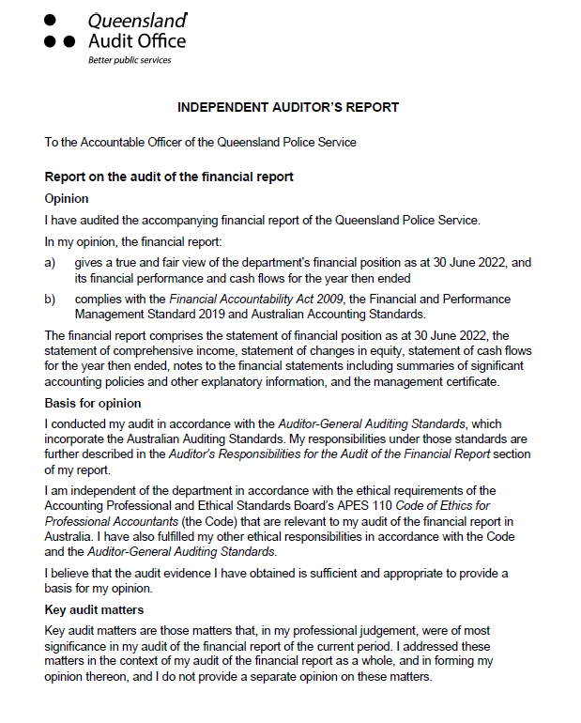

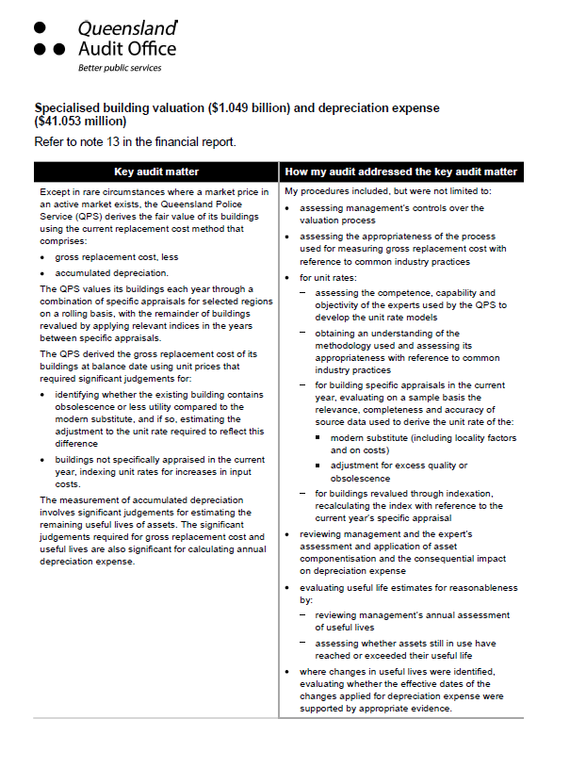

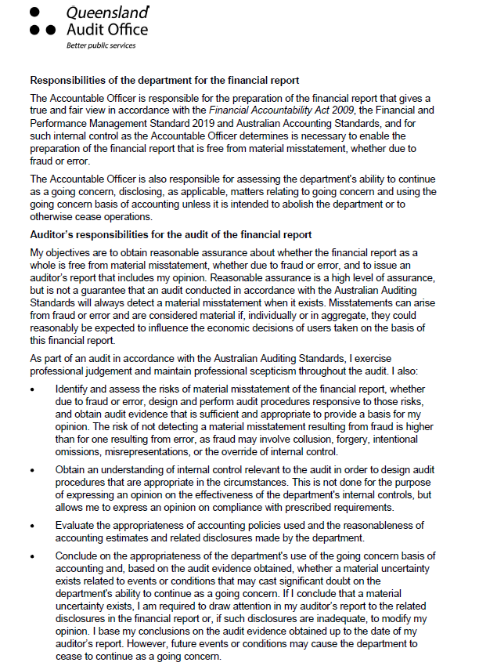

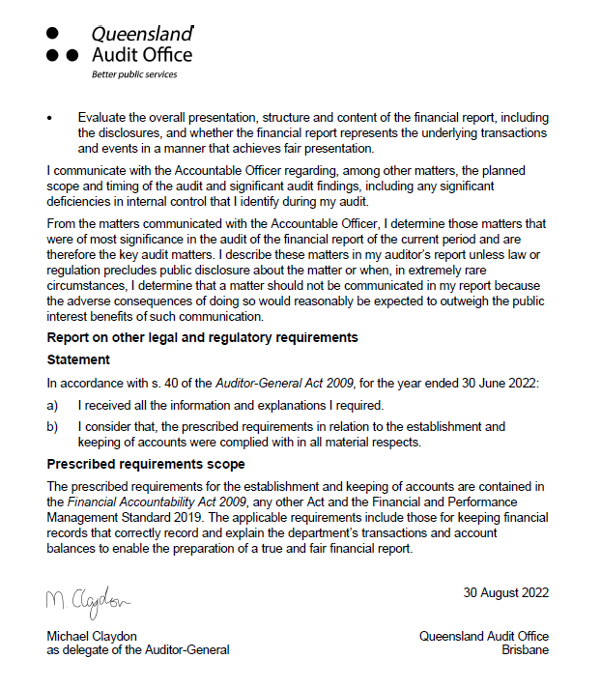

**Appendices**

**Government bodies**

|  |  |
| --- | --- |
| **Commissioner for Police Service Reviews** | |
| Act/instrument | The Commissioner for Police Service Reviews is established under the *Police Service Administration Act 1990* and *Police Service Administration Regulation 2016*. |
| Functions | The Review Commissioner is responsible for hearing grievances from police officers relating to appointments, promotions, transfers or disciplinary actions made under the Act.  Appeals are heard before a Review Commissioner nominated by the Crime and Corruption Commission yet otherwise independent of the Crime and Corruption Commission and the QPS. Where a matter progresses to a hearing, the Review Commissioner will consider the material presented and prepare written recommendations for the Police Commissioner who will make the final decision. Where the Police Commissioner does not implement the recommendation, reasons must be provided to the Review Commissioner and the parties to review.  The Crime and Corruption Commission provides secretariat support to the review function. |
| Further information about the Commissioner for Police Service Reviews is available at [www.ccc.qld.gov.au/](http://www.ccc.qld.gov.au/). | |
| **Controlled Operations Committee** | |
| Act | The Controlled Operations Committee is established under the *Police Powers and Responsibilities Act 2000.* |
| Functions | The Controlled Operations Committee is responsible for considering and making recommendations about applications for an authority, or variation to an authority, to conduct a controlled operation under Chapter 11 of the *Police Powers and Responsibilities Act 2000.* |
| Achievements | The committee provides its own annual report after 30 June each year, detailing the work and activities of the QPS under Chapter 11 Controlled Operations of the Act for the preceding 12 months.  The committee’s annual report is available online at [www.parliament.qld.gov.au/work-of-assembly/tabled-papers](http://www.parliament.qld.gov.au/work-of-assembly/tabled-papers). |
| Financial reporting | Records are inspected by the Chairperson of the Controlled Operations Committee. Transactions of the entity are accounted for in the QPS financial statements which are certified by the Auditor-General of Queensland. |

|  |  |  |  |  |  |
| --- | --- | --- | --- | --- | --- |
| **Controlled Operations Committee (cont’d)** | | | | | |
| **Remuneration** | | | | | |
| Position | Name | Meetings | Approved fee | Approved sub-committee fees | Actual fees received |
| Independent Member and Chairperson | The Honourable Roslyn Atkinson AO  (Appointed Independent Member 16/11/2022) | 6 | $520 | n/a | $2,600* |
| Independent Member and Chairperson | Mr Manus Boyce | 6 (Includes annual inspection) | $167 | n/a | $1,002 |
| Member (QPS Commissioner’s nominee) | Acting Detective Chief Superintendent Denzil Clark | 5 | n/a | n/a | n/a |
| Member (QPS Commissioner’s nominee) | Acting Detective Chief Superintendent Colin Briggs | 3 | n/a | n/a | n/a |
| Member (QPS Commissioner’s nominee) | Acting Detective Chief Superintendent Michael O’Dowd | 3 | n/a | n/a | n/a |
| Member (CCC Chairperson) | Alan MacSporran  (Resigned 28/01/2022) | 6 | n/a | n/a | n/a |
| Member (CCC Chairperson) | Bruce Barbour  (Appointed A/Chairperson 28/01/2022)  (Appointed Chairperson 02/07/2022) | 4 | n/a | n/a | n/a |
| A/Member (CCC Chairperson nominee) | Ms Sharon Loder | 1 | n/a | n/a | n/a |
| No. of scheduled meetings | 12 (Includes annual inspection) | | | | |
| Total out of pocket expenses | $3,602 | | | | |

*\* The fee for one meeting in the reporting period was paid in the 2022-2023 financial year and is not included in this total*

|  |  |  |  |  |
| --- | --- | --- | --- | --- |
| **Public Interest Monitor** | | | | |
| Act | The Public Interest Monitor is appointed under the *Police Powers and Responsibilities Act 2000* and the *Crime and Corruption Act 2001*. | | | |
| Functions | The Public Interest Monitor has the following functions for surveillance device warrants, retrieval warrants, approvals of the use of surveillance devices under emergency authorisations, and covert search warrants:   1. to monitor compliance by police officers with chapter 9 of the *Police Powers and Responsibilities Act 2000* (the Act) in relation to matters concerning applications for covert search warrants 2. to monitor compliance by law enforcement officers with chapter 13 of the Act in relation to matters concerning applications for surveillance device warrants, retrieval warrants and approvals of the use of surveillance devices under emergency authorisations 3. to appear at any hearing of an application to a Supreme Court judge for a warrant or approval mentioned in paragraph a) or b), or to a magistrate for a warrant mentioned in paragraph b), to test the validity of the application, and for that purpose at the hearing, to – 4. present questions for the applicant to answer and examine or cross-examine any witness 5. make submissions on the appropriateness of granting the application to appear at a consideration of a report made to a Supreme Court judge or a magistrate or given to the monitor and referred to a judge or magistrate under section 357 of the Act 6. to appear at a consideration of a report made to a Supreme Court judge or a magistrate or given to the monitor and referred to a judge or magistrate under section 357 of the Act 7. to gather statistical information about the use and effectiveness of covert search warrants, surveillance device warrants, control orders, preventative detention orders, official warnings for consorting and public safety orders. 8. to report as required by this Act on any matter about which this Act expressly requires the Public Interest Monitor to report 9. whenever the public interest monitor considers it appropriate 10. to give to the Commissioner a report on noncompliance by police officers with chapter 9 of the Act; or 11. to give to the chief executive officer of a law enforcement agency a report on noncompliance by law enforcement officers of the law enforcement agency with chapter 13 of the Act.   The Public Interest Monitor also has the following functions:   1. under the Criminal Code of the Commonwealth, to exercise the power conferred on the monitor under the following sections –  * section 104.12 (Service, explanation and notification of an interim control order) * section 104.12A (Election to confirm control order) * section 104.14 (Confirming an interim control order) * section 104.18 (Application by the person for a revocation or variation of a control order) * section 104.17 (Service of a declaration, or a revocation, variation or confirmation of a control order) * section 104.19 (Application by the Australian Federal Police Commissioner for a revocation or variation of a control order) * section 104.23 (Application by the Australian Federal Police Commissioner for addition of obligations, prohibitions or restrictions)  1. under the *Terrorism (Preventative Detention) Act 2005*, to exercise the power conferred on the monitor under the following sections –  * section 14 (General provisions that apply if the Public Interest Monitor must be notified about an application to the issuing authority) * section 73 (Supreme Court hearing and decision) | | | |
| **Public Interest Monitor (cont’d)** | | | | |
| Functions (cont’d) | 1. to gather statistical information about the use and effectiveness of control orders and preventative detention orders under the Acts mentioned in paragraphs a) and b) 2. whenever the Public Interest Monitor considers it appropriate – to give to the Commissioner a report on noncompliance by police officers with the *Terrorism (Preventative Detention) Act 2005*.   The Public Interest Monitor must also report in relation to:  official warnings for consorting (“OWFC”) issued by QPS officers; and  public safety orders made by QPS commissioned officers under the *Peace and Good Behaviour Act 1982*.  The Public Interest Monitor is required to report on the following matters:  the number of OWFC given during the year;  the number of times the giving of an OWFC led to a person committing an offence against:  section 790 PPRA (assault or obstruct police officer); or  section 791 PPRA (contravene direction or requirement of police officer);   * the extent of compliance by the QPS with chapter 2, part 6A of the PPRA; and * the use of OWFC generally.   The Public Interest Monitor is responsible for the recording, reporting and inspection regime for telecommunications interception in accordance with the *Telecommunications Interception Act 2009* which enables the use by the QPS and the Crime and Corruption Commission of Commonwealth telecommunications interception powers as a tool for the investigation of serious offences.  The Public Interest Monitor is entitled to appear at the hearing of the application for a telecommunications interception warrant to test the validity of the application and, for that purpose at the hearing, to –   1. ask questions of any person giving information to the eligible Judge or nominated Administrative Appeals Tribunal member; and 2. make submissions to the eligible Judge or nominated Administrative Appeals Tribunal member about the following maters –    1. in relation to an application for a warrant in relation to a telecommunications service    2. in relation to an application for a warrant in relation to a person.   In addition, the Public Interest Monitor has record-keeping oversight to ensure eligible authorities keep documents connected with the issue of warrants in accordance with the *Telecommunications Interception Act 2009*.  As the inspecting entity for the QPS, the Public Interest Monitor:   1. must inspect the eligible authority’s records as required under section 23 of the legislation to ascertain the extent of compliance by the authority’s officers 2. must report in writing to the Minister about the results of the inspections   may do anything necessary or convenient for the performance of the functions mentioned in (a) and (b). | | | |
| Achievements | The annual report of the Public Interest Monitor is available at [www.parliament.qld.gov.au/work-of-assembly/tabled-papers](http://www.parliament.qld.gov.au/work-of-assembly/tabled-papers). | | | |
| Financial reporting | Financial transactions made with the Public Interest Monitor are accounted for in the QPS financial statements which are certified by the Auditor-General of Queensland. | | | |
| **Remuneration** | | | | |
| Position | Meetings* | Approved fee | Approved sub-committee fees | Actual fees received** |
| Public Interest Monitor David Adsett | 66 | A service fee of $450.00 per hour to a maximum of $2,250.00 per day | n/a | $188,597.00 |
| Deputy Public Interest Monitor Patricia Kirkman-Scroope | 27 | A service fee of $450.00 per hour to a maximum of $2,250.00 per day | n/a | $75,891.75 |
| Deputy Public Interest Monitor Gail Hartridge | 36 | A service fee of $450.00 per hour to a maximum of $2,250.00 per day |  | $66,156.75 |
| **Public Interest Monitor (cont’d)** | | | | |
| No. of scheduled meetings | 129 | | | |
| Total out of pocket expenses | $330,645.50 | | | |

*\* number of meetings refers to the number of court/tribunal appearances (where there may be one or multiple applications) and excludes inspections and incidental meetings.*

*\*\* Actual fees received includes all fees related to the Public Interest Monitor functions including applications, inspections and incidental meetings.*

**Acronyms**

|  |  |  |  |  |
| --- | --- | --- | --- | --- |
| ARO | Alternative Reporting Option |  | LCP | Leadership Capability Program |
| ARCC | Audit, Risk and Compliance Committee |  | LEAD | Leadership, Engagement and Development |
| ACCCE | Australian Centre to Counter Child Exploitation |  | MOHRI | Minimum Obligatory Human Resource Information |
| ANZCTC | Australia-New Zealand Counter-Terrorism Committee |  | MPB | Mobile Police Beats |
| BOM | Board of Management\ |  | NWQ | Neighbourhood Watch Queensland |
| CPU | Central Panels Unit |  | OLP | Online learning product |
| CCLO | Cross-Cultural Liaison Officer |  | OCG | Organised Crime Gangs |
| CTT | Cultural Transformation Team |  | OCCG | Organised Crime Gangs Group |
| DCC | Demand and Capability Committee |  | OMCG | Outlaw Motorcycle Gangs |
| DCYJMA | Department of Children, Youth Justice and Multicultural Affairs |  | PCAP | People Capability Command |
| TMR | Department of Transport and Main Roads |  | PLO | Police Liaison Officer |
| DFV | Domestic and Family Violence |  | PCYC | Police-Citizens Youth Club |
| eDRMS | Electronic Document Records Management System |  | QAO | Queensland Audit Office |
| ESC | Ethical Standards Command |  | QFES | Queensland Fire and Emergency Services |
| ELT | Executive Leadership Team |  | QHVSG | Queensland Homicide Victims Support Group |
| FNMAU | First Nations and Multicultural Affairs Unit |  | QPCYWA | Queensland Police- Citizens Youth Welfare Association |
| FTE | Full-time Equivalent |  | QPS | Queensland Police Service |
| ICT | Information and Communication Technology |  | QPV | Queensland Police Vessel |
| IMU | Information Management Unit |  | QUT | Queensland University of Technology |
| IGEM | Inspector-General Emergency Management |  | RoGS | Report on Government Services |
| SAP | Service Alignment Program |  | TSIPLO | Torres Strait Island Police Liaison Officer |
| SDP | Service Delivery Program |  | VIP | Volunteers in Policing |
| SDRP | Service Delivery Redesign Project |  | WFQ | Working for Queensland |
| SDS | Service Delivery Statement |  | WAST | Workplace Assessment and Support Team |

**Compliance checklist**

| **Summary of requirement** | | **Basis for requirement** | **Annual report reference** |
| --- | --- | --- | --- |
| **Letter of compliance** | * **A letter of compliance from the accountable officer or statutory body to the relevant Minister/s** | ARRs *–* section 7 | 2 |
| **Accessibility** | * **Table of contents** * **Glossary** | ARRs – section 9.1 | 2, 102 |
| * **Public availability** | ARRs – section 9.2 | 1 |
| * **Interpreter service statement** | *Queensland Government Language Services Policy*  ARRs – section 9.3 | 1 |
| * **Copyright notice** | *Copyright Act 1968*  ARRs – section 9.4 | 1 |
| * **Information Licensing** | *QGEA – Information Licensing*  ARRs – section 9.5 | 1 |
| **General information** | * **Introductory Information** | ARRs – section 10 | 7-11 |
| **Non-financial performance** | * **Government’s objectives for the community and whole-of-government plans/specific actions** | ARRs – section 11.1 | 9-11, 15 |
| * **Agency objectives and performance indicators** | ARRs – section 11.2 | 8, 25-39 |
| * **Agency service areas and service standards** | ARRs – section 11.3 | 25-29 |
| **Financial performance** | * **Summary of financial performance** | ARRs – section 12.1 | 21-24 |
| **Governance – management and structure** | * **Organisational structure** | ARRs – section 13.1 | 16-17 |
| * **Executive management** | ARRs – section 13.2 | 40-41 |
| * **Government bodies (statutory bodies and other entities)** | ARRs – section 13.3 | 51, 97-101 |
| * **Public Sector Ethics** | *Public Sector Ethics Act 1994*  ARRs – section 13.4 | 51 |
| * **Human Rights** | *Human Rights Act 2019*  ARRs – section 13.5 | 12-13 |
| * **Queensland public service values** | ARRs – section 13.6 | 7-8 |
| **Governance – risk management and accountability** | * **Risk management** | ARRs – section 14.1 | 52 |
| * **Audit committee** | ARRs – section 14.2 | 47 |
| * **Internal audit** | ARRs – section 14.3 | 54 |
| * **External scrutiny** | ARRs – section 14.4 | 52-53 |
| * **Information systems and recordkeeping** | ARRs – section 14.5 | 55 |
| * **Information Security attestation** | ARRs – section 14.6 | 13 |
| **Governance – human resources** | * **Strategic workforce planning and performance** | ARRs – section 15.1 | 56-61 |
| * **Early retirement, redundancy and retrenchment** | Directive No.04/18 *Early Retirement, Redundancy and Retrenchment*  ARRs – section 15.2 | 61 |
| **Open Data** | * **Statement advising publication of information** | ARRs – section 16 | 1 |
| * **Consultancies** | ARRs – section 31.1 | [www.data.qld.gov.au](http://www.data.qld.gov.au) |
| * **Overseas travel** | ARRs – section 31.2 | [www.data.qld.gov.au](http://www.data.qld.gov.au) |
| * **Queensland Language Services Policy** | ARRs – section 31.3 | [www.data.qld.gov.au](http://www.data.qld.gov.au) |
| **Financial statements** | * **Certification of financial statements** | FAA – section 62  FPMS – sections 38, 39 and 46  ARRs – section 17.1 | 92 |
| * **Independent Auditor’s Report** | FAA – section 62  FPMS – section 46  ARRs – section 17.2 | 93-96 |

FAA *Financial Accountability Act 2009*

FPMS *Financial and Performance Management Standard 2019*

ARRs *Annual report requirements for Queensland Government agencies*

